ZL 7261/7201 | V1 | 1030721 | 6B1Z-72003



Operation Manual

ZL 7261 CL
ZL 7261 CN
ZL 7261 DE
ZL 7261 FR
ZL 7261 IT
ZL 7261 JP
ZL 7261 KR
ZL 7261 RU
ZL 7261 US
Z-Wave Power Monitor

ZL 7201 CL
ZL 7201 CN
ZL 7201 DE
ZL 7201 FR
ZL 7201 IT
ZL 7201 JP
ZL 7201 KR
ZL 7201 RU
ZL 7201 US
Z-Wave On/Off Module

Introduction

Thanks for choosing the Vision’s Power Monitor or On/Off Module of the home automation device. This Power Monitor or On/Off Module is a Z-Wave TM enabled device (interoperable, two-way RF mesh networking technology) and is fully compatible with any Z-Wave TM enabled network. Every main powered Z-Wave TM enabled device acts as a signal repeater and multiple devices result in more possible transmission routes, which helps eliminate “RF dead-spot”.
Z-Wave TM enabled devices displaying the Z-Wave TM logo can also be used with it regardless of the manufacturer, and ours can also be used in other manufacturer’s Z-Wave TM enabled networks. This module will send On/Off signal to the appliance that attached to this module by receiving Z-Wave TM signal from controller or manually switch. It also sends the energy consumption (ZL7261 only) to the controller when it requests. With special design, this module won’t interfere the other power outlet when plug into the AC outlet. This module also acts as repeater (supporting FLiRS).

Product Description and Specification

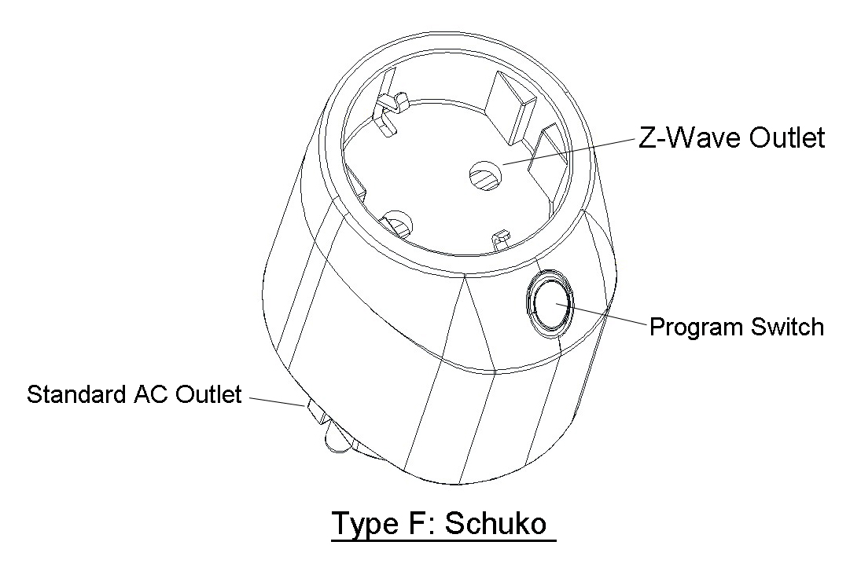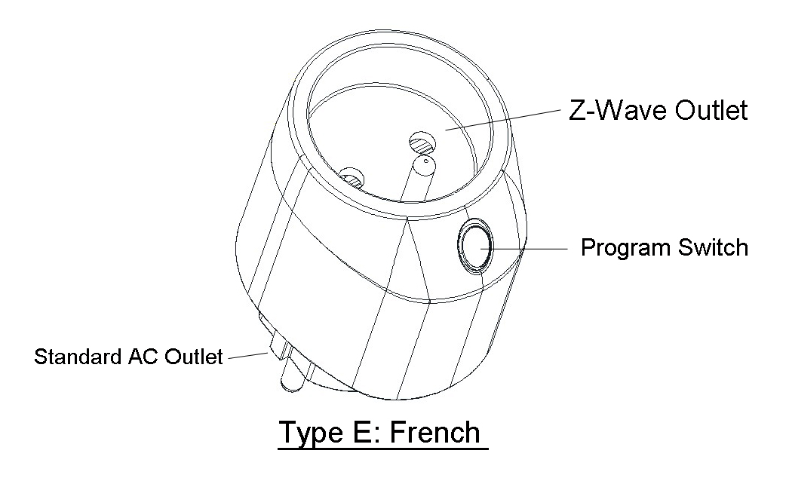

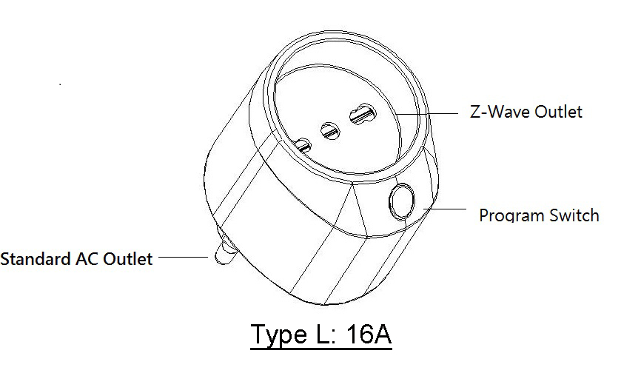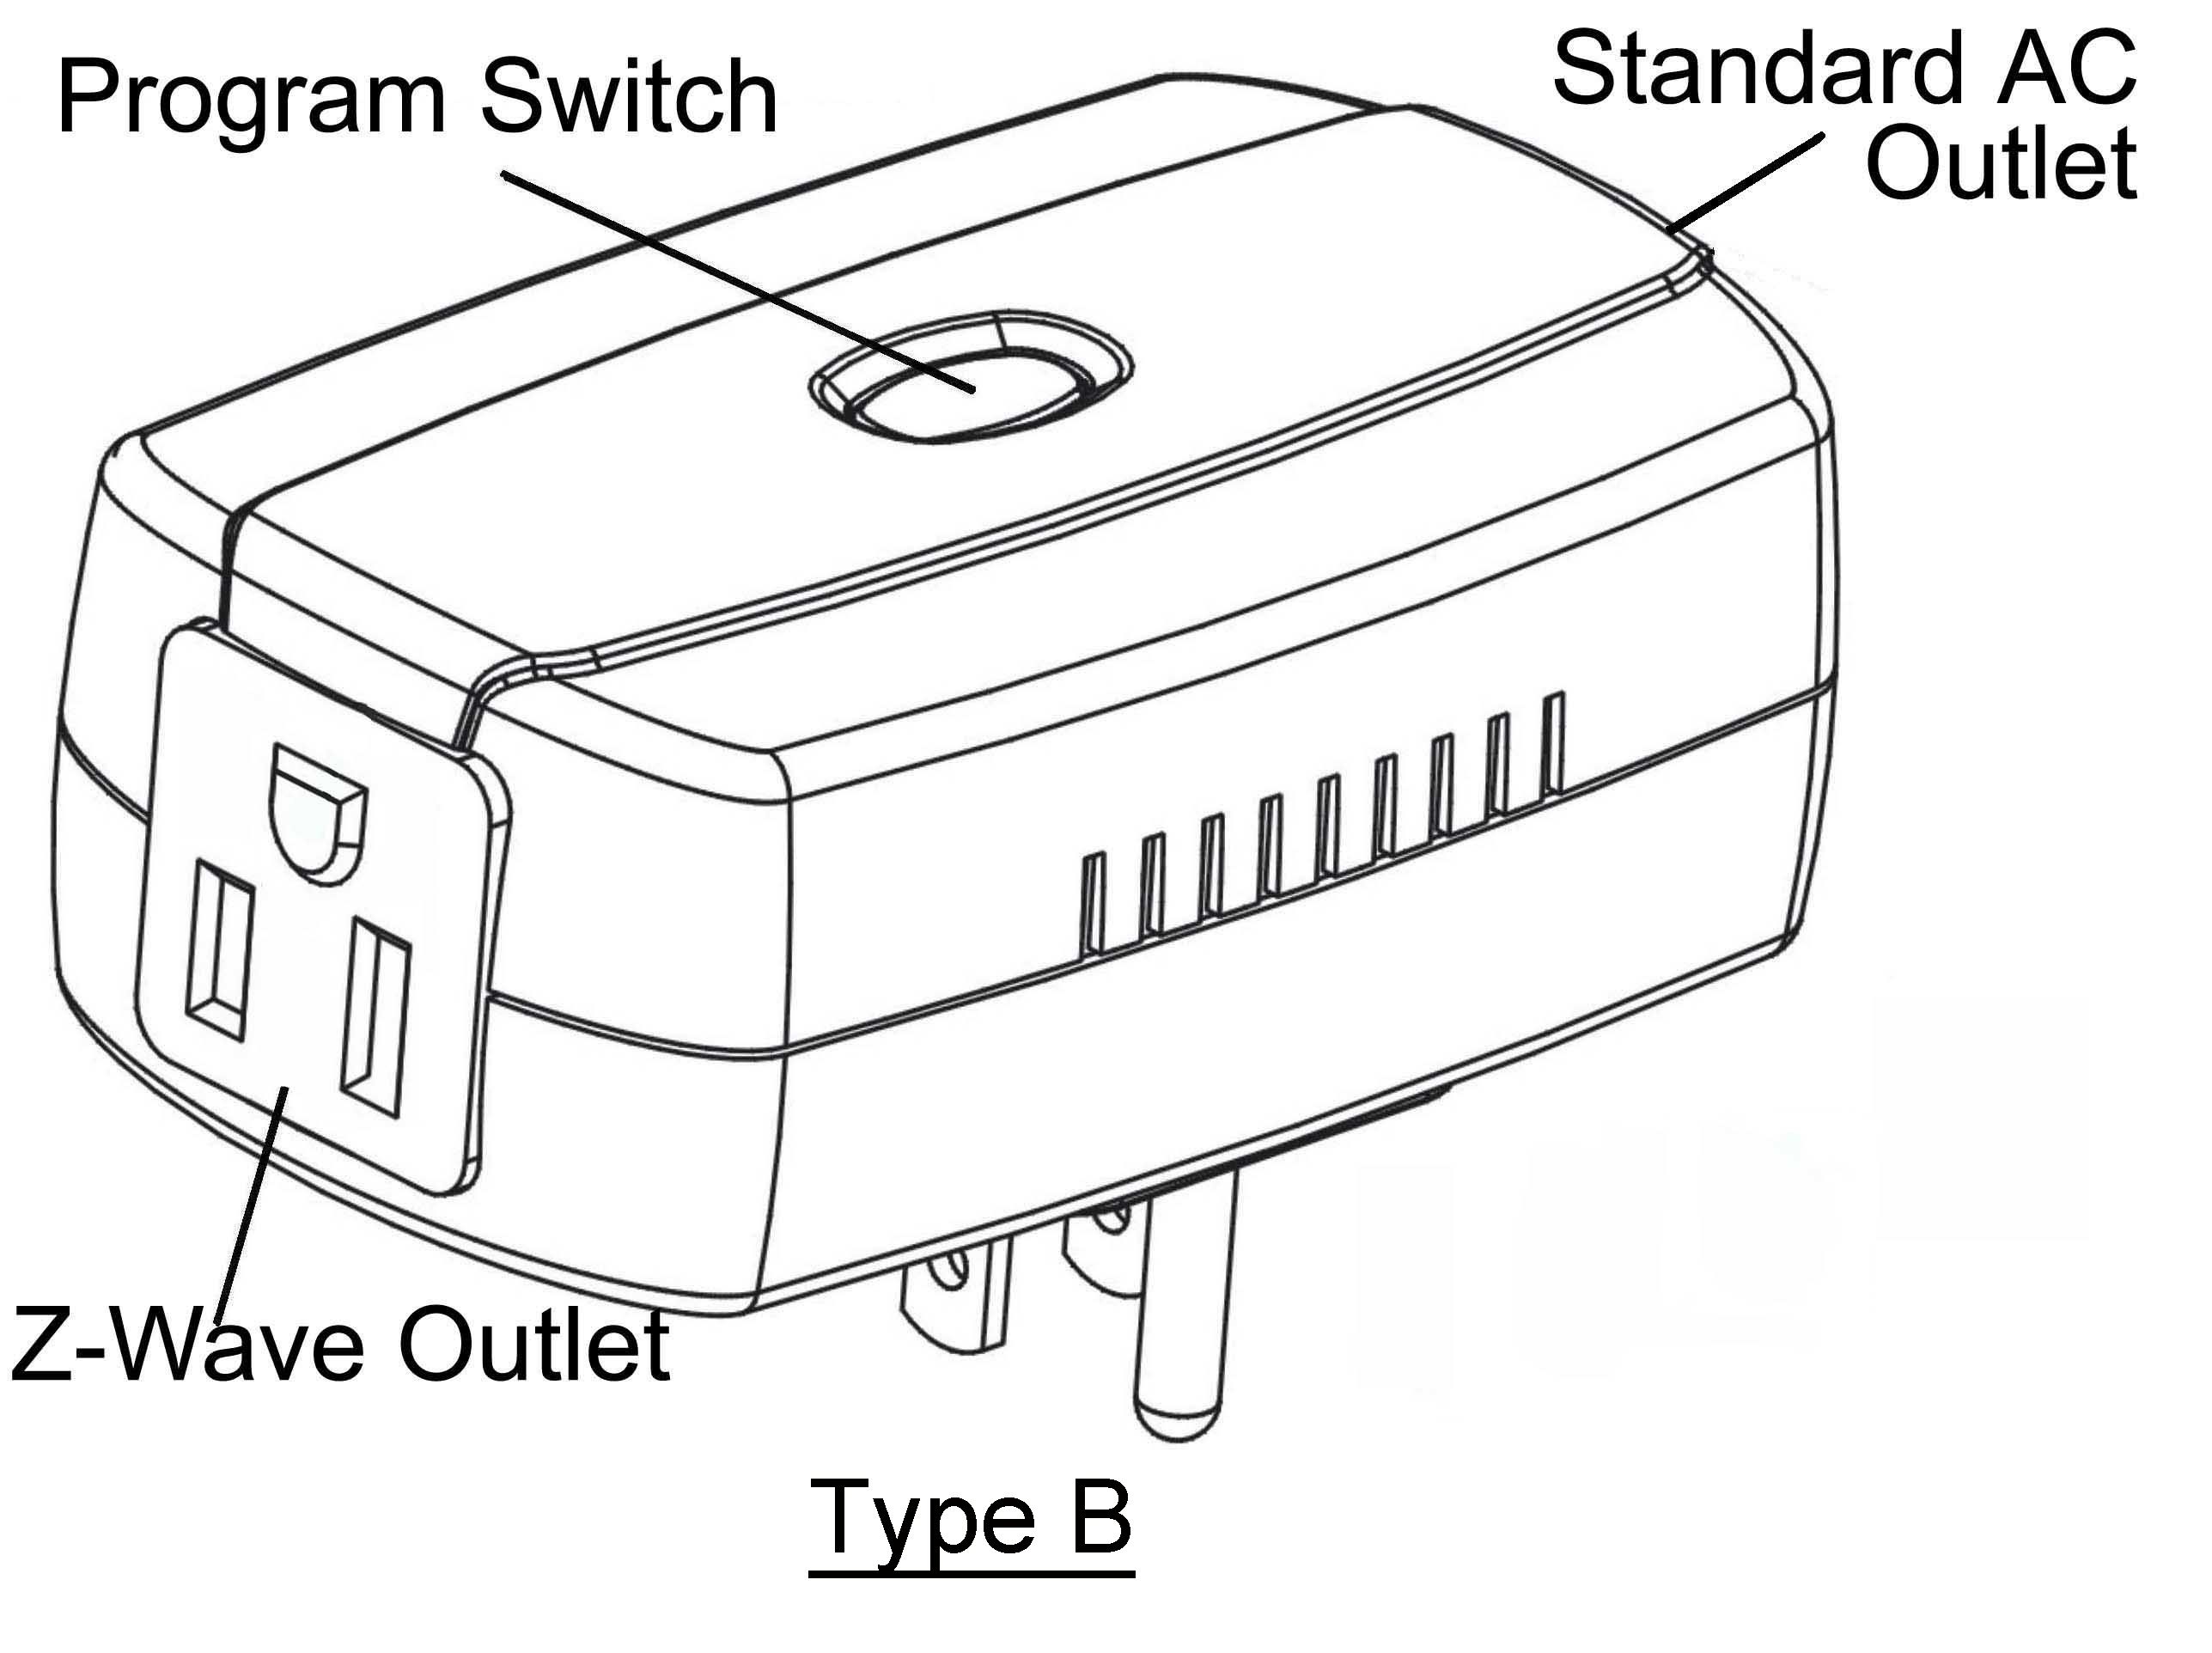

Specification: | Package Content:
Protocol: Z-Wave TM (ZM3102/ZM5202)  Frequency:  868.42 MHz (ZL7201CN/DE/FR/IT / ZL7261CN/DE/FR/IT)  869.00 MHz (ZL7201RU / ZL7261RU)  908.40 MHz (ZL7201CL/US / ZL7261CL/US)  919.70 MHz (ZL7201KR / ZL7261KR)  922-926MHz (ZL7201JP / ZL7261JP)  Operating Temp. -15°C~ 60°C (-5°F~ 140°F)  Operating Voltage: AC 100V~230V  Operating Range: Up to 100 feet (about 30m)  Data Rate: Up to 9.6k/40k/100kbps  Application: Indoor use  Max Loading  Type B: 110V/15A/1600W (Resistive)  220V15A/3200W (Resistive)  Type E, F & L: 220V/16A/3500W (Resistive) | 1pc Power Monitor or On/Off Module  1pc User Manual
Z-Wave™ Command Class:
COMMAND_CLASS_APPLICATION_STATUS
COMMAND_CLASS_ASSOCIATION_GRP_INFO
COMMAND_CLASS_ASSOCIATION_V2
COMMAND_CLASS_CONFIGURATION
COMMAND_CLASS_DEVICE_RESET_LOCALLY
COMMAND_CLASS_FIRMWARE_UPDATE_MD_V2
COMMAND_CLASS_POWERLEVEL
COMMAND_CLASS_MANUFACTURER_SPECIFIC_V2
COMMAND_CLASS_METER_V4 (ZL7261 only)
COMMAND_CLASS_SWITCH_ALL
COMMAND_CLASS_SWITCH_BINARY mapping COMMAND-CLASS_BASIC
COMMAND_CLASS_VERSION_V2
COMMAND_CLASS_ZWAVEPLUS_INFO

Operation

If you are installing the entire Z-Wave TM system for the first time, please refer to the installation guide of Z-Wave TM Interface Controller before installing ZL7261 or ZL7201.

- For “Inclusion” in (adding to) a network: Put the Z-Wave TM Interface Controller into “inclusion” mode, and following its instruction to add the ZL7261 or ZL7201 into your controller. To get in the “Inclusion” mode, the distance between ZL7261 or ZL7201 and controller is suggested to be in one meter. By power up to get included for first time, or press the Program switch 3 times within 2 seconds to be included.
For “Exclusion” from (removing from) a network: Set up the Z-Wave TM Interface Controller into “exclusion” mode, and following its instruction to delete the ZL7261 or ZL7201 from your controller. Press the Program Switch 3 times within 2 seconds to be excluded.

For “Association”: the Z-Wave TM interface controller set “Association”, and following its instruction to associate the ZL7261 or ZL7201 with other device. Support one group (5 nodes). ZL7261 or ZL7201 will report back every time ON and OFF status.

- For “Meter Supported Get” (ZL7261 only): the Z-Wave TM Interface Controller sends “Meter Get” then “Scale” command that see what kind of power consumption measurement want to report back according to the scales below. Then ZL7261 will report back the energy consumption values.
Scale: 0x00-kWh;
0x01-kVAh
0x02-W
0X04-V
0X05-A
0X06-Power Factor.

-2-

-1-

- LED visual indication:
Excluded | Red and Green LED flashing separately
Included | Switch ON Red, Switch Off Green | ZL7201 only
Energy | 0 ~ 5 AMP Green | ZL7261 only
Energy | 5 ~ 10 AMP Orange | ZL7261 only
Energy | 10 ~ 15 AMP Red | ZL7261 only

- Manually turn the connected appliance On/Off by your controller or pressing the Program Switch. This is toggle switch. If the connected appliance is OFF, pressing the Program Switch turns the connected appliance ON and vice versa.

- Status of “ON” (Binary Switch Set 0xFF or All Switch ON), status of “OFF” (Binary Switch Set 0x00 or All Switch OFF)

- Repeater Function

- Support Meter Auto Report Function (ZL7261 only)

- Configuration (ZL7261 only):
 | Parameter | Size | Value | Notes
Auto report timing | 1 | 1 byte | 60~255 seconds  (Default 60 seconds) | Report kWh/kVAh
Report when Watt change | 2 | 2 byte | 5~3600 watt  (Default 50 watt) | Report V.A.W

- Reset: Press the Program Switch then power on (plug-in) and hold for 5 seconds before release the switch.

- Support OTA Firmware update from controller. Please refer to your controller manual. Once OTA function success, please make sure to exclusive the device & inclusive again before use the device.

-3-

Federal Communications Commission Statement

This equipment has been followed to comply with the limits for a Class B digital device, pursuant to Part 15 of the FCC Rules. These limits are designed to provide reasonable protection against harmful interference in a residential installation. This equipment generates, uses and can radiate radio frequency energy and, if not installed and used in accordance with the instruction, may cause harmful interference to radio communications. However, there is no guarantee that interference will not occur in a particular installation. If this equipment does cause harmful interference to radio or television reception, which can be determined by turning the equipment off and on, the user is encouraged to try and correct the interferene by one of the following measures:

Reorient or relocate the receiving antenna,
Increase the separation between the equipment and receiver,
Consult the dealer or an experienced radio/TV technician for help.

This device complies with Part 15 of the FCC Rules. Operation is subject to the following two conditions: (1) this device may not cause harmful interference, and (2) this device must accept any interference received, including interference that may cause undersired operation.

FCC Caution: Any changes or modifications not expressly approved by the party responsible for compliance could void the user’s authority to operate this equipment.

Limited Warranty

Vision Guarantees that every wireless lighting module is free from physical defects in material and workmanship under normal use for one year from the date of purchase. If the product proves defective during this one-year warranty period, Vision will replace it free of charge. Vision does not issue any refunds. This warranty is extended to the original end user purchase only and is not transferable. This warranty does not apply to: (1) damage to units caused by accident, dropping or abuse in handling, or any negligent use; (2) units which have been subject to unauthorized repair, taken apart, or otherwise modified; (3) units not used in accordance with instruction; (4) damages exceeding the cost of the product; (5) transit damage, initial installation costs, removal cost, or reinstallation cost.

For information on addional devices, plesae visit us at www.visionsecurity.com.tw
-4-

