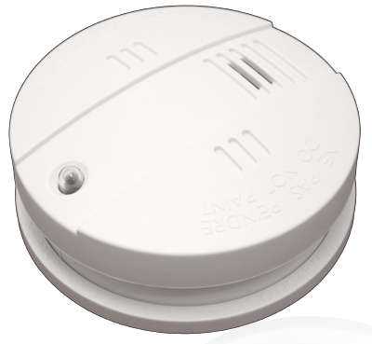

004001
Secure Z-Wave Smoke Detector and Siren

Quick Start
S This device is a combination of a Z-Wave Sensor (Smoke) and a Z-Wav Actuator (Siren). Pushing the internal button for 1 sec. includes (adds) and excludes (removes) the device. The device is either powered by battery or can be powered by an optional external power supply (12 V DC). It supports secure communication and will automatically recognize other smoke sensors sharing alarm messages to cover the whole home. The controller must support secure communication in order to fully utilize the secure functions of the device.
Please refer to the chapters below for detailed information about all aspects of the products usage.

What is Z-Wave?
This device is equipped with wireless communication complying to the Z-Wave standard. Z-Wave is the international standard for wireless communication in smart homes and buildings. It is using the frequency of 868.42 MHz to realize a very stable and secure communication. Each message is reconfirmed (two-way communication) and every mains powered node can act as a repeater for other nodes (meshed network) in case the receiver is not in direct wireless range of the transmitter.
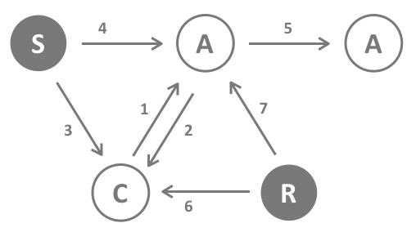
Z-Wave differentiates between Controllers and Slaves. Slaves are either sensors (S) transmitting metered or measured data or actuators (A) capable to execute an action. Controllers are either static mains powered controllers (C) also referred to as gateways or mobile battery operated remote controls (R). This results in a number of possible communication patterns within a Z-Wave network that are partly or completely supported by a specific device.
- Controllers control actuators
- Actuators report change of status back to controller
- Sensors report change of status of measured values to controller
- Sensors directly control actuators
- Actuators control other actuators
- Remote controls send signals to static controllers to trigger scenes or other actions
- Remote controls control other actuators.
There are two different role a controller can have. There is always one single primary controller that is managing the network and including/excluding devices. The controller may have other functions - like control buttons - as well. All other controllers don't manage the network itself but can control other devices. They are called secondary controllers. The image also shows that its not possible to operate a sensor just from a remote control. Sensors only communicate with static controllers.

Product description
This products consists of a standard photo electric Smoke detector with a pluggable Z-Wave wireless interface module. The Smoke detector will also work as a stand alone product and is certified by VDS according to DIN EN 14604. The smoke chamber of the detector has a stainless steel reel with antistatic plastic chamber.
A button allows on-device test of smoke chamber, electronics and battery. The device also offers a built-in self test and an electronic smoke chamber test to avoid the use of test aerosol. A low battery warning will last for 30 days but full function of the detector is guaranteed during this time.
The Z-Wave module allows to report the smoke and low battery alarm wirelessly to a central controller. The detector can also be used a wireless siren for alarm system or other applications. The wireless module is operated by the 9V battery of the smoke detector. An optional external power supply allows external powering the unit.
According to VdS 3515 (Smoke Detectors with Wireless Communication) this device will automatically send alarm signals to all other POPP smoke detectors to turn on their siren. The same time all PPOPP smoke detectors will further relay the alarm signals to any other detectors in wireless range. This function ensures that all smoke detectors will issue noise if one of them detected a smoke.

Batteries
The unit is operated by batteries. Use only batteries of correct type. Never mix old and new batteries in the same device. Used batteries contain hazardous substances and should not be disposed of with household waste!
Battery Type: 1 * 9 V Block

Installation Guidelines
Please refer to the installation manual of the Smoke Detector Base device on where and how to mount the device. The installation guideline follows the European Norm EN 14676.
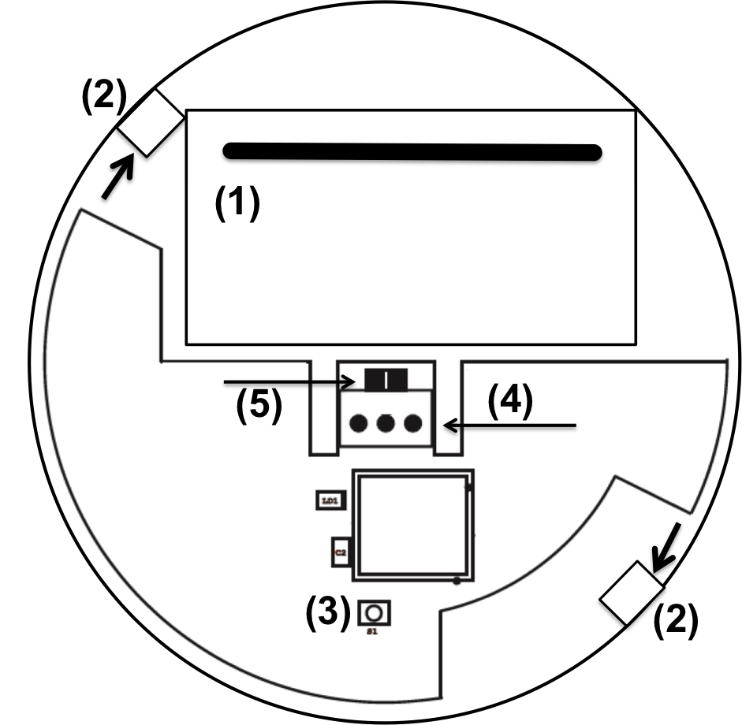
- Remove the bracket from the detector main unit by rotating it counter-clockwise.
- Place the bracket where you are going to install the detector. In each of keyhole slots, draw a mark to locate plastic anchor and screw. Using a 3/16-inch (5mm) drill bit, drills two holes at the marks and insert plastic anchor, and attached the bracket by using the screws.
- Plug the wireless module into the base device so that the three pins (4) in the center connect to the wireless interface. The battery compartment must be accessible.
- Open the battery compartment (1) to activate the battery, and then close the cover.
- The optional external power supply (12 V DC) will connect to the connector (5). The internal battery must stay inside the detector even when the external power supply is connected.
- Mount the smoke detector to the mounting ring. Make sure the hooks of the detector are placed between the hook and the twist stopper (2) of the mounting base (arrows in image above). Then turn about 15 % clockwise. (Hint. If the detector hook is not placed right between the two mounting ring structures the detector can’t be mounted to the ring).
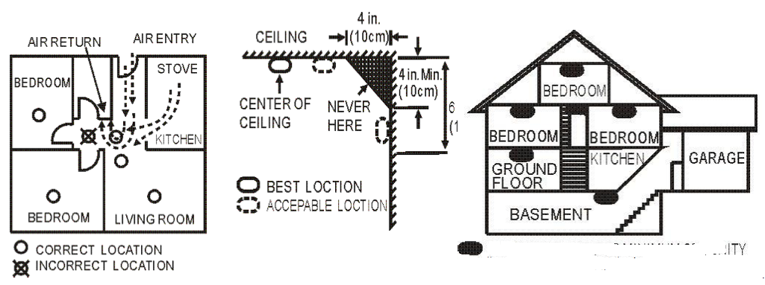
Please follow the recommendations about amount as position of the sensor in your home as given above. Avoid to place the sensor into the angle of walls, prefer positions in the middle of the room.

Behavior within the Z-Wave network
I On factory default the device does not belong to any Z-Wave network. The device needs to join an existing wireless network to communicate with the devices of this network. This process is called Inclusion or adding to the network. Devices can also leave a network. This process is called Exclusion or removing from the network. Both processes are initiated by the primary controller of the Z-Wave network. This controller will be turned into exclusion respective inclusion mode. Please refer to your primary controllers manual on how to turn your controller into inclusion or exclusion mode. Only if the primary controller is in inclusion or exclusion mode, this device can join or leave the network. Leaving the network - i.e. being excluded - sets the device back to factory default.
If the device already belongs to a network, follow the exclusion process before including it in your network. Otherwise inclusion of this device will fail. If the controller being included was a primary controller, it has to be reset first.
A simple click on the button of the wireless module (3) will include the device. Keeping the button (3) pressed for 2 seconds will force the device to be included without application level security. Single Click or 2 seconds hold will exclude the device. A blinking LED indicates when the device is in inclusion or exclusion pending status.

Operating the device
In case smoke is detected by the smoke detector the device will sound, the red LED will blink and the wireless module will issue a Z-Wave alarm command to the main controller and other associated devices. A low battery will be indicated on short siren noise plus the Z-Wave controller will be informed using Battery Low warning commands.
Note: All communication of the wireless module is performed with application level security if the device was included securely and all communication partners support secure communication as well. In case a non-secure device is associated for switching on smoke alarm, the smoke detector will detect this and change its communication style with this very device to non-secure. This process happens one time and will take about 20 seconds. This delay will happen on first communication only.
The siren can be used for other alarm indication. For this reason the device will be shown at Graphical user interface as a simple on/off switch. Turning on this switch start the siren, turning it off will stop the noise. The generic siren alarm has a different acoustic pattern than the permanent sound caused by smoke. The configuration parameters 1 and 2 define the style of the sound.
Wireless Alarm Meshing
The wireless meshing is performed by secure exchange of alarm commands among all wireless POPP smoke detectors. In case an alarm (battery or smoke) is issued by one device, this very device will broadcast a respective alarm (using Alarm CC V2 encapsulated into security wrapper if applied) to all devices in range. Every device that receives an alarm command and did not receive an alarm within the last 10 seconds will broadcast the same alarm command. Using this algorithm every POPP smoke sensor will also indicate an alarm within few seconds.
It is possible to wirelessly turn off the siren on all repeating smoke detectors but not on the detector that originally sent the alarm. You must find and remove the reason for the smoke detector to buzz.
Factory Reset
To reset the device keep the button pushed for 10 seconds. After 5 seconds the led starts flashing and after another 5 seconds there is a short beep signaling the successful reset back to factory defaults. Use this procedure only when the network primary controller is missing or otherwise inoperable.

Node Information Frame
NIF The Node Information Frame is the business card of a Z-Wave device. It contains information about the device type and the technical capabilities. The inclusion and exclusion of the device is confirmed by sending out a Node Information Frame. Beside this it may be needed for certain network operations to send out a Node Information Frame.
Once included a simple click on button (3) will issue a Node Information Frame.

Associations
A Z-Wave devices control other Z-Wave devices. The relationship between one device controlling another device is called association. In order to control a different device, the controlling device needs to maintain a list of devices that will receive controlling commands. These lists are called association groups and they are always related to certain events (e.g. button pressed, sensor triggers, ...). In case the event happens all devices stored in the respective association group will receive a common wireless command.
Association Groups:
1 | Lifeline (max. nodes in group: 4)
2 | Alarm Reports (max. nodes in group: 4)
3 | Switching Command when Alarm (max. nodes in group: 4)

Configuration Parameters
Z-Wave products are supposed to work out of the box after inclusion, however certain configuration can adapt the function better to user needs or unlock further enhanced features.
IMPORTANT: Controllers may only allow configuring signed values. In order to set values in the range 128 … 255 the value sent in the application shall be the desired value minus 256. For example: to set a parameter to 200 it may be needed to set a value of 200 minus 256 = minus 56. In case of a two byte value the same logic applies: Values greater than 32768 may needed to be given as negative values too.
Siren Alarm Sequence Interval (Parameter Number 1, Parameter Size 1)
The additional siren is creating a different acoustic signal differentiate from the smoke alarm. This sound is partly on and partly off. This parameter defines the total length of the interval in seconds.
Value | Description
3 — 127 | seconds (Default 10)

Siren Alarm Tone Length (Parameter Number 2, Parameter Size 1)
The additional siren is creating a different acoustic signal differentiate from the smoke alarm. This sound is partly on and partly off. This parameter defines the total length of the sound versus silence within this interval.
Value | Description
1 — 99 | sec (Default 8)

Value of On-Command (Parameter Number 3, Parameter Size 1)
Value | Description
0 — 99 | (Default 99)

Value of Off-Command (Parameter Number 4, Parameter Size 1)
Value | Description
0 — 99 | (Default 0)

Command Classes
Supported Command Classes
- Basic (version 1)
- Binary Switch (version 1)
- Binary Sensor (version 2)
- Association Group Information (version 1)
- Device Reset Locally (version 1)
- Z-Wave Plus Information (version 2)
- Configuration (version 1)
- Alarm (version 4)
- Manufacturer Specific (version 2)
- Firmware Update (version 2)
- Powerlevel (version 1)
- Battery (version 1)
- Association (version 2)
- Version (version 2)
- Security (version 1)
Controlled Command Classes
- Basic (version 1)
- Security (version 1)

Technical Data
IP Rating | IP 20, VdS-Number: C208090, CPD Number: 0789-CPD-20474
Battery Type | 1 * 9 V Block
Frequency | 868.42 MHz (SRD Band)
Wireless Range | up to 100 m outside, on average up to 20 m inside buildings
Explorer Frame Support | Yes
SDK | 6.5
Device Type | Slave with routing capabilities
Generic Device Class | Alarm Sensor
Specific Device Class | Specific Device Class not used
Routing | Yes (external power supply only)
FLiRS | Yes (in battery)
Firmware Version | 1.0

Explanation of Z-Wave specific terms
- Controller — is a Z-Wave device with capabilities to manage the network. Controllers are typically Gateways, Remote Controls or battery operated wall controllers.
- Slave — is a Z-Wave device without capabilities to manage the network. Slaves can be sensors, actuators and even remote controls.
- Primary Controller — is the central organizer of the network. It must be a controller. There can be only one primary controller in a Z-Wave network.
- Inclusion — is the process of bringing new Z-Wave devices into a network.
- Exclusion — is the process of removing Z-Wave devices from the network.
- Association — is a control relationship between a controlling device and a controlled device.
- Wakeup Notification — is a special wireless message issued by a Z-Wave device to announces that is able to communicate.
- Node Information Frame — is a special wireless message issued by a Z-Wave device to announce its capabilities and functions.

Disposal Guidelines
The product contains batteries. Please remove the batteries when the device is not used.
Do not dispose of electrical appliances as unsorted municipal waste, use separate collection facilities. Contact your local government for information regarding the collection systems available. If electrical appliances are disposed of in landfills or dumps, hazardous substances can leak into the groundwater and get into the food chain, damaging your health and well-being.

