Smoke Detector (SD-8ZW)
The SD-8ZW Smoke Detector is a wirelessly operated photo-electronic smoke detector designed to operate with any Z-wave enabled controller devices. The Smoke Detector’s alarm situations, battery condition, operating conditions, supervisory data and general fault information are sent to the Z-wave gateway/control panel wirelessly.
The Smoke Detector is a Z-Wave enabled device and is fully compatible with any Z-Wave enabled network.
Z-Wave is a wireless communication protocol that uses a low-power RF radio. By taking advantage of the Z-Wave mesh network, commands can be transmitted to their destination via intermediary “listening” Z-Wave products.
The Smoke Detector calibrates for the air contents after warming up to determine a standard condition for the environment. It is also pre-programmed to automatically calibrate once a month.
Mounting the Smoke Detector is simplified with the mounting bracket, where the mounting bracket is fixed to the surface using screws and dowels. The Smoke Detector is then fixed to the mounting bracket by hooking itself onto the mounting bracket.
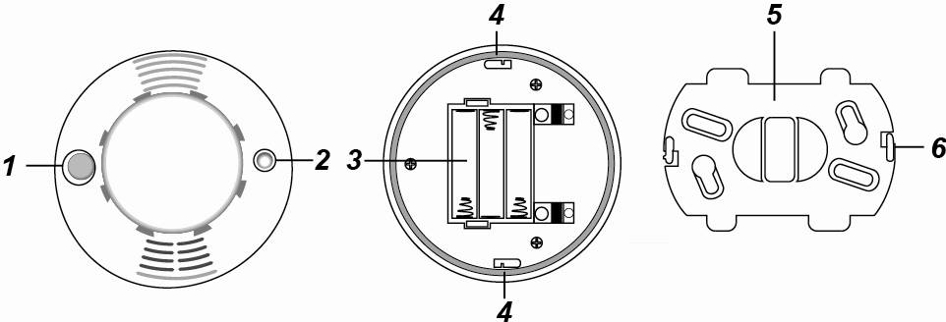
- LED
- When the Smoke Detector has low battery, the LED will flash once every 30 seconds (SD-8 will also emit a beep)
- While the smoke Detector is transmitting the signal, the LED will turn on.
- While the batteries are inserted and the Smoke Detector is in warming and calibration process, the LED will flash for 8-22 min.
- Test Button
- Press the Test Button 3 times within 1.5 seconds to send a learn code.
- Press the Test Button to test the radio communication range.
- Press the Test Button to test if the Smoke Detector is functioning normally.
- Press the Test Button to silence the alarm.
- Battery compartment
- Mounting Hole
- Mounting Bracket
- Hook

- Battery
- 3 “AA” Alkaline batteries are used to supply power.
- When the Smoke Detector has low battery, a low battery signal will be transmitted along with regular signal transmissions. If the battery voltage is low, the LED will flash accompanied with a Low-volume beep once every 30 seconds and inform the Control Panel regularly.
<NOTE>
- When changing batteries, press the Test button twice after removing the old batteries to fully discharge before inserting new batteries.

- Adding Device (Inclusion)
This product can be included and operated in any Z-Wave network with other Z-Wave certified devices from other manufactures and/or other applications. All non-battery operated nodes within the network will act as repeaters regardless of vendor to increase reliability of the network.
- Insert the 3 “AA” batteries into the battery compartment connecting the correct polarity as shown on the battery compartment lid. The Smoke Detector will emit a 2-tone beep.
- The LED will start flashing and begin a 6-minute warming period.
- Put the Z-wave gateway or control panel into Inclusion or Learning mode (please refer to the Z-wave gateway or control panel manual).
- Within 1.5 seconds, press the Test Button 3 times. The Smoke Detector will emit a 2-tone beep and the LED will turn on for ~2 seconds.
- Refer to the operation manual of the Z-wave gateway or control panel to complete the learn-in process.
- If the sensor has already been included (learnt) into another Z-wave Gateway/Control Panel, or if the sensor is unable to be learnt into the current Z-wave Gateway/Control Panel, please exclude it first (see Exclusion) before attempting to include it into the current Z-wave Gateway/Control Panel.
- When the 6-minute warming period is over, the Smoke Detector will emit one short beep to indicate that the Smoke Detector is starting calibration process. The process will be repeated every 100 seconds and notified by a short beep respectively. The Smoke Detector will emit a 2-tone beep and the LED will turn off to indicate calibration is completed.
- Normal calibration process lasts 2 - 16 minutes.
- If the Smoke Detector emits continuous beeps after 16 minutes, the calibration has failed. Remove the batteries to silence the continuous beeps.
- Restart the calibration process by re-inserting the batteries.

- Removing Device (Exclusion)
The Smoke Detector must be removed from existing Z-wave network before being included into another. There are two methods available to exclude a device.
Exclusion Mode
- Put the Z-wave gateway or control panel into Exclusion mode (please refer to the Z-wave gateway or control panel manual).
- Within 1.5 seconds, press the Test Button 3 times and the Smoke Detector will be removed from the Z-wave network.
Factory Reset
(Only use factory reset when network Control Panel/Gateway is missing or inoperable).
- Press and hold the Test Button of the Smoke Detector for 8 seconds to factory reset.
<NOTE>
- Factory resetting the Smoke Detector will restore it to factory default settings (excluded from the Z-wave network). The Z-wave gateway or control panel will still keep its Z-wave settings. Please refer to the gateway or control panel manual on how to remove the Smoke Detector’s Z-wave settings.

- Range Test
To test whether the device is able to communicate with the Z-wave gateway or control panel:
- Put the gateway / panel into range test mode (Walk Test).
- Press the Test Button on the device
- The gateway / panel should display if the device is within the operation range (please refer to the operation manual of the gateway / panel).

- Z-wave Sleep Mode
- The Smoke Detector will enter Z-wave Sleep mode (to conserve power) after waking up for a short period of time (~10 seconds). While in Z-wave sleep mode, Z-wave gateways or control panels are unable to send commands to the Smoke Detector.
- To program the Smoke Detector, please send command(s) to the Smoke Detector within the wake-up period.

- Auto-Calibration
- After first installation, SD-8 will perform auto-calibration after 4 hours. Afterwards it will perform auto-calibration once every month.
- During the auto-calibration process, SD-8 will not emit any sound.
- Each calibration sampling process takes 2 minutes, if the process fails, it will be retried for a maximum of 5 times. If the 5th retry fails, the LED will flash rapidly.
- The LED flashing can be cancelled by removing and reloading the batteries, or manually starting the calibration process. However, if the manual calibration fails again, SD-8 will emit continuous beeps. In this case you need to remove and reload the batteries to stop the beeping sound (please wait for 30 seconds after removing batteries before reloading them.)
<NOTE>
- When SD-8 auto calibration fails, the smoke alarm function will still work normally using the threshold value taken from last successful calibration

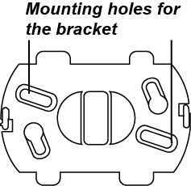
- Mounting
- Using the bracket as a template, mark the two holes according to the picture on the right to stabilize the bracket onto the surface.
- Insert the dowels.
- Screw the screws into the dowels to stabilize the bracket. The two hooks should be facing you.
- Locate the single line mark on the detector and line it up with one of the hooks of the bracket. After both hooks fits in the two mounting holes on the detector, rotate the detector clockwise to lock onto the bracket.

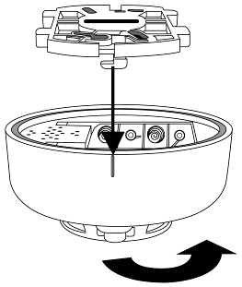
- Testing the Smoke Detector
By pressing the Test button on the Smoke Detector, you can test if the Smoke Detector is functioning normally.
- If the Smoke Detector functions normally, the LED will turn on for 2 seconds and emit a 2-tone beep.
- If the buzzer emits the 2-tone beep for 3 times, the “Optical Chamber” on the Smoke Detector is either dirty or out-of-order.
- The Smoke Detector is out-of-order if it does not respond.

- Supervisory Signal
- This function uses the Z-Wave Wake Up Command Class. The Wake Up Command Class allows the battery-powered Smoke Detector to notify the Control Panel/Gateway that it is awake and ready to receive any queued commands. The wake up interval time period is programmed automatically according to Control Panel’s setting when The Smoke Detector is included. The recommended setting of the interval time is between 30 to 60 minutes.

- Detecting the Smoke
- Once the concentration of the smoke exceeds the set threshold value, the Smoke Detector lights up its LED to indicate it is sending the Smoke Alarm signal to the Z-wave gateway/control panel. After the transmission is completed, the Smoke Detector will activate its buzzer with LED flashing rapidly for 10 seconds for local warning.
- After this 10-second local warning period, the Smoke Detector proceeds to perform a follow-up smoke check. If the smoke concentration is found to be alarming still, the Smoke Detector will repeat another 10 seconds of local warning with buzzer and rapid flashing LED.
- The Smoke Detector will repeatedly perform follow-up checks until the smoke concentration is lower than the set value. The alarm will stop automatically if the smoke concentration is lower than the set value. The alarm can also be stopped manually by using the “Alarm Silence” function.
- Once an alarm report has been transmitted, the Smoke Detector will continue to send an alarm report every 2 minutes if the smoke condition persists. This 2-minute cycle will be repeated until the smoke concentration is lower than the preset value, where the alarm will stop automatically.

- Alarm Silence
- Once the alarm is sounding, pressing the Test button will put the Smoke Detector into Alarm Silence mode for 10 minutes and the alarm will be stopped.
- During this 10-minute Alarm Silence period, the LED will flash once per second.
- After this 10-minute period is over, the Smoke Detector will sound a 2-tone beep and returns to normal operation mode. If the Smoke concentration is still over the set threshold value, the Smoke Detector will sound the warning alarm again.
- When alarm sounding, press Test button of the Smoke Detector to transmit cancel siren signal to the Control Panel. If Smoke Detector detects smoke after 10 minutes, it will sound the alarm again.
- Installation Note
- It is recommended to install the Smoke Detector at the center area of the ceiling.
- Do not locate the detector in the following locations:
- The Kitchen – Smoke from cooking might cause an unwanted alarm.
- Near a ventilating fan, florescent lamp or air-conditioning equipment – air drafts from them may affect the sensitivity of the detector.
- Near ceiling beams or over a cabinet – stagnant air in these areas may affect the sensitivity of the detector.
- In the peak of an “A” frame type of ceiling.
- Z-Wave Information
Device Type: Sensor - Notification
Role Type: Reporting Sleeping Slave (RSS)
Command Class Support/Control
Mandatory CC Support: Association CC, v2 or newer
Association Group Information CC
Battery CC
Device Reset Locally CC
Manufacturer Specific CC
Notification CC
Powerlevel CC
Version CC, v2 or newer
Wake UP CC
Z-Wave Plus Info CC
- Z-Wave’s Groups (Association Command Class Version 2)
The Smoke Detector can be set to send reports to associated Z-Wave devices. It supports 3 association groups with five nodes each.
Group 1 for “LifeLine”:
Notification CC,V4 (COMMAND_CLASS_NOTIFICATION)
Battery CC (COMMAND_CLASS_BASIC)
Device Reset Locally CC
Group 2 for “Basic Set”:
Basic CC, v2 (COMMAND_CLASS_BASIC)
Group 3 for “Notification Report”:
Notification CC,V4 (COMMAND_CLASS_NOTIFICATION)
- Trigger Report (smoke detected)
When the Smoke Detector is triggered, it will transmit Notification command (Notification Type:0x01, Event:0x02) to all nodes in Group1 and 3, and Basic set (0xFF) commands to the nodes in Group 2.
- Restore Report (smoke dissipate)
When the surrounding smoke has dissipated, it will transmit Notification command(Notification Type:0x01, Event:0x00 with one parameter 0x02) to all nodes in Group 1 and 3, and Basic set (0x00) commands to the nodes in Group 2.
- Low Battery Report
- When low battery voltage is detected, the Smoke Detector will transmit Battery command to all nodes in Group 1.
- When the Smoke Detector on low battery has its battery replaced, it will transmit Battery restore command to all nodes in Group 1
- Factory Reset
When the Smoke Detector is reset to factory default, it will send Device Reset Locally to all nodes in Group 1.

