Gewa Andromeda Socket
GB: Relay unit

Manual

Art.no 419880

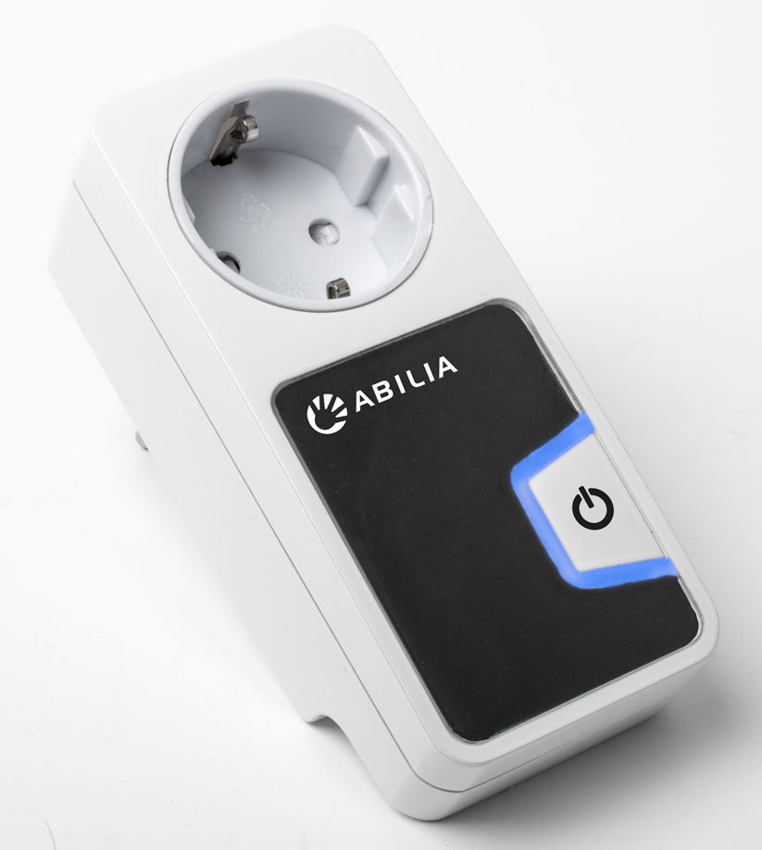

Contents

GB: English Instruction Gewa Andromeda Socket 3
1. Introduction 3
2. Product Overview 4
3. Connection 4
4. Programming 5
4.1 Control with IR transmitter 5
4.2 Control with Radio transmitter 6
4.3 Control with control switch 7
5. Resetting to default setting 7
6. Connecting an external detector eye 7
7. Cleaning 8
8. Safety and responsibility 8
8.1 Conformity with the Medical Devices Directive 8
8.2 Recycling Waste Electrical and Electronic Equipment 8
9. Technical data 9
9.1 Environment 9
9.2 Technical data 9

GB: English Instruction Gewa Andromeda Socket

Introduction
The Gewa Andromeda Socket is a so called relay unit. By connecting the relay unit between, for example, a lamp and a wall socket, you can turn the lamp off and on with a transmitter or a control switch.

Other examples of use could be to turn on and off the power to the stereo, TV, radio, computer or heater.

The Andromeda Socket can function in two different ways:
- The power switches between on and off. For example, switching on and off a lamp. (Bistable function).
- The power is on as long as the button on the transmitter is pressed. For example, to drive an electric mixer. (Monostable function.)

The Andromeda Socket is a part of the “GewaLink-system” and therefore can be used together with all of these products, including Gewa IR transmitter and Z-Wave transmitter.
The Andromeda Socket comes factory set with GewaLink channel 16 and bistable function.

 | Warning! For safety reasons, never connect devices that requires continuous power supply, e.g., life support devices.

Product Overview
Andromeda Socket consists of the following parts:
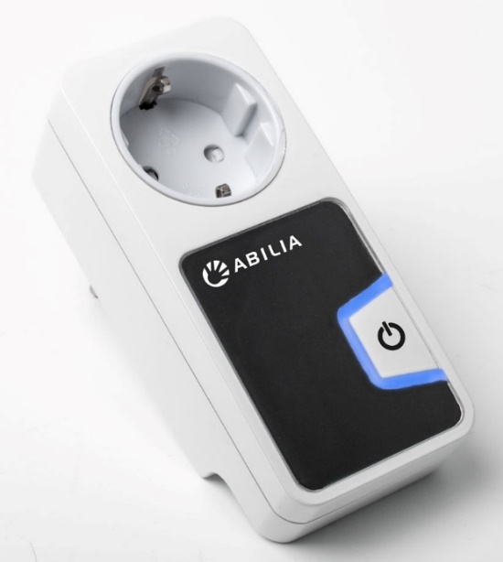
1
3

4

2
5

1. 230V socket. For connection of  the device to be controlled. | 4. Off/On button. For programming and to  manually turn off/on the power.
2. Detector eye. Receives IR signal. | 5. 3.5mm jack. For connecting an external  control switch or external detector eye.
3. Indication light.

Connection
- Make sure that the device to be connected, that has its own power switch is set to “on”. This is easiest done by connecting to a wall socket and ensure that the device is on (for example a lamp should be lit).
- Connect the Andromeda Socket to a wall socket.
- Connect the device to be controlled to the socket on the relay unit (1).
- Make sure that the device gets power by pressing the Off/On button (4).
- If IR is used, keep in mind that the range will be reduced if the detector eye (2) is covered or hidden in some way, for example by curtains or furniture.
- Program the relay unit by following the instructions in the next chapter.

The Andromeda Socket comes factory set with GewaLink channel 16 and bistable function. The relay unit does not need to be programmed if it is the function and channel to be used on the IR transmitter.

Programming
The Andromeda Socket can be programmed for the following use:
- IR control with GewaLink channels
- Radio control (Z-Wave)
- Control switch

Warning!
The relay is activated during the programming. This may cause an inadvertent activation of some equipment.

Control with IR transmitter

Off/On (bistable function)
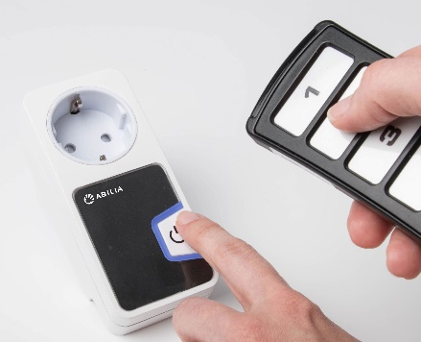
Example: To turn off and on a lamp every other time the button on the IR-transmitter is pressed.
CLICK, CLICK
- Press the Off/On button (4) and, at the same time, press the selected button on the IR transmitter until the indication light on the relay unit flashes and the relay have clicked 2 times.

- Check the function by pressing the selected button on the IR transmitter.

Keep turned on (monostable function)
Example: To run an electric mixer as long as the button on the transmitter is pressed.
- Press the Off/On button (4) and, at the same time, press the selected button on the IR transmitter until the indication light on the relay unit flashes and the relay have clicked 2+2 times.
CLICK, CLICK
CLICK, CLICK

- Check the function by pressing the selected button on the IR transmitter.

Control with Radio transmitter

Radio transmitter (Z-Wave)
Example: To turn a lamp off and on every other time you press the button on the transmitter.
When controlling with radio you can only have the Off/On function (bistable function).

Z-Wave network functions

Add:
- Put your system controller into inclusion mode by following the instructions provided by your controller manufacturer.
- Press the push Off/On button located on the front of the device three times within 1.5 seconds.

Remove:
- Put your system controller into exclusion mode by following the instructions provided by your controller manufacturer.
- Press the push Off/On button located on the front of the device three times within 1.5 seconds.

Reset:
Note: Use this procedure only in the event that the network primary controller is missing or otherwise inoperable.
- Press and hold the push button located on the front of the device for approx. 6 seconds until the LED's is steady.
- Release the button and press ones again within 3 seconds.

Control with control switch

Off/On (bistable function)
Example: To turn off and on a lamp every other time the control switch is pressed.
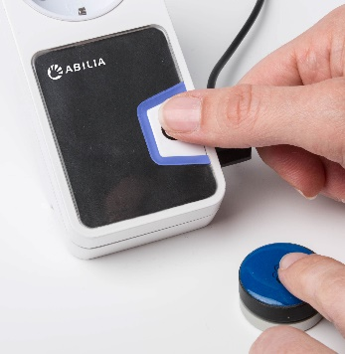
- Connect a control switch with 3.5mm plug to the jack (5).
CLICK, CLICK
- Press the Off/On button (4) and, at the same time, press the control switch until the indication light on the relay unit flashes and the relay have clicked 2 times.

- Check the function by pressing the control switch.

Keep turned on (monostable function)
Example: To practice cause and effect with a connected electric mixer. The mixer runs as long as the control switch is pressed.
- Connect a control switch with 3.5mm plug to the jack (5).
CLICK, CLICK
CLICK, CLICK
- Press the Off/On button (4) and, at the same time, press the control switch until the indication light on the relay unit flashes and the relay have clicked 2+2 times.

- Check the function by pressing the control switch.

Resetting to default setting
On delivery the Andromeda Socket is factory set with GewaLink channel 16 and bistable function.
Do the following to restore:
- Press the Off/On button (4) for 5 seconds until the indication light starts flashing.
- When the indication light lights steadily, press shortly on the Off/On button (4) within 2 seconds.
NOTE! This will also perform a Reset of Z-Wave network. See section 4.2.1.1”Reset” for more info.

Connecting an external detector eye
If the Andromeda Socket is used with an IR transmitter, it is possible to connect an external detector eye to decrease the range if the built-in detector eye (2) is covered or hidden in some way, for example by curtains or furniture. Contact Abilia for further information.

Cleaning
The Andromeda Socket can be cleaned with a damp cotton wool pad with surgical spirit, Chlorhexidine, ethyl alcohol or isopropanol.
It can also be cleaned with a damp cloth (weak solution of washing up liquid). Wipe dry after cleaning.
Warning!
Do not use any disinfectant except surgical spirit, Chlorhexidine, ethyl alcohol or isopropanol (45%).
These liquids are inflammable, handle with care!
When cleaning, the Andromeda Socket must be disconnected from the wall socket.

Safety and responsibility
Abilia has conducted a risk analysis for the product with reference to SS-EN 14971 for Medical equipment. The instructions for use and the technical specifications for the product have been drawn up in respect of the safety assessments carried out in this document.
It is always important to be aware of safety when first using this product and with its subsequent use. It is not possible to describe in the instructions all the situations in which the product must not be used. If you are not sure whether you have started using the product properly or set it up correctly, please contact your supplier.
Abilia is not liable for any loss, damage or consequential loss resulting from any use, correct or otherwise, lack of follow-up, incorrect set-up, incorrect connection or similar misuse. Abilia financial liability is at all times limited to the value of the product itself.

Conformity with the Medical Devices Directive
The Andromeda Socket is marketed as a technical aid for people with disabilities and meets the requirements in the Medical Devices Directive 93/42/EEC including relevant EMC and electrical safety requirements.

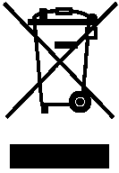
Recycling Waste Electrical and Electronic Equipment
The Andromeda Socket contains electronics components that must be recycled. When the product is no longer of use, hand it in to a recycling centre for waste electrical and electronic equipment.

Technical data

Environment
The Andromeda Socket may only be used indoors in a dry environment (IP21).

Technical data
Supply voltage: | 230V AC, 50Hz
Maximum power consumption at rest: | 1.6W
Maximum power consumption: | 2.3W (relay active, Z-Wave active)
Maximum relay load: | 3600VA, 16A resistive load
Programming channels: | GewaLink channels 0-127 (channel 62 has no function) and 4096 code.
Frequency Z-Wave: | 868.42MHz.
Input control switch type: | 3.5mm jack plug (2-pole mono female)
Range GewaLink: | 30m
Range Z-Wave | At free sight, approx. 30m
Measurements: | 53 x 122 x 43mm (excl. plug)
Weight: | 160g


4198XX Manual Gewa Andromeda Socket GB RevB.docx Aug 2015
Abilia AB, Kung Hans väg 3, Sollentuna, Box 92, 191 22 Sollentuna, Sweden
Phone +46 (0)8-594 694 00 | Fax +46 (0)8-594 694 19 | info@abilia.se | www.abilia.org.uk

