AXON™ Home Router User’s Guide
Model: GWS-HR-001

Greenwave Systems, Inc.
133 Technology Drive
Suite 200
Irvine, CA 92618
AXON™ Home Router User Guide

Introduction
Welcome to the AXON™ Home Router (Model GWS-HR-001) User Guide. This document will explain how to configure and use the Z-Wave functionality included in the AXON™ Home Router.

Feature Overview
The AXON™ Home Router is a full-featured Ethernet router and WiFi Access Point. The router provides a connection to a WAN port for connecting Broadband connection such as through a Cable or DSL modem and provides home automation control through the use of Z-Wave networking technology. The Z-Wave network allows devices from multiple manufacturers to be connected to your Broadband Home Router’s internal Z-Wave Plus Controller.

The Broadband Home Router has the following general features:

- 4 Port Ethernet Switch
- 1 WAN Port (Ethernet)
- WiFi Access Point
- Security Enabled Z-Wave Plus Enabled

The Z-Wave Plus functionality is achieved by using the SDK Application installed on an iOS 9 or later based mobile device. The Greenwave Systems SDK Application works in conjunction with the AXON™ Home Router to enable your Z-Wave devices and network.

The SDK Application will be pre-installed on a test phone for certification testing.

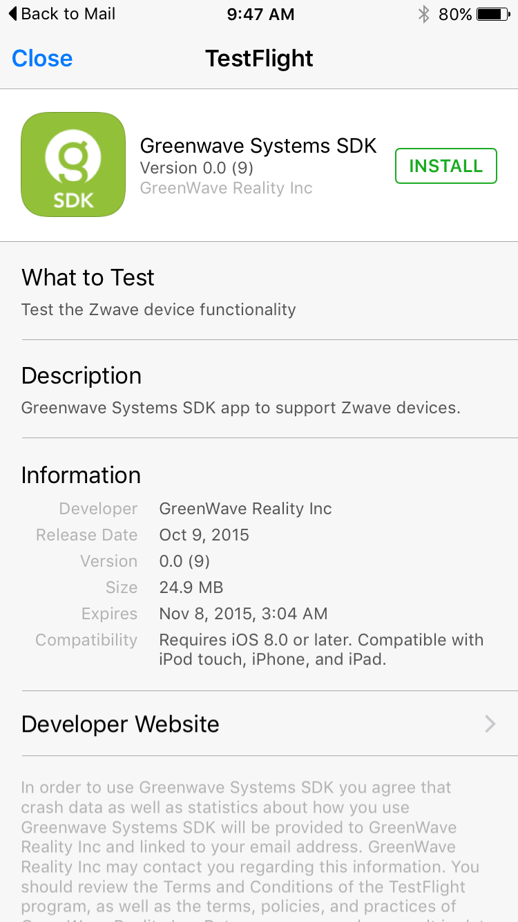

Provisioning your system

The AXON™ Home Router will be pre-provisioned for your use. An account has been setup so that you can log into your account through the mobile phone SDK Application and start using the AXON™ Home Router to include (add), exclude (remove), and manage Z-Wave devices on your Z-Wave network.

Steps:
- Plug an active Ethernet cable that has internet connectivity into the WAN port of the AXON™ Home Router
- Plug the power plug into the back of the AXON™ Home Router
- Wait until the lights on the AXON™ Home Router are a solid white
- Launch the Greenwave Systems SDK Application

Greenwave AXON™ SDK Application

To use the AXON SDK Application, you should follow the following steps:
- Launch the application by pressing on the icon associated with the application.
- Login to your account. Account information has been pre-configured for you and is listed in the box below for your convenience:
Account: Axonuser518@yahoo.com

Password: Passw0rd!
- Once you are logged in you will see a list of devices including the AXON™ Home Router listed. The AXON™ Home Router will show up listed as a Controller similar to the example below. In this case, the AXON™ Home Router is listed as “Controller – Gw485d3649b386”.
If this is the first time you powered on the device, you will not see any devices other than the Controller on your network.

Note: If the AXON™ Home Router does not appear, then you will be instructed to plug in a WAN connection and turn on power.

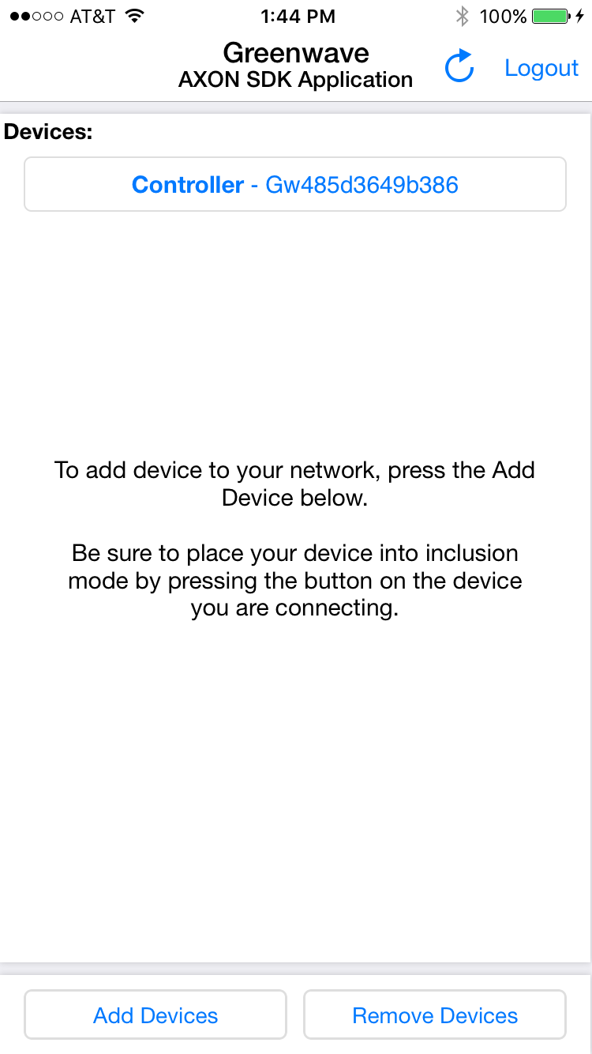
Devices Screen

- Once the Controller has appeared on the list of devices, you can proceed with the Add (the act of adding devices) and Remove (the act of removing devices) process to create the Z-Wave network of devices that you desire.

Adding and Removing Devices from your Z-Wave Network

Adding devices to your Z-Wave network is referred to as Inclusion. To add a device, start by pressing on the “Add Devices” button at the bottom of the SDK Application’s Devices Screen. Once this is pressed, the inclusion process is initiated and you have 60 seconds to complete the process. Before the timeout occurs, you need to perform an action on the device that you would like to add to the Z-Wave network. Many devices have a similar process for being included (such as pressing a button on the device), but you should follow the instructions provided with the device you are trying to include into the Z-Wave network.

Removing devices from your Z-Wave network is also referred to as exclusion and works in a similar way to adding devices. You start the remove process by pressing on the “Remove Devices” button at the bottom of the SDK Application’s Devices screen. Once this is pressed, the removal process is initiated and you have 60 seconds to complete the process. Before the timeout occurs, you need to perform an action on the device you would like to remove from the Z-Wave network. Many devices have a similar process for being removed (such as pressing a button on the device), but you should follow the instructions provided with the device you are trying to remove.

Controller Copy (Replication) and use of Learn Mode

If you have an existing Z-Wave network and want to add the AXON™ Home Router to the network, follow the steps below for Copy outlined in this section.

Copy refers to the protocol replication between Controllers and is used to copy (or exchange) protocol data between different Controllers of the same network. In a case where you have an existing Z-Wave network, your AXON™ Home Router will copy all necessary information from the initial network controller.

The AXON™ Home Router Z-Wave controller will copy the protocol data from the Z-Wave network through the Learn Mode function available to in the SDK Application.

To start this process, start the Include function on the pre-existing Z-Wave controller. Secondly, put the Axon™ Home Router into Learn Mode.
To put the controller into Learn mode, select the Controller from the Devices Screen to bring up the details of the Controller. From the Controller details screen, you will see the option to select the “Put this Controller in Learn Mode” command button.

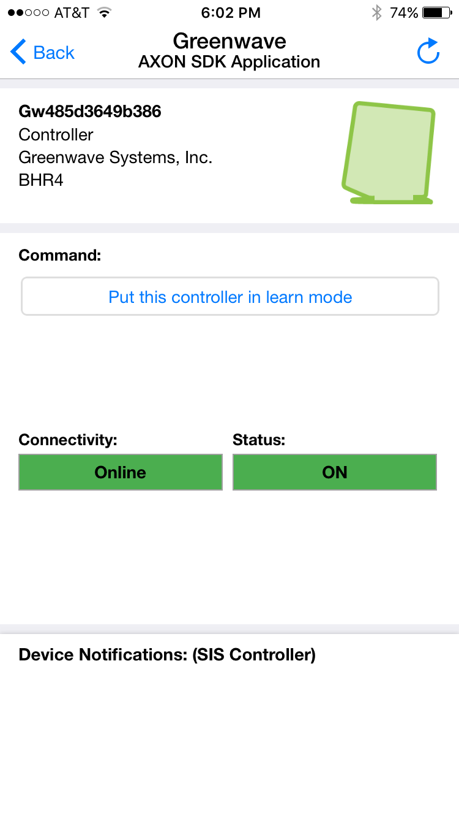
Controller Details Screen

Z-Wave Product Interoperability
Products from different manufacturers and as well as from different product categories (Example: Lighting, HVAC, Home Entertainment etc.) can be a part of the same Z-Wave network.
Different non-battery powered nodes are typically “listening” nodes that act as message repeaters. This is regardless of hardware manufacturer.

Command Class and Association Group Support

- Lifeline Association Group Supported
  - Group Id: 1
  - Max number of devices in group: 255
  - Group is used to send “device
reset locally” when the AXON™
Home Router is factory reset.
- Association Command Class Supported
- Configuration Command Class Not Supported

Description of Controlled Commands

CC.106 Application Status Command Class, version 1 [S]
CC.107.2 Association Command Class, version 2 [S + C]
CC.109 Association Group Information Command Class, version 1 [S]
CC.111 Basic Command Class, version 1 [C]
CC.114 Battery Command Class, version 1 [C]
CC.116 Binary Switch Command Class, version 1 [C]
CC.124 CRC­16 Encapsulation Command Class, version 1 [S+C]
CC.127 Device Reset Locally Command Class, version 1 [S]
CC.128.2 Door Lock Command Class, version 2 [C]
CC.142.2 Manufacturer Specific Command Class, version 2 [S+C]
CC.143.4 Meter Command Class, version 4 [C]
CC.148.3 Multi Channel Command Class, version 4 [C]
CC.149.2 Multi Channel Association Command Class, version 2 [C]
CC.153.7 Multilevel Sensor Command Class, version 7 [C]
CC.154.3 Multilevel Switch Command Class, version 3 [C]
CC.162.3 Notification Command Class, version 5 [C]
CC.163 Powerlevel Command Class, version 1 [S]
CC.180 Security Command Class, version 1 [S+C]
CC.187.3 Thermostat Mode Command Class, version 3 [C]
CC.190.3 Thermostat Setpoint Command Class, version 3 [C]
CC.195.2 Version Command Class, version 2 [S+C]
CC.196.2 Wake Up Command Class, version 2 [C]
CC.201 Z­Wave Plus Info Command Class, version 2 [S + C]

Receiving Basic Commands

The AXON™ Home Router will ignore Basic Commands received from other devices on the Z-Wave network. Typically these commands are used by devices that are being controlled (such as outlets, switches, etc.) rather than by a controller itself.

Resetting the AXON™ Home Router

A Reboot/Reset button is located on the backside of the AXON™ Home Router. It can easily be identified on the back of the unit by its red color and location directly above the yellow RJ45 Ethernet ports and below the USB ports. Pressing the button will perform one of two functions depending on how long the button is pressed.

A short press will trigger a reboot of the router and will not change any permanent settings.
A long press (3 second and longer) will trigger a reset operation and then will reboot the AXON™ Home Router. A reset operation will change all router settings including the Z-Wave Controller settings back to its factory default.

Terminology Cross-Reference

Terms that are interchangeable are listed below.

Include Add
Exclude Remove
Replicate Copy

