FCP-01
Smart Fire Controller

USER MANUAL

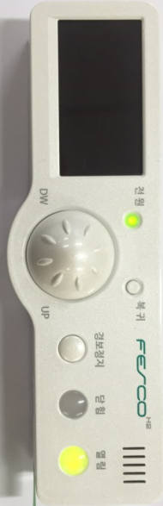



FCP-01 Smart Fire Controller

Introduction
FCP-01 Z-Wave Smart Fire Extinguisher device has below function. There are Gas Leak detection, Fire (Temperature) sensing, control of cooking time, cut-off time of gas valve, Fire Extinguisher operation, Gas Valve open/close function..

Figure 1. FCP-01

Product Specifications
Model No. | FCP-01
RF frequency | f_{c}±29.3kHz (f_{c}=919.7 / 921.7 / 923.1MHz)
RF operating distance | Up to 40m outdoor line of sight, in unobstructed environment
Powered by | Adaptor DC12V/2A  (backup battery Ni-Cd 12V AA 600mAh type)
Temperature | Operating : 0ºC ~65ºC  Storage : -10ºC ~75ºC
Dimensions(LxHxT) | 150 mm x 39 mm x 20 mm
Weight | 700 g

Feature List
Standard Fire Extinguisher & Gas Valve Timer plus Z-Wave remote control
Certification
- Korea Fire Safety Ltd
- Korea Gas Safety Cooperation
- KC : Korean Certification
- Z-Wave Plus
Z-Wave Feature
- Standard valve open/close but this model CLOSE ONLY
- OTA firmware update capability
- Notification of whether Fire extinguisher or not to controller
- Notification of temperature sensor status to controller
- Notification of gas sensor status to controller
- Notification of whether battery connection status or not to controller
- Notification of whether Main power use or Battery power use to controller
- Notification of whether operate panel connected or not to controller
- Notification of gas valve open or closed status
- Notification of Pressure Leak sensing status to controller
- Notification of current temperature status to controller
- Notification of time remaining cooking timer to controller
- Notification of time remaining cut-off timer of gas valve to controller
- Notification of gas valve timer start to controller
- Notification of gas valve timer stop to controller
- Notification of cooking timer start to controller
- Notification of cooking timer stop to controller
- Notification during timer setting to controller
- Configuration of Gas Valve timer Setting
- Configuration of Periodic report Setting

Z-Wave Specifications
Device Type
Valve-Open/Close
GENERIC_TYPE_SWITCH_BINARY
SPECIFIC_TYPE_VALVE_OPEN_CLOSE

Role Type
AOS(Always ON Slave): ROLE_TYPE_SLAVE_ALWAYS_ON

CC in Node Info
COMMAND_CLASS_ZWAVEPLUS_INFO
COMMAND_CLASS_VERSION_V2
COMMAND_CLASS_MANUFACTURER_SPECIFIC_V2
COMMAND_CLASS_POWERLEVEL
COMMAND_CLASS_DEVICE_RESET_LOCALLY
COMMAND_CLASS_ASSOCIATION_V2(Lifeline group only)
COMMAND_CLASS_ASSOCIATION_GRP_INFO
COMMAND_CLASS_ALARM_V1
COMMAND_CLASS_CONFIGURATION
COMMAND_CLASS_FIRMWARE_UPDATE_MD_V2
COMMAND_CLASS_SWITCH_BINARY_V1
COMMAND_CLASS_BASIC

Lifeline Report
Device Reset Locally

Activation of Basic CC & Binary switch CC
  - Basic Set & Switch Binary Set = 255 (On/open) is not activated but only 0(Off/close) is activated

Z-Wave Add(Include)/Delete(Exclude) into(from) Z-Wave Network
- After doing inclusion/exclusion action on controller, then hold 5 seconds “STOP SOUND” button till hearing beep once.

How to do Factory default reset?
- Hold 10 seconds “STOP SOUND” button till hearing beep once.

Association & Association Group Information
- Lifeline between controller and Smart Fire Extinguisher.
- Supported command class is Device Reset Locally notification.
- Maximum supported nodes are 5EA
- Maximum Association Groups : 1

Alarm v1
Alarm Type | Alarm level | Description
0x01 | ° 0x00: Normal  ° 0x01: Not connected  ° 0x02: Operation | Notification of whether Fire extinguisher or not to controller
0x02 | ° 0x00: Normal  ° 0x01: Not connected  ° 0x02: Preliminary fire  ° 0x03: Fire | Notification of temperature sensor status to controller
0x03 | ° 0x00: Normal  ° 0x01: Not connected  ° 0x02: Gas Leak | Notification of gas sensor status to controller
0x04 | ° 0x00: Connected  ° 0x01: Not connected | Notification of whether battery connection status or not to controller
0x05 | ° 0x00: Main Power  ° 0x01: Battery Power | Notification of whether Main power use or Battery power use to controller
0x06 | ° 0x00: Normal  ° 0x01: Not connected | Notification of whether operate panel connected or not to controller
0x07 | ° 0x00: Closed  ° 0xFF: Opened | Notification of gas valve open or closed status
0x08 | ° 0x00: Normal  ° 0x01: Pressure Leak | Notification of Pressure Leak sensing status to controller
0x09 | ° 0x00: ~ 99°C  ° 0x01: Not connected  ° 0x02: 100°C ~ 137°C  ° 0x03: 138°C ~ | Notification of current temperature status to controller
0x0A | ° 0x00 ~ 0xF0  (0 ~ 240 minutes) | Notification of time remaining cooking timer to controller
0x0B | ° 0x00 ~ 0xF0  (0 ~ 240 minutes) | Notification of time remaining cut-off timer of gas valve to controller
0x0C | ° 0x00 ~ 0xF0  (0 ~ 240 minutes) | Notification of gas valve timer start to controller
0x0D | ° 0x00: gas valve timer stop | Notification of gas valve timer stop to controller
0x0E | ° 0x00 ~ 0xF0  (0 ~ 240 minutes) | Notification of cooking timer start to controller
0x0F | ° 0x00: cooking timer stop | Notification of cooking timer stop to controller
0x10 | ° 0x00: Normal  ° 0x01: It is being set. | Notification during timer setting to controller

Configuration Parameters
Parameter Number | Size | Description
1 | 1 | [Gas Valve Timer]  - 0x01 ~ 0xF0 (1 ~ 240)  -default: 0x3C(60)  (1 ~ 240 minutes) Time Settings
2 | 1 | [Reporting periods]  - 0x00 (Reporting periods: off)  - 0x01 ~ 0x90 (1 ~ 144)  -default : 0x90(144)  (Min 10 minutes ~ Max 24 hours)

Devices from multiple manufacturers in one network

- This product can be used in any Z-Wave network with other Z-Wave certified devices from other manufacturers and/or other applications. All non-battery operated nodes within the network will act as repeaters regardless of vendor to increase reliability of the network.

Setup and Operations
Product Overview

POWER LED
REINSTATE
STOP SOUND
TIME BUTTON
OPEN
CLOSE
BUZZER
LCD DISPLAY

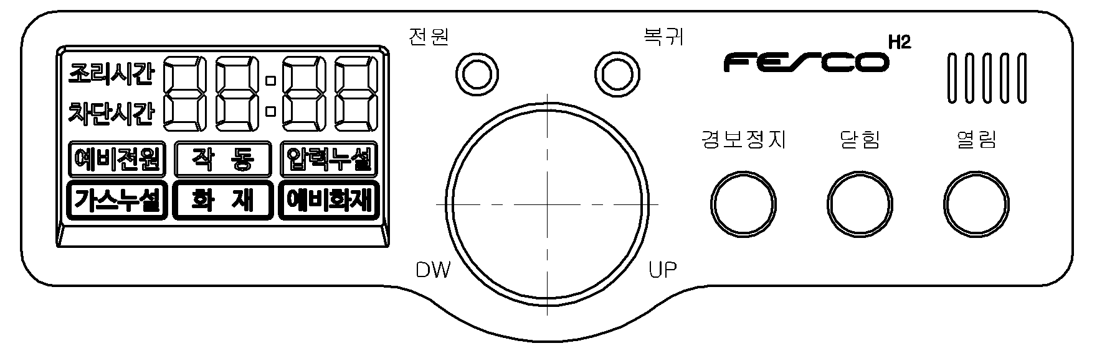

Description of Function Keys

Symbol & Key | Key Description
POWER LED | The LED that indicates the power status.
LCD Display | LCD for displaying the status of the device
BUZZER | Alarm tone
REINSTATE | Button for reinstatement the alarm status.
TIME BUTTON | Button for various time settings
STOP SOUND | 1. Button for alarm tone pause  2. Inclusion(Exclusion) : Press 5 seconds for Inclusion(Exclusion)  3. Reset for Z-Wave : Press 10 seconds for Z-Wave Reset
CLOSE | Button for closing the gas valves
OPEN | Button for opening the gas valve

LCD and LED displays.

State of the automatic fire extinguishing is displays on the LCD and LED, System are as follows.
If occur event of multiple, is displayed at the same time.
The timer function is shutdown during an emergency such as Gas leak, Preliminary fire, Fire.
No. | Figture | Description
1 | 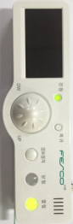 | State : Nomal  - When the gas valve open state, the "open LED(열림)" lights.
2 | 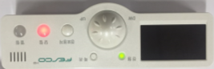 | State : Nomal  - When the gas valve close state, the "close LED(닫힘)" lights.
3 | 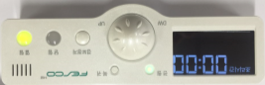 | State : Cooking Time  - "Cooking time(조리시간)" and "00:00(hours: minutes)" on the LCD is Turned on the lights.  - When the cooking time is action time display lights up, (:) colon flashes.  - This alarm is generated when the cooking time ends.  (alarm : 200msec On/OFF)
4 | 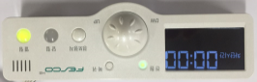 | State : Cut-off Time  - "Cut-off time(차단시간)" and "00:00(hours: minutes)" on the LCD is Turned on the lights.  - When the Cut-off time is action time display lights up, (:) colon flashes.  - This alarm is generated when the Cut-off time ends.  (alarm : 200msec On/OFF)  - Gas valve is closed when the cut-off time ends.
5 | 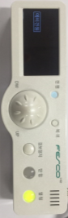 | State : Main Power off  - "Reserve power(예비전원)" on the LCD is lights up, Power LED is Turned off the lights.
6 | 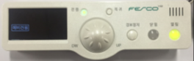 | State : Battery disconnected  - "Reserve power(예비전원)" on the LCD is flashes.  (Power LED is Turned on the lights.)
7 | 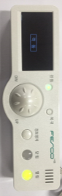 | State : Operating device disconnected  - "operation(작동)" on the LCD is flashes.
8 | 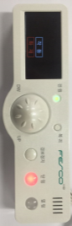 | State : Operating device operation.  - "Operating(작동)" on the LCD is lights up.  - If fire temperature(138°C) is more than 7 sec sensing, operation device is operated during 5 sec.
9 | 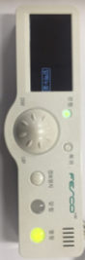 | State : Pressure Leak Sensing  - "Pressure Leak(압력누설)" on the LCD is lights up.  - Alarm is generated when Pressure Leak is more than 2 sec sensing.  (Alarm : 1sec On/Off)
10 | 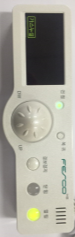 | State : Gas Leak disconnected  - "Gas Leak(가스누설)" on the LCD is flashes.
11 | 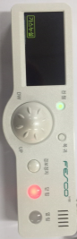 | State : Gas Leak Sensing  - "Gas Leak(가스누설)" on the LCD is lights up.  - Alarm is generated when Gas Leak(LNG : 0.06~1.25%, LPG : 0.06~0.45% is more than 3 sec sensing.  (Alarm : 200msec On/Off)  - Gas valve is closed when the Gas Leak Sensing.
12 | 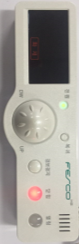 | State : Fire Sensing  - "Fire(화재)" on the LCD is lights up.  - Alarm is generated when fire temperature(138°C) is more than 1 sec sensing.(Alarm : On Continue)  - Gas valve is closed when the Fire Sensing.
13 | 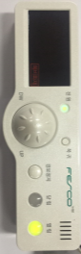 | State : temperature Sensor disconnected  - "Preliminary fire(예비화재)" on the LCD is flashes.
14 | 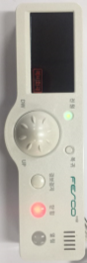 | State : Preliminary Fire Sensing  - "Preliminary Fire(예비화재)" on the LCD is lights up.  - Alarm is generated when Preliminary fire temperature(100°C) is more than 1 sec sensing.(Alarm0000 : 200msec On/OFF)  - Gas valve is closed when the Preliminary Fire Sensing.

Gas Detector LED displays
No. | Figure | Description
1 | 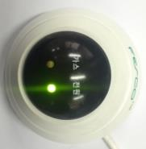 | State : Nomal  - When the Power On, the "Power LED(전원)" lights.  - when the initial power is applied, "Gas LED(가스)" is can be lit up by sensor stabilization problem. Therefore, gas leakage detection of Gas Detector is started after 25 seconds to the initial power-up.  - Within the stabilization time, the "Gas LED(가스)" is turned off .
2 | 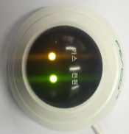 | State : Gas Leak Sensing  - "Gas LED(가스)" is lights up when Gas Leak Sensing.(LNG : 0.06~1.25%, LPG : 0.06~0.45%)

Gas Valve
No. | Figure | Description
1 | 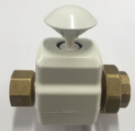 | State : Open  - If the knob is pressed, the gas valve open state.
2 | 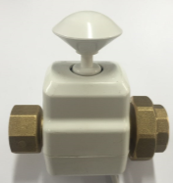 | State : Close  - If the knob is not pressed, the gas valve closed state.

Operating device & Pressure Leak Sensor
No. | Figture | Description
1 | 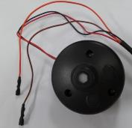 | Operating Device  - If fire temperature(138°C) is more than 7 sec sensing, operation device is operated during 5 sec.  - The extinguishing agents is injected in the fire extinguishing vessel with an internal motor of the operating device is in works.
2 | 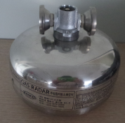 | fire extinguishing vessel  - When the Operating Device is operated inside the extinguishing agent it is injected.
3 | 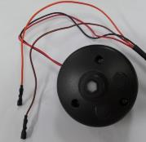 | Pressure Leak Sensor  - It is used to detect pressure leakage.  (Short-circuit pressure leakage)

Glossary
Device or Node | Devices and nodes are all terms to describe an individual Z-Wave device. These are all interchangeable when setting up your Z-Wave network
Inclusion | Add a Z-Wave device to the network
Exclusion | Delete a Z-Wave device from the network
Remove | To take a device out of a group, scene or association group while that device still exists in the same Z-Wave network
Network Wide Inclusion(NWI) | Network Wide Inclusion(NWI) enables both end-user friendly, Plug and Play like Z-Wave network installation as well as professional installation scenario where the inclusion process in items of time will be reduced significantly. NWI is a feature supported by a new frame type named Explorer which enables the Z-Wave protocol to implement Adaptive Source Routing.
Z-Wave Network | A collection of Z-Wave devices is controlled by primary and secondary controllers operating on the same system. A Z-Wave network has its own unique ID code so that controllers not in the network cannot control the system.
Primary Controller | The first controller is used to set up your devices and network. Only the Primary Controller can be used to include or delete devices from a network. It is recommended that you mark the primary controller for each network for ease in modifying your network.
Association | Association is used to organize nodes in different groups allowing the device to identify the nodes by a group identifier. The groups can also be copied to other devices.

