IoT DoorCam

Guide Document

1. IoT DoorCam description.
LG Uplus IoT DoorCam streams live video feed to your phone remotely. The app receives push notifications of different activities and record motion videos when visitors arrive. It also checks the battery life with the app and receives reminders when the battery is low.

2. IoT DoorCam Z-Wave Specifications
- Device Type : On/Off Power Switch
- Role Type : LSS (Listening Sleeping Slave)
- Security Enabled Z-Wave Plus Product
- Security Enabled Z-Wave Controller must be used
- Command Class Support/Control
- Z-Wave plus info Command Class Version 2
- Manufacture Specific Command Class Version 1
- Association Command Class Version 2
- Association Group Information Command Class Version 1
- Battery Command Class Version 1
- Device Reset Locally Command Class Version 1
- Power Level Command Class Version 1
- Firmware Update MD Command Class Version 1
- Security Command Class Version 1
- Version Command Class version 2
- Switch Binary Command Class Version 1 (Secured mode)
- Basic Command Class Version 1 (Secured mode)
- Alarm Command Class Version 1 (Secured mode)

3. Technical Specifications
- South Korea 919-923 MHz RF Frequency
- Battery Powered (D type Battery)
- Operating Temperature 0 ºC ~ 50 ºC.

4. Add for Inclusion
This must be done when DoorCam is exclusion status
(Z-Wave LED remained on).
After doing inclusion action on Controller, please do the followings.
- Press & hold ‘Z-Wave’ button for 5 seconds when DoorCam is exclusion status.
- When Z-Wave LED blinks with 250ms interval, release ‘Z-Wave’ button to try inclusion.
- DoorCam will try inclusion for 30sec.
- Z-Wave LED will be turned off if inclusion is successful.
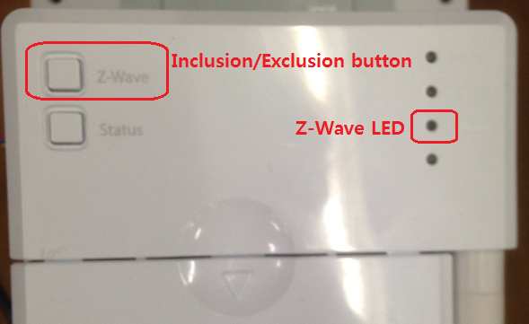

5. Remove for Exclusion
This must be done when DoorCam is inclusion status (Z-Wave LED remained off).
After doing exclusion action on Controller, please do the followings.
- Press & hold ‘Z-Wave’ button for 5 seconds when DoorCam is inclusion status.
- When Z-Wave LED blinks with 250ms interval, Release ‘Z-Wave’ button to try exclusion.
- DoorCam will try exclusion for 30sec.
- Z-Wave LED will be turned on if exclusion is successful.

6. Factory Default Reset
- Hold the ‘Z-Wave’ button for 10seconds.
(Z-Wave LED will blink after 5 seconds with 250ms interval then Z-Wave LED will be turned off after another 5 seconds.)
- When Z-Wave LED stops blinking after 10 seconds, release Z-Wave button.
- When factory reset is successful, LED will be on.

Please use this procedure only if the network primary controller is missing or inoperable.

7. Supported Alarm Report (COMMAND_CLASS_ALARM)
No | Description | Byte size | Value | Note
1 | Alarm Type | 1 | 0x01 | Power status
2 | Alarm Level | 1 | 0x00/0xFF | Power On/Power off

8. Association & Association Group Information
- Grouping identifier : Association Group support is only 1.
- Maximum number of devices that can be added to the group : The maximum number of nodes is 5.
- Description of how the association group is used and/or triggered by the product : This product's Association Group are used by Life Line of products.

9. Battery Report
- The device sends Battery Report when the power is on.
- The device sends Battery Report when battery level is changed.
- The device sends Low Battery Report 1 time if battery voltages drops under 4.6V
Battery Level | Battery Voltage | % | Data
FULL | 6.4V | 100% | 64(h)
HIGH1 | ∙∙∙ | 74% | ∙∙∙
HIGH2 | ∙∙∙ | 45% | ∙∙∙
HIGH3 | ∙∙∙ | 23% | ∙∙∙
LOW | ~ 4.6V(Low battery warning) | ~ 14% | FF(h)

10. ZWAVE_PLUS_ INFO
No | Description | Byte size | Value | Note
1 | Z-Wave Plus Version | 1 | 0x01
2 | Role Type | 1 | 0x07 | LSS
3 | Node Type | 1 | 0x00 | Z-Wave Plus node
4 | Installer Icon Type | 2 | 0x1500 | ICON_TYPE_GENERIC_VALVE_OPEN_CLOSE
5 | User Icon Type | 2 | 0x1500 | ICON_TYPE_GENERIC_VALVE_OPEN_CLOSE

11. Version Command
No | Description | Byte size | Value | Note
1 | Z-Wave Library Type | 1 | 0x03 | Enhanced Slave
2 | Z-Wave Protocol Version | 2 | 0x0405
3 | Firmware Version | 2 | 0x2714 | v1.00.04
4 | Hardware Version | 1 | 0x01

12. Manufacturer Command
No | Description | Byte size | Value | Note
1 | Manufacturer ID | 2 | 0x023D | LG Uplus
2 | Product Type ID | 2 | 0x0043
3 | Product ID | 2 | 0x0001 | DoorCam
4 | Device ID Type | 3bits | 2 | Pseudo Random
5 | Device ID Data Format | 3bits | 1 | Binary
6 | Device ID Data Length Indicator | 5bits | 6 | Device ID Data Length Indicator
7 | Device ID Data 1 ~ 6 | 6 | 023D43xxxxxx | Serial Number

13. Basic Command Class’s SET
- Same as Switch Binary Command Class SET.
- Will wake up DoorCam’s camera module by value 0xFF.
- As DoorCam’s camera module will not work on SoftAP mode (Users must register DoorCam as SoftAp mode does not connect DoorCam to the server), please ignore this command.

