CO-8ZW Carbon Monoxide Detector

Introduction
CO-8 is a Carbon Monoxide Detector. It is capable of sending wireless signals to the Z-Wave Gateway/Control Panel upon detection of Carbon Monoxide concentration.
The Carbon Monoxide Detector is a Z-Wave enabled device and is fully compatible with any Z-Wave enabled network.
Z-Wave is a wireless communication protocol that uses a low-power RF radio. By taking advantage of the Z-Wave mesh network, commands can be transmitted to their destination via intermediary “listening” Z-Wave products.
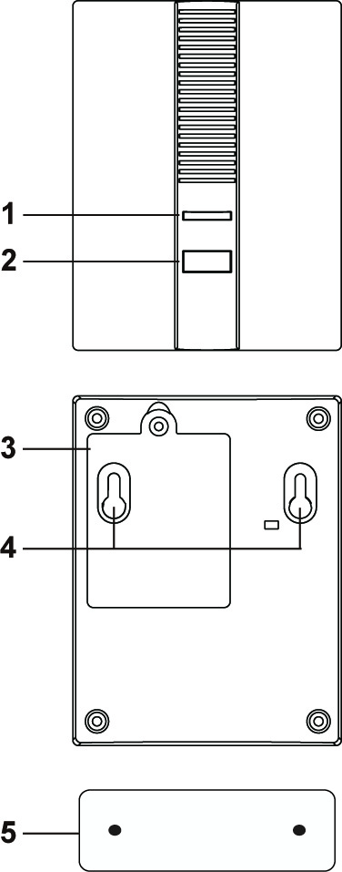
Parts Identification
1. Dual Color LED indicator (Amber/Red)
The LED indicator lights up in the following conditions:
- Red LED flashes twice
The Carbon Monoxide Detector has successfully included (learnt) into Z-Wave Gateway/Control Panel.
- Red continuous flash:
The Carbon Monoxide Detector is activated.
- Amber LED flashes every second:
The Carbon Monoxide Detector is in Alarm Silence mode.
2. Function Button
- Press the button once to send a supervision signal.
- Press the button once during alarm to silence the alarm.
- Press and hold the button 3 times within 1.5 seconds to send a learn code.
- Press and hold the button for 10 seconds to factory reset.
3. Battery Compartment
The Carbon Monoxide Detector is powered by three AA Alkaline 1.5V batteries.
4. Mounting Hole
5. Mounting Bracket

Features
- Carbon Monoxide Detection
- The Carbon Monoxide Detector will be activated according to the following table when CO concentration is detected.
CO concentration  level | Time taken before alarming
30 ppm | None
50 ppm | 60-90 minutes
100 ppm | 10-40 minutes
300 ppm | Under 3 minutes
- Once the CO concentration level exceeds the threshold and persists for the time length as listed in the above table, the Carbon Monoxide Detector will transmit the signal to the Z-Wave Gateway/Control Panel and raise alarm with its built-in siren.
- After the alarm has been activated, the Carbon Monoxide Detector will continue to send the alarm signal every 2 minutes as long as CO concentration remains above 30 ppm.
- If the CO concentration drops below 30 ppm, the Carbon Monoxide Detector will stop alarming and transmit a restore signal

- Alarm Silence
- When the Carbon Monoxide Detector is alarming, you can press the Function button once on Carbon Monoxide Detector to enter Alarm Silence mode for 10 minutes
- Under Alarm Silence mode, the Carbon Monoxide Detector will not sound alarm; the Amber LED Indicator will flash every second to indicate it is under Alarm Silence mode.
- After 10 minutes, if CO concentration still exceeds 30ppm, the Carbon Monoxide Detector will raise alarm and send alarm signal again.
- Battery and Low Battery Detection
- The Carbon Monoxide Detector uses three 1.5V Alkaline batteries as its power source. The batteries are included in the package.
- The Carbon Monoxide Detector feature Low Battery Detection. When low battery voltage is detected, the Carbon Monoxide Detector will transmit Low Battery signal to notify the user.
- The Carbon Monoxide Detector will report its battery percentage to the Control Panel respectively at 100%, 75%, 50% and 25%. If the battery voltage is low (25%), a Low Battery signal will be sent to the Z-Wave Gateway/Control Panel to notify the user.
- When changing batteries, after removing the old batteries, press the Function Button twice to fully discharge before inserting new batteries.
- Supervision
This function uses the Z-Wave Wake Up Command Class. The Wake Up Command Class allows the battery-powered Carbon Monoxide Detector to notify the Control Panel/Gateway that it is awake and ready to receive any queued commands. The wake up time is programmed automatically according to Control Panel’s setting when The Carbon Monoxide Detector is included. The recommended setting of the wake up time is 60 minutes above.
- Adding Device (Inclusion)
This product can be included and operated in any Z-Wave network with other Z-Wave certified devices from other manufactures and/or other applications. All non-battery operated nodes within the network will act as repeaters regardless of vendor to increase reliability of the network.
- Insert the 3 “AA” batteries into the battery compartment connecting the correct polarity as shown on the battery compartment lid. CO-8 will emit a 2-tone beep.
- Put the Z-Wave gateway or control panel into Inclusion or Learning mode (please refer to the Z-Wave gateway or control panel manual).
- Within 1.5 seconds, press the Function Button 3 times. CO-8 will emit a 2-tone beep.
- Refer to the operation manual of the Z-Wave gateway/Control panel to complete the learn-in process.
- If the sensor has already been included (learnt) into another Z-Wave Gateway/Control Panel, or if the sensor is unable to be learnt into the current Z-Wave Gateway/Control Panel, please exclude it first (see Exclusion) before attempting to include it into the current Z-Wave Gateway/Control Panel.
- Removing Device (Exclusion)
The Carbon Monoxide Detector must be removed from existing Z-Wave network before being included into another. There are two methods available to exclude a device.
Exclusion Mode
- Put the Z-Wave gateway or control panel into Exclusion mode (please refer to the Z-Wave gateway or control panel manual).
- Within 1.5 seconds, press the Function Button 3 times and the Carbon Monoxide Detector will be removed from the Z-Wave network.
Factory Reset
(Only use factory reset when network Control Panel/Gateway is missing or inoperable).
- Remove the batteries of the Carbon Monoxide Detector first.
- Press and hold the Test Button. While holding the Test Button, power on the Heat Detector by re-inserting the batteries, wait for 10 seconds to factory reset.
<NOTE>
- Factory resetting the Carbon Monoxide Detector will restore it to factory default settings (excluded from the Z-Wave network). The Z-Wave gateway or control panel will still keep its Z-Wave settings. Please refer to the gateway or control panel manual on how to remove the Carbon Monoxide Detector’s Z-Wave settings.

- Z-Wave Sleep Mode
- The Carbon Monoxide Detector will enter Z-Wave Sleep mode (to conserve power) after waking up for a short period of time (~10 seconds). While in Z-Wave sleep mode, Z-Wave gateways/Control panels are unable to send commands to the Carbon Monoxide Detector.
- To program the Carbon Monoxide Detector, please send command(s) to the Carbon Monoxide Detector within the wake-up period.

Installation
- Mounting the Carbon Monoxide Detector
The Carbon Monoxide Detector has a mounting bracket for wall mounting.
- Use the mounting bracket as template to mark the two holes on the wall for installing screws
- Screw the mounting bracket onto the wall according to marked location. Install wall plugs if necessary
- Hook the Carbon Monoxide Detector onto the mounting bracket. Installation is now complete

Z-Wave Information
- Z-Wave Information
Device Type: Sensor - Notification
Role Type: Reporting Sleeping Slave (RSS)
Command Class Support/Control
Mandatory CC Support: Association CC, v2 or newer
Association Group Information CC
Battery CC
Device Reset Locally CC
Manufacturer Specific CC
Notification CC
Powerlevel CC
Version CC, v2 or newer
Wake UP CC
Z-Wave Plus Info CC
- Z-Wave’s Groups (Association Command Class Version 2)
The Carbon Monoxide Detector can be set to send reports to associated Z-Wave devices. It supports 3 association groups with five nodes each.
Group 1 for “LifeLine”:
Notification CC,V4 (COMMAND_CLASS_NOTIFICATION)
Battery CC (COMMAND_CLASS_BASIC)
Device Reset Locally CC
Group 2 for “Basic Set”:
Basic CC, v2 (COMMAND_CLASS_BASIC)
Group 3 for “Notification Report”:
Notification CC,V4 (COMMAND_CLASS_NOTIFICATION)
- Trigger Report (carbon monoxide detected)
When Carbon Monoxide Detector is triggered, it will transmit Notification command (Notification Type:0x02,Event:0x02) to all nodes in Group1,3.
- Restore Report (carbon monoxide dissipate)
When the surrounding carbon monoxide dissipated, it will transmit Notification command (Notification Type:0x02, Event:0x00 with one parameter 0x02) to all nodes in Group 1 and 3.
- Low Battery Report
- When low battery voltage is detected, the Carbon Monoxide Detector will transmit Battery command to all nodes in Group 1.
- When the Carbon Monoxide Detector on low battery has its battery replaced, it will transmit Battery restore command to all nodes in Group 1
- Factory Reset
When the Carbon Monoxide Detector is reset to factory default, it will send Device Reset Locally to all nodes in Group 1.
Z-Wave Basic Set Command Class
- Trigger Report (carbon monoxide detected)
- Basic Set (0xFF) commands to the nodes in Group 2.
- Restore Report
- Basic restore (0x00) command to the nodes in Group 2.

