PIR Motion Sensor (IR-16SLZW / IRP-16SLZW)
Our Digitalized Adaptive Signal Processor algorithm enables this Z-Wave based PIR to pick up movements within an assigned area and signals the control panel or gateway to activate the alarm if an intruder crosses its’ path of detection.
The PIR is a Z-Wave enabled device and is fully compatible with any Z-Wave enabled network.
Z-Wave is a wireless communication protocol that uses a low-power RF radio. By taking advantage of the Z-Wave mesh network, commands can be routed to their destination via intermediary “listening” Z-Wave products.
The PIR consists of a two-part design made up of a cover and a base. The cover contains all the electronics and optics and the base provides a means of fixing. The base has knockouts to allow mounting on either a flat surface or in a corner situation with a triangular bracket for corner mounting.
The PIR includes a tamper switch that will be activated when the cover is detached from the base to prevent unauthorized access and removal from the mounting surface. The PIR can also alert you to signal communication problems and low battery situations.
The PIR is designed to give a typical detection range of 12 meters when mounted at 2 meters above ground.
The pet-immune model of the PIR (IRP-16SLZW) has pet-immune range of 7 meters and will not detect pet within this distance.
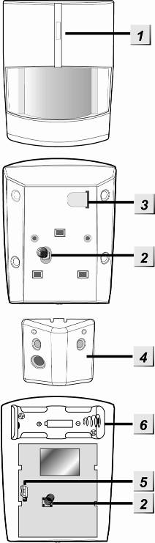
- Identifying the parts.
- Function Button/LED indicator
The Function Button is used for testing the radio performance and for adding PIR to the Z-Wave gateway or control panel.
The LED indicator is used to indicate the status of system.
- Tamper Switch
The Tamper Switch protects the PIR from unauthorized cover opening.
- Battery Insulator
- Corner mounting bracket
- Sensitivity Increaser Jumper Switch (JP3)
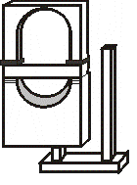
It is a 2-pin jumper switch
- If the jumper is OFF (if the jumper link is removed or “parked” on one pin), the PIR’s detection sensitivity is in normal level. (Factory default for IR-16SLZW)
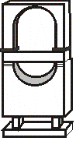
- If the jumper is ON (if the jumper link connects the two pins), the PIR’s detection sensitivity is high. (Factory default for IRP-16SLZW)
- Battery Compartment
- Sleep Timer
The PIR has a “sleep time” of approximately 1 minute to conserve power. After transmitting a detected movement, the PIR will not retransmit for 1 minute. Any further movement detected during this sleep period will extend the sleep time by another minute. In this way continuous movement in front of a PIR will not unduly exhaust the battery.
- Supervision Function
This function uses the Z-Wave Wake Up Command Class. The Wake Up Command Class allows the battery-powered PIR to notify the Control Panel/Gateway that it is awake and ready to receive any queued commands. The wake up interval time period is programmed automatically according to Control Panel’s setting when The PIR is included. The recommended setting of the interval time is between 30 to 60 minutes.
- Sensitivity Increaser Function
You can use the sensitivity increaser function to increase the IR’s detection sensitivity. To increase detection sensitivity, please enable the Jumper to ON position. To maintain the normal detection sensitivity, enable the Jumper to OFF position
- Test mode
The PIR can be put into Test mode by pressing the Function Button. During Test mode, sleep timer is disabled and will enable the LED indicator to flash every time a movement is detected.
Each time the Function Button is pressed the PIR will transmit a test signal to the Control Panel for radio range test and enter the test mode for 3 minutes. It will exit Test Mode automatically after 3 minutes and returns to normal mode.
- LED Indicator
The LED Indicator lights up in the following situations:
- When movement is detected under low battery condition.
- When the tamper switch is triggered.
- When movement is detected while the Tamper condition persists.
- When movement is detected under Test mode
- When the Function Button is pressed under tamper condition, test mode, or if PIR is under low battery condition.
- Battery
- The PIR uses one 3V Lithium battery as its power source. A low battery signal will be sent to the Control Panel along with regular signal transmissions for the Control Panel to display the status accordingly.
- The PIR will report its battery percentage to the Control Panel respectively at 100%, 75%, 50%, 25%. If the battery voltage is low (25%), a Low Battery signal will be sent to the Control Panel to notify the user.
- The battery is pre-inserted by the factory before shipment with a battery insulator inserted.
<NOTE>
- When changing battery, after removing the old battery, press the Tamper Switch twice to fully discharge before inserting new battery.
- Adding Device (Inclusion)
This product can be included and operated in any Z-Wave network with other Z-Wave certified devices from other manufactures and/or other applications. All non-battery operated nodes within the network will act as repeaters regardless of vendor to increase reliability of the network.
- Pull out the battery Insulator steadily.
- The LED indicator will flash for 30 seconds (The PIR is warming up). During the warm up period, the PIR will not be activated. It is recommended that you stay away from the detection area during this time. After the warming period is over, the LED will turn off and the PIR will be ready for operation.
- Put the Z-Wave control panel into Inclusion mode (please refer to the Z-Wave control panel manual).
- Within 1.5 seconds, press the Function Button 3 times.
- Refer to the operation manual of the Z-Wave gateway or control panel to complete the adding process.
- Please press and release the Tamper Switch once after inclusion is completed to ensure the Gateway/Control Panel recognizes the current Tamper condition.
- If the device has already been added (included) into another Z-Wave Gateway/Control Panel, or if the device is unable to be added into the current Z-Wave Gateway/Control Panel, try removing it first (see Removing Device).
- Removing Device (Exclusion)
The device must be removed from existing Z-Wave network before being added into another.
Exclusion Mode
- Put the Z-Wave gateway or control panel into Exclusion mode (please refer to the Z-Wave or control panel manual).
- Within 1.5 seconds, press the Function Button 3 times and the device will be removed from the Z-Wave network.
Factory Reset
Factory resetting the device will restore it to factory default settings (i.e. not included into any Z-Wave network). Please only use this procedure if the Z-Wave gateway or control panel is lost or otherwise inoperable.
- Press and hold the Function Button of the device for 12 seconds to factory reset.
- Range Test
To test whether the device is able to communicate with the Z-Wave gateway or control panel:
- Put the gateway / panel into range test mode (Walk Test).
- Press the Function Button on the device
- The gateway / panel should display if the device is within the operation range (please refer to the operation manual of the gateway / panel).
- Z-Wave Sleep Mode
- The PIR will enter Z-Wave Sleep mode (to conserve power) after waking up for a short period of time (~10 seconds). While in Z-Wave sleep mode, Z-Wave gateways or control panels are unable to send commands to the PIR.
- To program the PIR using the Z-Wave Gateway/Control Panel, please send command(s) to the PIR within the wake-up period.
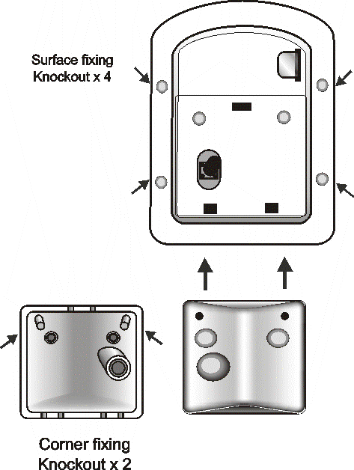

- Mounting Method
- The PIR is designed to be mounted on either a flat surface or in a corner situation with fixing screws and plugs provided.
- The base has knockouts, where the plastic is thinner, for mounting purpose. Four knockouts are for surface fixing.
- For corner mounting, an optional triangular bracket is provided to add Back Tamper Protection. Mount the triangular bracket on the wall first with the two pointing sticks on top facing you. Fit the PIR onto the hooks of the triangular bracket or screw the PIR onto it.
- Surface mounting:
- Remove the fixing screw and cover assembly.
- Break through the appropriate knockouts on the base.
- Using the holes as a template, drill holes in the surface.
- Insert the wall plugs if fixing it into plaster or brick.
- Screw the base into the wall plugs.
- Replace the cover back onto the base and secure it by tightening the fixing screw.
- Corner mounting:
- Break through the two knockouts on the triangular bracket.
- Using the two holes as a template, drill holes in the surface of the corner.
- Insert the wall plugs.
- Screw the triangular bracket into the wall plugs with the two pointing sticks on top facing you.
- Fit the PIR onto the hooks of the triangular bracket.
- If necessary, open the PIR by removing the fixing screw and cover assembly.
- Break through the appropriate corner fixing knockouts.
- Using the corner fixing knockouts as a template, drill holes in the surface in the corner again.
- Insert the wall plugs if fixing it into plaster or brick.
- Screw the base into the wall plugs.
- Replace the cover back onto the base and secure it by tightening the fixing screw.
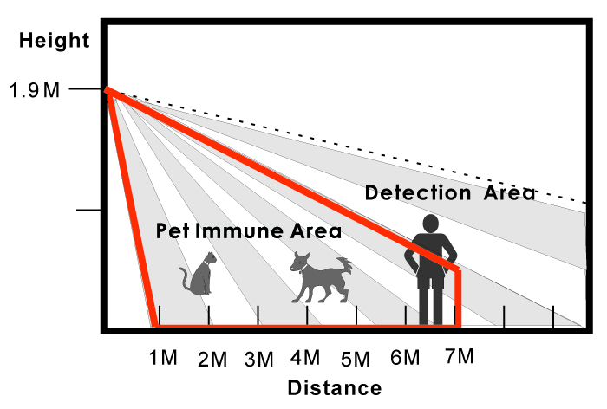
- Installation Recommendations
The PIR is designed to give a typical detection range of 12 meters when mounted at 2 meters above ground. The pet-immune model also have 7 meters of pet-immune range.
To take full advantage of PIR, the following guidelines should be considered:
- It is recommended to install the PIR in the following locations
- Mount the detector at 1.9M-2.0M height for best performance.
- Mount where the animals cannot come to the detection area by climbing on furniture or other objects.
- Don’t aim the detector at stairways the animals can climb on.
- In a position such that an intruder would normally move across the PIR’s field of view from side to side.
- In a corner to give the widest view.
- Where its field of view will not be obstructed e.g. by curtains, ornaments etc.
- Limitations
- Do not position a PIR to look directly at a door protected by a Door Contact, this could cause the Door Contact and PIR radio signals to be transmitted at the same instant when entering, canceling each other out.
- Do not install the PIR completely exposed to direct sunlight.
- Avoid installing the PIR in areas where devices may cause rapid change of temperature in the detection area, i.e. air conditioner, heaters, etc.
- Avoid large obstacles in the detection area.
- Not pointing directly at sources of heat e.g. fires or boilers, and not above radiators.
- Avoid moving objects in the detection area i.e. curtain, wall hanging etc.
- Z-Wave Information
Device Type: Sensor - Notification
Role Type: Reporting Sleeping Slave (RSS)
Command Class Support/Control
Mandatory CC Support: Association CC, v2 or newer
Association Group Information CC
Battery CC
Device Reset Locally CC
Manufacturer Specific CC
Notification CC
Powerlevel CC
Version CC, v2 or newer
Wake UP CC
Z-Wave Plus Info CC
- Z-Wave’s Groups (Association Command Class Version 2)
The PIR can be set to send reports to associated Z-Wave devices. It supports 3 association groups with five nodes each.
Group 1 for “LifeLine”:
Notification CC,V4 (COMMAND_CLASS_NOTIFICATION)
Battery CC (COMMAND_CLASS_BASIC)
Device Reset Locally CC
Group 2 for “Basic Set”:
Basic CC, v2 (COMMAND_CLASS_BASIC)
Group 3 for “Notification Report”:
Notification CC,V4 (COMMAND_CLASS_NOTIFICATION)
- Trigger Report (movement detected)
- When the PIR is triggered, it will transmit Notification command (Type 0x07, Event 0x08) to all nodes in Group1 and 3.
- Restore Report
- One minute after the trigger, the PIR will transmit Notification restore command (Type 0x07, Event 0x00, with one Parameter 0x08) to all nodes in Group1 and 3.
- Tamper Report
- When the Tamper is removed and triggered, it will transmit Notification command (Notification Type:0x07, Event:0x03) to all nodes in Group 1 and 3.
- When the Tamper is restored, it will transmit Notification command (Notification Type:0x07, Event 0x00 with one parameter 0x03) to all nodes in Group 1 and 3.
- Low Battery Report
- When low battery voltage is detected, the PIR will transmit Battery command to all nodes in Group 1.
- When PIR on low battery has its battery replaced, it will transmit Battery restore command to all nodes in Group 1
- Factory Reset
- When the PIR is reset to factory default, it will send Device Reset Locally to all nodes in Group 1.
Z-Wave Basic Set Command Class
- Trigger Report (Movement detected)
- Basic set (0xFF) commands to the nodes in Group 2.
- Restore Report
- Basic restore (0x00) command to the nodes in Group 2.

