

Instruction Manual
Wireless Water Leak Alarm
Model number: GS156B Ref：ST156B

Thank you for your support

- Please read the instruction manual carefully before operating
- Please keep the instruction manual for future reference
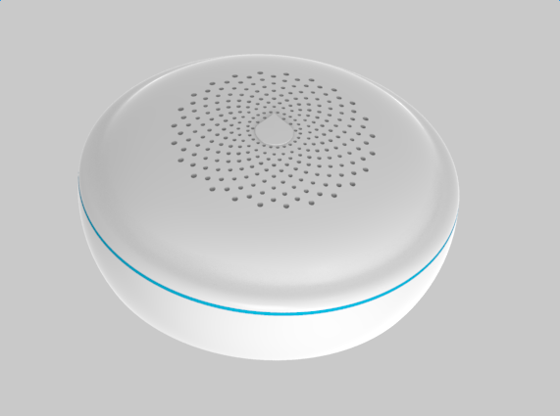






SITERWELL ELECTRONICS CO., LIMITED
Product Specification
Power: DC2*1.5V Alkaline AA battery
(Golden Peak Group: GP 15A LR6 or Energize: E91)
Standby Current: <5µA
Battery Life: 1 years
Alarm Current: <40mA
Radio Protocol: Z-WAVE
Wireless frequency: 868.4MHz EU; 908.4MHz US; 921.4MHz ANZ; 869.2MHz RU
Wireless distance: >50 meters
Waterproof Grade: IP65
Alarm Volume: ≥ 85dB(A) at 100cm
Operation Ambient Condition: 0~40℃, <80%R.H.
Alarm sound pattern: 3 short beeps, pause 1.5s with the red LED flash.

Product Description
The water alarm is an intelligent security equipment that can be controlled by the Z-Wave network which has particular frequency. The water alarm can be connected to any Z-Wave main controller. Different countries or areas, the radio frequency of the Z-Wave is different. This product can be included and operated in any Z-Wave network with other Z-Wave certified devices from other manufacturers and/or other applications. All non-battery operated nodes within the network will act as repeaters regardless of vendor to increase reliability of the network. In the Z-Wave network communications, the water alarm can communicate with other devices associated. When the water leak is detected, the sensor will send messages to the main controller, and then the alarm sound. Through the Z-Wave network, the devices associated can response after water leak is detected, For instance, the water valve can be turned off and the alarm device can be triggered. Through the Z-Wave network controller, you can get the status of the sensor, such as battery level, also you will be notified when the water is leaking.
The water alarm is small and battery powered, it works on the hard or soft surfaces, such as carpet, floor etc. when water leak cause the two sensing probes to be short circuit, the water alarm will sound.

Recommended Installation Locations
The following is a list of ideal locations to place your water alarm, Place a Water Alarm in every room where water damage is possible:
● Washing machines ● Water heater
● Dishwasher ● Toilet
● Sink ● Humidifier
● Ice maker ● Pipes close to outdoor taps
Note: Be sure that the sensing probes is placed flat on the floor.

Restore the Sensor to Factory Default Settings
This operation will delete all information on Z-Wave network, and restore the factory default settings.
1. Remove the battery, power off for a while. Now put on the battery.
2. Wait for 5 seconds, When the LED is on, you should short the two sensing probes together with wet cloth within 5 seconds (before the LED turn off), and then remove the wet cloth quickly .
3. Repeat the Step2 one times.
4. The sensor will sound after successful operation, and it will last 2 seconds.
Note: If this sensor is reset, the information of Z-Wave network in the sensor will be deleted. The sensor will be itself restored to factory default settings. Please use this procedure only when the network primary controller is missing or otherwise inoperable.

Add (Including) Sensor To Z-Wave Network
The water alarm can be included to the Z-wave network by following operations:
1. Power on the alarm.
2. Make sure the alarm is on its final install location, then set the controller into the inclusion mode.
3. Quickly, triple short the two sensing probes together with wet cloth, the LED will flash alternately.
4. The LED will flash 3 times with beeping after the alarm being Add (included) to the network successfully.
Remove (Excluding) Sensor From Z-Wave Network
1. Make sure the alarm is connected to power source.
2. Set the Z-Wave Network controller into exclusion mode.
3. Quickly, triple short the two sensing probes together by wet cloth, the LED light will flash for 3 times with beeping sound.
4. Wait for the controller to remove (excluded) the alarm.
Note: If the alarm is remove(excluded), then the sensor will be itself restored to factory default settings.
Associations
This has the effect that when the sensor detects the water leak, all devices associated with the sensor will receive the relevant reports and can be controlled by the sensor, e.g. the water valve, alarm device etc.
This device supports two linkage groups:
Linkage group 1 is lifeline.
Linkage group 2 is assigned to the devices status - sending BASIC SET control frame to the associated devices having detected the water leak.
Linkage group 3 reports the detection's status to the associated device.

Note that only when the sensor detects the leak, the sensor will send BASIC SET 0xFF, there are no report (BASIC SET 0x00) will be sent after the leak is cleared.
The maximum number of devices that can be added to the Linkage group 1 is 1.
The maximum number of devices that can be added to the Linkage group 2 or Linkage group 3 is 5.
Command Classes
This sensor supports Command Classes as below:
COMMAND_CLASS_ZWAVEPLUS_INFO (V2)
COMMAND_CLASS_ASSOCIATION (V2)
COMMAND_CLASS_MULTI_CHANNEL_ASSOCIATION (V3)
COMMAND_CLASS_ASSOCIATION_GRP_INFO (V3)
COMMAND_CLASS_VERSION (V2)
COMMAND_CLASS_MANUFACTURER_SPECIFIC (V2)
COMMAND_CLASS_DEVICE_RESET_LOCALLY (V1)
COMMAND_CLASS_POWERLEVEL (V1)
COMMAND_CLASS_BATTERY (V1)
COMMAND_CLASS_NOTIFICATION (V8)
COMMAND_CLASS_WAKE_UP (V2)
Supported Notification Type: Water Alarm
Supported Event: 1. Event inactive (push mode) / Previous Events cleared (pull mode) (V4)
2. Water Leak detected, Unknown Location (V2) (This event is triggered when the sensor detects water leak.)
Test the water alarm
Use your fingers or damp cloth connect with two sensing probes, the alarm will sound.
If the alarm is not operating properly, and is still under warranty, return it to the original place you buy.
DANGER: If the alarm sounds, and it is not being tested, it means the unit is sensing the water, the sound of the alarm requires your immediate attention and action.
Battery Life
The battery should last about one year.
Low Battery warning
When the voltage of the battery is too lower, the water alarm will beeps once every 32 seconds. Please replace the battery.
Replace Battery:
1: According to the counter clockwise rotation to open 2 screws, remove the battery cover plate.
2: Take out the old battery from the battery box.
3: Fix the two new batteries to the battery box. Please note the battery polarity.
4: Fix the battery into battery box, Confirm that the sealing ring is not damaged, deformation, leakage, is located in the groove, Press the cover of the battery, press the screw clockwise and fix the screw in place.
5: According to the information in the “Test the water alarm” to detect whether the function of the product is ok. If there’s no sound output, it means that the water alarm is faulty or the installing operation is wrong, and you should gain the correctly method of disposal through reading “TROUBLE SHOOTING”.
NOTE：Confirm that the sealing ring is not damaged, deformation, leakage, is located in the groove.

Trouble shooting:
General Maintenance
Problem | Method of disposal
Water Leak alarm does not sound when tested. | Remove the battery cover plate, then Check the battery is properly connect to battery connector.
Water Leak alarm beeps with the red LED flash about once 32 seconds. | Replace battery, please refer to “REPLACE BATTERY” section.
Fail to include the sensor to the Z-Wave network. | Check if the sensor has been included to another Z-Wave network. If yes, do Excluding Sensor From Z-Wave Network before including the sensor to a new Z-Wave Network.
1. Test Water Alarm monthly.
2. Do not allow lint or debris to accumulate around the water alarm.
3. Remove Water Alarm from the water as soon as possible when it is alarming.
4. When the unit is low battery warning, replace the unit.

Product Dimension
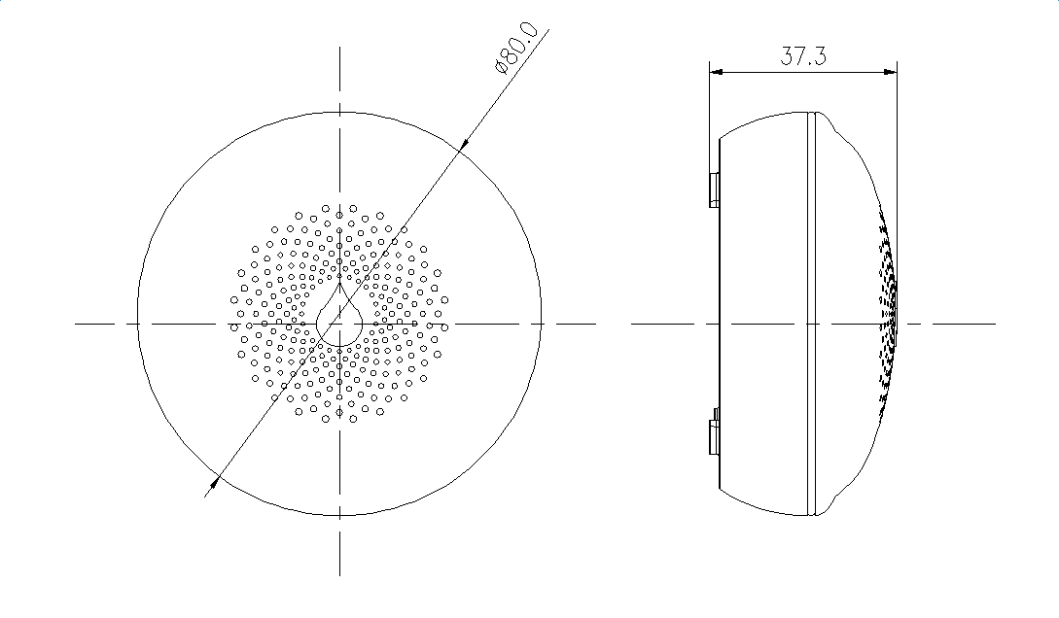
Manufacturer:
SITERWELL ELECTRONICS CO., LIMITED
ADDRESS:No.76 Haichuan Road，Chuangye Zone B , Jiangbei , Ningbo ,China
TEL: 0086-574-83076656
FAX: 0086-574-83076652
E-MAIL:Sales@china-ster.com

