BX-32ZW Outdoor Bellbox

Introduction
BX-32ZW is a Z-Wave Outdoor Bellbox. It is capable of raising alarm upon receiving alarm signal from the Z-Wave network when an alarm is activated. During the alarm, the Bellbox will sound alarm with its built-in siren and also flash the strobe light to attract attention.
The Bellbox is a Z-Wave enabled device and is fully compatible with any Z-Wave enabled network.
Z-Wave is a wireless communication protocol that uses a low-power RF radio. By taking advantage of the Z-Wave mesh network, commands can be transmitted to their destination via intermediary “listening” Z-Wave products.
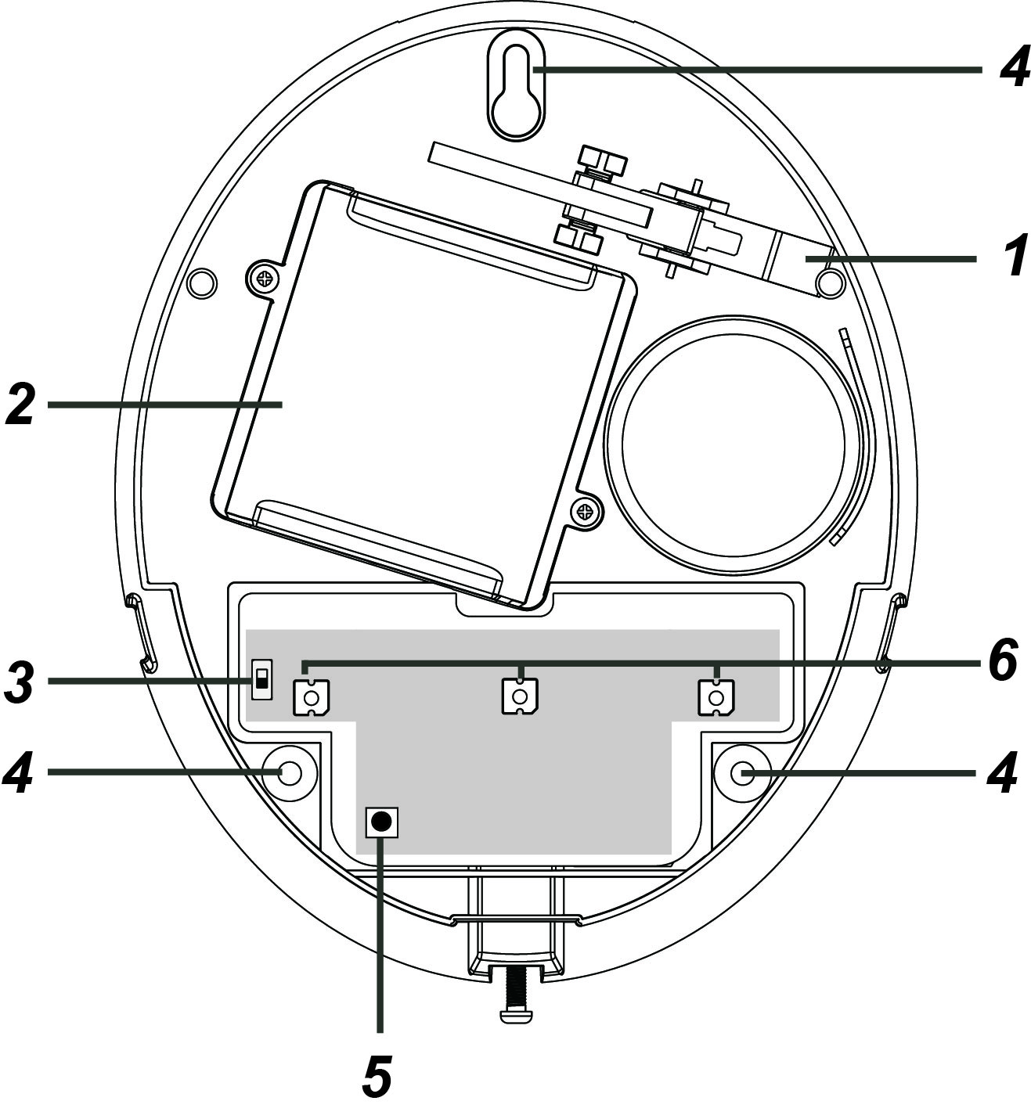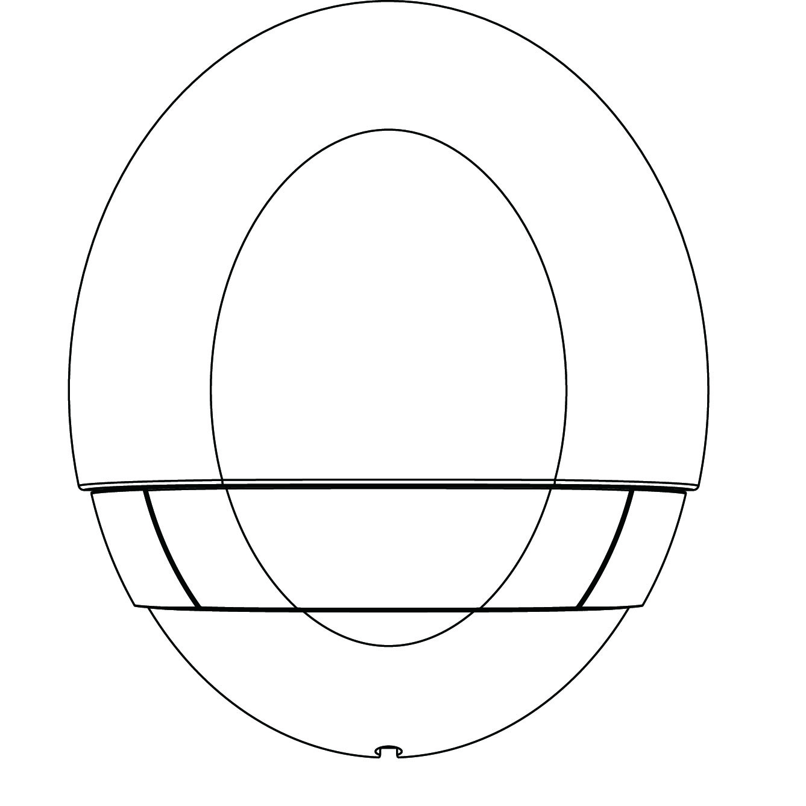
Parts Identification
1. Tamper Switch
The Tamper switch will be activated when the Bellbox is removed from mounted surface, or it cover
opened.
2. Battery Compartment
The Bellbox is powered by two 1.5V D-Cell alkaline battery.
3. Battery Switch
The battery switch is used when battery is installed in the Outdoor Bellbox. To power on/off the
Outdoor Bellbox, switch the ON/OFF button.
4. Mounting Holes x 3
5. Function Button
- Press the button 3 times within 1.5 seconds to send a learn code.
- Press and hold the button for 10 seconds, Refer to Removing Device (Exclusion) for details.
6. LED 3 & 2 & 1 (From left to right)

Features
- Audio and Visual Status Indication
The Siren can be set to indicate system status such as Arm, Home, Disarm and Fault. Please see the table below for indication patterns. (Functionality may vary depending on the controller)
The strobe light includes 3 LEDs (From right to left: LED 3-> LED 2->LED 1).
Refer to below table for LED and siren beep for status indication.
 | Siren Audio | Strobe Light Indication
Arm/Home | 1 Long Beep | 3 LED’s Flash at Once
Disarm | 2 Beeps | Sequentially flashes for one cycle
Disarm + Alarm Memory | 5 Beeps | None
Fault in System 1-sec | Short Beep | None
Alarm | Siren | LED’s Flash
Burglar | Siren | LED’s Flash
Fire | Siren | LED’s Flash
Water | Continuous Beeps | LED’s Flash
Entry Count Down | Short Beep | None
Exit Count Down | Short Beep | None
Door Chime | Ding-Dong | None
Stop Beep | None | None
<NOTE>
- Arm/Home/Disarm LED and siren beep behaviour are the same under fault conditions (Tamper Fault/Low Battery).
- Alarm Activation
When an alarm is activated, the Bellbox will activate its siren and strobe light according to different alarm type:
- Burglar and Emergency alarm: Continuous alarm, all LED flashes.
- Fire alarm: 2-second alarm with1-second interval, all LED flashes.
- Alarm Length Setting
When the Bellbox receives an alarm signal via Z-Wave network, it will activate siren and strobe light according to the alarm length set by the system control panel (default is 10 minutes).
- Battery and Low Battery Detection
The Bellbox uses two 1.5V alkaline D-cell batteries as its power source. With the battery, use the battery switch to power on/off the Bellbox manually.
The Bellbox features Low Battery Detection function. When the battery voltage is low, the Bellbox will transmit Low Battery signal to the coordinator in Z-Wave network.
The Bellbox will report its battery percentage to the Control Panel respectively at 100%, 75%, 50%, 25%, 10%. If the battery voltage is low (10%), a Low Battery signal will be sent to the Control Panel to notify the user.
When changing battery, after removing the old battery, press the Tamper Switch twice to fully discharge before inserting new battery.
- Tamper Protection
The Bellbox is protected by a tamper switch which is compressed against the mounting surface when mounted. Whenever the Bellbox is removed from mounted location, or its cover opened, the tamper switch will be activated and the Bellbox will send a tamper open signal to remind the user of the condition and activate an alarm immediately.
- Adding Device (Inclusion)
This product can be included and operated in any Z-Wave network with other Z-Wave certified devices from other manufactures and/or other applications. All non-battery operated nodes within the network will act as repeaters regardless of vendor to increase reliability of the network.
- Insert the two 1.5V D-Cell alkaline batteries into the battery compartment connecting the correct polarity as shown on the battery compartment lid.
- The Bellbox will emit a 2-tone beep.
- Put the Z-Wave gateway or control panel into Inclusion mode (please refer to the Z-Wave gateway or control panel manual).
- Within 1.5 seconds, press the Function Button 3 times.
- Refer to the operation manual of the Z-Wave Gateway or Control Panel to complete the adding process.
- If the sensor has already been added (included) into another Z-Wave Gateway/Control Panel, or if the sensor is unable to be added into the current Z-Wave Gateway/Control Panel, please exclude it first (see Removing Device) before attempting to include it into the current Z-Wave Gateway/Control Panel.
- Removing Device (Exclusion)
The Bellbox must be removed from existing Z-Wave network before being included into another. There are two methods available to exclude a device.
Exclusion Mode
- Put the Z-Wave gateway or control panel into Exclusion mode (please refer to the Z-Wave gateway or control panel manual).
- Within 1.5 seconds, press the Function Button 3 times and the Bellbox will be removed from the Z-Wave network.
Factory Reset
(Only use factory reset when network Control Panel/Gateway is missing or inoperable).
- Press and hold the Function button of the Bellbox for 10 seconds to factory reset with all LED flashes once.
<NOTE>
- Factory resetting the Bellbox will restore it to factory default settings (excluded from the Z-Wave network). The Z-Wave gateway or control panel will still keep its Z-Wave settings. Please refer to the gateway or control panel manual on how to remove the Bellbox’s Z-Wave settings.

Installation
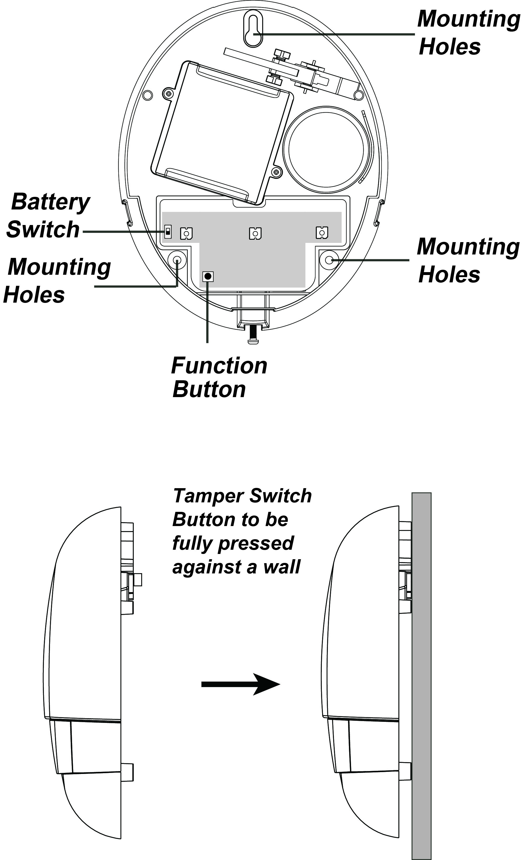
- Installation Guideline
- The Bellbox is designed with a waterproof case to be mounted on external wall of your house.
- When mounting the Bellbox, mount as high as possible for its siren and strobe light to attract attention when an alarm is activated.
- The Bellbox is designed to be mounted on a flat surface with fixing screws and plugs provided.
- The base has 3 mounting holes for you to screw the Bellbox onto the wall.
- Mounting the Bellbox
- Find the location where the Bellbox is to be mounted.
- Remove the Top cover by releasing the bottom screw using a Philips screwdriver and pulling the outer case out carefully.
- Hold the Bellbox at the position where it will be mounted.
- Check whether BX has a strong enough signal with the Control Panel by putting the Control Panel into Walk Test mode (please refer to Control Panel manual). Press the Function Button check whether the signal is strong enough (please refer to Control Panel manual for signal strength).
- If you are satisfied with the signal strength, remove the Bellbox from mounting location.
- Identify the 3 mounting holes, mount and fix the Bellbox on the wall using the large screws and wall plugs provided. Secure the screws using a Philips screwdriver. Make sure the Tamper Switch is fully depressed against the wall.
<NOTE>
- The tamper switch is secured with a button at the back of the base. When the siren is pulled off from the wall, button will be released, the alarm will be activated. Ensure the button is fully depressed when the siren is mounted. If there is a gap, pack with a suitable spacing material.
- Replace the Top cover by hooking the top of the Top cover onto the top of the base. Push the bottom of the Top cover onto the base and tighten the bottom screw using a Philips screwdriver.
- Check if the installation is successful by testing from the Control Panel by arming and disarming function.
- The installation is now completed.

- Z-Wave Information
BX-32ZW is a “Security Enabled Z-Wave Plus Product.” The Controller also supports as ‘Security Enabled Z-Wave Controller.”
Device Type: Generic Siren
Role Type: Listen Sleeping Slave (LSS)
Command Class Support/Control
Mandatory CC Support: Association CC, v2 or newer
Association Group Information CC
Binary Switch CC
Battery CC
Device Reset Locally CC
Manufacturer Specific CC
Notification CC
Configuration CC
Scene Activation CC
Powerlevel CC
Version CC, v2 or newer
Z-Wave Plus Info CC
Recommended CC Support: Firmware Update Metadata CC
- Z-Wave’s Groups (Association Command Class Version 2)
The Bellbox can be set to send reports to associated Z-Wave devices. It supports three association groups.
Group 1 for “LifeLine” (maximum node:1):
Battery CC (COMMAND_CLASS_BATTERY)
Notification CC,V4 (COMMAND_CLASS_NOTIFICATION)
SwitchBinary CC, V1 (COMMAND_CLASS_SWITCH_BINARY)
Device Reset Locally CC
Group 2 for “Tamp rep” (maximum node: 5):
Notification CC,V4 (COMMAND_CLASS_NOTIFICATION)
When Tamper Open, Group 2 send Notification
(Type:07,Event:03), Tamper Close send Notification
(Type:07,Event:00,Parameter:03)
Group 3 for “AC rep” (maximum node: 5):
Notification CC,V4 (COMMAND_CLASS_NOTIFICATION)
When AC Fail send Notification (Type:08,Event:02),
When AC Restore send Notification (Type:08, Event:03)
- Z-Wave Configuration
[COMMAND_CLASS_CONFIGURATION]
[CONFIGURATION_SET]
Parameter Number: 0x01~0x04
Size:0x01
Reserved: 0x00
Default:0x00
Configuration Value: 0xXX
Parameter Number | Configuration Value
0x01, Alarm Length | 0x01~0x0A (1~10 min), default 0x0A
0x02, Alarm LED Flash ON/OFF | 0x00: disable,  0x01: enable; default 0x01
0x03, Comfort LED | 0x00~0x19 (disable, 10sec,…,250sec)  Default:0x00  Each unit is 10 sec
0x04, Tamper Enable/Disable | 0x00:disable,0x01:  enable; default 0x01

