Frequency | 908.42 MHz
Battery Type | CR2450 Battery 1 PCS
Operating Temperature | −10 °C to 55 °C (14°F - 131°F)
Storage Temperature | −20°C to 60 °C (-4°F - 140°F)
Operating Air Range | Up to 152 feet line of sight
Low Voltage Alarm | 2.5V±0.2V
HO-09ZW Magnetic Contact Installation Guide
Introduction
HO-09ZW Magnetic Contact are designed to secure the perimeter of the residential premise, and provide the ability to add various automation services. The Z-Wave Magnetic Contact which consists of a magnet that
attaches to a door or window, will communicate door events to the home security system. When the magnet is
moved away from the sensor, a signal will be sent to the control panel that communicates the changed state to the
security system. Signals can also be used to activate a chime or convenience lighting based on system settings.
Specification

Inclusion Sensor
For Inclusion a network: Put the Z-Wave Interface Controller into “Inclusion” mode, and following its instruction to include HO-09ZB to your controller. This magnetic contact needs to be included
before installation.

1. Pull out the insulating strip, making the device power on. (Figure 1)

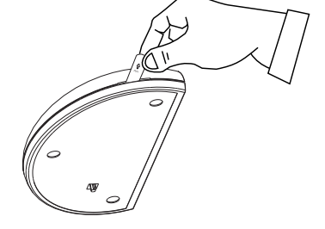 Figure 1
2. Pressing the anti-tamper switch three times.

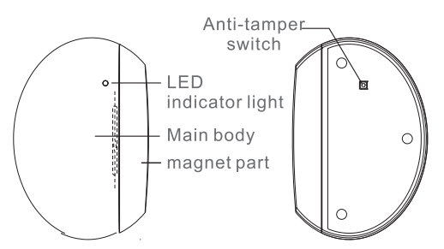 Figure 2

- Red LED will blink three times while inclussion the network successful (Figure 2).

4. If inclussion failed, the sensor will go into sleep mode. To wake the sensor again, you
need to use magnet or anti-tamper switch (Figure 2) to trigger an inclusion process, and then sensor will repeat
steps from 3 to 4.
Exclusion Sensor

For Exclusion a network: Put the Z-Wave Interface Controller into “Exclusion” mode,
and following its instruction to exclude magnetic contact from your Z-Wave controller.

- Pressing the anti-tamper switch Triple then enter exclusion mode.
- Red LED will blink three times while exclussion the network successful.

Factory Default Reset

Press the anti-tamper switch five times to reset.
Note: Use this procedure only in the event that the primary controller is lost.

Installation

1. Please make sure that the sensor and magnet is located less than 14mm from each other. For optimal
performance, it is highly recommended to install the Door/Window sensor on the fixed frame and the magnet
on the moving part of the door/window. Place the sensor near the top of the door that close to the opening
edge of the door. This is the mounting location for the sensor.
2.Use the provided double-sided tape on the sensor(Figure 3). Attach the sensor to the door.
Press firmly and hold in placefor a few seconds . Secure it with silicone if needed.

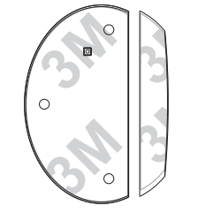
Figure 3

Adhesive application surface: Acrylic, Glass
Aluminum and Stainless steel…etc.

3. Use provided double-sided tape on the magnet. Make sure the alignment of both sensor and magnet alignment
mark are facing each other (Figure 4). Press firmly and hold in place for a few seconds. Secure it with
silicone if needed.

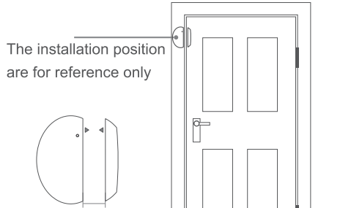

Figure 4

4. HO-09ZW can be included and operated in any Z-Wave network with other Z-Wave certified devices
from other manufacturers and/or other applications. All non-battery operated nodes within the network will
act as repeaters regardless of vendor to increase reliability of the network.

5. Association
Support grouping identifier = 1
Support one group with 5 nodes.
All triggering report and low voltage report will be sent to the associated nodes.

Z-Wave Command Classes
COMMAND_CLASS_ZWAVEPLUS_INFO,
COMMAND_CLASS_VERSION,
COMMAND_CLASS_MANUFACTURER_SPECIFIC,
COMMAND_CLASS_DEVICE_RESET_LOCALLY,
COMMAND_CLASS_POWERLEVEL,
COMMAND_CLASS_BATTERY,
COMMAND_CLASS_SENSOR_BINARY,
COMMAND_CLASS_NOTIFICATION，
COMMAND_CLASS_ASSOCIATION,
COMMAND_CLASS_ASSOCIATION_GRP_INFO,
COMMAND_CLASS_WAKE_UP
 | Switch Type | Status
Notification Type | Reed Switch | 0x06
Notification Type | Tamper Switch | 0x07
Event | Reed Switch | Close:0x17, Open:0x16
Event | Tamper Switch | Close:0x00, Open:0x03
Sensor Binary Report | Reed Switch | Close:0x00, Open:0xFF
Notification Type

Operation
1. The LED will stay off during the normal operation.
2. The sensor is equipped with a anti-tamper switch. If the cover of sensor is removed, the sensor will send an alarm
to the home controller.
3. Anti-tamper switch event will be ignored when in auto inclusion procedure.

This product can be included and operated in any Z-Wave network with other Z-Wave certified
devices from other manufacturers and/or other applications. All non-battery operated nodes
within the network will act as repeaters regardless of vendor to increase reliability of the network.

