Base Station

Z-Wave Technical Manual

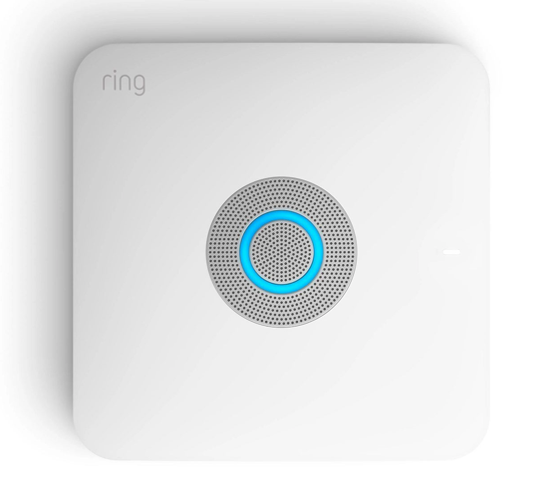

Ring Base Station

Z-WaveTM
This product can be operated in any Z-WaveTM network with other Z-Wave certified devices from other manufacturers. All mains operated nodes within the network will act as repeaters regardless of vendor to increase reliability of the network.
SmartStart enabled products can be added into a Z-Wave network by scanning the Z-Wave QR Code present on the product with a controller providing SmartStart inclusion. No further action is required and the SmartStart product will be added automatically within 10 minutes of being switched on in the network vicinity.

Adding Sensor to a Z-Wave Network
Ring Sensors can be added via SmartStart or via classic inclusion mode –
Ring Device Smart Start Inclusion Steps:
- Initiate add device flow in the Ring Alarm mobile application by going to Menu Set Up a Device – Follow the guided add flow instructions provided in the application
- Scan the QR code found on the package of the device or the QR code found on the back of the device
Non-Ring Device Smart Start Inclusion Steps:
- Initiate add device flow in the Ring Alarm mobile application by choosing Set Up a Device from the main menu.
- Choose any Ring device such as Security Range Extenders Range Extender (2nd Gen) -> follow on screen instructions and scan the QR code.
Classic Inclusion Steps:
- Initiate add device flow in the Ring Alarm mobile application by choosing Set Up a Device from the main menu.
- Go to Security Works With Ring
- Select Add
- Enter learn mode on the joining device

Removing a Sensor to a Z-Wave Network
- Ring Sensors can be removed from the network by going to Menu Devices Select the device you want to remove.
- Select Device Settings
- Select Remove and follow the on screen instructions to put your device into learn mode for removal.

Access / Edit Provisioning List
- Device gets added to provisioning list after scanning QR code
- Menu Devices Select the device you want to access/edit.
- Complete editing and save

Rediscovery of a Sensor’s Capabilities
- Menu Devices Select the device you want to reconfigure.
- Select Device Settings Advanced Options
- Select Reconfigure Device. Note: this may set your device configurations and settings back to defaults.

Ring Base station – Lifeline
Association
This base station has Group 1 is the “Lifeline” group, which can hold one devices. Base station will send device reset locally notification to this group.

Ring Base Station – Reset
Factory Default Instructions
- Launch Ring app (iOS or Android)
- Navigate to Base Station Setting: Devices à Alarm Base Station à Tap on gear icon located on top right-hand corner
- Navigate to Advanced Options Z-Wave
- Tap “Reset Z-Wave Network” and Select “Reset”
Warning: This process is irreversible. All your Z-Wave devices will be removed from your Base Station. You will have to manually reset and re-add each device to rebuild your network.
Use this procedure only in the event that the network primary controller is missing or otherwise inoperable.

Ring Base station – Learn Mode
Since Learn mode is not mandatory anymore, Learn mode is no longer supported by Ring Base station.

Ring Base station – Replication
Since Replication is not mandatory anymore, Replication is no longer supported by Ring Base station.

Ring Base Station – Z-WaveTM Supported Command Classes

Command Classes | Version | Required Security Classes
Application Status | 1 | None
CRC16 | 1 | None
Inclusion Controller | 1 | None
Security | 1 | None
Security 2 | 1 | None
Supervision | 1 | None
Time | 1 | None
Transport Service | 2 | None
Z-Wave PlusTM Info | 2 | None
Multi Command | 1 | None
Indicator | 3 | Highest granted Security Class
Manufacturer Specific | 2 | Highest granted Security Class
Power Level | 1 | Highest granted Security Class
Version | 3 | Highest granted Security Class
Firmware Update | 5 | Highest granted Security Class
Network Management Basic | 2 | Highest granted Security Class
Network Management Inclusion | 3 | Highest granted Security Class
Network Management Proxy | 3 | Highest granted Security Class
Network Management Installation Maintenance | 2 | Highest granted Security Class
Node Provisioning | 1 | Access Control
Association | 2 | Highest granted Security Class
Association Group Info | 3 | Highest granted Security Class
Device Reset Locally | 1 | Highest granted Security Class
Multichannel Association | 3 | Highest granted Security Class

Ring Base Station – Z-WaveTM Controlled Command Classes
The follow section provides information on how to control minimum features of the command class in the system. In general, features are all accessible in the device’s detail page in the Ring App by going to Menu Devices select the device you want to control.

Basic CC
- Upon adding a binary switch device, you can go into the device details page and toggle the device ON or OFF
Door Lock CC
- Upon adding a door lock to the system, the device will be configured during the inclusion process based on it’s capabilities.
- Once configured, within the device details page, you can send commands to lock/unlock your device.
Multilevel Switch CC
- Within the devices details page, you can slide the bar to set the desired level, adjust it up or down, or stop the level change.
Sound Switch CC
- Upon adding a sound switch device such as the Ring Outdoor Siren, the volume and turning the siren on/off sound can controlled via the device details page.
Thermostat Mode and Thermostat Setpoint CC
- In the device details page, the thermostat mode can be set by toggling the on-screen buttons to Off, Heat or Cool. The temperature can be adjusted up or down as well to the desired setpoint.
Configuration CC
- When your device is included into the system, default configurations are set by the system already. If available, various configuration parameters can be modified on your device within the device’s detail page. These include things such as LED settings, brightness and volume levels, etc.

