CTT3.2.1 beta Self-certification Operations

Contents
Software 2
Hardware 2
Trigger Un-associated events 2
Set up 2
Test case note: 2
Serial devices in CTT3.2.1 3
Controller data in CTT3.2.1 3
DUT data in CTT3.2.1 3

Software
- CTT v3.2.1 beta – Z-Wave™ Certification Portal (ZCP)-based
- Simplicity Studio V5
- Zniffer
- Z-Wave™ Programmer

Hardware
- 1xUZB-S Z-Wave™ Network Zniffer
- 1xUZB 700 Z-Wave™ Controller V7.16
- Regulated DC power supply that is sued to trigger the un-associated battery low report
- 1x700 series Z-Wave™ development board with a ZGM130S module programmed with a special firmware for emulating slave devices
- 2 x DUT (DUT_1 and DUT_2)
- 1 x Pushbutton connected to SW1 of DUT. It is used as a reed sensor to trigger the Notification type 0x06 (events 0x16 and 0x17)

Trigger Un-associated events
- Battery level report
The battery level reports every 2 minutes for 10 minutes when DUT has just power up.
- Battery Low report
Supply the power by the regulated DC power supply connected to battery terminals. Adjust the power supply voltage to around 2.75V and power up the DUT. The battery (low) level reports every 2 minutes since power up for 10 minutes.
- Notification report
Press/release the pushbutton which connected to SW1 to trigger the Notification report
- Door states report
Short press the on board manual lock/unlock button to trigger door states reports.

Set up
- Connect the ZB 700 Z-Wave™ Controller, Z-Wave™ Network Zniffer and development board to PC before run the CTT3.1.3
- Follow the instruction in CTT3.1.3

Test case note:
- CSR_LifelineMandatoryReports_Rev02
- If the 700 series devices (development board with a ZGM130S module programmed with a special firmware for emulating slave devices) does not support S2 Access, add it as S0.
- Restart the DUT before this test case. The Battery level report every 2 minutes within 10 minutes
- Connect a pushbutton which connected to SW1 working as reed sensor to trigger the notification door open/close event.

- BatteryCmdClassV1_Rev03_Orig
Before test battery low event, supply the power by the regulated DC power supply connected to battery terminals. Adjust the power supply voltage to around 2.75V and power up the DUT. The battery (low) level reports every 2 minutes since power up for 10 minutes.

- S2_SeveralSeparateECDHKeyPairs_Rev01
Failed
The DUT only support S0 and S2_Access, the S2_Unauthenticated and S2_Authenticated are not supported this test case will not be tested

- CDR_MulticastNoResponse_Rev01
This test cased failed in Z-Wave™ Certification Portal (ZCP)-based. It is CDR_MulticastNoResponse_Rev01 issue, that the DUT does not answer non-secure Z-Wave Plus™ Info Get (unless non-secure is the highest level).

After recommended by Jiehui (Silicon Labs Technical Support), test is by CDR_MulticastNoResponse_Rev02.
Created a new DUT-based test project. It is passed CDR_MulticastNoResponse_Rev02 in the first go!

Serial devices in CTT3.2.1

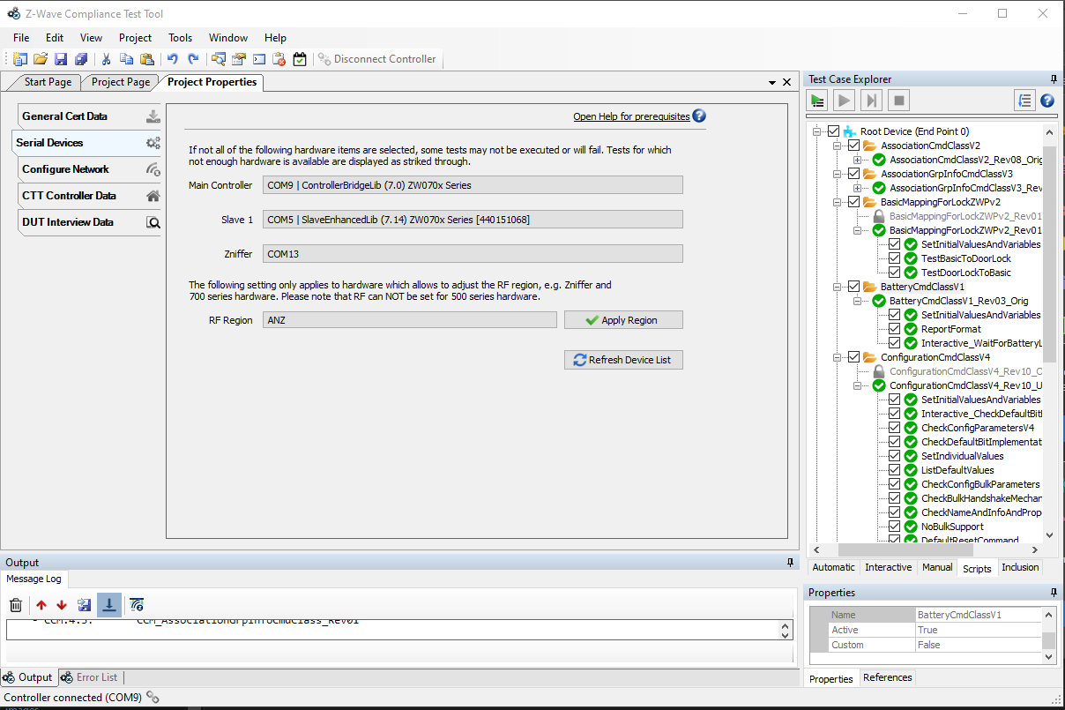

Controller data in CTT3.2.1
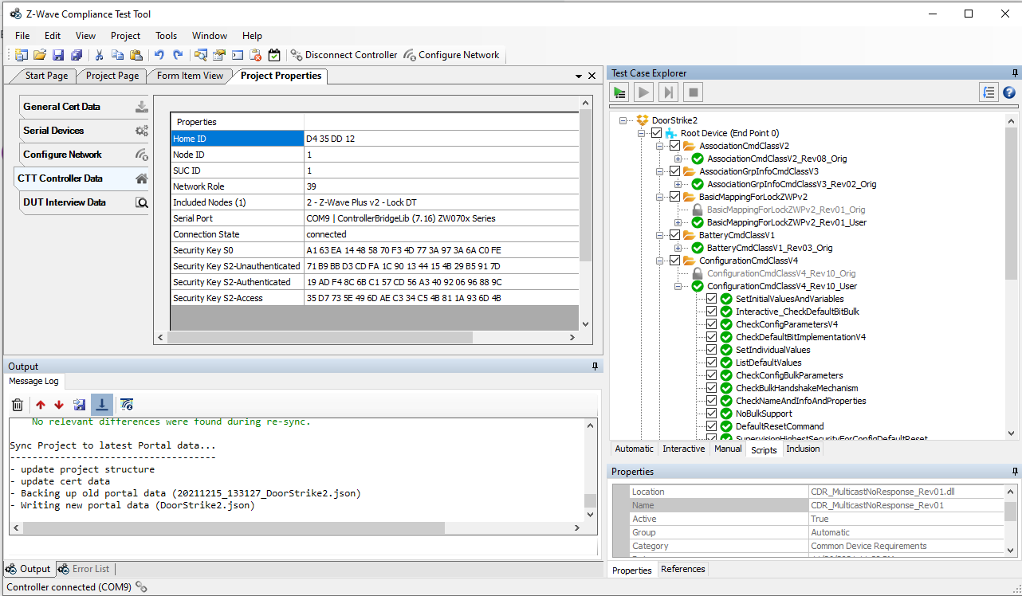

DUT data in CTT3.2.1
- Common Data:
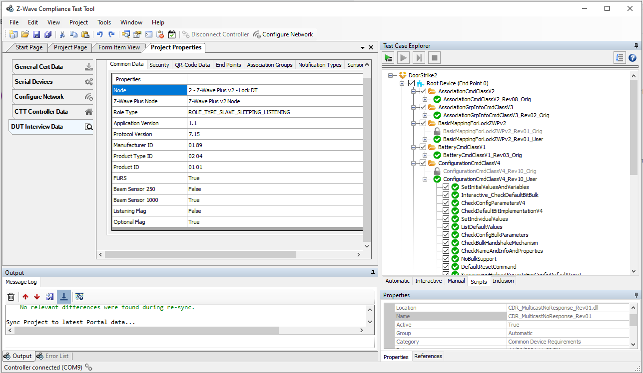

- Security
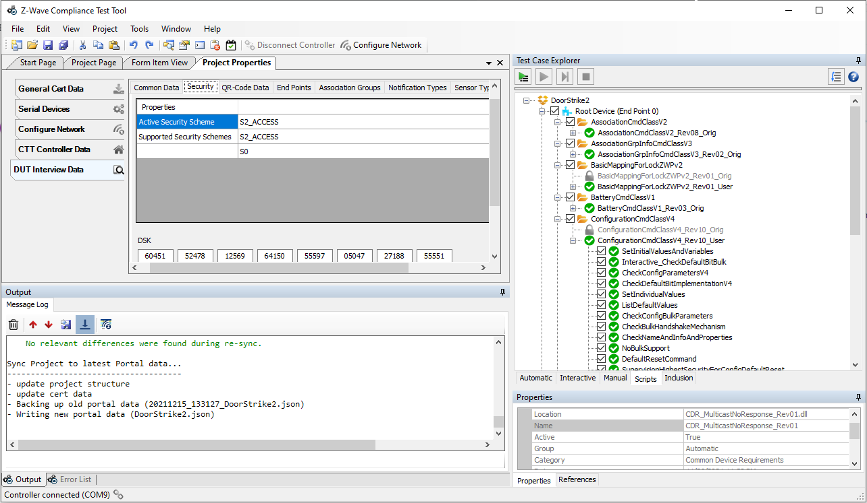

- QR-Code data
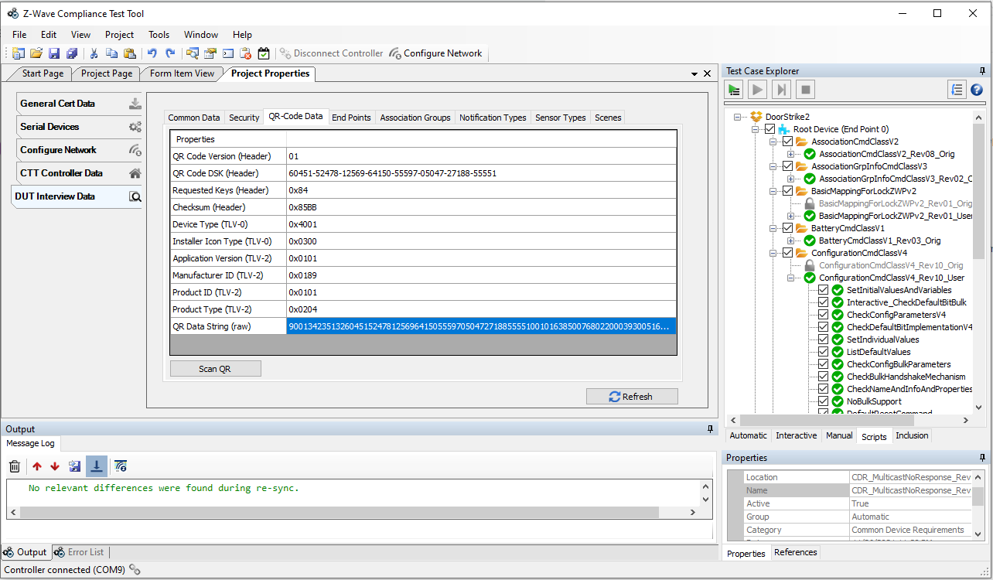

- End Points
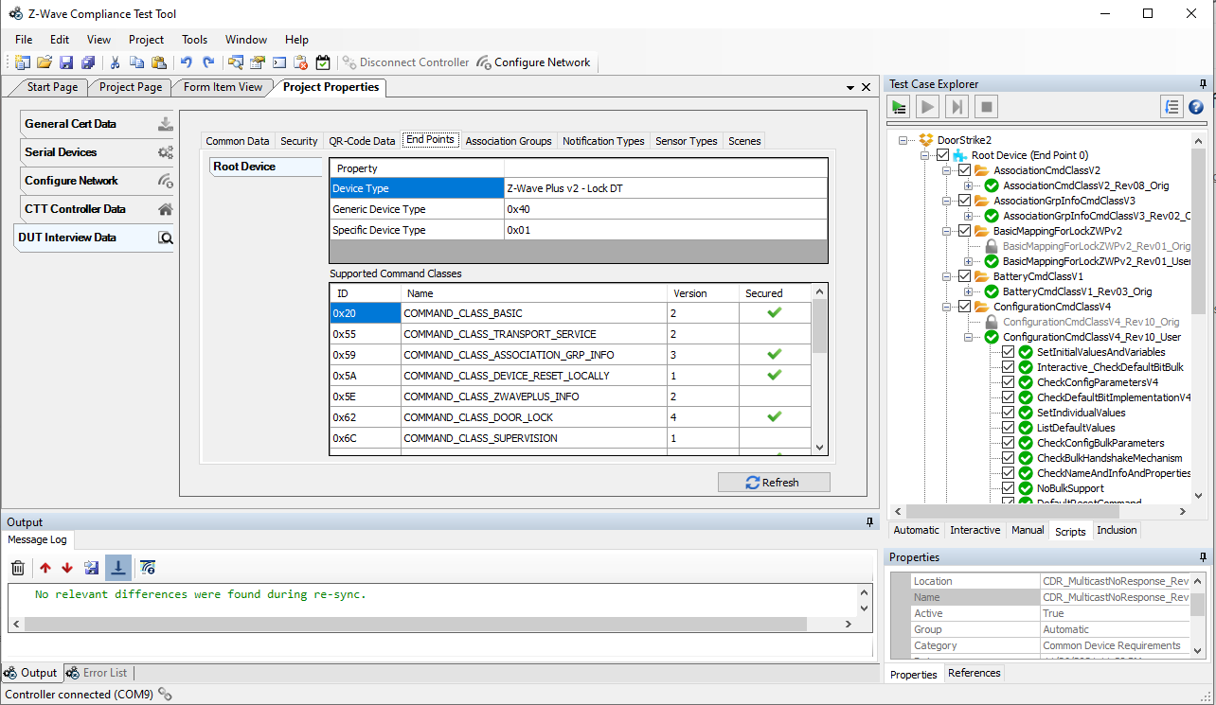

- Association Groups
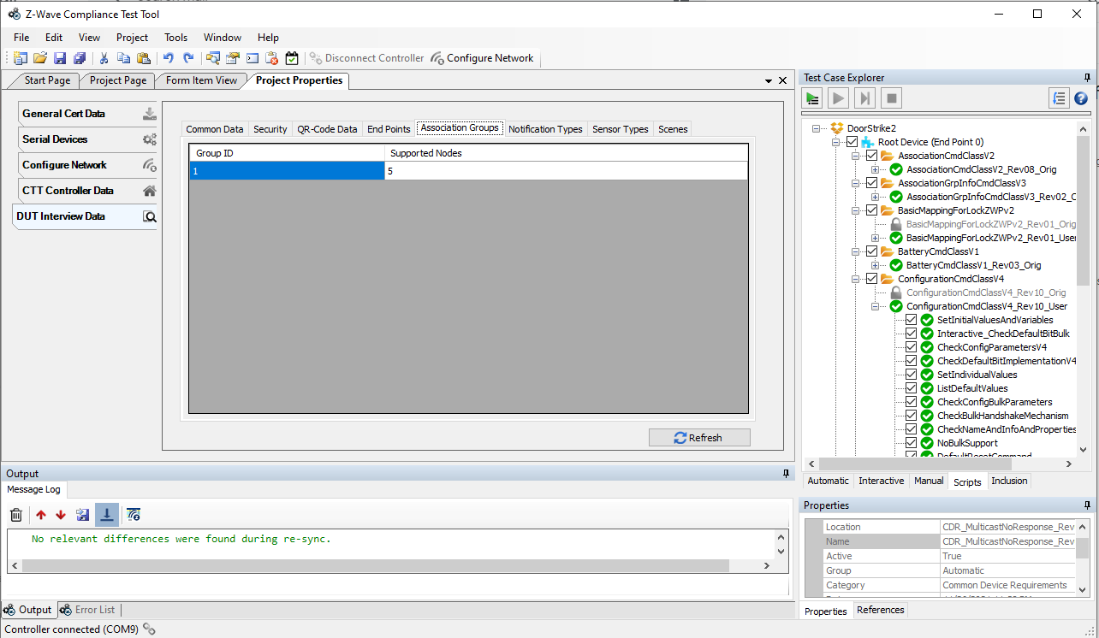

- Notification Type
