Rev. 1.0

ONU Integrated Service Router

User’s Guide

Model: NSD-G1000T

Introduction
This document describes the ONU Integrated Service Router (Model NSD-G1000T) overview and how to use Z-Wave™ functionality.

Feature Overview
The current product is a home gateway device. IoT devices such as sensors are connected and can be controlled with this
device. This device supports various interfaces for the functionalities of Wireless LAN, Bluetooth, Z-Wave™ and Mobile
networks.
The device can collect sensing data from various Z-Wave™ sensor devices, and uploading of the data to a cloud server by
wired LAN communication is available.
This product can be operated in any Z-Wave™ network with other Z-Wave™ certified devices from other manufacturers. All
mains operated nodes within the network will act as repeaters regardless of vendor to increase reliability of the network.

The ONU Integrated Service Router has the following general features:
- 4 LAN Ports
- Wireless LAN client
- Z-Wave™ communication
- Bluetooth communication

Note: The diagrams shown in this guide are for Windows® OS with Internet Explorer 8 unless otherwise specified. Your experience may vary slightly depending on your platform configuration.

Names of Product Device Parts
The top and bottom view of the product device and parts names are as follows.
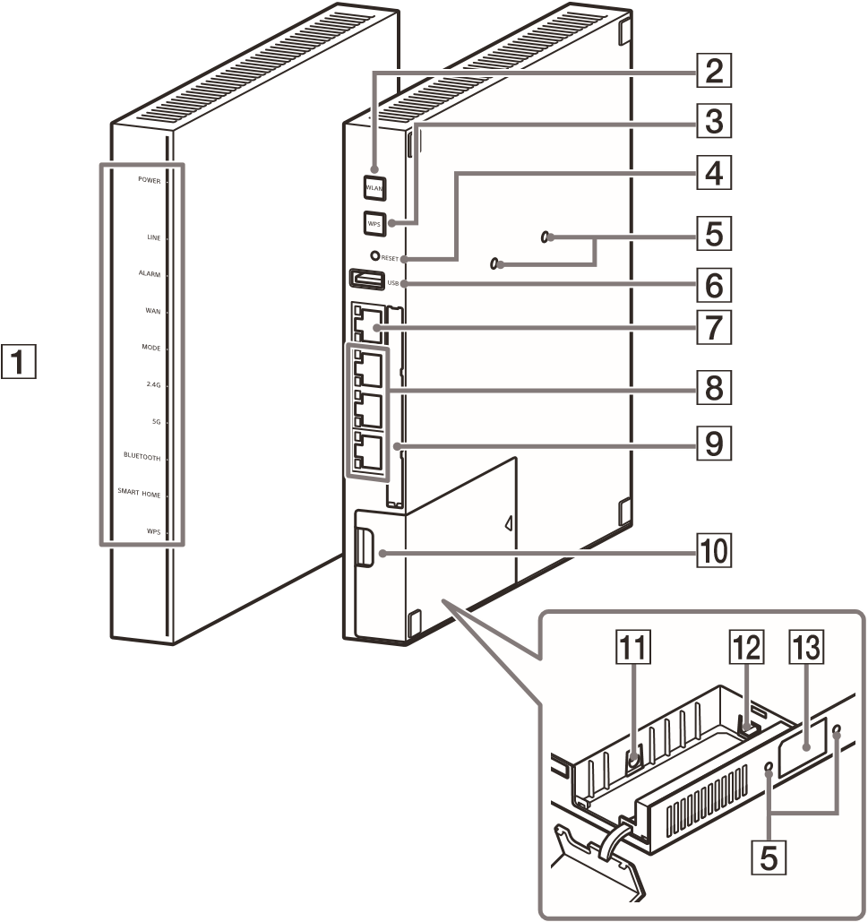
No | Part Name
1 | System Status Lamp
2 | WLAN Button
3 | WPS Button
4 | Reset Button
5 | Mounting Hole
6 | USB Port
7 | WAN Port
8 | LAN Ports
9 | LAN Plate
10 | Cover
11 | DC-IN Jack
12 | Optical Fiber Jack
13 | SSID Label

Installation
Installation of the ONU Integrated Service Router is only a one step process:
- Connect an AC adapter to the gateway and plug it into an AC outlet. The gateway has no power switch. It will begin operating as soon as it is plugged into the AC adapter/outlet.
* The Z-Wave gateway must be connected via LAN port or Wifi to the application-specific device for control, and all control is done via the URL to be described later.

LED Indication Information
System status LED/Lamp Indicator:
LED  Indicator/Lamp  Type | Lamp Color and Status | Device Status
POWER | Green Steady State | Power is on
LINE | Green Blinking | Connecting G-PON
LINE | Green Steady State | Connected G-PON
ALARM | Red Steady State | Optical fiber is disconnected
WAN | Green Steady State | Internet is connected via wired LAN
MODE | Green Steady State | G-PON mode
MODE | Red Steady State | IPoE mode
2.4G | Green Steady State | Wi-Fi(2.4GHz) is enabled
5G | Green Steady State | Wi-Fi(5GHz) is enabled
BLUETOOTH | Green Steady State | Pairing with Bluetooth
WPS | Red Blinking | Pairing with WPS
WPS | Red Steady State | Pairing was successful

ONU Settings
This unit supports multi-language. It also supports GPON and IPoE as communication modes.
The following settings must be made at first startup.

Log in from the following URL set in this instrument.

URL: 192.168.1.1
Username: admin
Password: Key (WPA) listed on the side of the device.

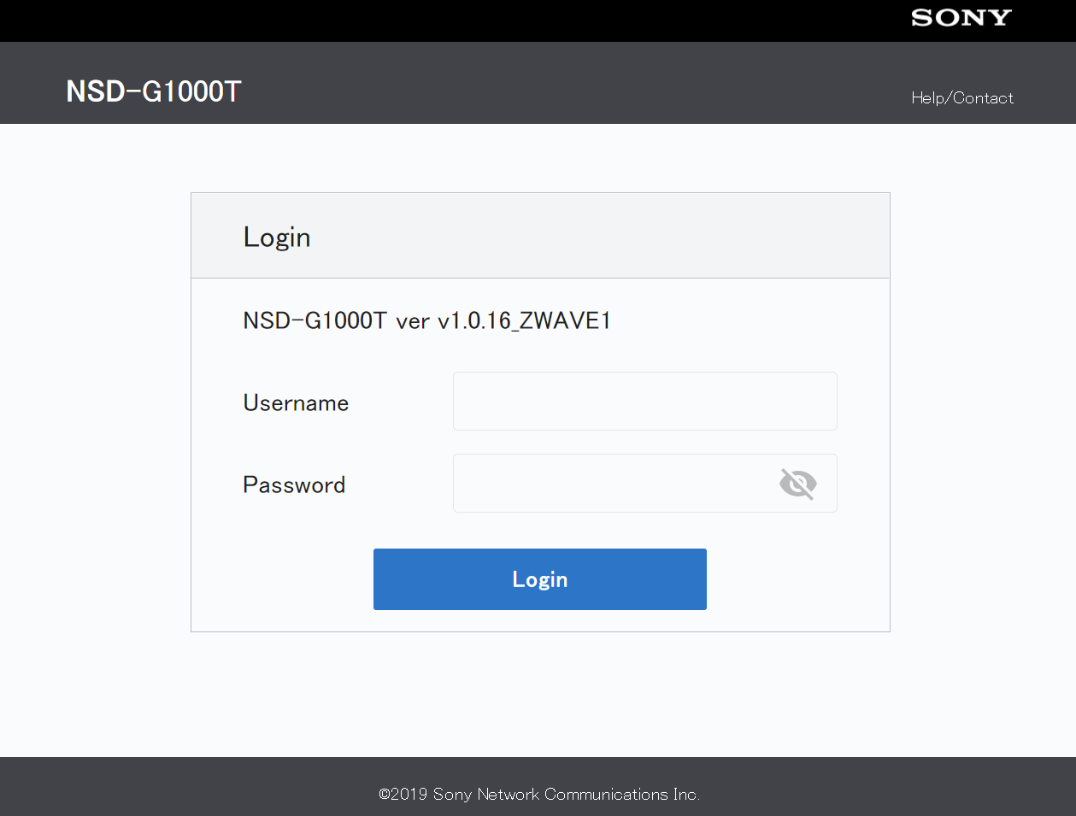
Figure 1 : NSD-G1000T Login Page

Language Selection

If the language is set to Japanese, press the Basic Settings button to switch to the Settings screen.
Select "English" from "Language" and press the Apply button.

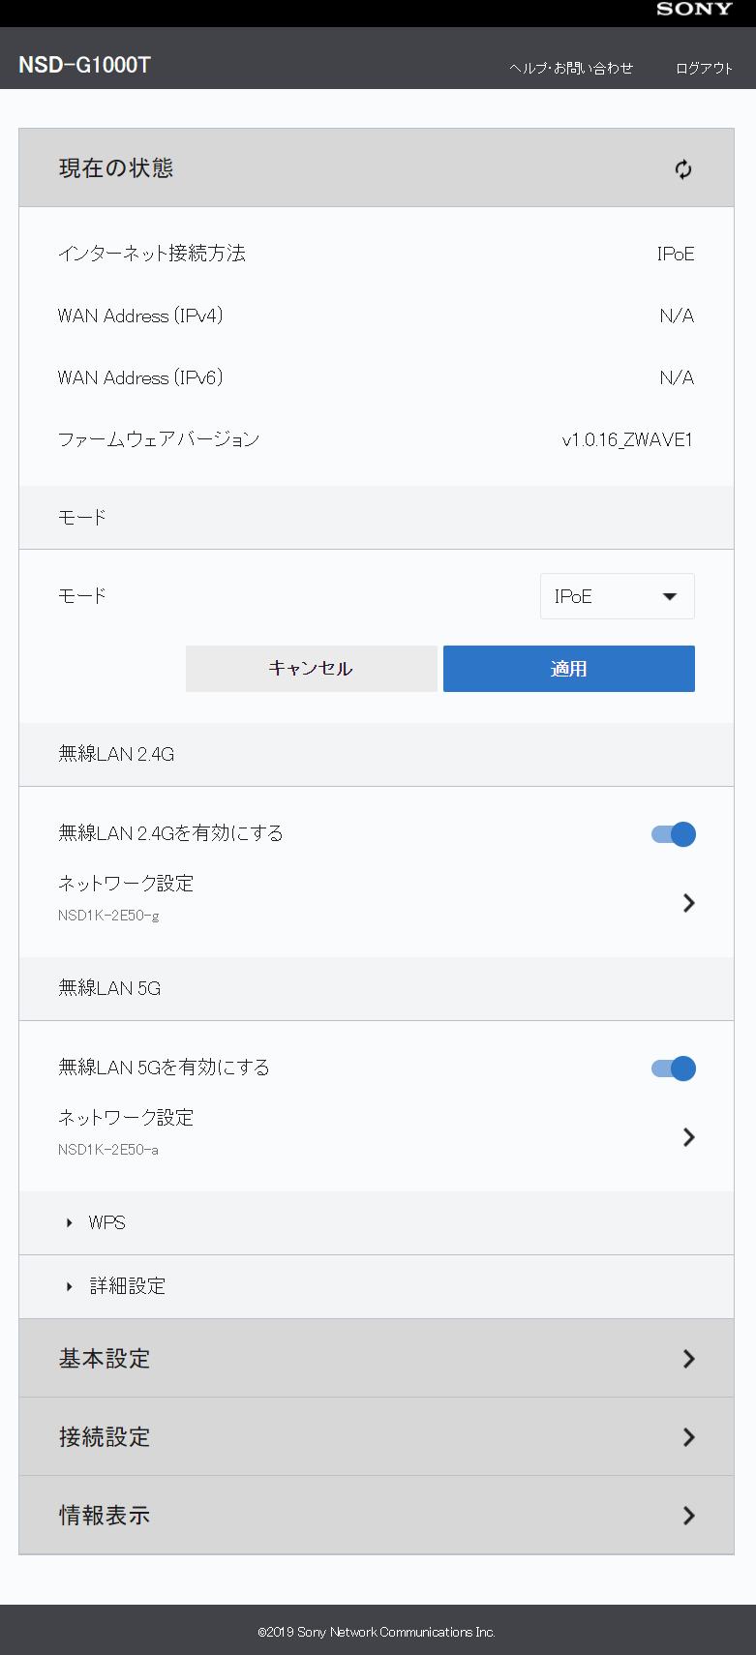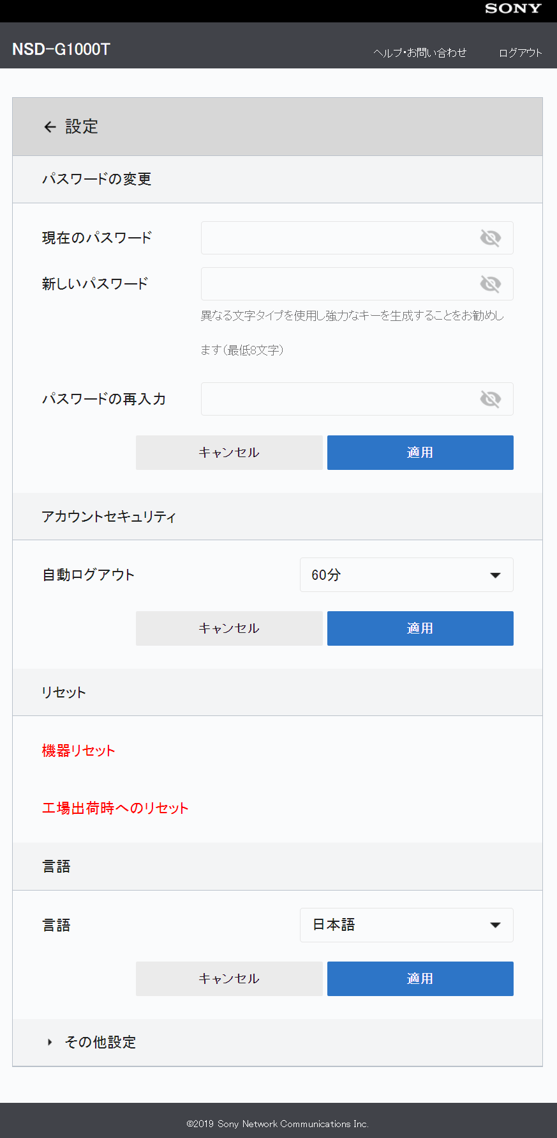
Figure 2 : NSD-G1000T Select Language

Router Mode Selection

If the mode is set to "GPON", change it to "IPoE" and press the Apply button.

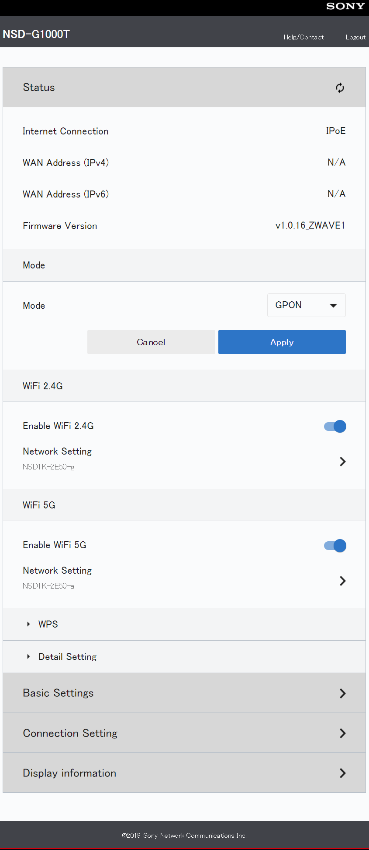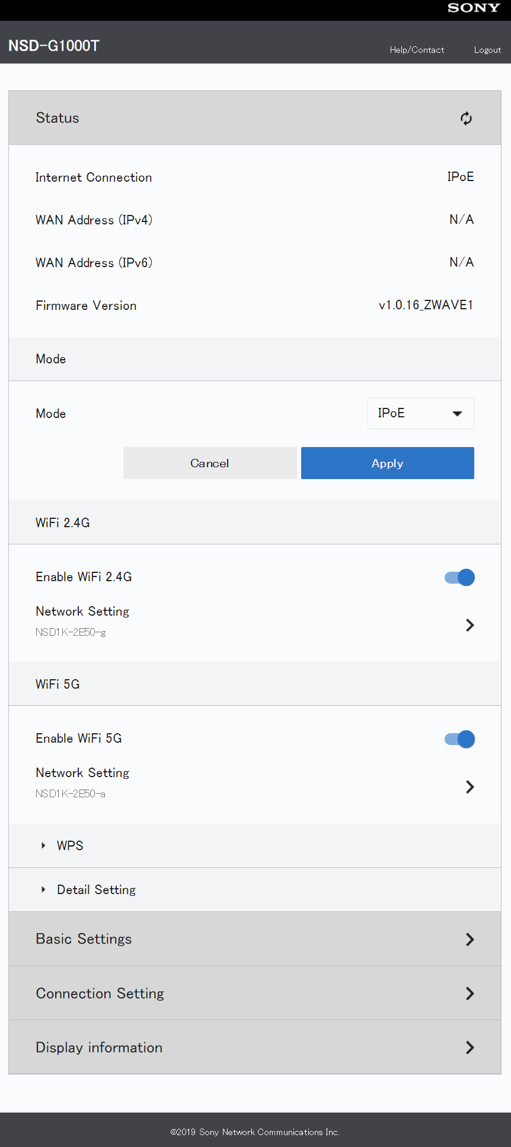
Figure 3 : NSD-G1000T Select Mode

The device is reset when the mode is changed. (You will need to wait a few tens of seconds.)
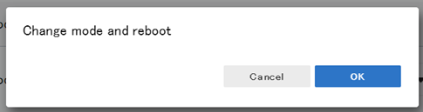
Figure 4 : NSD-G1000T Confirmation message(reboot)

Factory Reset

The following procedure is required to restore the Z-Wave status to the factory defaults.

Display the "Settings" screen and press "Factory Reset".
Press the "OK" button when the confirmation screen is displayed. （Press the "OK" button (all functions of the ONU will be initialized).
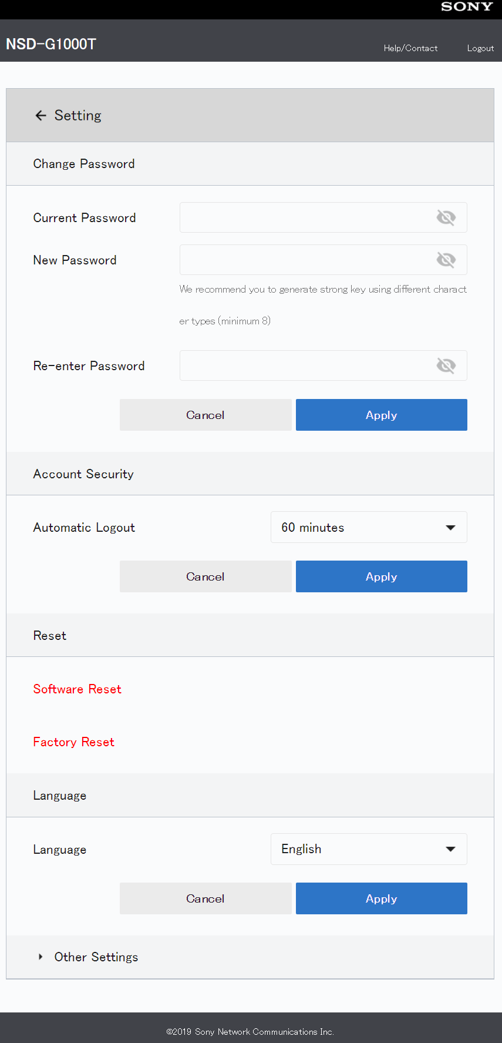
Figure 5 : NSD-G1000T Setting(Factory Reset)
The device is reset when the mode is changed. (You will need to wait a few tens of seconds.)
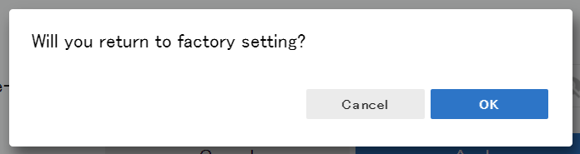
Figure 6 : NSD-G1000T Confirmation message(Factory Reset)

NOTE: If the LAN1 connector was used in IPoE mode, unplug the LAN1 cable.
When a factory reset is performed, the device enters GPON mode, so if LAN1 is still connected, the IP address of the device may not be set to "192.168.1.1".
Be sure to change the mode of LAN1 cable to IPoE mode again before plugging it in.
Z-Wave Overview
General Information
Device Type Gateway
Role Type Central Static Controller (CSC)
Product Type General Z-Wave Plus™ v2 Product

Command Class Support
CC | Version | Required Security classes
COMMAND_CLASS_APPLICATION_STATUS | 1 | None
COMMAND_CLASS_ASSOCIATION | 2 | None
COMMAND_CLASS_ASSOCIATION_GRP_INFO | 3 | None
COMMAND_CLASS_CRC_16_ENCAP | 1 | None
COMMAND_CLASS_DEVICE_RESET_LOCALLY | 1 | None
COMMAND_CLASS_ MULTICHANNEL_ASSOCIATI ON | 3 | None
COMMAND_CLASS_MANUFACTURER_SPECIFIC | 2 | Highest granted security class
COMMAND_CLASS_POWERLEVEL | 1 | Highest granted security class
COMMAND_CLASS_SECURITY * | 1 | None
COMMAND_CLASS_SECURITY_2 | 1 | None
COMMAND_CLASS_VERSION | 2 | Highest granted security class
COMMAND_CLASS_ZWAVEPLUS_INFO | 2 | None
COMMAND_CLASS_FIRMWARE_UPDATE_MD * | 5 | Highest granted security class
COMMAND_CLASS_INCLUSION_CONTROLLER | 1 | None
COMMAND_CLASS_INDICATOR | 3 | Highest granted security class
COMMAND_CLASS_MAILBOX | 2 | LAN-side only
COMMAND_CLASS_MULTI_CMD | 1 | None
COMMAND_CLASS_NODE_PROVISIONING * | 1 | Access Control, only when SIS
COMMAND_CLASS_NW_MGMT_BASIC * | 2 | Highest granted security class
COMMAND_CLASS_ NW_MGMT_INCLUSION * | 3 | Highest granted security class
COMMAND_CLASS_ NW_MGMT_PROXY * | 2 | Highest granted security class
COMMAND_CLASS_ SUPERVISION | 1 | None
COMMAND_CLASS_ TRANSPORT_SERVICE | 2 | None
COMMAND_CLASS_ TIME | 1 | None
COMMAND_CLASS_ ZIP | 4 | LAN-side only
COMMAND_CLASS_ ZIP GATEWAY | 1 | LAN-side only
COMMAND_CLASS_ ZIP_ND | 2 | LAN-side only
COMMAND_CLASS_ ZIP PORTAL | 1 | LAN-side only
COMMAND_CLASS_ ZWAVEPLUS_INFO | 2 | None
*Removed if included non-securely:
• 0x98 - COMMAND_CLASS_SECURITY
• 0x7A - COMMAND_CLASS_FIRMWARE_UPDATE_MD
• 0x34 - COMMAND_CLASS_NETWORK_MANAGEMENT_INCLUSION
• 0x52 - COMMAND_CLASS_NETWORK_MANAGEMENT_PROXY
• 0x4D - COMMAND_CLASS_NETWORK_MANAGEMENT_BASIC
• 0x67 - COMMAND_CLASS_NETWORK_MANAGEMENT_INSTALLATION_MAINTENANCE

*Only available on S2_Access level, only when DUT is SIS:
• 0x78 - COMMAND_CLASS_NODE_PROVISIONING

Control
CC | Version | CC | Version
ANTITHEFT UNLOCK | 1 | NW_MGMT_PROXY | 2
APPLICATION_STATUS | 1 | POWERLEVEL | 1
ASSOCIATION | 2 | NOTIFICATION/ALARM | 8
ASSOCIATION_CMD_CFG | 1 | NW_MGMT_BASIC | 2
ASSOCIATION_GRP_INFO | 3 | NW_MGMT_INCLUSION | 3
BASIC | 2 | SECURITY | 1
BATTERY | 3 | SECURITY_2 | 1
CENTRAL_SCENE | 3 | SENSOR_MULTILEVEL | 11
CLOCK | 1 | SENSOR_ALARM | 1
CONFIGURATION | 4 | SENSOR_BINARY | 2
CRC16_ENCAP | 1 | SUPERVISION | 1
DEVICE_RESET_LOCALLY | 1 | SWITCH_ALL | 1
DOOR_LOCK | 2 | SWITCH_BINARY | 2
FIRMWARE_UPDATE_MD | 5 | SWITCH_MULTILEVEL | 4
INDICATOR | 3 | TIME | 1
MANUFACTURER_SPECIFIC | 2 | VERSION | 2
METER | 5 | WAKE_UP | 2
MULTI_CHANNEL | 4 | ZIP | 4
MULTI_CHANNEL_ASSOCIATION | 3 | ZIP_GATEWAY | 1
MULTI_CMD | 1 | ZIP_ND | 2
NO_OPERATION | 1 | ZIP_PORTAL | 1
NODE_NAMING | 1 | ZWAVEPLUS_INFO | 2
NODE_PROVISIONING | 1 | TRANSPORT_SERVICE | 2

Support for Association Command Class
Group id: 1 – Lifeline
Maximum number of devices that can be added to the group: 1
All devices are associated with the group.

NOTE: This product can be operated in any Z-Wave network with other Z-Wave certified devices from other manufacturers. All mains operated nodes and non-battery operated nodes within the network will act as repeaters regardless of vendor to increase reliability of the network.

Installation Guide
To connect and control a Z-Wave compliant device to the ONU, the following steps are required.

(1) Confirm that the ONU (NSD-G1000T) is connected via USB to a small computer with built-in portal function attached to the ONU.
(2) Connect the ONU to the power supply and wait for about 3 minutes after startup.
(3) Confirm that the ONU's Wifi (2.5G) is available, and make a Wifi connection to the ONU with a PC or other device.
After that, confirm that the connection to the portal site is available according to the instruction manual.

Note: If a factory reset of the ONU is performed, the Wifi 2.5G band channels must be masked 12 and 13.

======================================================================================

How to boot and reset Z-Wave

Start
When power is supplied to the device and the router starts up, the Z-Wave chip will also start up automatically.

Reset
You will need to reboot the device.

Note: You can also reset the gateway from the control portal site described below.

How to control a Z-Wave device

The NSD-G1000T is equipped with functions to control Z-Wave gateways and various compatible devices.
Please follow the steps described below to open the control page.

- After starting NSD-G1000T, access the following URL from your PC.
URL:192.168.1.33

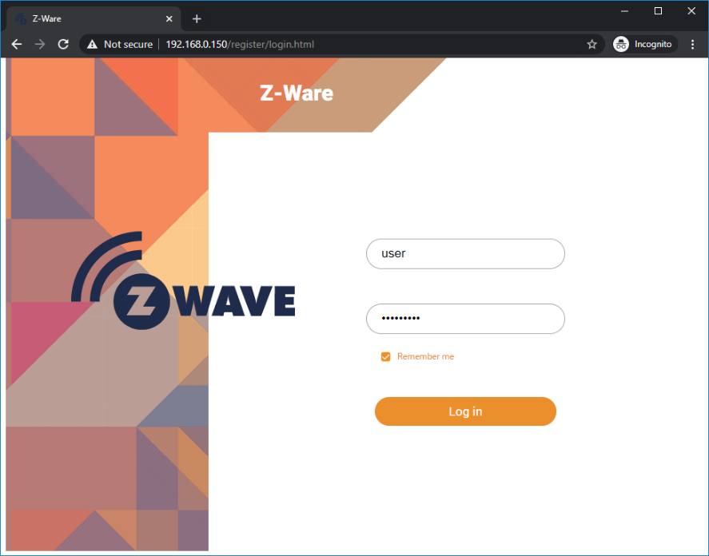
Figure 7 : Login Page

When the login screen appears, enter your ID and PASSWORD, then click the Login button to display the main screen.

ID : user
Password : smarthome

Note: The control server device and NSD-G1000T are connected via Wifi. After power-on, please wait a few minutes for the startup process and the connection between the NSD-G1000T and the network to be established.

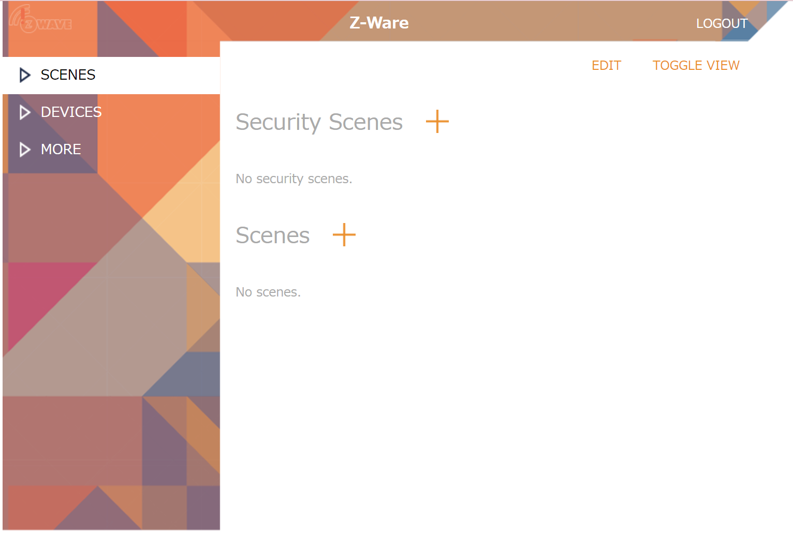
Figure 8 : Main Page

- After successfully logging in, you will be taken to the main (menu) screen.
- Setting up Gateway

On the [MORE]->[SETTINGS] screen, select the Gateway to be connected, enter the following information, and press the [INITIALIZE] button.

Choose Gateway : 192.168.1.4 (Please make selections as needed.)
Unsolicited Port : 41234
Secure Connection : Yes
Pre-shared Key : 123456789012345678901234567890AA
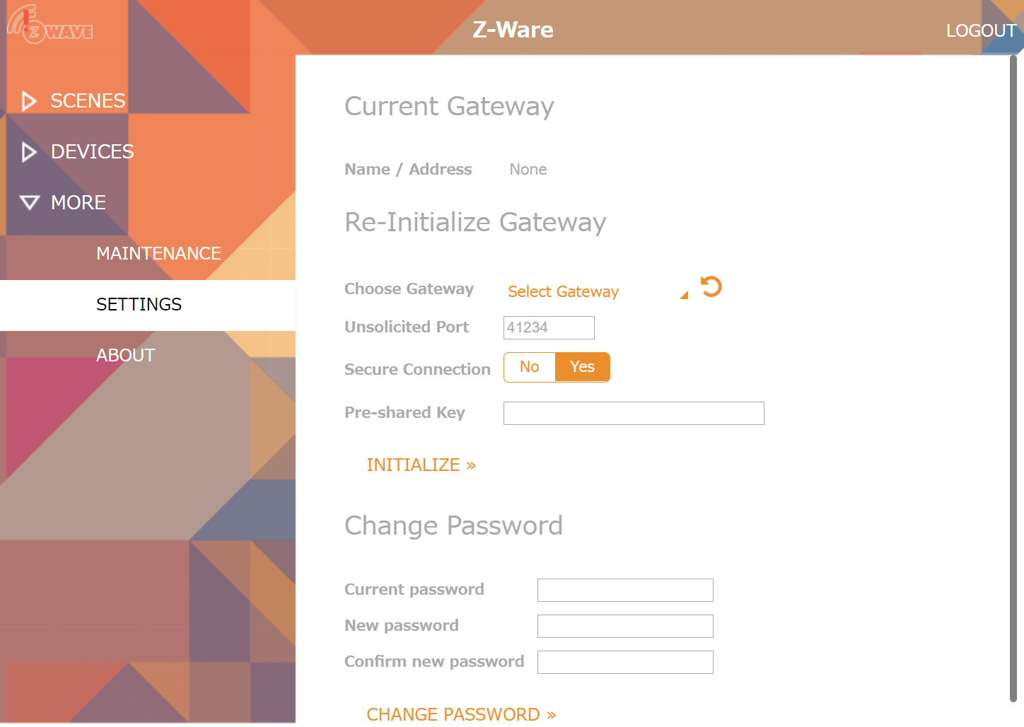
Figure 9 : Settings Page (Before selection)
Note: Normally, when you open this page, the "Choose Gateway" field will show the discovered gateway and allow you to select it, but if not, press the reload button to the right of the field to make the gateway selectable.

3.1 If the connection with the Gateway is successful, the "Name/Address" and "Unsolicited Port" of the connected Gateway will be displayed in the Current Gateway display area.
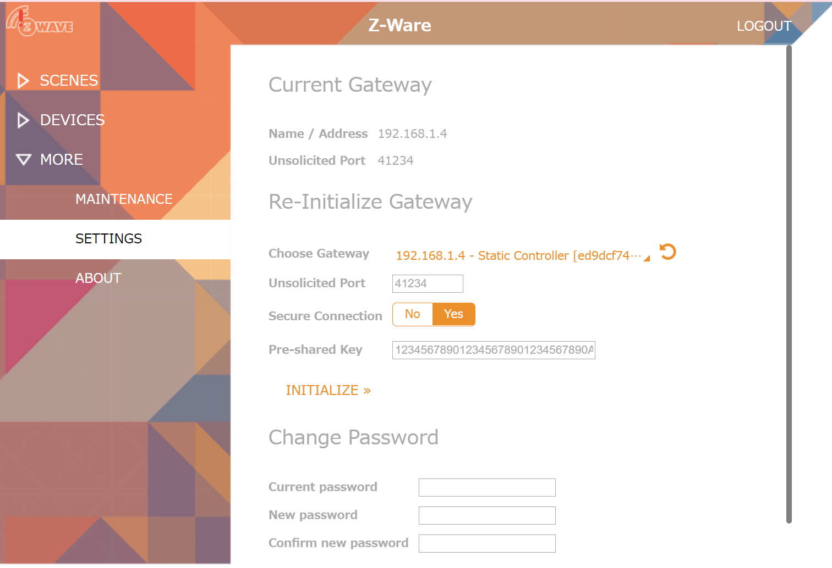
Figure 10 : Settings Page (After setup)

3.2 If you are correctly connected to the Gateway, you can check the Gateway and network status by pressing ABOUT on the left side of the screen.
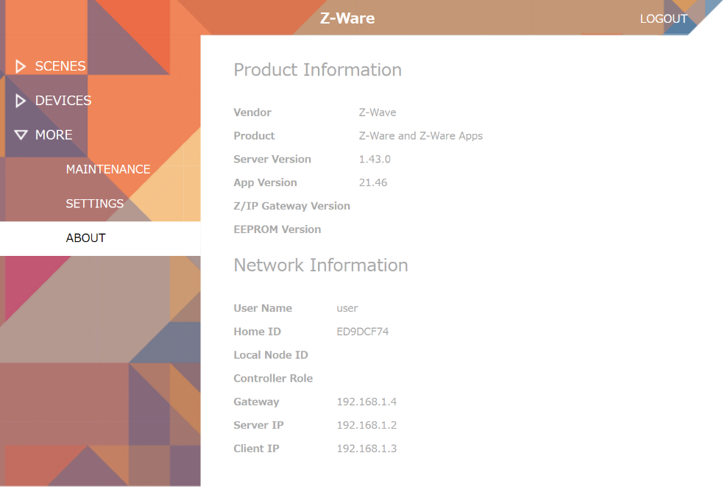

Figure 11 : ABOUT Page

Various Gateway settings can be changed by selecting "Z/IP GATEWAY" on the "MAINTENANCE" page. After changing the necessary items, press "UPDATE ADDRESS" or "UPDATE ADDRESS TO LOCAL" to apply the changes.
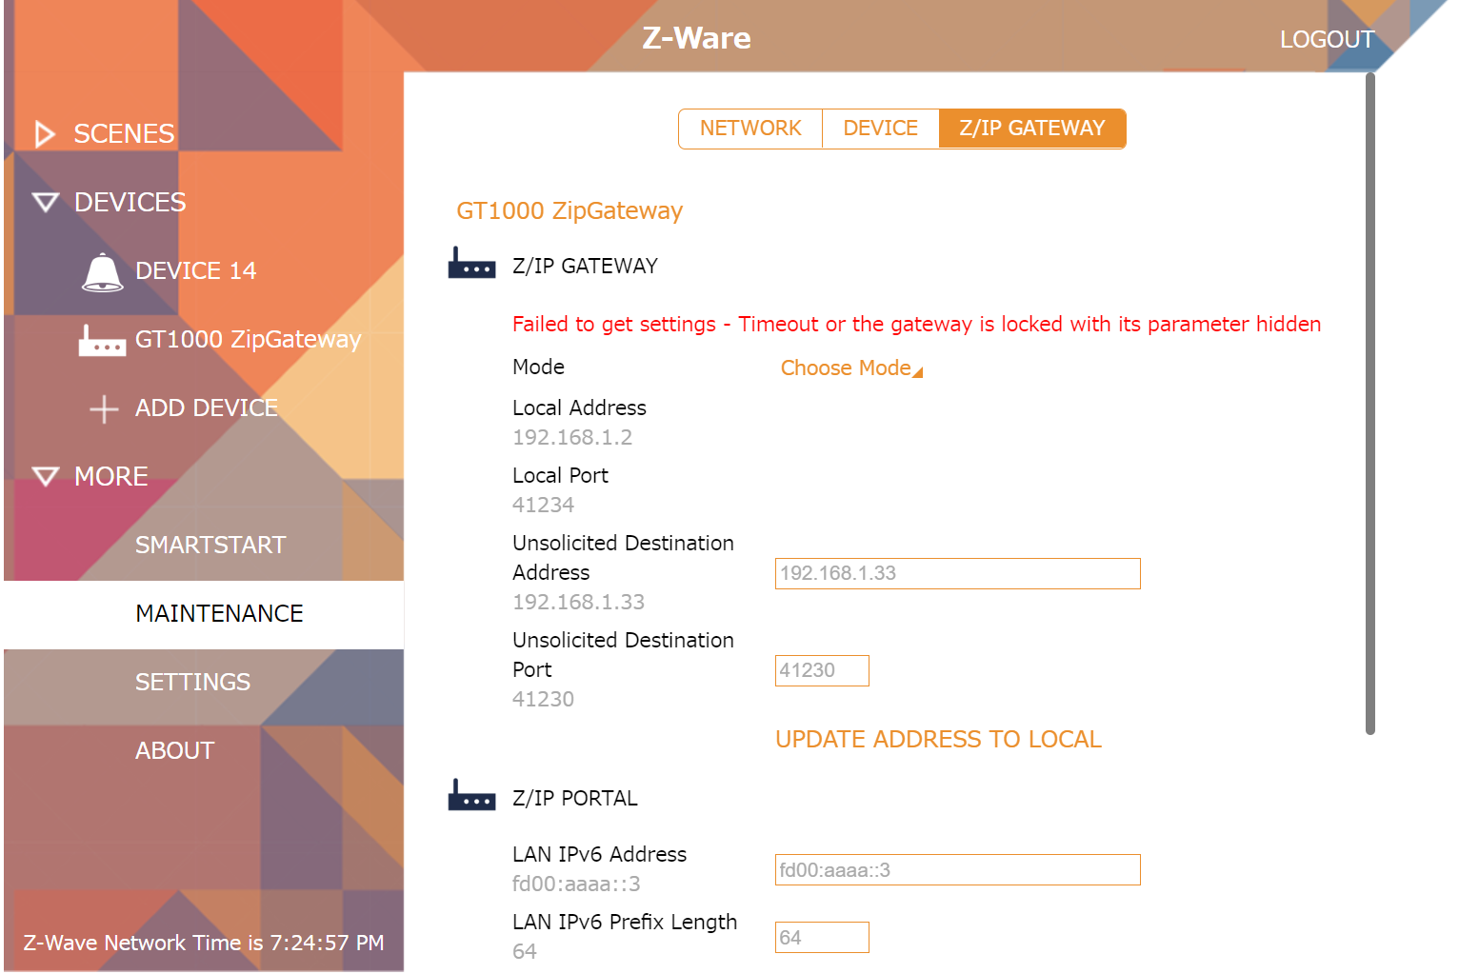
Figure 12 : MAINTENANCE(Z/IP GATEWAY) Page

- How to add and remove various devices.

The ‘Maintenance’ page under the ‘More’ menu supports advanced network functions under the network tab. Use the functions on this page to add and remove various devices.
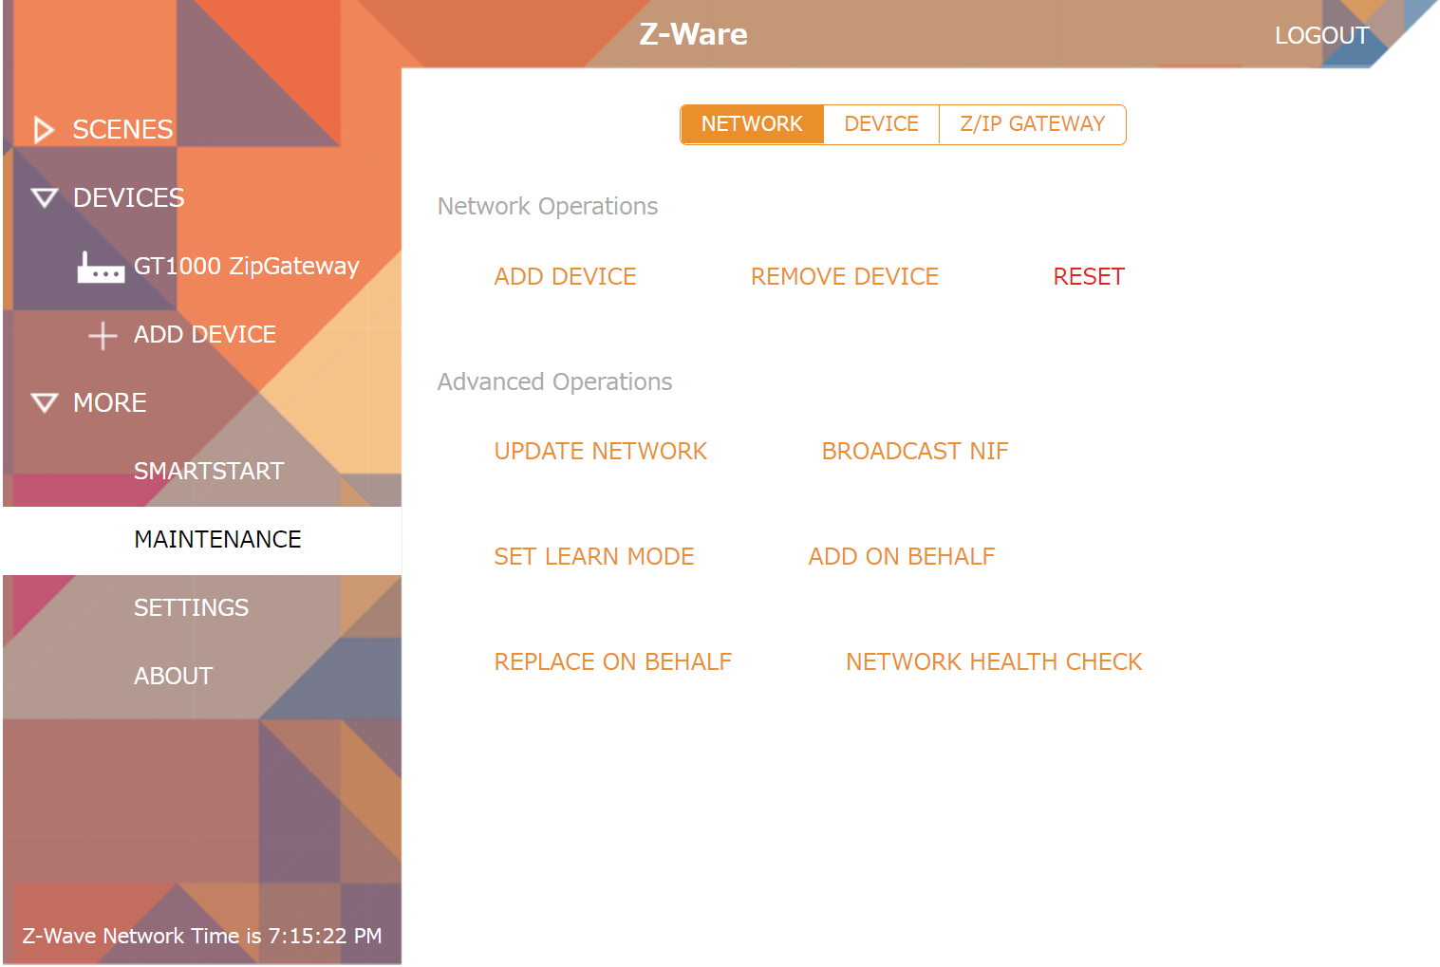
Figure 13 : Tab UI – Maintenance (Network)

Inclusion (Add) Select ADD DEVICE to start device inclusion.
Exclusion (Remove) Select REMOVE DEVICE to start device exclusion.
RESET Select RESET to restore factory default settings.
If this controller is the primary controller for your network, resetting it will result in the nodes in your network being orphaned and it will be necessary after the reset to exclude and re-include all of the nodes in the network. If this controller is being used as a secondary controller in the network, use this procedure to reset this controller only in the event that the network primary controller is missing or otherwise inoperable.

This is the Z-Wave include/exclude network operation for non-SmartStart devices. Native apps can also scan the QR code on the device. Devices are automatically named if not previously named in the Node Naming CC. Users may rename them at this point as well.

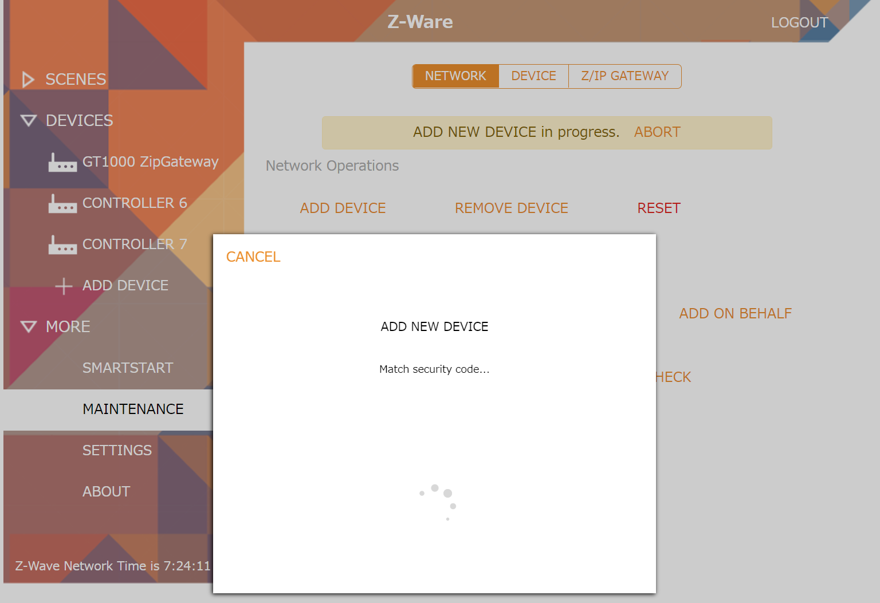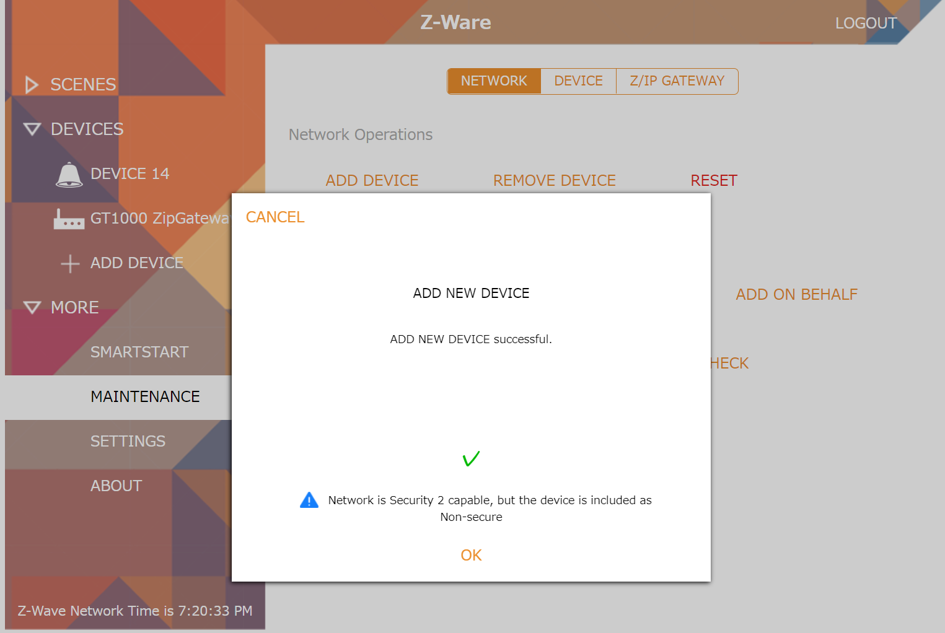
Figure 14 : Tab UI - Add New Device: Initiate
Note: Adding a device may take several tens of seconds. It may also take several retries to succeed.
With Z-Wave Security 2, users need to accept or modify the security class settings. Only users who are very familiar with Z-Wave Security 2 should attempt to change the security class settings.

Note: While this operation can be aborted at any time with ‘Cancel’, it is a compound operation that may perform secure bootstrapping and elaborate device discovery after a normal Z-Wave inclusion. Therefore, after abort, the device may still be included but insecurely or with interfaces undiscovered.

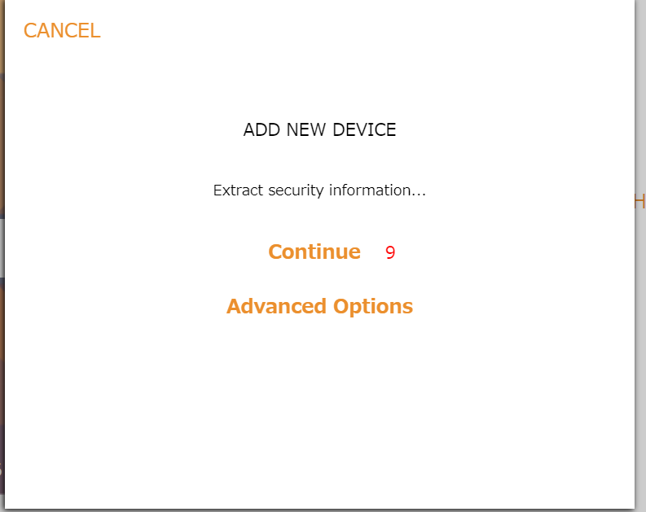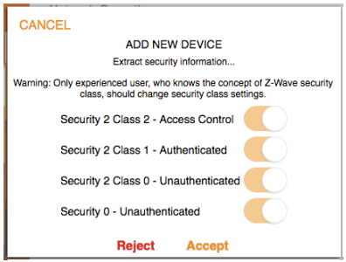
Figure 15 : Tab UI - Add New Device: Advanced Options and Grant Keys

Additionally, for Security 2 Class 1 and 2 devices, key in the 1st 5 digits of the DSK, unless it is scanned in the Native Apps.

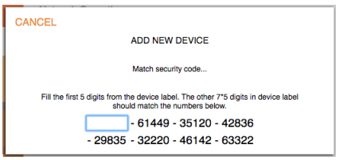
Figure 16 : Tab UI - Add New Device: DSK

With CSA (Client Side Authentication), input the controller’s DSK on the device being included instead.

Update Network
This rediscovers and updates all devices in the network.

Set Learn Mode
This performs the Z-Wave Set Learn Mode network operation. To complete an S2 inclusion, the DSK may need to be entered on the including Controller

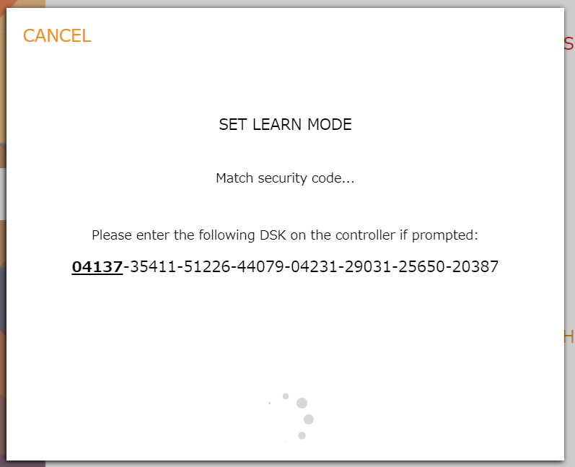
Figure 17 : Tab UI – Set Learn Mode

Note:In this operation, the DSK of this device (ONU) is displayed on the screen.

Remove/Replace Failed Devices
This is a Z-Wave network function on failed devices. It pops up a list of devices belonging to failed nodes for removal or replacement. As with most network operations, it can be aborted. For Replace Failed Node on Security 2 devices, additional pop ups, such as Add Node will appear.

Update Device
This rediscovers and updates the device

Identify
The “Indicator-Identify” command can be used to identify the controller with the Indicator ID 0x50 or any node that supports the Identify command. The “Indicator-Set” command can be used to send specific indicating parameters to a node.
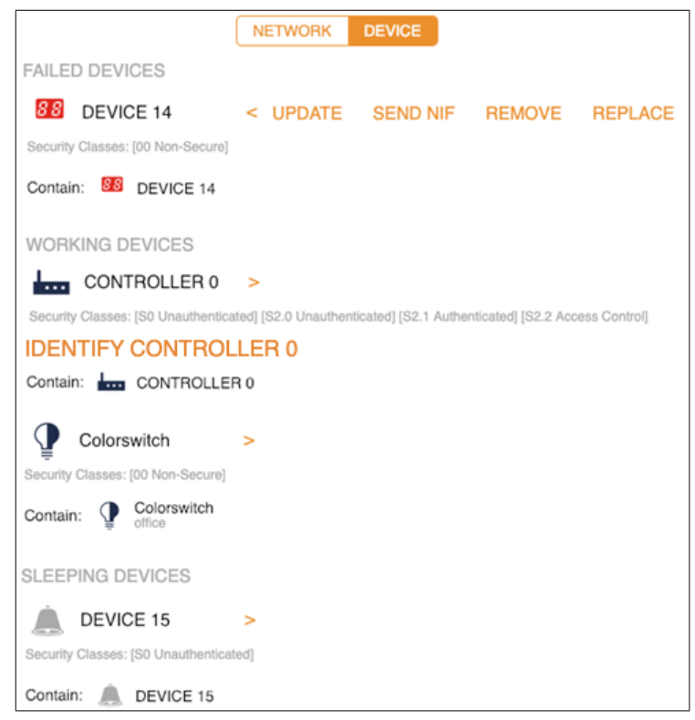
Figure 18 : Tab UI – Maintenance (Device)

- DEVICE

Users control and monitor individual devices using the Devices menu. Clicking on the devices tab lists devices in the network. Z-Wave Inclusion is supported through the ‘+ Add Device’ link. This is also accessible through the ‘More’ menu and is described there. Clicking a device lists its interfaces on the larger right panel. The name and location can be changed. The battery status, if available, will be shown.

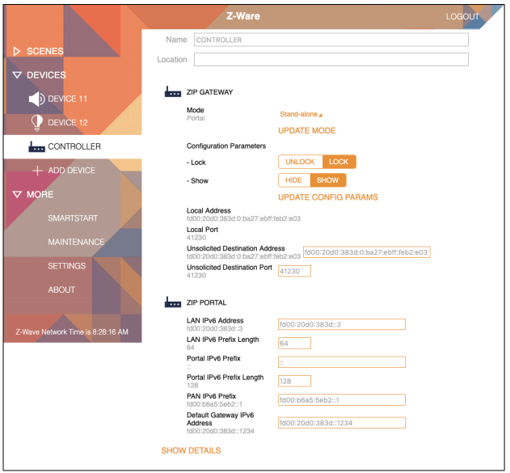
Figure 19 : Tab UI - Devices

The figure above shows the attached controller device page which allows setting the ZIP Gateway and Portal settings. ‘Show/Hide Details’ will toggle between showing and hiding the Z-Wave Node ID, multichannel endpoint number, product information, software versions, CC versions, and other interfaces that are not graphically represented for easy access. Similarly, Configuration, Firmware Update, Association and Wakeup Interfaces, if available on the device, can be found here.

Note: This product does not support Wake Up Command Class. Only control can be performed.

Initiate Controller Replication

In the event that the gateway is already the controller of the Z-Wave™ network, put the gateway into Inclusion Mode, and put another controller into the Learn Mode. The Replication will begin and network information will be sent to another controller. In the event that the gateway is integrated into an existing Z-Wave™ network, put the gateway into Learn Mode, and put the existing controller into Inclusion Mode.
The Replication will begin and network information will be received from the existing controller.

