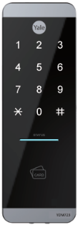


MUST READ
- SmartStart enabled products can be added into a Z-Wave network by scanning
the Z-Wave QR Code present on the product with a controller providing SmartStart
inclusion. No further action is required and the SmartStart product will be added
automatically within 10 minutes of being switched on in the network vicinity.

- This Product can be included and operated in any Z-Wave network with other
Z-wave certified devices from other manufacturers and/or other applications.
All non-battery operated nodes within the network will act as repeaters regardless of vendor to increase reliability of the network.

- This product (YDM723 Z7) is a Security Enabled Z-Wave Plus v2 Product.

- Security Enabled Z-wave Controller must be used in order to fully utilize
this product.

- Network Module Setting : This setting becomes available through the Main Menu
and allows the lock to connect with Controllers.
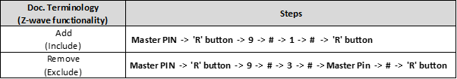

If prompted, scan QR code
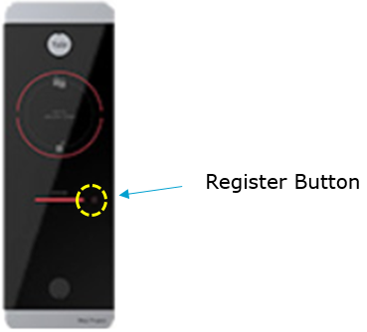
- QR code location
- 1ea on manual
- 2ea in polybag
- 1ea on side of external body
Association Command Class

※ Association Group
- This product supports ONE association Group.
- Group is the Lifeline Group.
- Yale locks support only one group, which can contain up to 5 nodes

※ S2 Security Command Class and security level

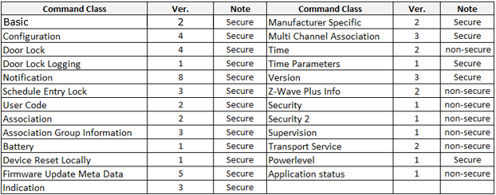

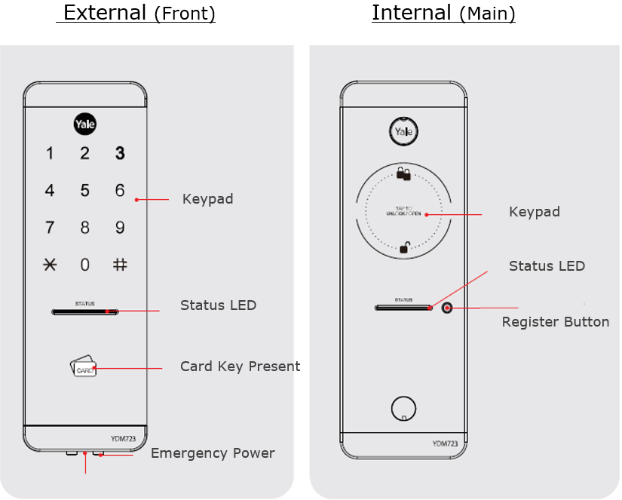

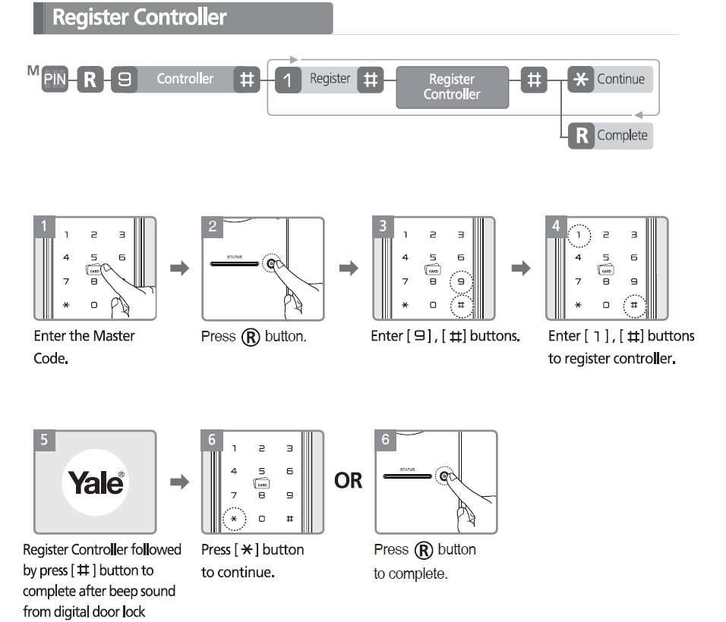

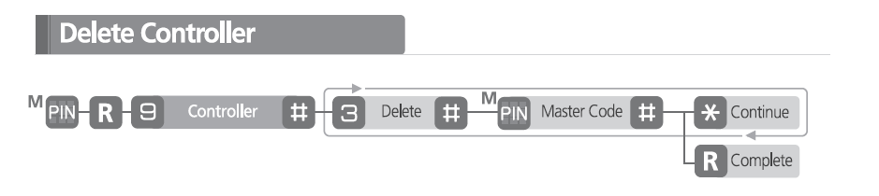

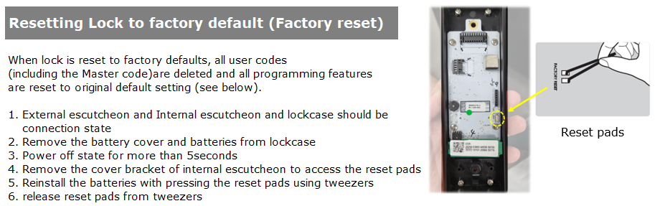
Function | UI
Set Advanced(Master)Code after Factory  reset  No registered Advanced(Master) Code |  | 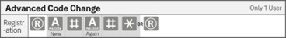
Change  Advanced(Master) Code |  | 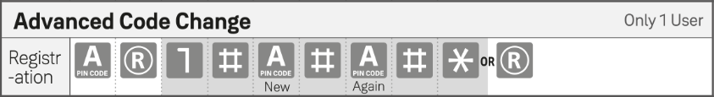
Registration  User Code | 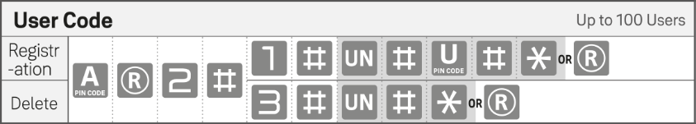
Registration  Onetime Code | 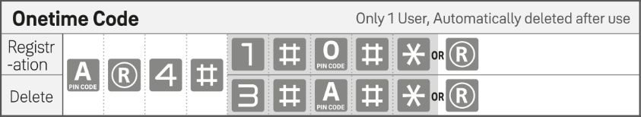
Registration  RFID Key Tag  (RFID Key Tag Only) | 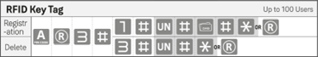
Delete all credentials and Pincode | 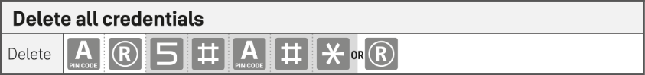
Set  Automatic Lock | 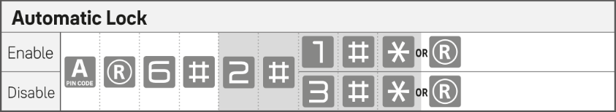
Set  Volume Control | 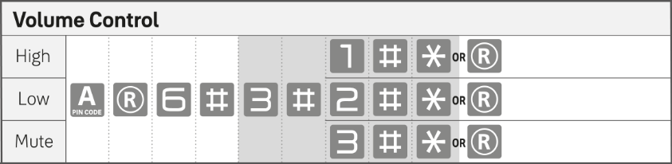

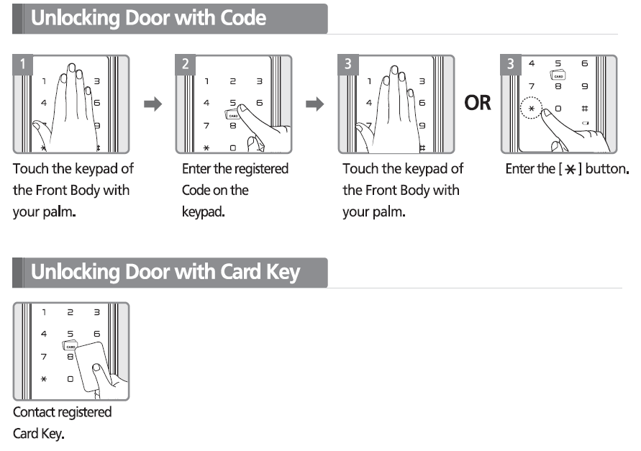

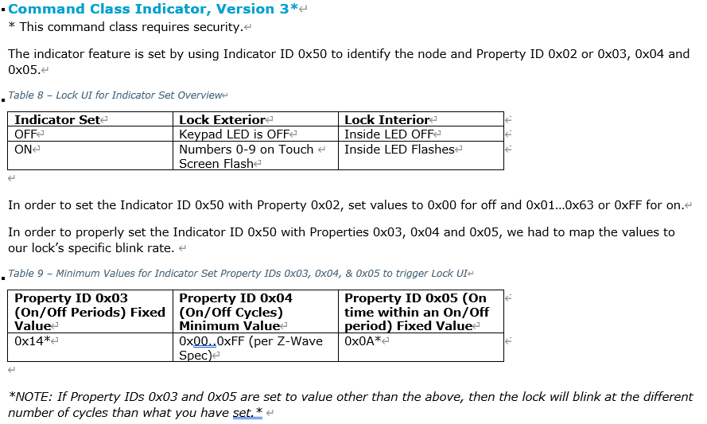

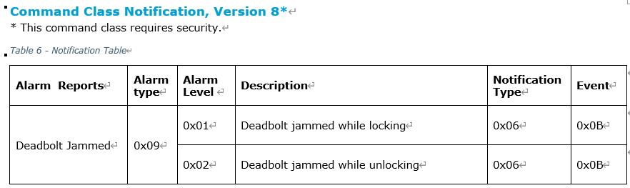
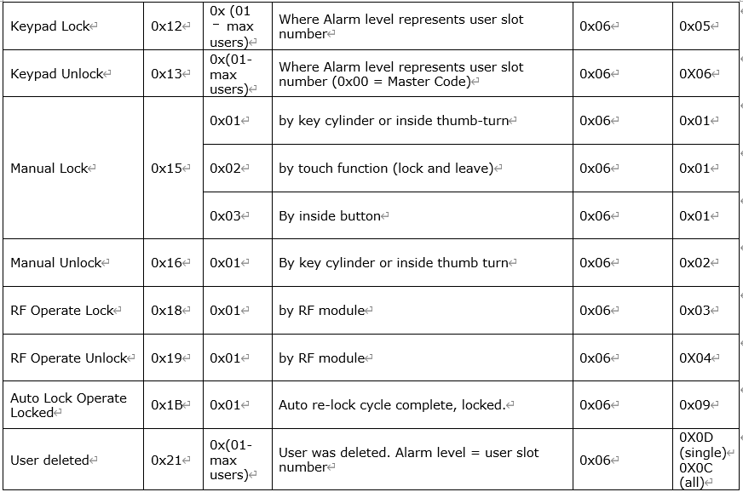
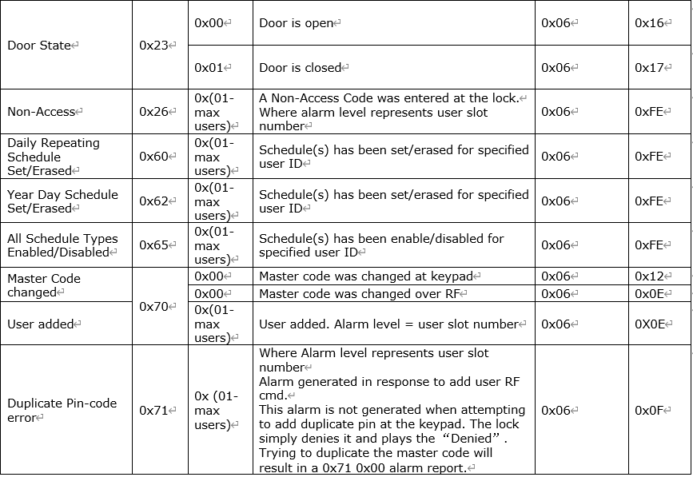
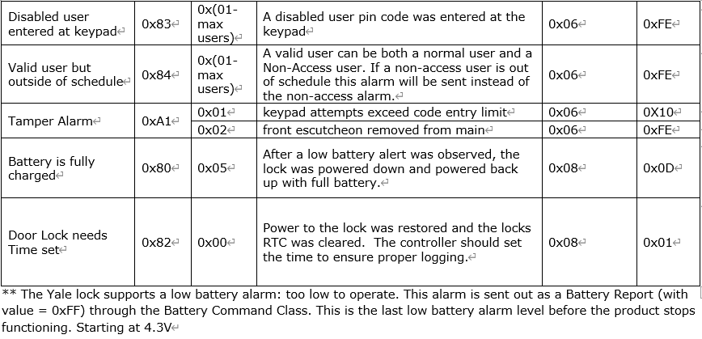

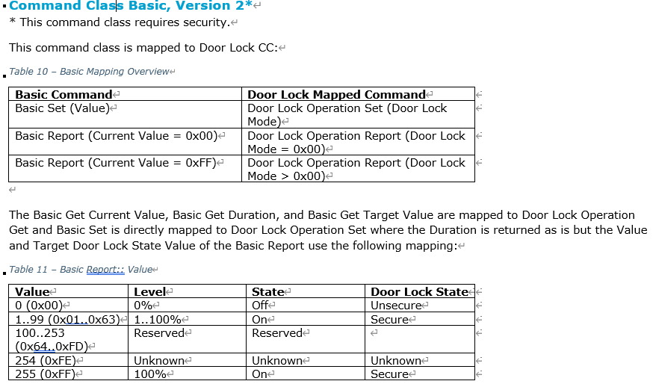

Command Class Configuration, Version 4*
Parameter Number: 0x01
Name: Volume
Info: Set Volume Level to high (3), low (2), or silent (1).
Format: 0x00
Size: 1 Byte;
Min Value: 0x01
Max Value: 0x03
Default Value: 0x03

Parameter Number: 0x02
Name: Auto Relock
Info: Set Auto Relock feature to enable or disable.
Format: 0x01
Size: 1 Byte;
Min Value: 0x00
Max Value: 0xFF
Default Value: 0xFF

Command Class Security 2, Version 1
This command class has been implemented per the Z-Wave Specification.


Warning: Changes or modiﬁcations to this device, not expressly approved by ASSA ABLOY Residential Group could void the user's authority to operate the equipment.

This device is a security enabled Z-Wave Plus v2 product that is able to use encrypted Z-Wave Plus v2 messages to communicate to other security enabled Z-Wave Plus v2 products. This device must be used in conjunction with a Security Enabled Z-Wave Controller in order to fully utilize all implemented functions. This product can be operated in any Z-Wave network with other Z-Wave certiﬁed devices from other manufacturers. All non-battery operated nodes within the network will act as repeaters regardless of vendor to increase reliability of the network.

FCC:
Class B Equipment
This equipment has been tested and found to comply with the limits for a Class B digital device, pursuant to Part 15 of the FCC Rules. These limits are designed to provide reasonable protection against harmful interference in a residential installation. This equipment generates, uses, and can radiate radio frequency energy and, if not installed and used in accordance with the instructions, may cause harmful interference to radio communications. However, there is no guarantee that interference will not occur in a particular installation. If this equipment does cause harmful Interference to radio or television reception, which can be determined by turning the equipment off and on, the user is encouraged to try to correct the interference by one or more of the following measures:

- Reorient or relocate the receiving antenna.
- Increase the separation between the equipment and receiver.
- Connect the equipment into an outlet on a circuit different from that to which the receiver is connected.
- Consult the dealer or an experienced radio/TV technician for help.

THIS DEVICE COMPLIES WITH PART 15 OF THE FCC RULES. OPERATION IS SUBJECT TO THE FOLLOWING TWO CONDITIONS. (1) THIS DEVICE MAY NOT CAUSE HARMFUL INTERFERENCE, AND (2) THIS DEVICE MUST ACCEPT ANY INTERFERENCE RECEIVED, INCLUDING INTERFERENCE THAT MAY CAUSE UNDESIRED OPERATION.

This equipment complies with FCC radiation exposure limits set forth for an uncontrolled environment. This equipment should be installed and operated with minimum distance 20cm between the radiator & your body.

Industry Canada:

Section 7.1.2 of RSS-GEN Under Industry Canada regulations, this radio transmitter may only operate using an antenna of a type and maximum (or lesser) gain approved for the transmitter by Industry Canada. To reduce potential radio interference to other users, the antenna type and its gain should be so chosen that the equivalent isotropically radiated power (e.i.r.p.) is not more than that necessary for successful communication.
En vertu des règlements d'Industrie Canada, cet émetteur radio ne peut fonctionner avec une antenne d'un type et un maximum (ou moins) approuvés pour gagner de l'émetteur par Industrie Canada. Pour réduire le risque d'interférence aux autres utilisateurs, le type d'antenne et son gain doivent être choisies de façon que la puissance isotrope rayonnée équivalente (PIRE) ne dépasse pas ce qui est nécessaire pour une communication réussie.

Section 7.1.3 of RSS-GEN This Device complies with Industry Canada License-exempt RSS standard(s). Operation is subject to the following two conditions: 1) this device may not cause interference, and 2) this device must accept any interference, including interference that may cause undesired operation of the device.
Cet appareil est conforme avec Industrie Canada RSS standard exemptes de licence(s). Son fonctionnement est soumis aux deux conditions suivantes: 1) ce dispositif ne peut causer des interférences, et 2) cet appareil doit accepter toute interférence, y compris les interférences qui peuvent causer un mauvais fonctionnement du dispositif.

CAN ICES-3B/NMB-3B

