Water Dragon™
Installation Guide
ADC-SHM-100-A

Table of content (floating sidebar)

- Service package requirements
- Installation precautions
- In the box
- Additional hardware
- Component labelling
- LEDs
- Buttons
- Adding the Water Dragon to the Z-Wave network
- Using the Add Device wizard
- Installation Guide
- Troubleshooting
- Deleting the Water Dragon from the Z-Wave network
- Resetting the Water Dragon to factory default settings
- Calibration issues

Service package requirements
The Water Dragon (ADC-SHM-100-A) requires both the Water Management and Water Management Plus service package add-ons.
For information about how to update the service package on an account, see Update the service package on a customer account.

Installation precautions
- Adhere to all relevant local codes and ordinances as they pertain to the Water Dragon.
- Water shutoff valves and leak detection devices should never be installed on a fire suppression system. If a fire suppression system is present, ensure that the Water Dragon is installed downstream of the branch leading to the fire suppression system.
- The Water Dragon (ADC-SHM-100-A) is AC-powered. Ensure the area around the power outlet is dry before plugging in the device.
- Do not apply power to the Water Dragon until the unit is fully assembled.
The Water Dragon should only be powered using the supplied power adapter (supports mains voltage: 100-240 VAC ~50/60 Hz).

In the box
- Water Dragon (with DSK label)
- Magnalube packet
- Allen wrench
- Pipe clips with 3M VHB tape (3/4’’ & 1’’) and zip ties
- Power supply
- Abrasive cloth strip
- Spare transducer set screw
- Spare zip ties
- Spare pipe clip foam tape

Additional required hardware
- Phillips screwdriver
- Zip tie cutters
- At least 7 inches of exposed water pipe (acceptable types: 3/4‘’ or 1’’ rigid copper, CPVC, or PEX)
- Alarm.com compatible Z-Wave™ controller

Component Labelling
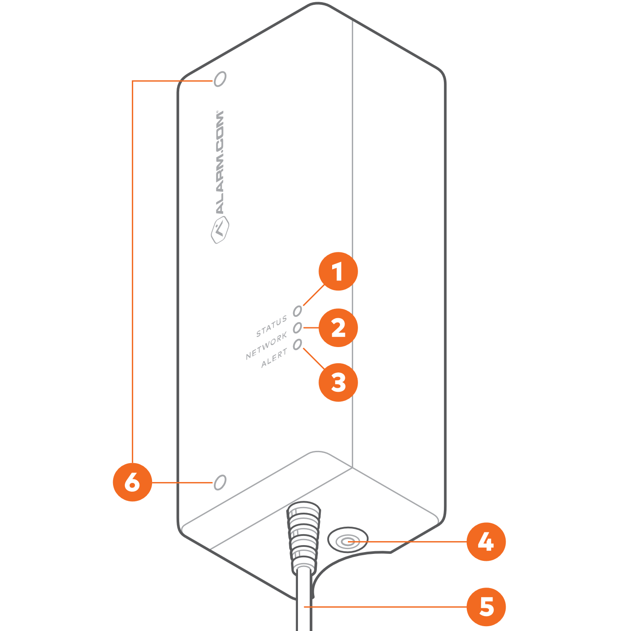
- Status LED
- Network LED
- Alert LED
- Network button
- Power plug
- Holes for Allen wrench (attaches the unit to clamps that clamp onto the pipe)

LEDs

Name | Color | Description
Network | Green | - On: Added to a Z-Wave network  - Blinking: In Add mode  - Off: Not added to a Z-Wave network
Alert | Red | - Blinking: Flow/Temperature event active; log in to the customer account for more details  - Off: No active events
Status | Yellow | - On: System calibrated and monitoring  - Blinking  - 1 blink: Not calibrated  - 2 blinks: Calibration in progress  - 3 blinks: Hardware error detected

LEDs can be on or blinking independently of each other.
If all LEDs are off, the device has no power.
If the device is in Device Identification Mode, indicating there are multiple Water Dragon devices within range, all three LEDs will be blinking.
All three LEDs will also blink if the Network button is pressed for greater than 15 seconds, indicating that the button can be released, and a factory reset will occur. See Resetting the Water Dragon to factory default settings for more information.

Network Button
The Network button is used for Z-Wave Add/Delete mode as well as to factory reset the device.

Adding the Water Dragon to a Z-Wave network
After bringing the Water Dragon to the installation site,
- Put the Z-Wave controller in Add mode. Refer to the controller’s documentation for more information.
- Press the Network button on the side of the Water Dragon to begin the Add process. The Network LED on the unit will begin blinking.
After the Water Dragon is successfully added to the Z-Wave network, the Network LED on the control unit will turn solid green. If the Network LED is not illuminated after the Add process, repeat steps 1 and 2.
SmartStart enabled products can be added to a Z-Wave network by scanning the Z-Wave QR Code present on the product if the controller is SmartStart enabled. No further action is required, and the SmartStart product will be added automatically within 10 minutes of being in the network’s vicinity. Please find the DSK as part of the product label on the side of the Water Dragon unit.
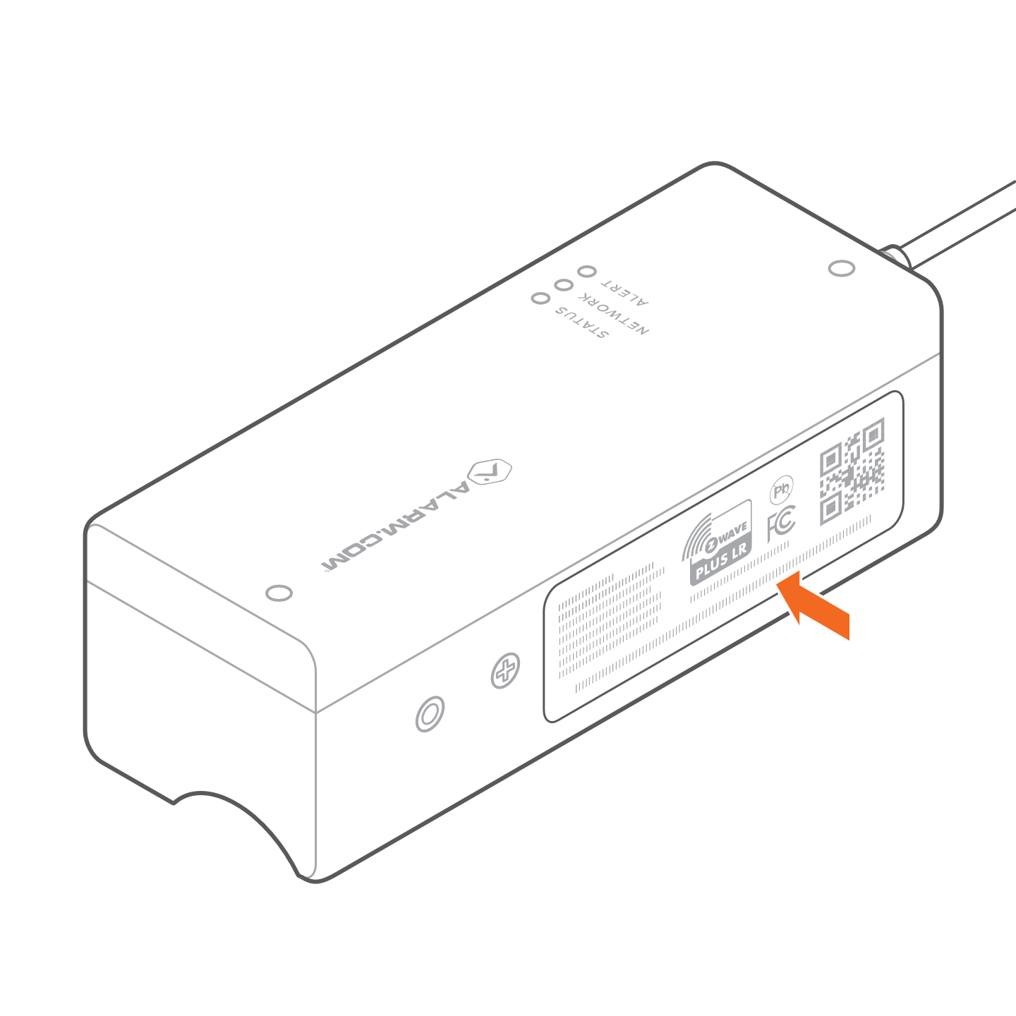

Using the Add Device wizard
Customers can access the Add Device wizard from the Customer Website or app > Settings > Managed Devices > Add Device > Water Valves or Meters > Water Dragon.
Installation technicians can access the Add Device wizard from Partner Portal > Customer Account > Equipment > Z-Wave Devices > Start Add Device Wizard > Water Valves and Meters > Water Dragon or MobileTech > Customer Account > Quick Actions > Add Device > Water > Water Dragon.

Installation location
First identify the type of system you have. Schematics are provided to show an example of each type.

Pressure regulator
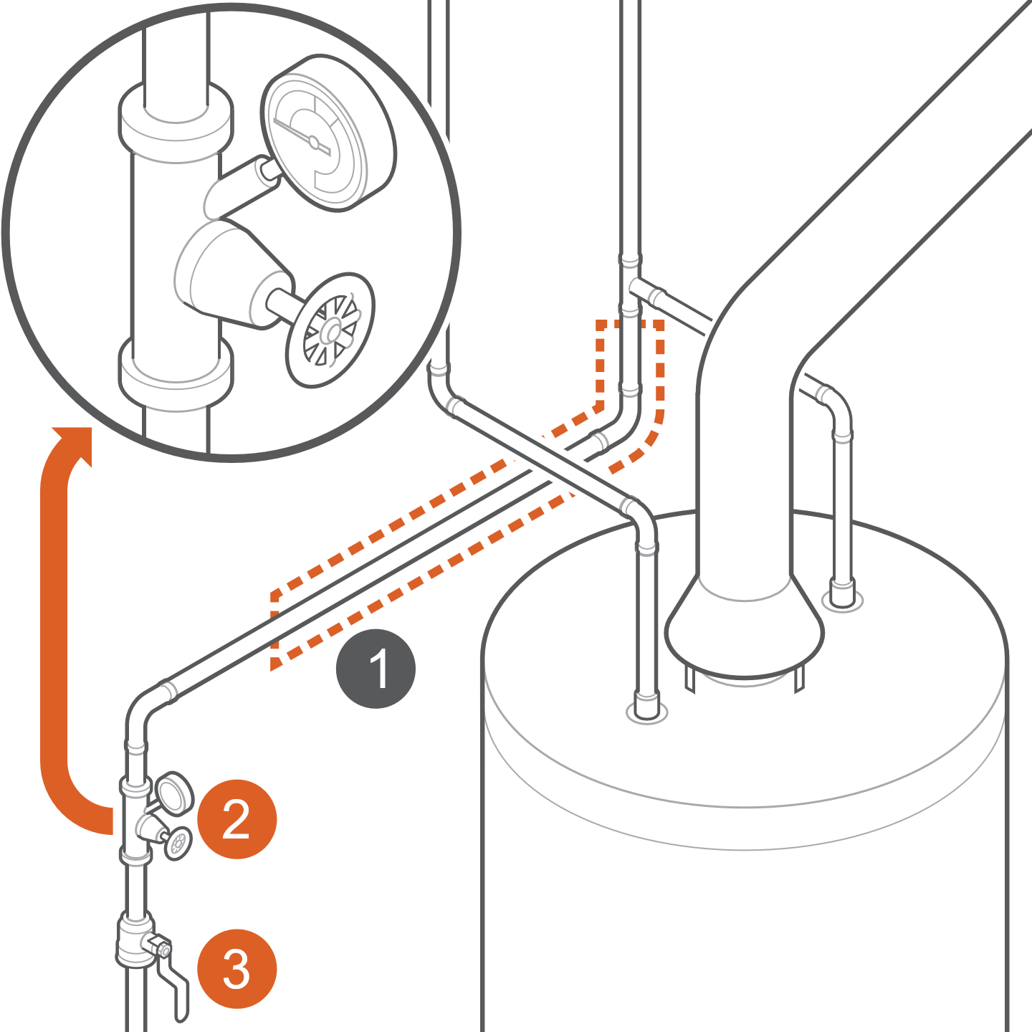
- Installation location
- Pressure regulator
- Shutoff valve

Locate at least 7 inches of pipe downstream from the pressure regulator, which is where you will install the Water Dragon.
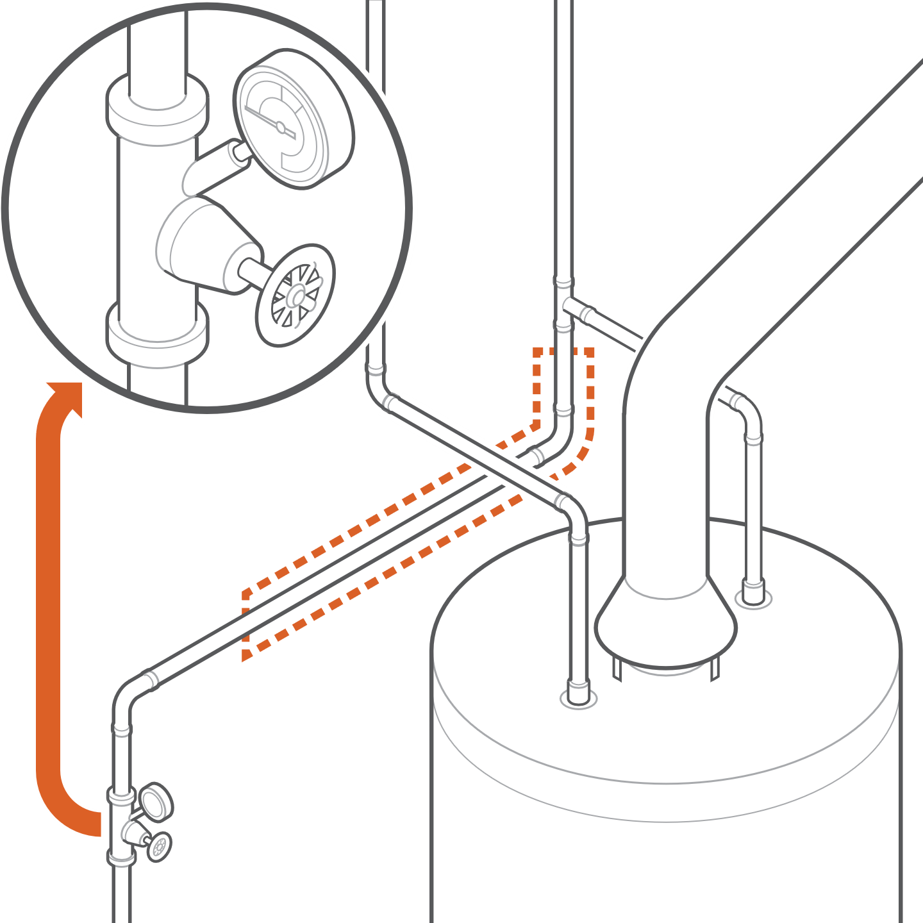

Well system
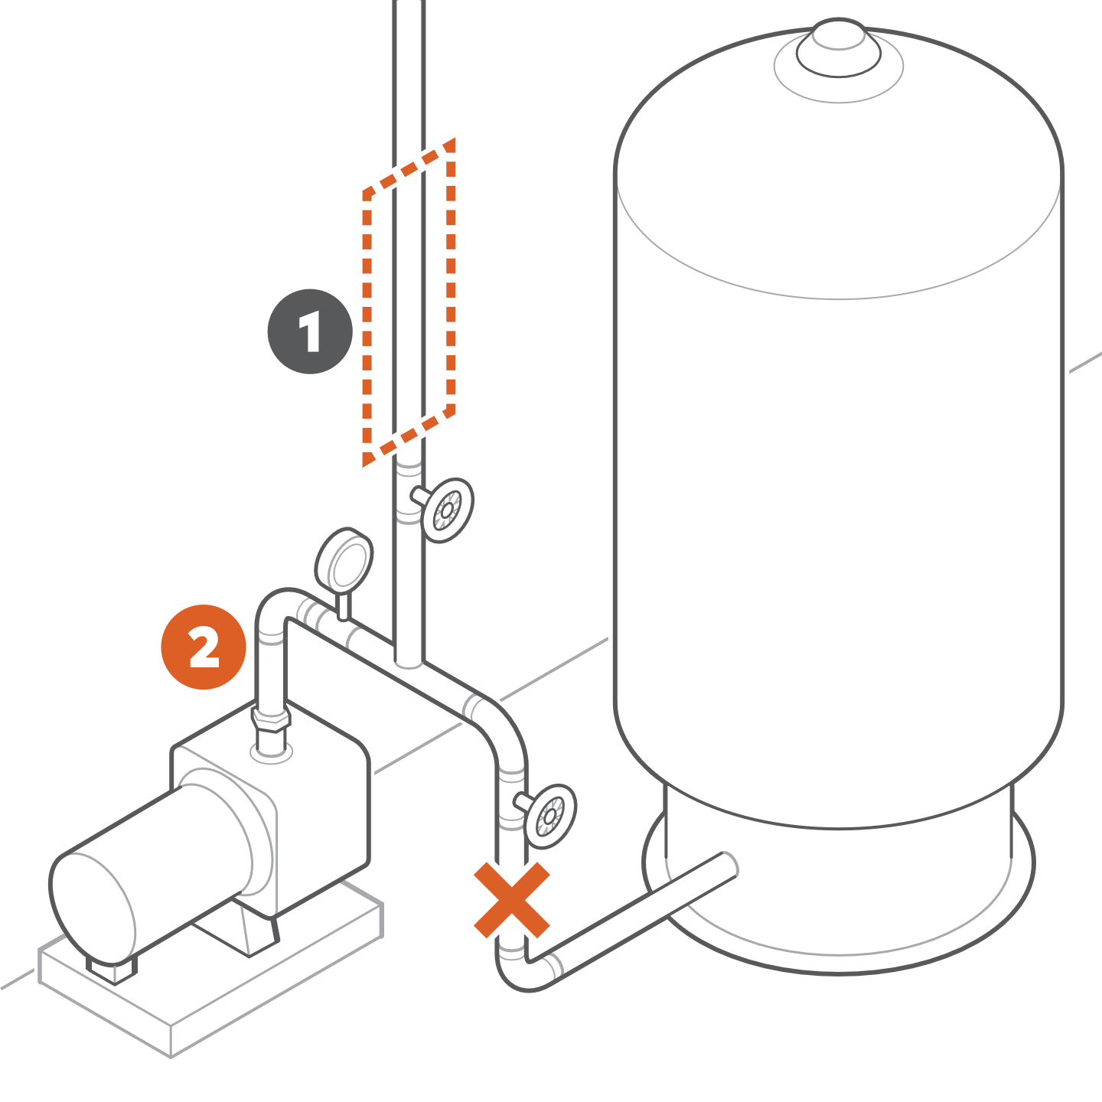
- Installation location
- Pump output
Check whether the pump connects to the pressure tank and then to the house supply, in that order.
If yes, locate 7 inches of pipe downstream from the pressure tank, which is where you will install the device.
If no, locate 7 inches of pipe on the line that feeds the house, which is where you will install the device. Do not install the device on pipe that feeds into the tank.
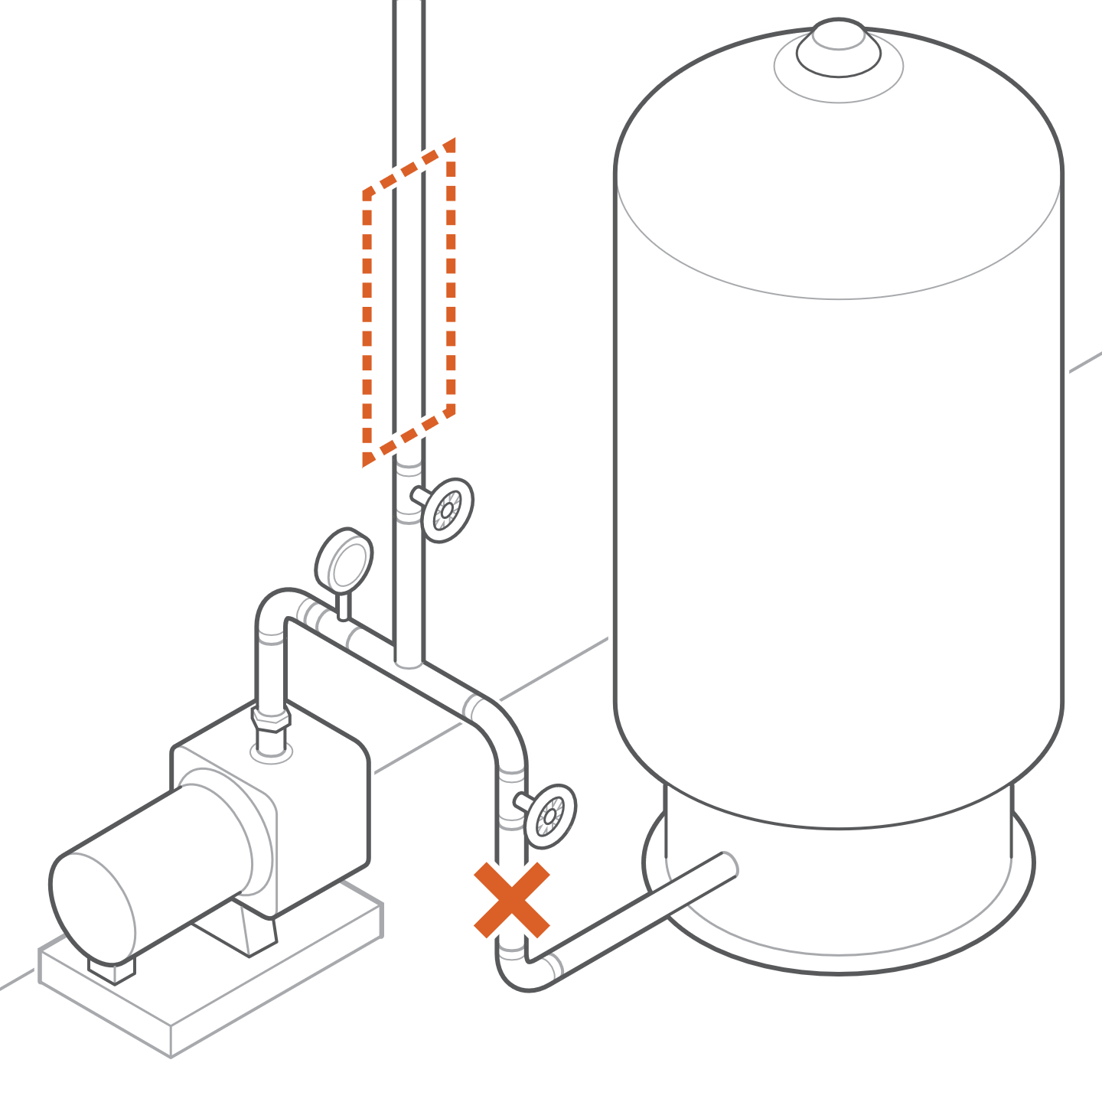

Radon mitigation system
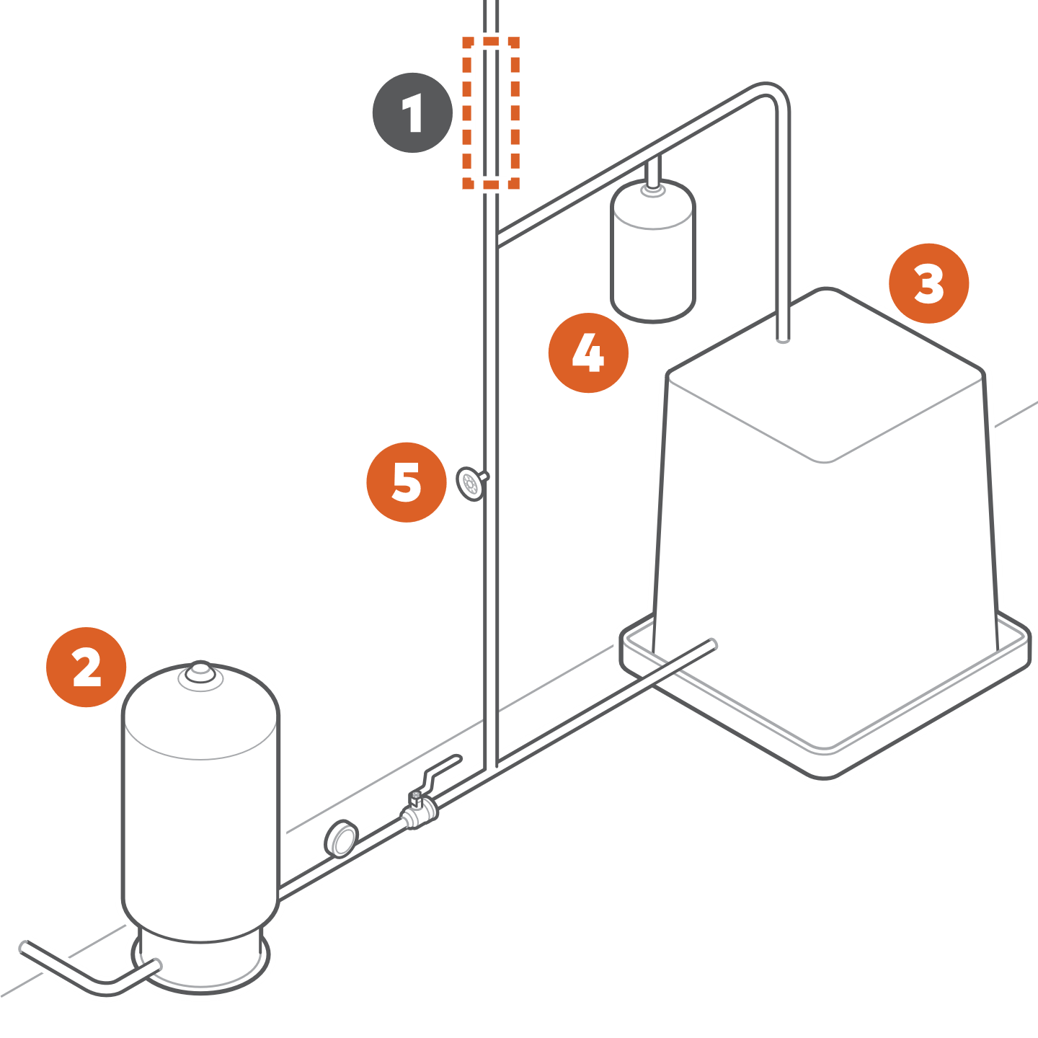
- Installation location
- Water tank
- Radon unit
- Secondary unit
- Bypass valve
Locate at least 7 inches of pipe downstream from the radon mitigation system, which is where you will install the device.
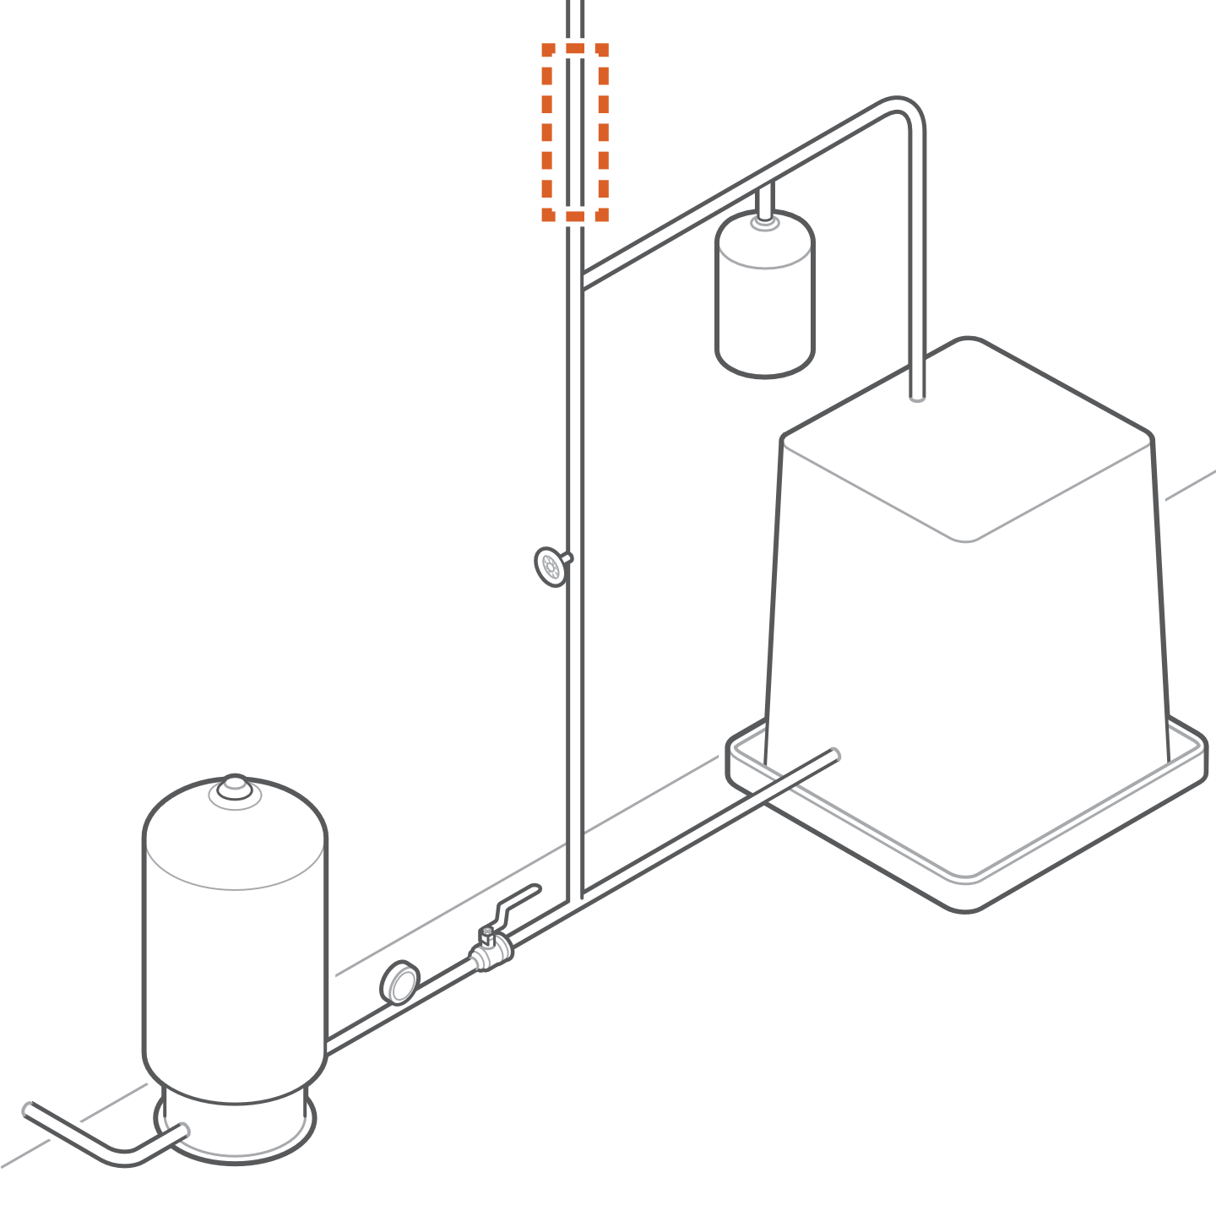

Pipe type
The Water Dragon is compatible with the following diameter and material of pipes:
- ¾” Copper M
- 1” Copper M
- ¾” Copper L
- 1” Copper L
- ¾” PEX
- 1” PEX
- ¾” CPVC
- 1” CPVC

Pipe type identification
- PEX: Comes in red, blue, and white
- CPVC: Typically, a yellowish, cream color
- Copper M: Labeled “Type M” or has red print
- Copper L: Labeled “Type L” or has blue print
An easy way to determine the pipe diameter is to try the clips on for size. The smaller clip is ¾’’ diameter and the larger clip is 1’’ diameter. The correctly sized clip should snap on and hold onto the pipe.

Set transducer spacing
Depending on the pipe material and diameter, the transducer spacing may need to be adjusted. Examine the module and the engraved labels as shown in the illustration to see whether adjustment is needed.
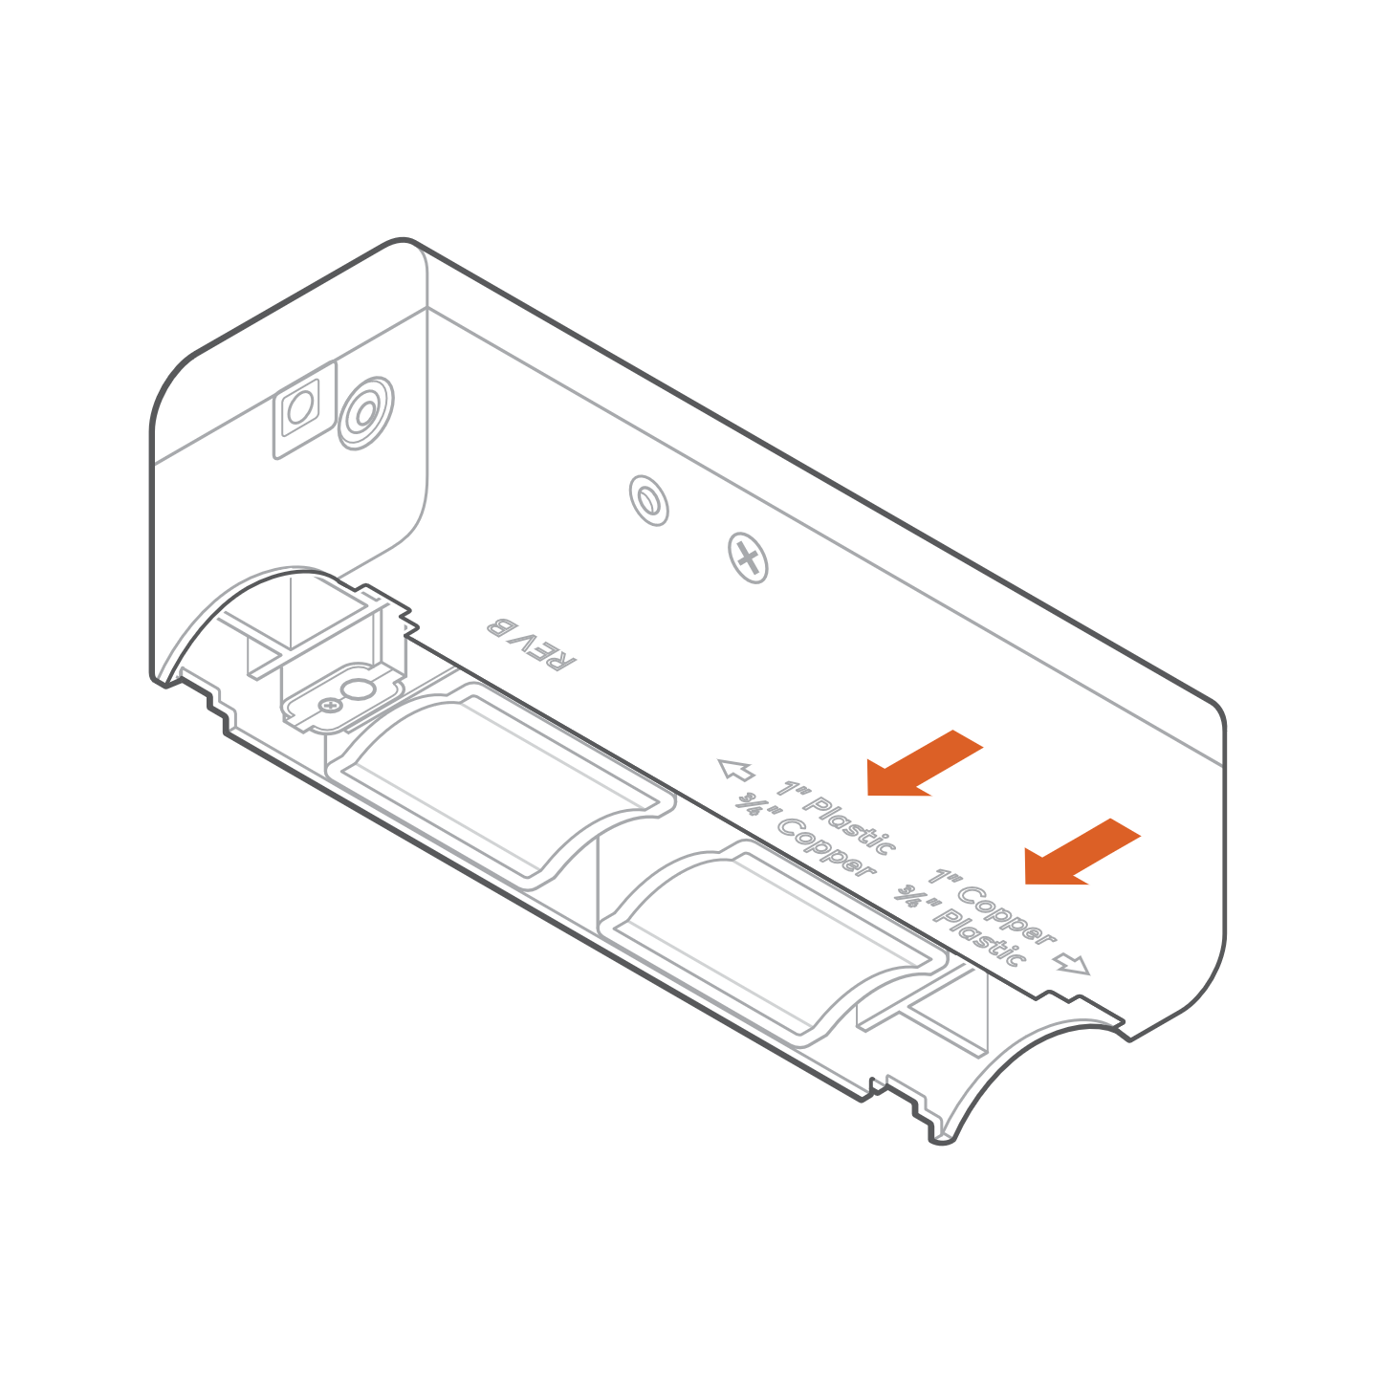
If adjustment is needed, locate the side screw. A singular side screw should be in either of the two holes. To adjust transducer spacing, remove the screw with a Phillips screwdriver and carefully slide the module into position. Retighten the side screw in the new position. Do not overtighten.

Prepare surface
Wipe down the selected pipe section with a towel or rag. Ensure there is a clean and smooth surface for installation.
If you have a copper pipe, use the provided abrasive cloth to lightly buff the surface until the exposed metal is smooth and shiny. Wipe down the surface of the pipe again with a towel or rag.

Install clips
- Depending on the pipe diameter, locate either the pair of 3/4’’ or 1” clips for this installation. Place the clips on the pipe for size. It should easily fit and hold onto the pipe, leaving no gap.
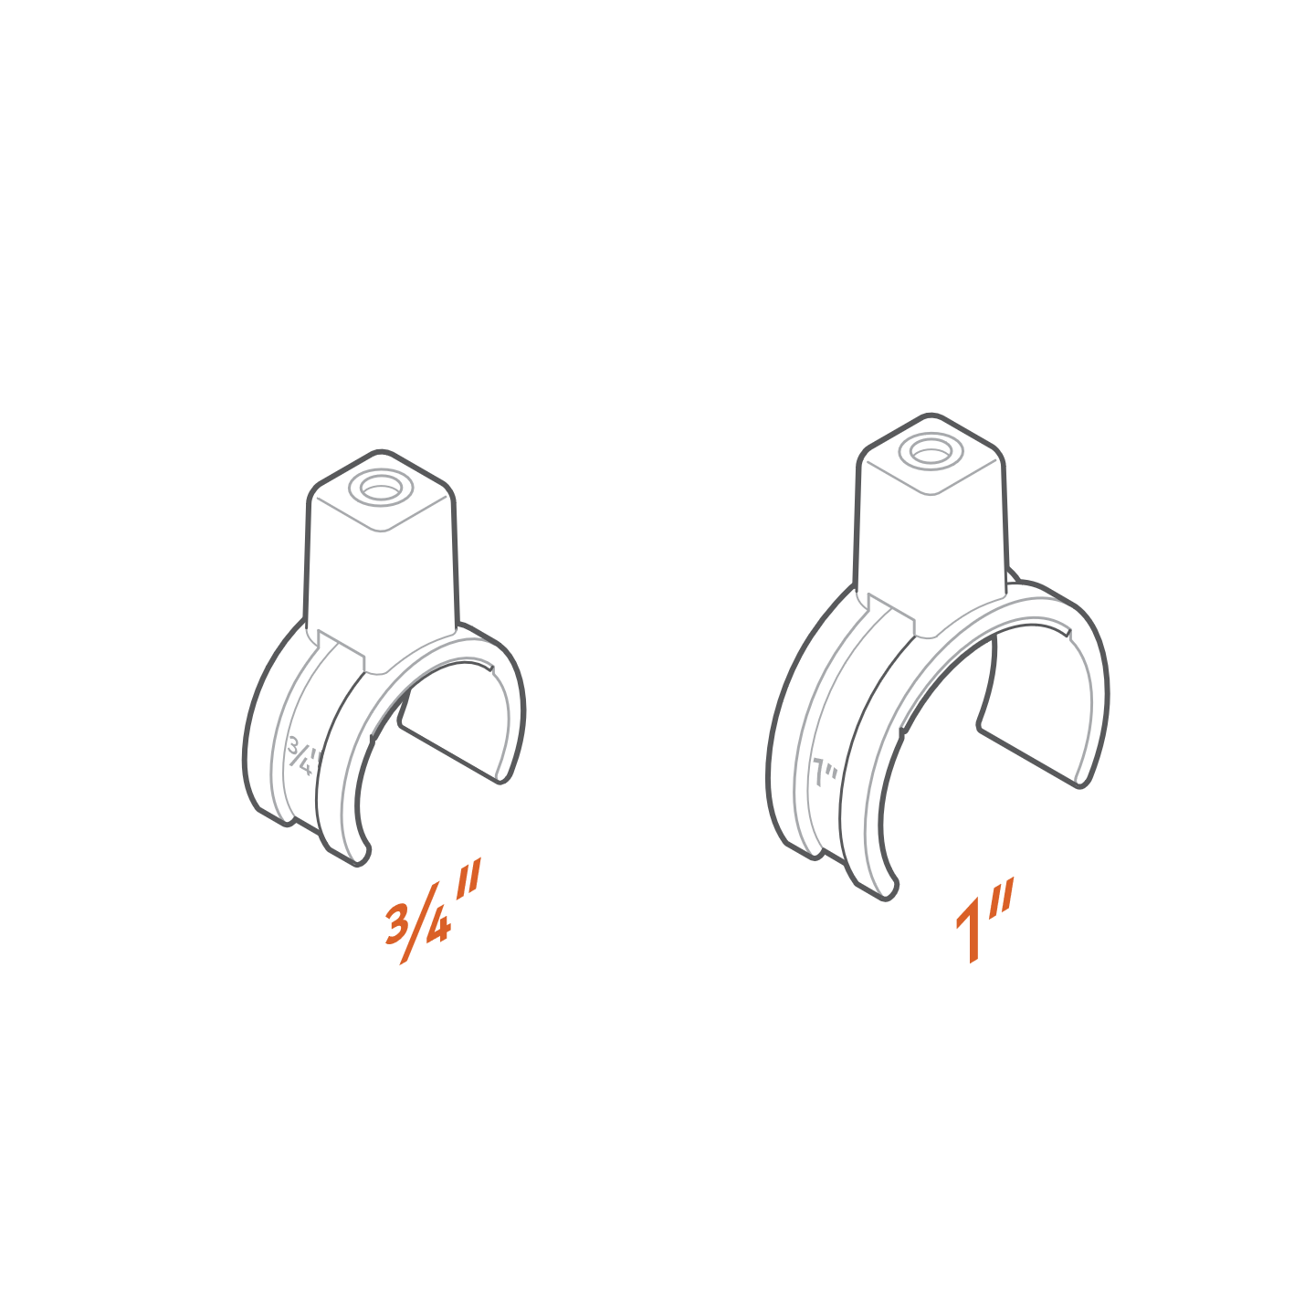
- Insert the pipe clips into the device.
- Lightly tighten the screws with the provided Allen wrench, just enough for both pieces to stay in place.
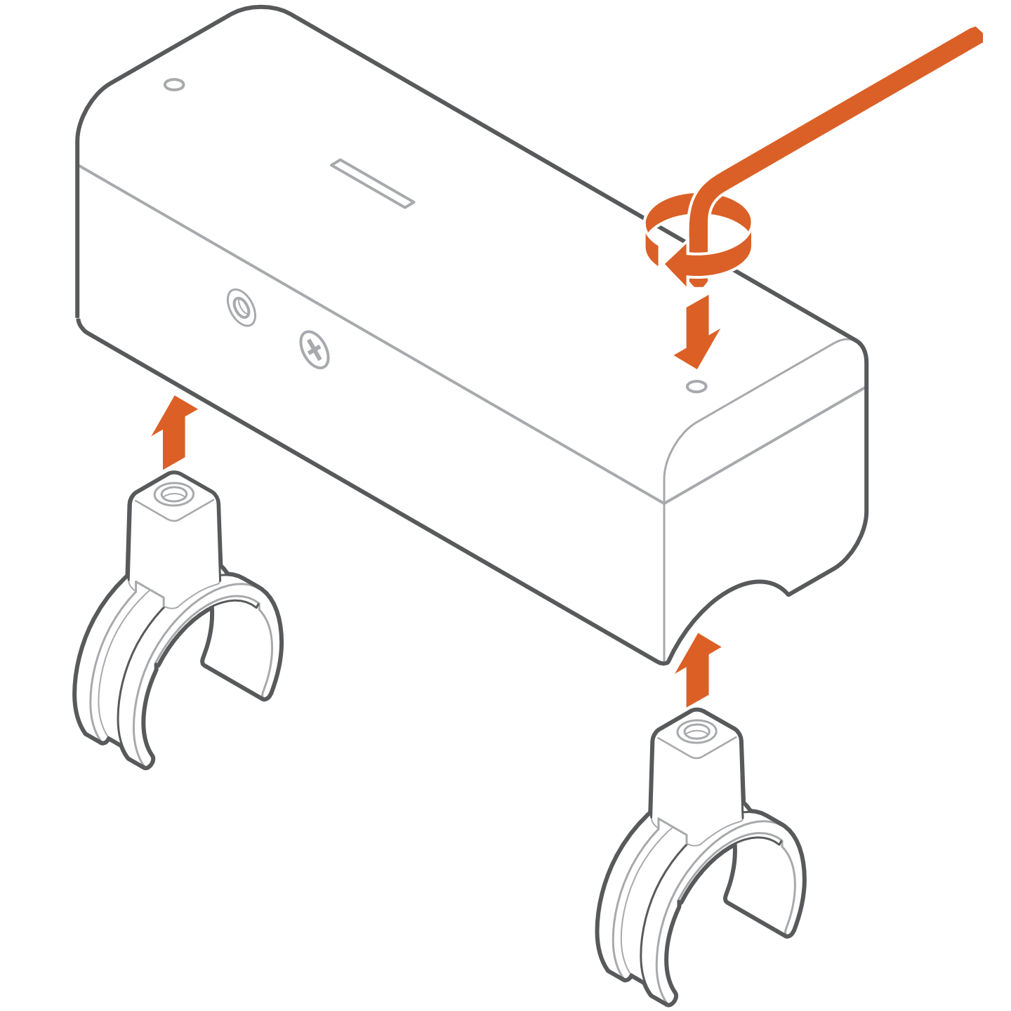
- Remove the red film tape from the clips’ adhesive pads.
- If you are installing on a horizontal pipe section, the preferred mounting method is between 45 and 0 degrees offset. See the diagram.

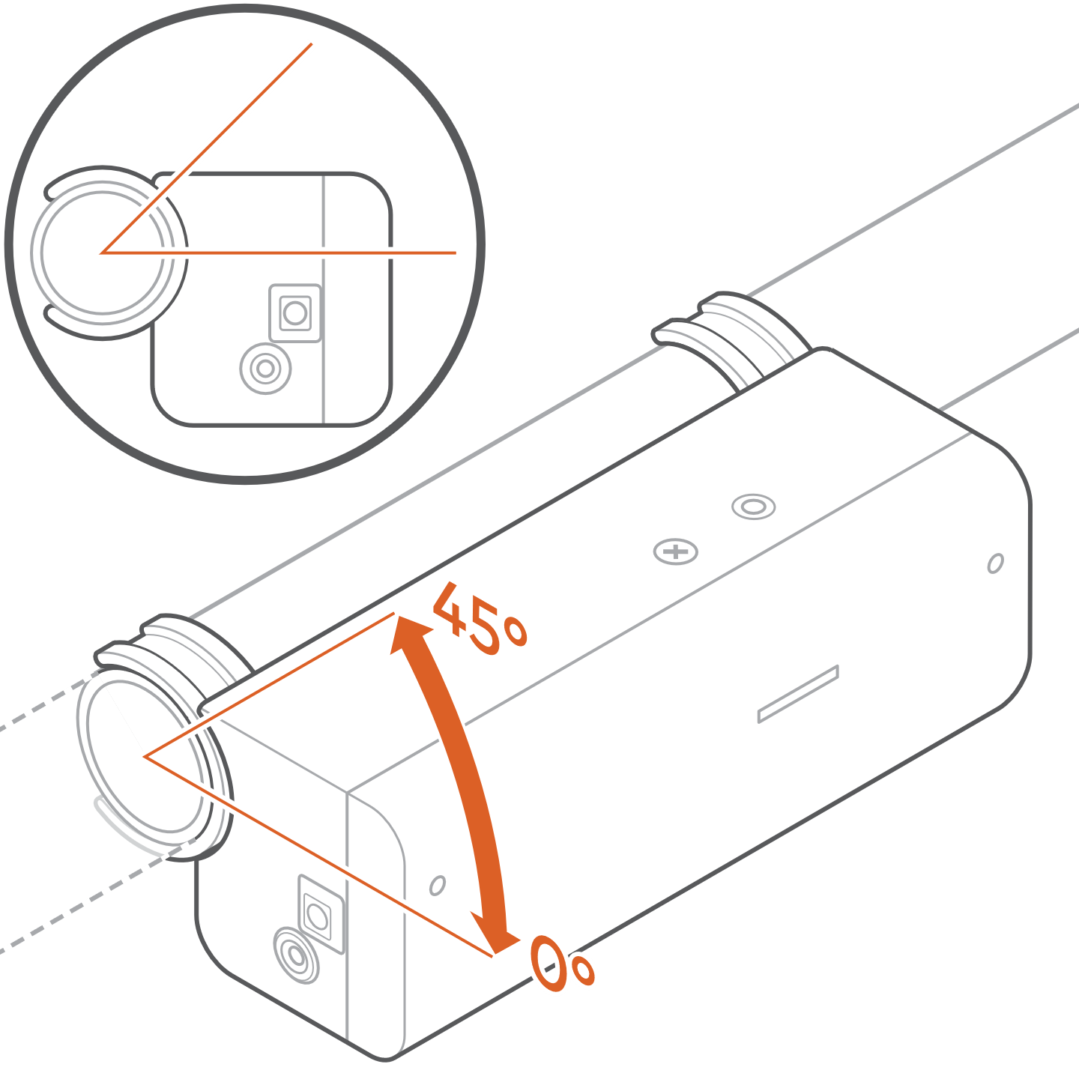
- Press the Water Dragon onto the pipe for at least 30 seconds to adhere the clips in place.

Secure clips with zip ties
- Gently remove the Water Dragon from the clips by loosening the screws with the Allen wrench.
- Secure the clips in place by threading zip ties through the clips. Make sure the tail of the zip tie is pointing away from the unit so it will not impede the unit from seating on the clips. See diagram.
Use zip tie cutters to trim off the tail of the zip tie. 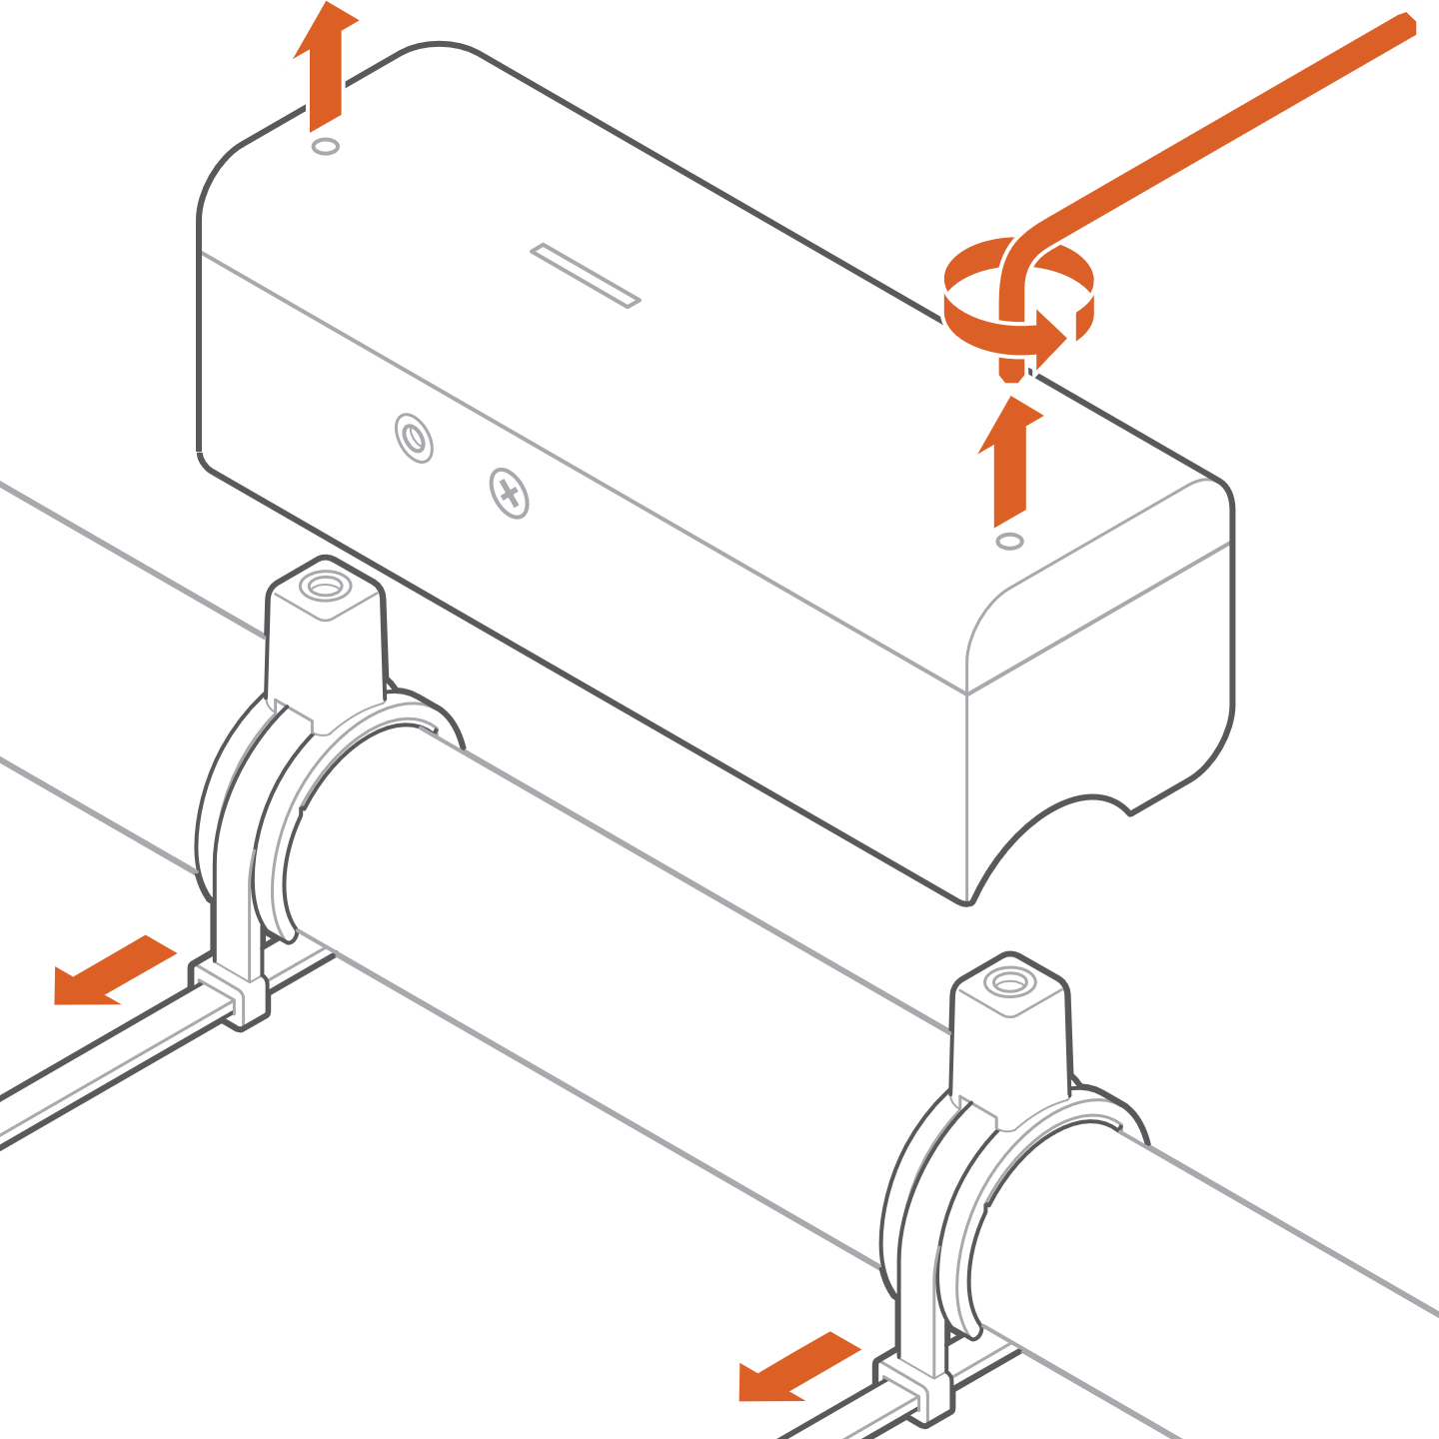

Add Magnalube
- Apply a strip of Magnalube to both transducer modules as shown in the illustration and a dot of Magnalube onto the brass temperature pad.
- Retain any extra Magnalube in case a reinstall is required at any point in the future.
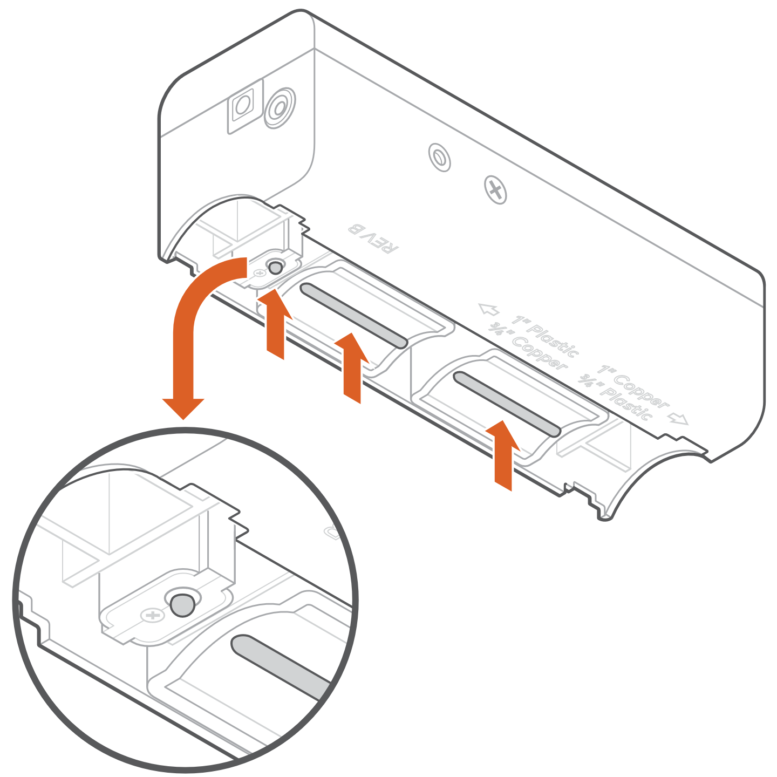

Finish installation
- Slide the device down onto the clips.
- Tighten the screws with the Allen wrench until the unit is secure. The device should not rock or wobble on the clips and pipe.
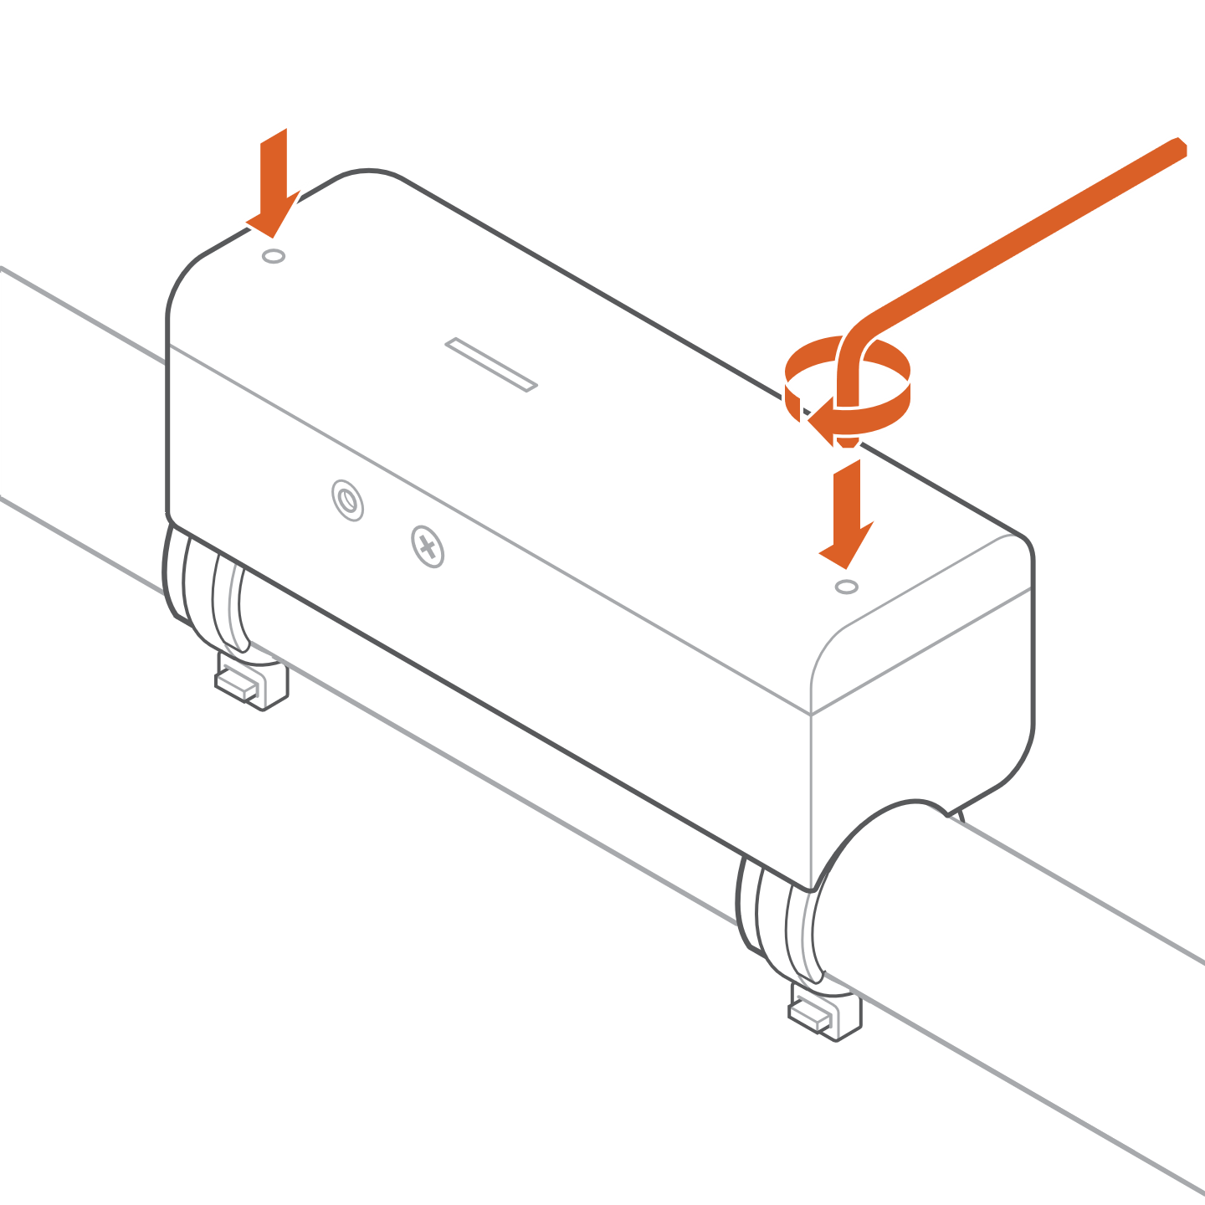
- Plug in the provided power supply and wait for the device to power up.
- Close your main water supply valve.
- Use the installation wizard in the customer mobile app or MobileTech to start the calibration, which will take about 5 minutes.
Optionally, with a Partner Portal login, you can run calibration by navigating to Partner Portal > Select Customer > Equipment > Configure Device > Calibrate Meter.
- Turn on your main water supply valve and fully open a faucet in the home.
- Wait while the device is calibrated, which will take about 1 minute once the water is flowing.
- Close the opened faucet.
- Wait while the calibration data is finished validating.

Troubleshooting

The Water Dragon is not communicating with the Z-Wave controller

If the Water Dragon did not pair properly to the Z-Wave network (check if the device appears on the Z-Wave controller or the Alarm.com account), try deleting the device from the network (see “Deleting the Water Dragon from the Z-Wave network”) and re-adding it.

If step 1 does not resolve the issue, install a Z-Wave repeater nearby and perform a Z-Wave network rediscovery. Repeat step 1 to verify the effectiveness of the repeater.

NOTE: Any wall-powered Z-Wave device acts as a repeater and improves the communication between the Z-Wave controller and the Z-Wave device you are installing.
- If the Water Dragon did pair properly to the Z-Wave network, run a link quality test

Removing the Water Dragon from the Z-Wave network
- Put the Z-Wave controller in Remove mode. Refer to the controller’s documentation for more information.
- Press the Network button on the side of the Water Dragon to begin the Remove process. The Network LED on the control unit will begin blinking.
- After the Water Dragon is successfully removed from the network, the Network LED will turn off. If the Network LED is still illuminated after completing the Remove process, repeat steps 1 and 2.

Resetting the Water Dragon to factory default settings

CAUTION: Resetting the Water Dragon to its factory default settings will delete the device from the Z-Wave network and restore all settings to their default values.

Press and hold the Network button for 15 seconds. All 3 LEDs will blink until the factory reset is complete. Please use this procedure only when the network primary controller is missing or otherwise inoperable.

Calibration issues
If calibration is unsuccessful, the install wizard will show one of the following issues and recommended actions.
Calibration issue | Recommended action(s)
Calibration signal too high | Verify pipe type  Verify transducer spacing
Calibration signal too low | Verify pipe type  Verify transducer spacing  Re-apply Magnalube
Zero flow out of range | Verify unit placement  Check water valve and faucet
Insufficient flow | Verify unit placement  Check water valve and faucet
Noise | Verify pipe surface
Waveform validation error | Verify pipe type  Verify transducer spacing
Calibration gain high/low | Verify pipe type  Verify transducer spacing  Re-apply Magnalube

Verify pipe type
Check the pipe type and select the diameter and material. For copper, look for markings on the pipes to determine whether it is Copper M or L. If you cannot determine the type, select Copper M.

Verify transducer spacing
Examine the engraved labels on the transducer and verify that your module is in the correct setting.

Re-apply Magnalube
- Unplug the Water Dragon.
- Unscrew it from the pipe clips.
- Wipe the Magnalube off with a clean, dry rag.
- Apply a strip of Magnalube to each transducer module and apply a drop to the brass temperature pad.
- Slide the Water Dragon back down onto the clips and retighten the screws.

Verify Unit Placement
- The unit should be installed on the main water line with at least 7 inches of pipe downstream from your water system
- Refer to Installation Location earlier in the manual to identify your water system and ideal install location

Check Water Valve and Faucet
- Ensure the main water supply and a faucet are fully open during water flow stage of calibration.

Verify pipe surface
- Wipe down the selected pipe section with a towel or rag to ensure there is a clean and smooth surface for installation.
- For a copper pipe, use the provided abrasive cloth to lightly buff the surface until the exposed metal is smooth and shiny.
- Wipe down the surface of the pipe again with a towel or rag.

Notices

FCC
The ADC-SHM-100-A complies with part 15 of the FCC Rules. Operation is subject to the following two conditions:
1. This device may not cause harmful interference.
2. This device must accept any interference received, including interference that may cause undesired operation.
NOTE: Changes and Modifications not expressly approved by Alarm.com can void your authority to operate this equipment under Federal Communications Commission rules.
This equipment has been tested and found to comply with the limits for a Class B digital device, pursuant to part 15 of the FCC Rules. These limits are designed to provide reasonable protection against harmful interference in a residential installation. This equipment generates, uses and can radiate radio frequency energy and, if not installed and used in accordance with the instructions, may cause harmful interference to radio communications. However, there is no guarantee that interference will not occur in a particular installation. If this equipment does cause harmful interference to radio or television reception, which can be determined by turning the equipment off and on, the user is encouraged to try to correct the interference by one or more of the following measures:
- Reorient or relocate the receiving antenna.
- Increase the separation between the equipment and receiver.
- Connect the equipment into an outlet on a circuit different from that to which the receiver is connected.
- Consult the dealer or an experienced radio/TV technician for help.

IC statement
This device (ADC-SHM-100-A) complies with Industry Canada license-exempt RSS standard(s). Operation is subject to the following two conditions:
(1) this device may not cause interference, and
(2) this device must accept any interference, including interference that may cause undesired operation of the device.
Le présent appareil (ADC-SWM150) est conforme aux CNR d’Industrie Canada applicables aux appareils radio exempts de licence. L’exploitation est autorisée aux deux conditions suivantes :
(1) l’appareil ne doit pas produire de brouillage, et
(2) l’utilisateur de l’appareil doit accepter tout brouillage radioélectrique subi, même si lebrouillage est susceptible d’en compromettre le fonctionnement.

Z-Wave
This product can be operated in any Z-Wave network with other Z-Wave-certified devices from other manufacturers. All mains operated nodes with the network will act as repeaters regardless of vendor to increase reliability of the network.

Z-Wave Long Range
This product supports Z-Wave Long Range.

Questions?
Visit: answers.alarm.com or contact your service provider.

