

Z-Wave PlusTM System Integrators Guide
ADB1-0 smart deadbolt lock

May 2023
LM

The smart deadbolt lock by TLJ is wireless battery powered digital keypad. The smart deadbolt lock is based upon Z-WaveTM Slave Library V7.16.3 supporting numeric PIN codes and remote lock/unlock when connected to a Z-Wave gateway. It can be included and operated in any Z-Wave network alongside other Z-Wave certified devices from other manufacturers and/or applications. All non-battery operated nodes within the network will act as repeaters regardless of vendor to increase reliability of the network.
The smart deadbolt lock is a secure Z-Wave device (s0 & s2) so a security enabled controller is needed for take full advantage of all functionally for the Door Lock. It also supports over the air (OTA) firmware upgrades. In addition SmartStart and low battery alerts are also supported.

Technical Specifications

Communication Protocol | Z-Wave (700Series) | BLE (5.1)
Radio Frequency | 908.42MHz (US)  868.42MHz (EU) | 2.4Ghz
Wireless Range | To Gateway:  More than 100m outdoors  Approx. 30m indoors (depending  on building materials) | To Door Lock:  Max. 4m outdoors  Max 6m indoors
Power Source | Battery (6Volt 4 x LR6)
Working current | 15mA
Standby current | 30uA
Battery Life | ~12 Months
Operating Temperature | 32-104° F (0-40° C)
Operating Humidity | 8% to 85% non-condensing
Certifications | Z-Wave
Dimensions (mm) | Front: 132mm*98mm*57mm ; Back: 100mm*68mm*41mm

Z-WaveTM Specifications

SDK Version | 7.16.03
SDK Library | libZWaveSlave
Explorer Frame Support | Yes
Routing | Yes
SmartStart | Yes
Device Type | Lock
Basic Device Class | BASIC_TYPE_ROUTING_SLAVE
Generic Device Class | GENERIC_TYPE_ENTRY_CONTROL (0x40)
Specific Device Class | SPECIFIC_TYPE_DOOR_LOCK (0x01)
Role Type | Listening Sleeping Slave (LSS)

Familiarize yourself with Door Lock
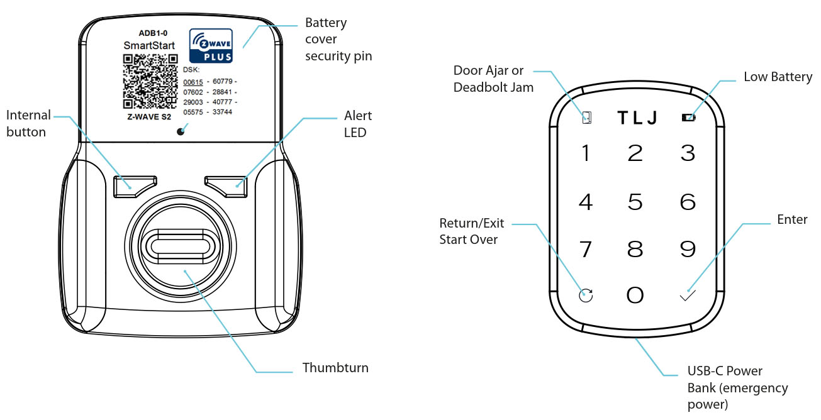

The smart deadbolt lock is a security enabled Z-Wave PlusTM product that is able to use encrypted Z-Wave Plus messages to communicate to other security enabled Z-Wave Plus products. When a node includes into a S0, S2 Z-Wave network, the node supports S0, S2Access and so do the supported CCs

Supported Security Levels
  - SECURITY_KEY_S2_ACCESS_BIT
  - SECURITY_KEY_S0_BIT

Commands List
Command Classes | Version | Required Security Class
COMMAND_CLASS_ZWAVEPLUS_INFO_V2 | 2 | None
COMMAND_CLASS_TRANSPORT_SERVICE_V2 | 2 | None
COMMAND_CLASS_SECURITY_V1 | 1 | None
COMMAND_CLASS_SECURITY_2_V1 | 1 | None
COMMAND_CLASS_SUPERVISION_V1 | 1 | None
COMMAND_CLASS_TIME_V2 | 2 | None
COMMAND_CLASS_NOTIFICATION_V8 | 8 | S0 or S2 Access
COMMAND_CLASS_DOOR_LOCK_V4 | 4 | S0 or S2 Access
COMMAND_CLASS_USER_CODE_V1 | 1 | S0 or S2 Access
COMMAND_CLASS_BATTERY_V1 | 1 | S0 or S2 Access
COMMAND_CLASS_CONFIGURATION_V4 | 4 | S0 or S2 Access
COMMAND_CLASS_ASSOCIATION_V2 | 2 | S0 or S2 Access
COMMAND_CLASS_ASSOCIATION_GRP_INFO_V1 | 3 | S0 or S2 Access
COMMAND_CLASS_VERSION_V3 | 3 | S0 or S2 Access
COMMAND_CLASS_MANUFACTURER_SPECIFIC_V2 | 2 | S0 or S2 Access
COMMAND_CLASS_DEVICE_RESET_LOCALLY_V1 | 1 | S0 or S2 Access
COMMAND_CLASS_POWERLEVEL_V1 | 1 | S0 or S2 Access
COMMAND_CLASS_FIRMWARE_UPDATE_MD_V5 | 5 | S0 or S2 Access
COMMAND_CLASS_MULTI_CHANNEL_ASSOCIATION_V3 | 3 | S0 or S2 Access
COMMAND_CLASS_INDICATOR_V3 | 3 | S0 or S2 Access
COMMAND_CLASS_TIME_PARAMETERS | 1 | S0 or S2 Access
COMMAND_CLASS_BASIC | 2 | S0 or S2 Access
COMMAND_CLASS_DOOR_LOCK_LOGGING | 1 | S0 or S2 Access
COMMAND_CLASS_SCHEDULE_V1 | 1 | S0 or S2 Access
COMMAND_CLASS_SCHEDULE_ENTRY_LOCK | 3 | S0 or S2 Access

All functions of each trigger

SmartStart Inclusion
SmartStart enabled products can be added into a Z-Wave network by scanning the Z-Wave QR Code present on the product with a controller providing SmartStart inclusion. No further action is required and the SmartStart product will be added automatically within 10 minutes of being switched on in the network vicinity.
Add the smart deadbolt lock into the Z-Wave network via SmartStart (SmartStart Inclusion):
a. Add smart deadbolt lock DSK into the primary controller SmartStart Provisioning List (DSK is printed on the back side of the smart deadbolt lock).
b. Please refer the user manual to trigger the smart deadbolt lock to enter learn mode for SmartStart inclusion.
c. The smart deadbolt lock will send “Z-Wave protocol Command Class” frame to start SmartStart Inclusion.

Operating mode via Z-Wave™
All functions of each trigger

Onboard Menu
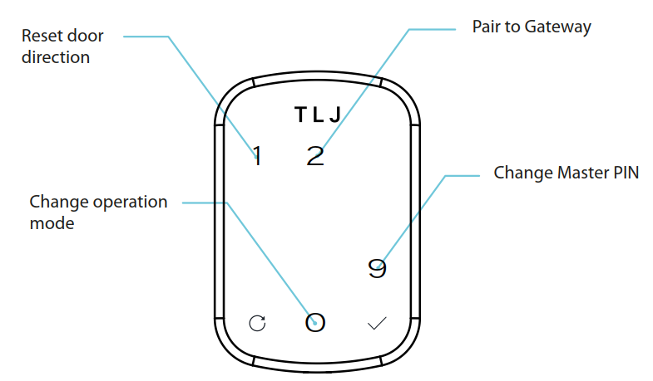
Initially power on for the first time, touch the keypad,it will display “M”(number 1 3 4 5 6 7 9 light up) then “+”(number 2 4 5 6 7 8 light up). Input the first PIN code as master PIN (4 - 8 digit), then tap button “√”. The previous input PIN code will display on the keypad again as confirmation, then tap button “√” to confirm the master PIN code.

Touch the screen and input two random code. Hold the button “√” for 3 seconds,it will display “M”(number 1 3 4 5 6 7 9 light up). Later all keys are light up then input the master PIN. Later “number 1 2 9 0” will light up, tap “2” to enter into Z-Wave gateway paring mode.

Ensure to enter the gateway into inclusion/exclusion mode at the same time. The Smart deadbolt lock will timeout after 60 seconds of inactivity. When inclusion or exclusion is finished The Smart deadbolt lock will sound audible beeps and returns to the main menu.

Factory Reset
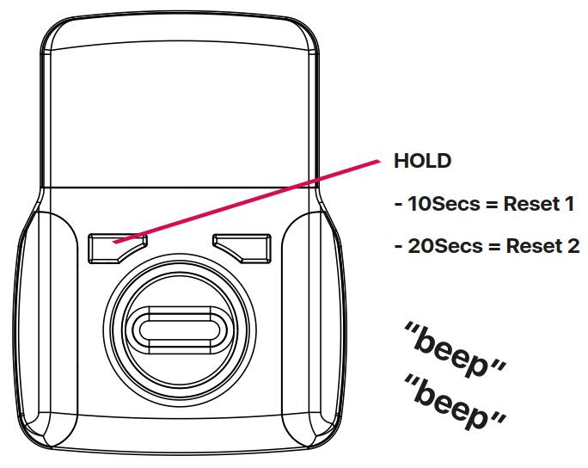
Factory Reset : Hold the Reset button(internal button) for 20seconds until the panel display number “1”and“2”, then release the button, then press “✔" button on front screen (the keypad LED will flash).
Reset all configurations to default status
Delete access for all users and user types
Delete the current Master PIN
Delete the current operating mode
Delete the directional handling
Gateway pairing deleted
Please use this procedure only when the network primary controller is missing or otherwise inoperable.

Z-Wave Plus Report Command Class

Manufacturer ID: TLJ smart deadbolt lock 0x0449
Product ID: 0x0002
Product Type ID: 0x00 04
Node Type: 0x00 (NODE_TYPE_ZWAVEPLUS_NODE)
Installer Icon Type: 0x0300 (ICON_TYPE_GENERIC_DOOR_LOCK_KEYPAD)
User Icon Type: 0x0300 (ICON_TYPE_GENERIC_DOOR_LOCK_KEYPAD)

Supported Command Classes

Basic Command Class
Basic Set (Value) maps Door Lock Operation Set (Door Lock Mode).
Basic get (Value) maps Door Lock Operation Get.
Basic Report (Current Value = 0x00) maps Door Lock Operation Report (Door Lock Mode = 0x00).
Basic Report (Current Value = 0xFF) maps Door Lock Operation Report (Door Lock Mode > 0x00).
Association Command Class

Grouping Identifier | Max Nodes | Send Commands
Group 1(Lifeline Group) | 0x05 | 1. NOTIFICATION_REPORT  The smart deadbolt lock will send NOTIFICATION_REPORT when access control or power management notification type triggered.  2. BATTERY_REPORT  The smart deadbolt lock will send BATTERY_REPORT when be unlocd.  3. DEVICE_RESET_LOCALLY_NOTIFICATION  Press and hold Reset Button more than 30s and when the button is released. The smart deadbolt lock will reset itself to factory default by sending a “Device Reset Locally Notification” to gateway.  4. USER_CODE_REPORT  The smart deadbolt lock will send USER_CODE_REPORT when user code changed.  5. DOOR_LOCK_OPERATION_REPORT_V4  The smart deadbolt lock will send DOOR_LOCK_OPERATION_REPORT when manual door lock operationed.  6. DOOR_LOCK_CONFIGURATION_REPORT  The smart deadbolt lock will send DOOR_LOCK_CONFIGURATION_REPORT when Door Lock configuration has changed.  7. INDICATOR_REPORT

Notification Commands

Notification Type | Notification Event
ACCESS_CONTROL (0x06) | MANUAL_LOCK_OPERATION(0x01)  RF_LOCK_OPERATION(0x03)  RF_UNLOCK_OPERATION(0x04)  KEYPAD_LOCK_OPERATION(0x05)  KEYPAD_UNLOCK_OPERATION(0x06)  AUTO_LOCK_LOCKED_OPERATION(0x09)  ALL_USER_CODES_DELETED(0x0C)  SINGLE_USER_CODE_DELETED(0x0D)  NEW_USER_CODE_ADDED(0x0E)  NEW_USER_CODE_NOT_ADDED_DUE_TO_DUPLICATE_CODE(0x0F)  KEYPAD_TEMPORARY_DISABLED(0x10)
POWER_MANAGEMENT (0x08) | REPLACE_BATTERY_SOON(0x0A)  REPLACE_BATTERY_NOW(0x0B)  Previous Events cleared (0x00)

Access Control
MANUAL_LOCK_OPERATION(0x01): when manual lock.
MANUAL_UNLOCK_OPERATION(0x02) : when manual unlock.
RF_LOCK_OPERATION(0x03) : when used RF lock.
RF_UNLOCK_OPERATION(0x04) : when used RF unlock.
KEYPAD_LOCK_OPERATION(0x05) : when used IC card lock.
KEYPAD_UNLOCK_OPERATION(0x06) : when used IC card unlock.
AUTO_LOCK_LOCKED_OPERATION(0x09) when auto lock
ALL_USER_CODES_DELETED(0x0C) when delete all user
SINGLE_USER_CODE_DELETED(0x0D) when delete single user
NEW_USER_CODE_ADDED(0x0E) : when New user code added.
NEW_USER_CODE_NOT_ADDED_DUE_TO_DUPLICATE_CODE(0x0F) : when New user code not added due to duplicate code.
KEYPAD_TEMPORARY_DISABLED(0x10) when keypad temporary disabled
Power Management:
REPLACE_BATTERY_SOON (0x0A): When the battery level is LOW.
REPLACE_BATTERY_NOW (0x0B): When the battery level is POWER OFF.

Indicator Command Class

The Receptacle support the Indicator Command Class, version 3 and support the Indicator ID 0x50 (Identify) and Properties ID 0x03, 0x04 and 0x05
Configurable Parameters

# | Name | Size | Range | Default | Description
1 | SilentOnOff | 1 | 0~3 | 0 | Control the sound, 00 = On, 03= Off. Default is 00, Sound ON
2 | RelockOnOff | 1 | 0~255 | 255 | 0x00 = OFF (Stay Open Mode) 0xFF = ON (Auto Lock) Default is 0xFF (Auto Lock Mode)
3 | RelockTimer | 1 | 1~180 | 3 | 1 to 180 seconds. Default is 03 seconds
4 | WrongCode | 1 | 0-255 | 5 | 0 to 255. Default is 5 times
6 | PressRandom | 1 | 0~255 | 255 | 0xFF = ON Default. 0x00 = OFF (normally utilised for blind user)
7 | LockOutTime | 1 | 10~180 | 30 | 10 to 180 seconds. Default is 30 seconds
8 | OpreatingMode | 1 | 0~3 | 1 | 00 = normal mode, will follow Auto Relock parameter 2 setting. Default Mode  01= Forbidden mode, keypad & RF lockout mode (except Master Code)  02 = privacy mode, keypad lockout mode but RF unlock will work (Master Code will also still work)  03 = passage mode, Lock is permanently unlocked
9 | DoorLockPair9 | 4 | 0~16777215 | 16777215 | Collect the BLE Mac address of the door lock. Send the first 3 bytes in parameter 9, and the other 3 bytes in parameter 10. Example MAC of lock = A0F769B40DED, send parameter 9 - A0 F7 69, send parameter 10 - B4 0D ED
10 | DoorLockPair10 | 4 | 0~16777215 | 16777215 | Collect the BLE Mac address of the door lock. Send the first 3 bytes in parameter 9, and the other 3 bytes in parameter 10. Example MAC of lock = A0F769B40DED, send parameter 9 - A0 F7 69, send parameter 10 - B4 0D ED
11 | OneTouchLock | 1 | 0~255 | 0 | 0x00 = OFF, 0xFF = ON. Default is 0x00 (OFF)
15 | ResetDefault | 1 | 0~1 | 0 | 01 = Lock will execute Reset to Factory and forget the gateway pairing  00 = Lock will execute Reset to Factory and remember the gateway pairing
17 | DeadblotFunc | 1 | 0~255 | 0 | This parameter is only applicable when:  Parameter 8 = normal mode (00)  Parameter 2 = Auto Relock Off (00)  0x00 = Apply deadbolt will lock door, then un-applying it will NOT unlock the door  0xFF = Default setting. Apply deadbolt will lock door, then un-applying it WILL unlock the door again
18 | DoorPosition | 1 | 0~60 | 10 | Alarm sounds from Lock when the door is improperly closed into the frame keeper.  0 to 60 Seconds. Default = 10 second
20 | DeadblotInstall | 1 | 0~255 | 255 | 0x00 = No Deadbolt, 0xFF = Yes have Deadbolt, Default = Yes have deadbolt (0xFF) Some locks contain optional deadbolt hardware. This parameter is used to determine if one is installed.
22 | PrivacyMode | 1 | 0~255 | 255 | 0x00 = OFF, 0xFF = ON. Default Is 0x00 (OFF) - If enabled, when extending (applying) the deadbolt the smart deadbolt lock will resort to Forbidden mode (No PIN or RF even if valid cannot access, please note the Master Code can still open the door)
24 | BLEInterface | 1 | 0~255 | 0 | 0x00 = OFF, 0Xff = ON. Default Is 0x00 (OFF)
25 | BleKeyUid25 | 4 | 0~16777215 | 16777215 | For example: 01 02 03. Set before using
26 | BleKeyUid26 | 4 | 0~16777215 | 16777215 | For example: 04 05 06. Set before using
48 | LowBatPercent | 1 | 5~50 | 10 | This parameter defines a battery level as the “low battery” unit %

