Advanced Information Product Manual

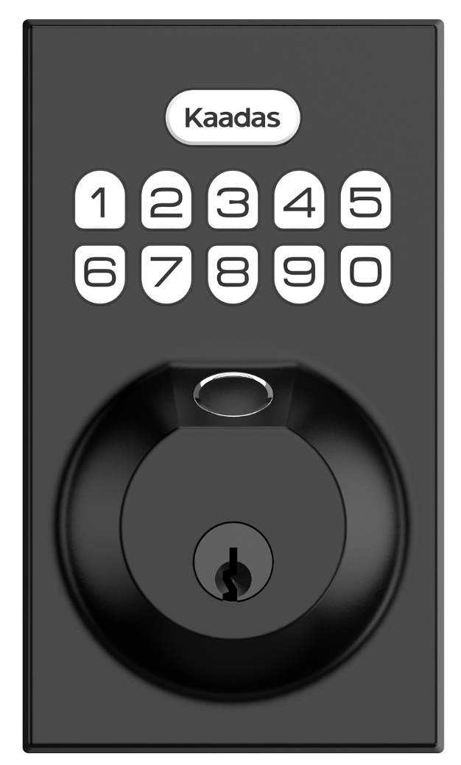

Engineering Specification

Advanced Information Product Manual

Document No. | SPEC-KA252-Z
Version | 1.1
Description | This document mainly introduces the new generation Kaadas Door Lock. The content mainly includes its interfaces, accessories, features, specifications, quick start, and software function definition.  This device must be used in conjunction with a security enabled Z-Wave™ controller in order to fully utilize all implemented functions. This product can be operated in any Z-Wave™ network with other Z-Wave™ certified devices from other manufacturers. All non-battery operated nodes within the network will act as repeaters regardless of vendor to increase reliability of the network

Written By

Date

Reviewed By

Date

Approved By

Date

Version | Date | Brief description of changes
1.0 | 2023.10.04 | First revision.

Table of Content
1 INTERFACES & ACCESSORIES 1
2 FEATURES & SPECIFICATIONS 2
2.1 Structural Characteristics 2
2.2 Hardware Characteristics 2
2.3 Software Characteristics 2
3 PRODUCT QUICK START 4
3.1 Important safety information 4
3.2 About Z-WaveTM 4
3.3 About SmartStart 4
3.4 How to add the product into Z-Wave network 4
3.5 How to remove the product from Z-Wave network 4
3.6 How to factory reset 5
3.7 Z-Wave DSK Location 5
3.8 About Product 5
3.9 About Security 5
4 SOFTWARE FUNCTION DEFINITION 6
4.1 User Behavior Interaction 6
4.2 Supported Command Classes 7
4.3 Basic Command Class mapping 7
4.4 ZWAVEPLUS_INFO 8
4.5 Manufacturer Specific 8
4.6 Version 8
4.7 Association Group Info 9
4.8 Notification 10
4.9 Door Lock 11
4.10 Door Lock Logging 11
4.11 User Code 11
4.12 Schedule 11
4.13 Battery 12
4.14 Indicator 12
4.15 Time 12
4.16 Time Parameters 12
4.17 Configuration 13

INTERFACES & ACCESSORIES

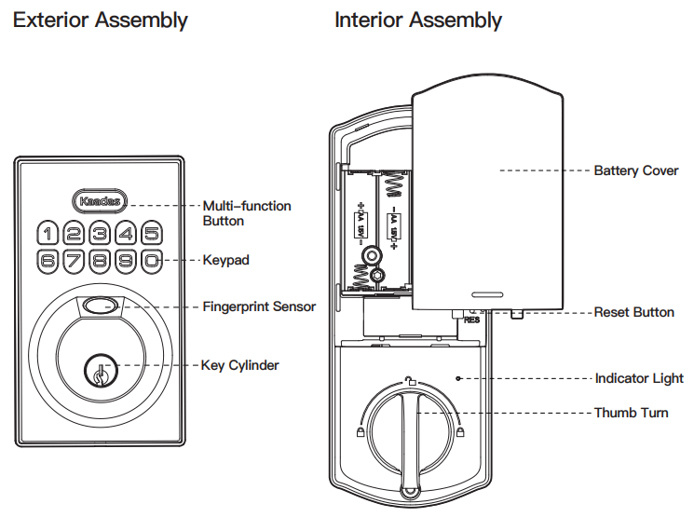

Terminology | Description
Keypad | Used to operate various functions of the door lock
Thumb Turn | For manual lock / unlock operation
Reset button | Restore factory settings

FEATURES & SPECIFICATIONS

Structural Characteristics
Parameter | Value
Product Identifier | KA252-Z
Color | black
Shell Material | kirsite
Shell Fire-proof Level | Frosting
Usage | For indoor use.
Operating Temperature | -25-55℃
Relative Humidity | 20-80%

Hardware Characteristics
Parameter | Value
Module | ZGM130S037
TX Power | Max: 13dBm
Antenna Distance | 40m (Indoor) /150m (Outdoor)
Battery Info | AA alkaline battery x4
Working Current | Module: 10mA(Wake Up), 40mA（Send message）  Door Lock body: 52mA(Wake Up), 190mA（operate door lock）
Standby Current | Module: 24uA  Door Lock body: 170uA

Software Characteristics
Parameter | Value
Wireless Technology | Z-Wave™
Certification Type | Z-Wave Plus™ v2
Z-Wave SDK Version | 7.18.1
Z-Wave Library Type | Enhanced 232 Slave
Z-Wave Role Type | ZWAVEPLUS_INFO_REPORT_ROLE_TYPE_SLAVE_SLEEPING_LISTENING (0x07)
Generic Device Type | GENERIC_TYPE_ENTRY_CONTROL (0x40)
Specific Device Type | SPECIFIC_TYPE_DOOR_LOCK (0x01)
Security Class | Non-Security, S0, S2-ACCESS
SmartStart | Support. After powering on, SmartStart is auto active if it’s out of the Z-Wave network.
Over The Air （OTA） | Support. Firmware can be updated via RF.
Multichannel Device | No
Association | Support. Refer to Section 4.7 Association Group Info.
Factory Reset | Support. Refer to Section 3.6 How to factory reset.
Power-down Memory | Support. All command settings will stay unchanged even power down.
Timed battery report | Support. Refer to Configuration Parameter 3.
Low battery warning | Support.
Door State Report | Support. When door lock mode changed, send out notification via Group 1.
User code Report | Support. When user code changed, send out notification via Group 1.

PRODUCT QUICK START

Important safety information
Please read this Engineering Specification carefully for correct and effective use.
Failure to follow the recommendations set forth by Kaadas Limited may be dangerous or cause a violation of the law. The manufacturer, importer, distributor, and/or reseller will not be held responsible for any loss or damage resulting from not following any instruction in this guide or in other materials.
The product is intended for indoor use in dry locations only. Do not use in damp, moist, and /or wet locations.

About Z-WaveTM
Z-Wave is the international wireless protocol for communication in the Smart Home.
Z-Wave ensures a reliable communication by reconfirming every message (two-way communication) and every mains powered node can act as a repeater for other nodes (meshed network) in case the receiver is not in direct wireless range of the transmitter.
This device and every other certified Z-Wave device can be used together with any other certified Z-Wave device regardless of brand and origin as long as both are suited for the same frequency range.
If a device supports secure communication it will communicate with other devices secure as long as this device provides the same or a higher level of security. Otherwise it will automatically turn into a lower level of security to maintain backward compatibility.

About SmartStart
SmartStart enabled products can be added into a Z-Wave network by scanning the Z-Wave QR Code present on the product with a controller providing SmartStart inclusion. No further action is required and the SmartStart product will be added automatically within 10 minutes of being switched on in the network vicinity.

How to add the product into Z-Wave network
- Follow the user guide of hub to enter inclusion mode.
- Operate on lock following guide below:
- Enter master mode(Kaadas + Kaadas + Master PIN Code + Kaadas)
- Input "0" to enter "Network settings"
- Input "1 + Kaadas" to enter "Include mode"

How to remove the product from Z-Wave network
- Follow the user guide of hub to enter exclusion mode.
- Operate on lock following guide below:
- Enter master mode(Kaadas + Kaadas + Master PIN Code + Kaadas)
- Input "0" to enter "Network settings"
- Input "2 + Kaadas" to enter "Exclusion mode"

How to factory reset
- Operations on lock
- Keep your lock in "unlock" status, insert 4AA batteries in battery pack.
- Use the provided reset pin to press and hold the reset button for more than 5 seconds until hearing beep sound.
- If reset is successful, the bolt will extend on its own to learn the orientation of the door.
2. Please use this procedure only when the network primary controller is missing or otherwise inoperable.
3. Default master pin code is “12345678”, please modify it after reset:
- Enter Master Mode(Kaadas + Kaadas + Master PIN Code + Kaadas)
- Enter "1" to select Modify Master Pin Code.
- Enter NEW 4-10 Digit Master PIN Code followed by "Kaadas"
- Repeat Step 3 to confirm NEW Master PIN Code

Z-Wave DSK Location
You can find the QR code when you open the battery box
You may also find the QR Code and DSK on individual package of each product.
Please do not remove or damage them.

About Product
This product can be operated in any Z-Wave network with other Z-Wave certified devices from other manufacturers. All mains operated nodes within the network will act as repeaters regardless of vendor to increase reliability of the network.

About Security
This device is a security enabled Z‐Wave Plus product that is able to use encrypted Z‐Wave Plus messages to communicate to other security enabled Z‐Wave Plus products. S2 Security Enabled Controller is required to operate the device.

SOFTWARE FUNCTION DEFINITION

User Behavior Interaction
User behavior | Out of the Z-Wave network | In the Z-Wave network
Power on | keypad light is on  Send Inclusion Requests for SmartStart | keypad light is on
Inclusion network | Enter master mode(Kaadas + Kaadas + Master PIN Code + Kaadas)  Input "0" to enter "Network settings"  Input "1" + "Kaadas" to enter "Inclusion mode" | NA
Exclusion network | NA | Enter master mode(Kaadas + Kaadas + Master PIN Code + Kaadas)  Input "0" to enter “Network settings"  Input "2" + "Kaadas" to enter “Exclusion mode"
unlock  (user code / manual / Z-Wave) | The green indicator lights up for 3 seconds | The green indicator lights up for 3 seconds  Send Notification Report and Door Lock Operation Report to association group
Lock  (Touch / Auto Lock / manual / Z-Wave) | The red indicator lights up for 3 seconds | The red indicator lights up for 3 seconds  Send Notification Report and Door Lock Operation Report to association group
User code  (Add / delete / modify) | NA | Send Notification Report and User code Report to association group

Supported Command Classes
Command Class | Version | Not added | Non-secure added | Securely 0 added |  | Securely 2 added
 |  |  |  | Non-secure CC | Secure CC | Non-secure CC | Secure CC
ZWAVEPLUS_INFO | 2 | Support | Support | Support |  | Support
ASSOCIATION | 2 |  |  |  | Support |  | Support
ASSOCIATION_GRP_INFO | 3 |  |  |  | Support |  | Support
MULTICHANNEL ASSOCIATION | 3 |  |  |  | Support |  | Support
NOTIFICATION | 8 |  |  |  | Support |  | Support
DOOR LOCK | 4 |  |  |  | Support |  | Support
USER CODE | 2 |  |  |  | Support |  | Support
SCHEDULE | 4 |  |  |  | Support |  | Support
DOOR LOCK LOGGING | 1 |  |  |  | Support |  | Support
CONFIGURATION | 4 |  |  |  | Support |  | Support
APPLICATION STATUS | 1 | Support | Support | Support |  | Support
TIME | 1 | Support | Support | Support |  | Support
TIME PARAMETERS | 1 |  |  |  | Support |  | Support
VERSION | 3 |  |  |  | Support |  | Support
MANUFACTURER_SPECIFIC | 2 |  |  |  | Support |  | Support
DEVICE_RESET_LOCALLY | 1 |  |  |  | Support |  | Support
POWERLEVEL | 1 |  |  |  | Support |  | Support
INDICATOR | 3 |  |  |  | Support |  | Support
BATTERY | 1 |  |  |  | Support |  | Support
SECURITY | 1 | Support | Support | Support |  | Support
SECURITY_2 | 1 | Support | Support | Support |  | Support
TRANSPORT_SERVICE | 2 | Support | Support | Support |  | Support
SUPERVISION | 1 | Support | Support | Support |  | Support
FIRMWARE_UPDATE_MD | 5 |  |  |  | Support |  | Support

Basic Command Class mapping
Basic Command maps to Door Lock Command Class, as shown below.
Command | Value | Mapped | Value | Function
Basic Set | 0x00 | Door Lock Operation Set | Door Unsecured | Open the door
Basic Set | 0xFF | Door Lock Operation Set | Door Secured | Close the door
Basic Report | 0x00 | Door Lock Operation Report | Door Unsecured | The door is opened
Basic Report | 0xFF | Door Lock Operation Report | Door Secured | The door is closed
Basic Get |  | Door Lock Operation Get

ZWAVEPLUS_INFO
The Command is used to differentiate between Z-Wave Plus v2, Z-Wave for IP and Z-Wave devices. This command provides additional information about the Z-Wave Plus v2 device in question.
Parameter | Value
Z-Wave Plus Version | 2
Role Type | 7 (ZWAVEPLUS_INFO_REPORT_ROLE_TYPE_SLAVE_SLEEPING_LISTENING)  (APPLICATION_FREQ_LISTENING_MODE_1000ms)
Node Type | 0 (ZWAVEPLUS_INFO_REPORT_NODE_TYPE_ZWAVEPLUS_NODE)
Installer Icon Type | 0x0300 (ICON_TYPE_GENERIC_DOOR_LOCK_KEYPAD)
User Icon Type | 0x0300 (ICON_TYPE_GENERIC_DOOR_LOCK_KEYPAD)

Manufacturer Specific
The Command is used to advertise manufacturer specific information.
Parameter | Value
Manufacturer ID 1 | 0x02
Manufacturer ID 2 | 0x1D
Product Type ID 1 | 0x00(EU) / 0x01(US) / 0x02(AU)
Product Type ID 2 | 0x03
Product ID 1 | 0x03
Product ID 2 | 0x22

Version
The Command may be used to obtain the Z-Wave library type, the Z-Wave protocol version used by the application, the individual command class versions used by the application.
Parameter | Value
Z-Wave Protocol Library Type | 0x03
Z-Wave Protocol Version | 0x07
Z-Wave Protocol Sub Version | 0x12
Firmware 0 Version | Z-Wave Chip Firmware Version Major
Firmware 0 Sub Version | Z-Wave Chip Firmware Version Minor
Hardware Version | 0x22
Number of firmware targets | 0x01
Firmware 1 Version | Door Lock Firmware Version Major
Firmware 1 Sub Version | Door Lock Firmware Version Minor

Association Group Info
The Command is used to manage associations to Node ID destinations.
ID | Name | Count | Profile | Function

1 | Lifeline | 5 | General: Lifeline  (0x0001) | Battery Report(0x8003)：  Issued periodically to report the current battery level;  Issued when battery becomes low.  Device Reset Locally Notification (0x5A01) ：  Issued when Factory Reset is performed.  Door Lock Operation Report(0x6203)：  Issued when door lock mode changed  Door Lock Configuration Report(0x6206)：  Issued when door lock configuration changed  Indicator Report(0x8703)：  Issued when indicator set received  Notification Report(0x7105)：  Issued when door lock event changed  User Code Report(0x6303)：  Issued when user code changed by keypad  Master Code Report(0x6310)  Issued when master code changed by keypad  User Code KEYPAD MODE Report(0x630A)  Issued when keypad mode changed by keypad  Configuration Report(0x7006)  Issued when the volume configuration value is changed by keypad
2 | On/Off control | 5 | General: Control  (0x2000) | Basic Set (0x2001) ：  Issued when door lock mode changed (value is determined by parameter 0x04)

Notification
The Command is used to advertise events or states, such.
Notification Type = Access Control (0x06)，according to Table 4-8-1
Notification Type = Home Security (0x07)，according to Table 4-8-2

Table 4-8-1:
Description | Event | Alarm type | Alarm Level | Parameters
Manual lock operation  (mechanical key or thumb turn) | 0x01 | 0x15 | 0x01 | 0x01
Manual unlock operation  (mechanical key or thumb turn) | 0x02 | 0x16 | 0x01 | 0x01
RF lock operation | 0x03 | 0x18 | 0x01 | 0x01
RF unlock operation | 0x04 | 0x19 | 0x01 | 0x01
Keypad lock operation | 0x05 | 0x15 | 0x02
Keypad unlock operation | 0x06 | 0x13 | User ID | User Code Report
Keypad unlock operation |  | 0x13 | 0xFB
Auto lock locked operation | 0x09 | 0x1B | 0x01
Lock jammed | 0x0B | 0x00 | 0x00
All user codes deleted | 0x0C | 0x21 | 0xFF
Single user code deleted | 0x0D | 0x21 | User Id | User Code Report
New user code added (add and modify) | 0x0E | 0x70 | User Id | User Code Report
New user code not added due to duplicate code | 0x0F | 0x71 | User Id | User Code Report
New program code entered : unique code for lock configuration | 0x12 | 0x70 | 0x00 | Master Code Report
Manually enter user access code exceeds code limit | 0x13 | 0x00 | 0x00

Table 4-8-2:
Description | Notification Event | Alarm type | Alarm Level | Parameters
Tampering Product covering removed  (front escutcheon removed from door) | 0x03 | 0x00 | 0x00

Door Lock
The Command is used to operate and configure a door lock device.
Support Door Lock Mode: Door Secured (0xFF), Door Unsecured (0x00)
The auto relock time mapping table of door lock and Z-Wave is as follows:
Z-Wave definition | Door lock function
Auto-relock time = 0 | disabled
Auto-relock time = 1 - 30 | 30 Seconds
Auto-relock time = 31 - 60 | 60 Seconds
Auto-relock time = 61 - 120 | 120 Seconds
Auto-relock time = 120 – 65535 | 180 Seconds

Door Lock Logging
The Command provides an audit trail in an access control application. Each time an event takes place at the door lock, the system logs the user's ID, date, time etc.

User Code
The Command is used to manage User Codes in access control systems
- Support master code
- Supported User ID Status: available(0x00), enabled/grant access (0x01), Disable(0x02)
- Supported Keypad Modes: Normal mode, Vacation mode, Privacy mode
In Privacy mode, it will ignore Door Lock Operator Set Command, and will send Application Rejected Request.

Schedule
The Command allows scheduling the execution of commands for a given duration in a supporting device. It is a generic Command Class that may be used to schedule commands of any other Command Class.

- SCHEDULE_SUPPORTED_REPORT:
- Number of Supported Schedule IDs: 10
- Support Enable / disable: 0
- Fall-back Support: 0
- Start Time Support: 1
- Number of supported CC: 1
- Supported CC 1: USER_CODE_COMMAND_CLASS
- Supported Command1: 0x01 (Only Set Commands are supported)
- Number of Supported Schedule Blocks: 1
- SCHEDULE_SUPPORTED_COMMANDS_REPORT：
- Supported Command Class: USER_CODE_COMMAND_CLASS
- Supported Command: USER_CODE_SET

Battery
The Command is used to request and report battery levels for a given device.
1. If send Battery Get to the device, it will issue Battery Report with current battery level to the requester.
2. If re-power on, it will issue Battery Report with current battery level via Lifeline.
3. If waked up, it will detect battery level, and issue Battery Report (Value=0xFF) via Lifeline when battery level is less than 20%.
4. Support timed battery report, refer to Configuration Parameter 3.

Indicator
The Command is used to help end users to monitor the operation or condition of the application provided by a supporting node.
Indicator ID |  | Property ID
Node Identify | 0x50 | On Off Period | 0x03
Node Identify | 0x50 | On Off Cycles | 0x04
Node Identify | 0x50 | On time within an On/Off period | 0x05

Time
The Command is used to read date and time from a supporting node in a Z-Wave network.

Time Parameters
The Command is used to set date and time in a device hosting this facility

Configuration
The Command allows product specific configuration parameters to be changed.
Note: No Bulk Support equals to True. It will return an Application Rejected Request Command when receiving Configuration Bulk Set or Get (if received without Supervision encapsulation). It will reset all its configuration parameters if either manually reset to factory default or receives a Configuration Default Reset Command. It will NOT modify or reset any configuration parameter when being included or excluded of a Z-Wave network.
Parameter | 0x01 (1)
Name | Configure volume level
Info | Configure volume level
Properties | Size |  | 1 | Min Value | 0
Properties | Format |  | Enumerated | Max Value | 2
Properties | Read-only |  | False | Default Value | 2
Properties | Altering capabilities |  | False | Advanced | False
Description | Configure volume level
Description | Value | Function
Description | 0 | silent
Description | 1 | Low volume
Description | 2 | High volume

Parameter | 0x02 (2)
Name | Configure led
Info | Enable/disable led
Properties | Size |  | 1 | Min Value | 0
Properties | Format |  | Enumerated | Max Value | 1
Properties | Read-only |  | False | Default Value | 1
Properties | Altering capabilities |  | False | Advanced | False
Description | LED on the inside of the product.
Description | Value | Function
Description | 0 | OFF
Description | 1 | ON (blink)

Parameter | 0x03 (3)
Name | Timed battery report
Info | Configure timed battery report
Properties | Size |  | 2 | Min Value | 0
Properties | Format |  | Unsigned Integer | Max Value | 14400(0x3840)  (10 days)
Properties | Read-only |  | False | Default Value | 1440(0x05A0)  (one day)
Properties | Altering capabilities |  | False | Advanced | False
Description | Enable/Disable timed battery report and sets how often battery is reported in minutes.
Description | Value | Function
Description | 0 | Disable timed battery report
Description | 1-14400 | Enable timed battery report and sets how often battery is reported in minutes.

Parameter | 0x04 (4)
Name | Association Group 2 Settings
Info | Configure the Basic Set value
Properties | Size |  | 1 | Min Value | 0
Properties | Format |  | Enumerated | Max Value | 6
Properties | Read-only |  | False | Default Value | 1
Properties | Altering capabilities |  | False | Advanced | False
Description | Determine the Basic Set value to control other Z-Wave devices directly.
Description | Value | Function
Description | 0 | Disable completely.
Description | 1 | Unlocked Status sends Basic SET 0xFF, Locked Status sends Basic SET 0x00.
Description | 2 | Unlocked Status sends Basic SET 0x00, Locked Status sends Basic Set 0xFF.
Description | 3 | Sends only Basic SET 0xFF when Unlocked Status happens.
Description | 4 | Sends only Basic SET 0x00 when Locked Status happens.
Description | 5 | Sends only Basic SET 0x00 when Unlocked Status happens.
Description | 6 | Sends only Basic SET 0xFF when Locked Status happens.

