Z-Wave 800s light bulb quick user guide

Contents:

1. Basic operation: ................................................................................................................. 2

1.1 Adding your device to a Z-Wave network ...................................................................... 2

1.2 To remove and reset the device ....................................................................................... 2

1.3 Configuration Parameters:............................................................................................... 3

1.4 Supported Associations: .................................................................................................. 3

2. Z-Wave Specific:............................................................................................................... 4

2.1 Basic Command Class mapped: ...................................................................................... 4

2.2 Supported Command Classes list: ................................................................................... 4
2.3 Z-Wave Z-Wave Plus v2 documentation terminology：................................................ 4

1.Basic operation:

1.1 Adding your device to a Z-Wave network

Method 1: Classic Inclusion:
1. When initially powered, the bulb is in SmartStart inclusion mode. To change the bulb to classic inclusion mode, turn bulb OFF, then ON three times. The bulb rapidly flashes four times continuously for 10 seconds to indicate classic mode.
2. Follow the instructions for your Z-Wave certified controller to add the LED Smart Bulb to the
Z-Wave network.
2. Once the controller is ready to add your LED Smart Bulb, turn bulb OFF, then ON. The smart bulb flashes twice to indicate it was added to the network.
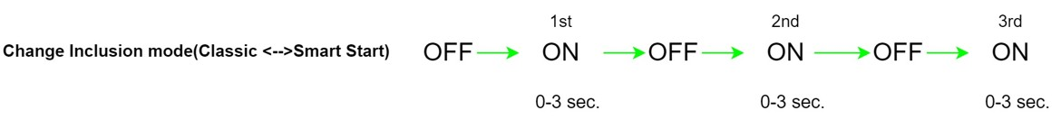

If prompted by the controller to enter the S2 security code, refer to the QR code/security number on the side of the box or the QR code label on the product (see Figure 1). Enter the 5-digit pin code.
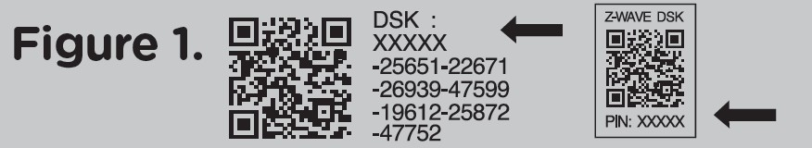

Method 2: SmartStart:
1. When initially powered, the bulb is in SmartStart inclusion mode. If the bulb is in classic mode.Turn the bulb OFF, then ON three times to change it to SmartStart inclusion mode. The bulb rapidly flashes six times for 10 seconds to indicate SmartStart mode.
2. If your hub supports SmartStart, scan the QR code. Turn bulb OFF, then ON. The bulb can be added into a Z-Wave network by scanning the Z-Wave QR Code.
3. The bulb flashes twice to indicate it was added to the network.

Note: The bulb remains in the last known inclusion mode when cycled OFF/ON once.

1.2 To remove and reset the device

Method 1: Using Exclusion:
1. Follow the instructions for your Z-Wave certified controller to remove a device from the Z-Wave network.
2. Once the controller is ready to remove your device, turn bulb OFF, then ON three times. The smart bulb flashes twice when removed from the network.

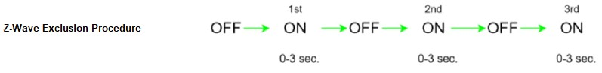

Method 2: Using Device Reset Locally:
Starting with the bulb on, cycle the wall switch OFF/ON four times.
1. Turn the switch off, pause one second, then turn back ON.
2. Repeat three times (four times total).
3. The smart bulb flashes twice when reset.
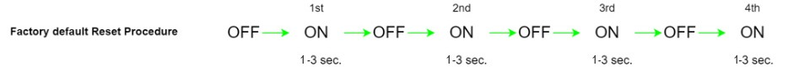
Note: Device Reset Locally will reset all configuration parameters to their default value and reset the inclusion mode to Smart Start mode.

1.3 Configuration Parameters:

Parameter 1:
Dim level when light bulb is turned ON Length: 1 Byte
Valid Values: 0, 1 or 2 (default = 0)
value = 0, the brightness level will resume to full brightness when the Smart Bulb is turned ON
every time by manual switch (or when power is restored after a power failure).
value = 1, the brightness level will maintain same dim level as the last setting when the Smart Bulb is turned ON again by manual switch (or when power is restored after a power failure).
value = 2, restoring power to the light bulb will always keep last lamp status

Parameter 6:
Enable/Disable Ramping when power is restored to bulb
Length: 1 Byte
Valid Values: 0, 1(default = 0)
0: do not ramp, turn instantly to appropriate level when power is restored.
1: perform dimming ramping behavior to appropriate level when power is restored.

1.4 Supported Associations:

Grouping Identifier | Max Nodes | Report Commands
Lifeline | 5 | Multilevel Report  Device Reset Locally Notification  Indicator Report

2.Z-Wave Specific:

This product can be operated in any Z-Wave network with other Z-Wave certified devices from other manufacturers. All mains operated nodes within the network will act as repeaters regardless of vendor to increase reliability of the network.

2.1 Basic Command Class mapped:

Basic Command | Mapped Command
Basic Set (Value) | Multilevel Switch Set (Value)
Basic Report (Current Value, Duration) | Multilevel Switch Report (Value, Duration)

2.2 Supported Command Classes list:

Command Class | Version | Required Security Class
Z-Wave Plus Info | 2 | None
Configuration | 4 | Highest granted Security Class
Multilevel Switch | 4 | Highest granted Security Class
Association | 2 | Highest granted Security Class
Multi-Channel Association | 3 | Highest granted Security Class
Association Group Info | 3 | Highest granted Security Class
Transport Service | 2 | None
Version | 3 | Highest granted Security Class
Manufacturer Specific | 2 | Highest granted Security Class
Device Reset Locally | 1 | Highest granted Security Class
Indicator | 3 | Highest granted Security Class
Power level | 1 | Highest granted Security Class
Application Status | 1 | None
Security 2 | 1 | None
Supervision | 1 | None
Firmware Update Meta Data | 5 | Highest granted Security Class
Basic | 2 | Highest granted Security Class

2.3 Z-Wave Plus v2 documentation terminology：

Z-Wave functionality | Documentation terminology | Example
Inclusion | Add | The process of adding a node to the Z-Wave network.
Exclusion | Remove | The process of removing a node from the Z-Wave  network.
Replication | Copy | The process of copying network information from  one controller to another.

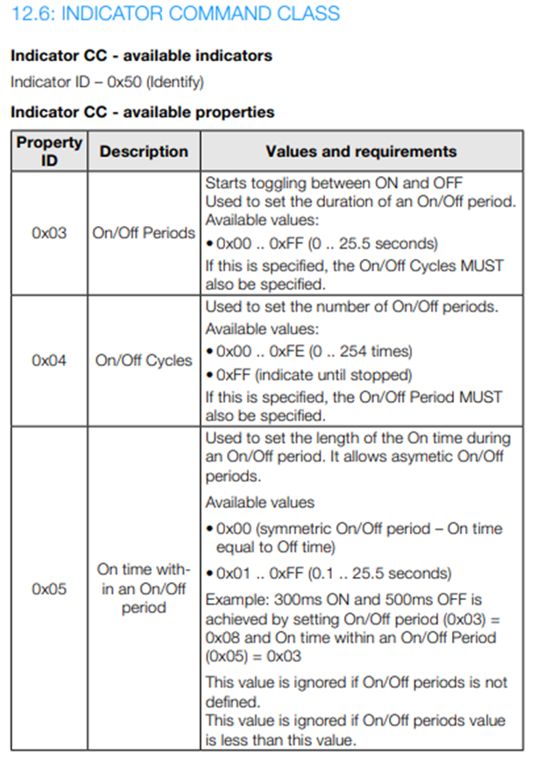
Indicator CC - Identifying the device with LED signal The device can be Identified using LED signal:
76609: the LED indicator will blink the bulb 3 times (3 times: ON for 600ms, then OFF for 200ms)

