Smoke Detector (SD-32-H-SC-AC-ZW)
SD-32-H-SC-AC-ZW is a wireless smoke detector designed to protect you against potential fire hazards. The Smoke Detector uses multi-criteria sensor technology to distinguish between fast-burning flames and slow-smoldering fires, while at the same time incorporates intelligent technology to differentiate between cooking smoke and actual life-threatening house-fire emergencies, virtually eliminating nuisance alarms.
In addition to its smoke detection capabilities, the Smoke Detector also features heat detection and temperature report to users.
The Smoke Detector is a Z-Wave® enabled device and is fully compatible with any Z-Wave® enabled network. Z-Wave® is a wireless communication protocol that uses a low-power RF radio. By taking advantage of the Z-Wave® mesh network, commands can be transmitted to their destination via Z-Wave® products. The Z-Wave® Smoke Detector allows access to the “S2 Unauthenticated” class.
The Smoke Detector’s alarm situations, battery condition, operating conditions, supervisory data and general fault information are sent to the Z-Wave® Gateway/Control Panel wirelessly. The device can also be serially connected with other sensors in the Z-Wave® gateway to serve as an extra siren. When any other sensor in the Z-Wave® network is activated and sends an alarm signal, the Smoke Detector will also raise alarm with its built-in buzzer as a siren to help sound warning.
The Smoke Detector calibrates for the air contents after warming up to determine a standard condition for the environment. It can also be manually instructed to calibrate for air content. It is also pre-programmed to automatically calibrate once every 15 days.
Parts Identification
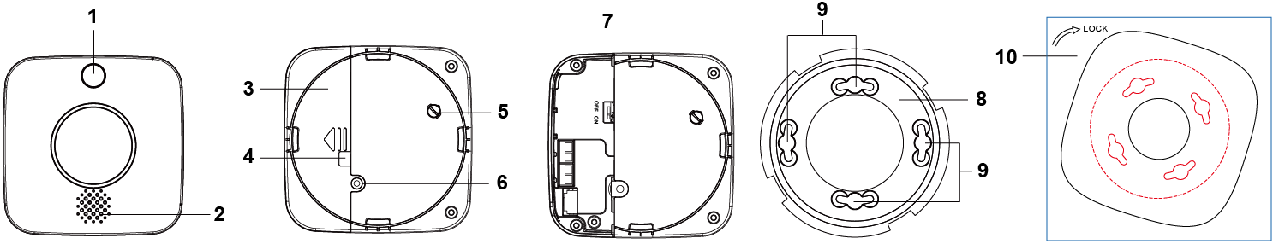
- LED Indicator / Function Button
Red LED
- Quick flash: Alarming
- Flashes every 1 second: Under Alarm Silence Mode
- Flashes every 2 seconds: Under warm-up and calibration process
- Flashes every 4 seconds with Orange LED (mixed color display): battery exhausted
- Turns on for 0.2 seconds: Test Button Press / Signal Transmission
Orange LED
- Flashes every second: Calibration failed
- Flashes every 4 seconds with Red LED (mixed color display): battery exhausted
- Flashes every 5 seconds: Detecting smoke failed or device malfunctioning
- Flashes every 45 seconds: Low battery
Function Button
- Press the button once to:
- Send a test signal
- Check smoke detection chamber
- Silence alarm when the Smoke Detector is alarming
- Press the button 3 times within 1.5 seconds to send a learn code
- Press and hold the button for 10 seconds to enter calibration process
- Press and hold the button for 20 seconds to perform factory reset
- Buzzer
Condition | Indication
Power ON | 2 beeps
Warm up completes | 1 beep
Calibration succeeds | 2-tone beeps
Calibration fails | Continuous beeps
Press the button once (SD functions normally) | 2-tone beeps
Press the button once (optical chamber dirty or out-of-order) | 2-tone beeps * 3
Low Battery | One beep every 45 seconds
Press the button for 10 seconds to enter manual calibration | 2 beeps
Press the button for 20 seconds to Factory Reset | 3 beeps
Alarm Activation | Alarm sound

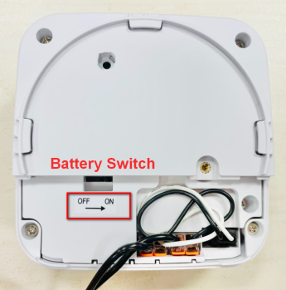
- Battery Compartment
- Pre-punched Hole for Wiring
- Tamper Switch
- Fixing Screw of Battery Comapartment Cover
- Battery Switch
Use a pair of tweezers to slide the Battery Switch to ON Position (Right).
- Mounting Bracket
- Mounting Holes
- Mounting Sheet
Features
- Power Supply
- The Smoke Detector uses AC 100-240V as its power source and has three 200mAh AAA Ni-MH rechargeable batteries as its backup battery in case of power failure. When AC power is applied, the rechargeable battery will be charged at the same time.
<Note>The backup batteries are NOT replaceable.
- When AC power supply is interrupted and restore, the Smoke Detector will transmit AC failure and restore signal respectively.
- The Detector will also report its battery percentage to the Gateway/Control Panel respectively at 20%, 30%, 40%, 50%, 60%, 70%, 80%, 90%, and 100%. If the battery voltage is low (20%), a Low Battery signal will be sent to the Control Panel to notify the user.
- Under low battery status, a low battery signal will be transmitted along with regular signal transmissions; the Orange LED will flash once along with one beep every 45 seconds.
<NOTE>
- The first press of the Function Button in the low battery status will stop the beep for 7 days. Any further button press after 7 days will not silence the warning beeps.
- The Red and Orange LEDs (mixed color display) will flash once every 4 seconds when the batteries are exhausted.
- Testing the Smoke Detector
By pressing the Function Button on the Smoke Detector, you can test if the Smoke Detector is functioning normally.
- If the Smoke Detector functions normally, the Red LED will be on for 0.2 seconds, followed by a 2-tone beep.
- If the buzzer sounds 2-tone beeps 3 times, the “Optical Chamber” on the Smoke Detector is either dirty or out-of-order.
- Tamper Switch
- The Smoke Detector is protected by a tamper switch which is compressed when it is hooked onto the mounting bracket. When the Detector is removed from the mounting bracket, the tamper switch will be activated and the Detector will send a tamper open signal to the system control panel to remind the user of this condition.
- The Smoke Detector will send a tamper close signal to the Control Panel after the device is hooked onto the mounting bracket. Please note that the Detector has to be included in the Z-Wave® network first.
- Temperature Detection
- The Temperature Sensor measures temperature every 10 seconds, and transmits temperature reading to the Control Panel every 30~33 minutes or when temperature changes by +/- 2°C.
- Users can also press the Function Button once to transmit current temperature reading manually.
- Alarm Activation
The Smoke Detector will activate the fire alarm when smoke is detected. SD-32-H-SC-AC-ZW, equipped with heat detection, will also activate the alarm when high heat is detected. When an alarm is activated, the Smoke Detector will transmit an alarm signal and sound its built-in buzzer.
Smoke Detection
- The Smoke Detector checks smoke concentration every 8 seconds.
- The alarm is activated whenever the smoke concentration exceeds the detection threshold, and will continue until the smoke concentration drops below alarm threshold.
- The Red LED will flash quickly while alarming.
Heat Detection
- The Smoke Detector checks temperature every 10 seconds. The alarm will be activated in the following conditions:
- When the temperature rises by 8.25°C per minute (Rate of Rise).
- When the temperature exceeds 57.25°C (High Heat).
- The Red LED will flash every second during alarm. The Smoke Detector will only stop alarming if the temperature drops below alarm threshold.
- If the alarm was triggered by Rate of Rise condition (8.25°C per minute or more), the temperature must drop to 4°C below highest temperature detected for the detector to stop alarming.
- If the alarm was triggered by High Heat condition (57.25°C), the temperature must drop below 49°C for the Smoke Detector to stop alarming.
- The Smoke Detector will transmit a restore signal if no smoke or high heat is detected for 160 seconds.
- If the alarm condition continues, the Smoke Detector will resend an alarm signal every 2 minutes.
- Interconnection
- By using the Basic Set On/Off commands, the Smoke Detector can be serially connected with other sensors in the Z-Wave® gateway to serve as an additional siren. When any other sensor in the Z-Wave® network is activated and sends an alarm signal, the Smoke Detector will also sound its alarm buzzer as a siren to help alert users to the alarm.
- Alarm Silence
- When the Smoke Detector is alarming, pressing the Function Button will put the Smoke Detector into Alarm Silence mode to mute the alarm for 9 minutes. The buzzer will only stop sounding after the alarm has been activated for at least 1-minute. If the button is pressed before alarm time reaches 1 minute, the Smoke Detector will wait until alarm time has reached 1 minute before silencing the alarm.
- During the 9-minute Alarm Silence period, the Red LED will flash once per second. The Smoke Detector will continue to monitor smoke concentration during the alarm silence period.
- After the 9-minute Alarm Silence period has expired, if the smoke concentration has dropped below the alarm threshold, the Smoke Detector will emit a 2-tone beep and return to normal operation without sounding the alarm.
- If smoke concentration still exceeds alarm threshold, the Smoke Detector will start alarming again.
- If smoke concentration continues to rise during the Alarm Silence period and exceeds a second alarm threshold, the Smoke Detector will start alarming again. An alarm activated by exceeding the second alarm threshold cannot be silenced by pressing the Function Button.
- Auto-Calibration
- The Smoke Detector will perform auto-calibration 12 hours after being powered on. Afterwards, it will perform auto-calibration once every 15 days. During the auto-calibration process, the Smoke Detector will not emit any sounds, but the Red LED will flash once every 2 seconds.
- If auto-calibration fails, the Orange LED will flash every second, and the Smoke Detector will send a calibration failure code to the Control Panel. To stop the Orange LED flashing, completely power off the device by removing the AC power and sliding the battery switch to OFF. Then, repower the device. Alternatively, you can manually restart the calibration process. Refer to the section below for details.
<NOTE>
- When the Smoke Detector’s auto-calibration fails, the smoke alarm function will still work normally using the threshold value taken from the last successful calibration.
- Recalibration (Manual Calibration)
- Press and hold the Function Button for 10 seconds and release when the Smoke Detector emits 2 short beeps. The Smoke Detector will begin calibration, and the Red LED will flash every 2 seconds to indicate.
- Calibration process lasts for 1 minute (If calibration fails, the smoke detector will retry calibration, calibration mode will last 9 minutes at most).
- When calibration is finished, the Smoke Detector will sound a two-tone beep. The Red LED will stop flashing to indicate it has returned to normal mode.
- If calibration fails, the Smoke Detector will beep continuously, and the Orange LED will flash every second. You will need to completely power off the device by removing the AC power and sliding the battery switch to OFF. Then repower on the device.
- If a smoke detector fails calibration continuously, inspect and clean the detector, and verify its installation environment. If troubleshooting does not resolve the issue, consult the supplier. The detector may need to be replaced.
Getting Started
- SD-32-H-SC-AC-ZW uses AC 100-240V as its power source and has three 200mAh AAA Ni-MH rechargeable batteries as its backup battery in case of power failure.
- To connect the Smoke Detector to AC (mains) power, please follow the steps below:
Step 1 Before you start, find the circuit breaker or fuse box.
Step 2 Once you have found it, open the door and turn off the main power switch.
Step 3 Two Wago 221 Splicing Connectors are provided. Take out one connector. Pull the lever up and insert the white wire (FIG. 1).
Step 4 Push the lever back down (FIG. 2). The transparent housing allows you to check if the wire is connected properly. Make sure the wire is tightly held in place before you proceed.
FIG. 1 | FIG. 2
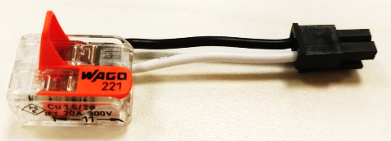 | 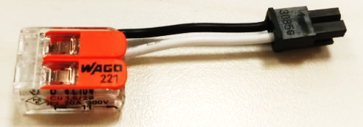
Step 5 Repeat Steps 3 and 4 to insert the black wire. Inserting the two wires to the same side (right) of the two connectors (FIG. 3) provides an easier installation in the following steps.
Step 6 Insert the AC wires to the two connectors respectively (FIG. 4). Use a pair of tweezers to turn the Battery Switch to ON position (right side); the rechargeable battery will begin to charge.
FIG. 3 | FIG. 4
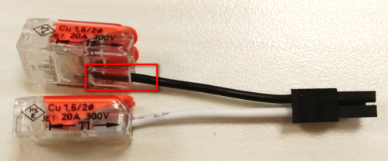 | 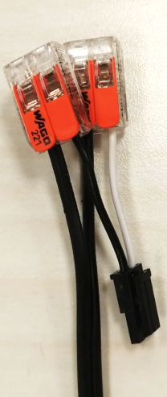
- Warm-up: After the power is supplied, the Smoke Detector will sound 2 short beeps, and the Red LED will start to flash to indicate the Detector is performing a 1-minute warm-up.
- Calibration: When the 1-minute warm-up is over, one short beep will sound to indicate the Detector is starting the calibration process. The Detector will emit a 2-tone beep to indicate the calibration is completed, and the Red LED will turn off.
The Smoke Detector will emit continuous beeps to indicate calibration failure. Disconnect the power supply and then re-connect it after a pause of at least 30 seconds to retry warm-up.
- After warm-up and calibration are complete, proceed to learn (include) the Smoke Detector into the Panel/gateway. Please refer to Add Device (Inclusion) section for details
Add Device (Inclusion)
The Smoke Detector can be included and operated in any Z-Wave® network with other Z-Wave® certified devices from other manufactures and/or other applications. All non-battery operated nodes within the network will act as repeaters regardless of vendor to increase reliability of the network. The device supports both classic inclusion and SmartStart inclusion.
Classic Inclusion
Step 1 Put the Z-Wave® gateway or control panel into Inclusion or Learning mode (please refer to the Z-Wave® gateway or control panel manual).
Step 2 Within 1.5 seconds, press the Function button 3 times. The Smoke Detector will emit a 2-tone beep and the LED will turn on for about 0.2 seconds. Refer to the operation manual of the Z-Wave® gateway or control panel to complete the learn-in process.
<NOTE>
- If the Detector has already been included (learnt) into another Z-Wave® Gateway/Control Panel, or if it is unable to be learnt into the current Z-Wave® Gateway/Control Panel, please remove it first (see Exclusion below) before attempting to include it into the current Z-Wave® Gateway/Control Panel.
SmartStart Inclusion
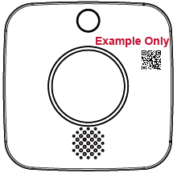
Z-Wave® SmartStart utilizes the DSK of the device to enhance and simplify the inclusion process. DSK is Device Specific Key used for authentication and encrypted communication. The DSK information is stored in the QR code format on the device.
Step 1 Scan the QR Code on the Smoke Detector to obtain DSK and transfer to the Z-Wave® gateway.
Step 2 Connect the Smoke Detector to AC power to power on the device, and a SmartStart inclusion request will be automatically sent to the gateway.
Step 3 The gateway will automatically include the device upon recognition of the device by matching the inclusion request with the DSK obtained
<NOTE>
- The DSK of the device is used only during inclusion process. It can be read without the Smoke Detector powering ON, so it is possible to prepare the gateway to include the device prior to installing and providing power to the device.
- If the Smoke Detector has already been included (learnt) into another Z-Wave® Gateway/Control Panel, please exclude it first (see Exclusion) before attempting to include it into the current Z-Wave® Gateway/Control Panel. The Smoke Detector will not send a SmartStart inclusion request if it’s already in a Z-Wave® Gateway/Control Panel.
- Range Test
To test whether the device is able to communicate with the Z-Wave® gateway or control panel after inclusion:
- Put the gateway / panel into range test mode (Walk Test).
- Press the Function button on the device.
- The gateway / panel should display the device information if the device is within the operation range (please refer to the operation manual of the gateway / panel).
Removing Device (Exclusion)
The Smoke Detector must be removed from existing Z-Wave® network before being included into another. There are two methods available to exclude a device.
Exclusion Mode
Step 1 Put the Z-Wave® gateway or control panel into Exclusion mode (please refer to the Z-Wave® gateway or control panel manual).
Step 2 Within 1.5 seconds, press the Function button 3 times and the Smoke Detector will be removed from the Z-Wave® network.
Factory Reset
(Only use factory reset when network Control Panel/Gateway is missing or inoperable).
Step 1 Press and hold the Function button for 20 seconds.
Step 2 Release the button after 3 beeps to factory reset.
<NOTE>
- Before you remove or factory reset the Smoke Detector, please ensure that the device DSK information has been removed or does not exist in the gateway. If you remove or factory reset the device, but its DSK still exists in the gateway, the gateway will automatically include the device again.
- Factory resetting the Smoke Detector will restore it to factory default settings (excluded from the Z-Wave® network). The Z-Wave® gateway or control panel will still keep its Z-Wave® settings. Please refer to the gateway or control panel manual on how to remove the Smoke Detector’s Z-Wave® settings.
Maintenance & Cleaning
Regular maintenance and cleaning will help keep your Smoke Detector in good working order.
- Test the Smoke Detector weekly to verify that the alarm sounds and indicators are working properly.
- Clean the Smoke Detector at least once every 6 months.
- Gently vacuum off the dirt/dust/small particles accumulated in the smoke detection chamber and slots.
- Clean the casing by swiping it thoroughly with a damp cloth and dry it. Do not get water inside the alarm.
- Never use cleaning agents, detergents or solvents on the detector.
- Avoid spraying air freshener, hair spray, or other aerosols near the Smoke Detector.
- Do not paint nor modify the detector under any circumstances.
Expiration
The Smoke Detector has a maximum life time of 10 years from the date of installation. You should replace the Smoke Detector immediately after 10 years of service.
It is recommended to write the “Replace by” date (10 years from installation date) on the back of the detector prior to installation.
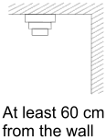
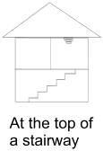
Installation
- Installation Guideline
- It is recommended that the installation site be in the center area of the ceiling.
- Do not locate the detector in the following locations:
- The Kitchen – Smoke from cooking might cause an unwanted alarm.
- Near a ventilating fan, florescent lamp or air-conditioner – air drafts from them may affect the sensitivity of the detector.
- Near ceiling beams or over a cabinet – stagnant air in these areas may affect the sensitivity of the detector.
- In the peak of an “A” frame type of ceiling.
- Mounting the Smoke Detector
- The Smoke Detector is designed to be mounted on the ceiling. The ideal mounting height for the Smoke Detector is 3 meters. Mounting above 3 meters can affect detection performance.
- A mounting sheet is provided to help users correctly install the Smoke Detector.
- The mounting sheet has a perforated design (as shown in red dashed lines below) for mounting holes and the mounting bracket, and can be removed from the mounting surface easily after installation.
Please follow the steps below to mount the Smoke Detector:
Step 1– Using Mounting Sheet: Place the mounting sheet on the surface to be mounted; use the mounting holes on the mounting sheet to drill four mounting holes into the surface.
Step 2: (Optional) Insert wall plugs if required. Ensure the wall plugs are flush with the mounting surface.
Step 3 – Aligning Mounting Bracket: Precisely align the four mounting holes on the mounting bracket with those on the mounting sheet and screw the mounting bracket onto the wall plugs.
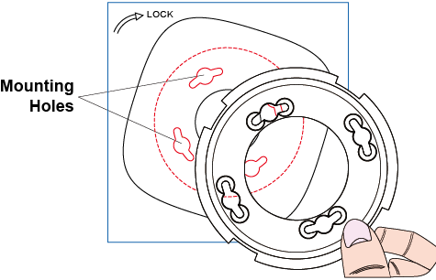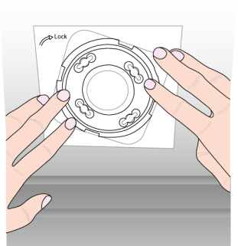
Step 4 – Mounting Detector: The Smoke Detector has 4 hooks (circled in red) on its back cover. Carefully hold the Detector and fit it onto the four notches (circled in green) on the mounting bracket (FIG. 1).
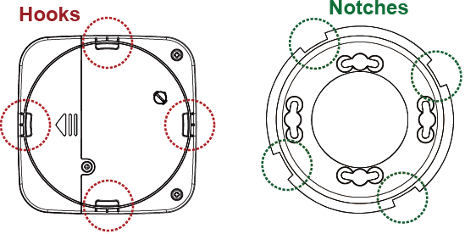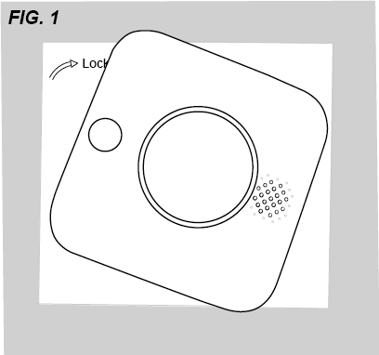
Step 5: Rotate the Smoke Detector clockwise to lock it in place (FIG. 2).
Step 6: Installation is now complete (FIG. 3). You can remove the mounting sheet.
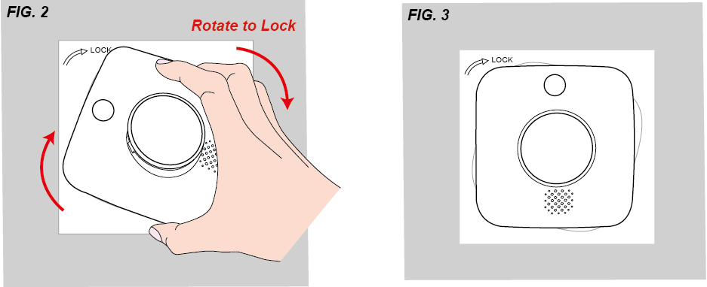
- Z-Wave® Information
Device Type: Sensor – Notification Smoke Alarm
Role Type: Always on Slave (AOS)
Max Association Group: 2
Max Node: 10
Command Class Support/Control
Mandatory CC Support:
Command Class | Version
Z-Wave® Plus Info CC | 2
Association CC, (S2) | 2
Multi Channel Association, (S2) | 3
Association Group Information CC, (S2) | 1
Transport Service CC | 2
Version CC, (S2) | 2
Manufacturer Specific CC, (S2) | 2
Device Reset Locally CC, (S2) | 1
Power Level CC, (S2) | 1
Battery CC, (S2) | 1
Security 2 | 1
Notification CC, (S2) | 8
Sensor Multilevel CC, (S2) | 11
Supervision CC, (S2) | 1
Firmware Update Md CC, (S2) | 5
Indicator CC (S2) | 3

- Z-Wave®’s Groups (Association Command Class Version 2)
The Smoke Detector can be set to send reports to associated Z-Wave® devices. It supports 2 association groups.
Group 1 for “LifeLine”
Max Node:10
Battery CC (COMMAND_CLASS_BATTERY)
Notification CC, V4 (COMMAND_CLASS_NOTIFICATION)
SensorMultilevel CC, V4 (COMMAND_CLASS_SENSOR_MULTILEVEL)
Device Reset Locally CC (COMMAND_CLASS_DEVICE_RESET_LOCALLY)
Group 2 for “Sensor Basic set”
Max Node:10
Basic CC (COMMAND_CLASS_BASIC)
    - When the Smoke Detector is activated, it will send Basic Set (0xFF) in Group 2.
    - When the Smoke Detector is restored, it will send Basic Set (0x00) in Group 2.
- Command Class Data Format
- AC Failure/Restore: [COMMAND_CLASS_NOTIFICATION] [NOTIFICATION_REPORT]
- When an AC power failure is detected, the Detector will send an AC failure signal to the Control Panel. When AC power is restored, the Detector will send a restore signal to the Control Panel.
- AC Failure: 00 00 00 FF 08 02 00 00
- AC Restore: 00 00 00 FF 08 03 00 00
- Battery: [COMMAND_CLASS_BATTERY] [BATTERY_REPORT]
- 0x64 --- 100% Battery Full
- 0x5A --- 90% Battery
- 0x50 --- 80% Battery
- 0x46 --- 70% Battery
- 0x3C --- 60% Battery
- 0x32 --- 50% Battery
- 0x28 --- 40% Battery
- 0x1E --- 30% Battery
- 0x14 --- 20% Low Battery
- 0xFF --- Battery Dead (Cut Off)
- Cut Off --- The device will stop working and both Red and Amber LEDs will flash every 4 seconds.
- When AC power is applied, the rechargeable battery will be charging at the same time, and the Detector will report its battery percentage to the Gateway/Control Panel respectively.
- When AC power is removed or power failure takes place, the Detector will use its built-in rechargeable battery and report its battery percentage. After AC power is reapplied, the Detector will report its battery percentage detected.
- Smoke Detection Triggered/Smoke Detection Restored: [COMMAND_CLASS_NOTIFICATION] [NOTIFICATION_REPORT]
- Smoke Alarm Triggered: 00 00 00 FF 01 02 00
- Smoke Alarm Restored: 00 00 00 FF 01 00 01 02
- Smoke Alarm Silenced: 00 00 00 FF 01 06 00
- Dust Force Maintenance: [COMMAND_CLASS_NOTIFICATION] [NOTIFICATION_REPORT]
- If the Optical Chamber gets too much dust for the Smoke Detector to function normally, the Detector will report to the Panel for force maintenance warning.
- Force Maintenance: 00 00 00 FF 01 08 00
- Heat Detection Triggered/Heat Detection Restored: [COMMAND_CLASS_NOTIFICATION] [NOTIFICATION_REPORT]
- Heat Alarm Triggered: 00 00 00 FF 04 02 00
- Heat Alarm Restored: 00 00 00 FF 04 00 01 02
- Heat Alarm Silenced: 00 00 00 FF 04 09 00
- Tamper Open/Close report [COMMAND_CLASS_NOTIFICATION] [NOTIFICATION_REPORT]
- The Detector is protected by a tamper switch which is compressed when it is hooked onto the mounting bracket. When the Detector is removed from the mounting bracket, the tamper switch will be activated and the Detector will send a tamper open signal to the system control panel to remind the user of this condition.
- Tamper Open: 00 00 00 FF 07 03 00 00
- Tamper Close: 00 00 00 FF 07 00 01 03
- Temperature Report: [COMMAND_CLASS_SENSOR_MULTILEVEL] [SENSOR_MULTILEVEL_REPORT]
- The Smoke Detector can report temperature signal to the Control Panel every 30 to 33 minutes with Smoke Detector normal operating or when temperature changes by +/- 2°C.
- Temperature: 01 22 00 FA
- If a temperature signal 01 22 00 FA is transmitted, 00 FA can be viewed as 0x00FA in Hexadecimal number. You can convert hexadecimal to decimal and divide by 10 to check the temperature data (in Celsius).
0x00FA=250=25.0°C

- Indicator Control : [COMMAND_CLASS_INDICATOR] [INDICATOR_SET]
- The LED indicator of SDCO Detector can be controlled by using Indicator Set commands.
- The following commands can be used to set the indicator command:
7 | 6 | 5 | 4 | 3 | 2 | 1 | 0
Command Class = COMMAND_CLASS_INDICATOR
Command = INDICATOR_SET
Indicator 0 Value (Indicator ID 0=00, Property ID 0=01)
Reserved |  |  | Indicator Object Count
Indicator ID 1
Property ID 1
Value 1
- Indicator Object Count (0x01) --- to control LED indicator ID 1
- Indicator ID (0x50) --- NODE IDENTIFY
Indicator ID | Description | Appearance and use
0x50 | NODE IDENTIFY | Use to draw attention to button 1.
- Property ID (0x04) --- LED on off times
Value | General Description | Specific use
0x04 | On_Off_Cycles | Number of On_Off_Period to run  0x00 – 0xFE = 0-254 times  0xFF = Run until stopped by On_Off
- If you would like the SDCO Detector to flash 5 times to show its location, send: 0x00 01 50 04 05
- For more details, please refer to “SDS-13781-1 Z-Wave® Application Command Class Specification”.

