In-Wall Smart Switch Advanced Information Product Manual

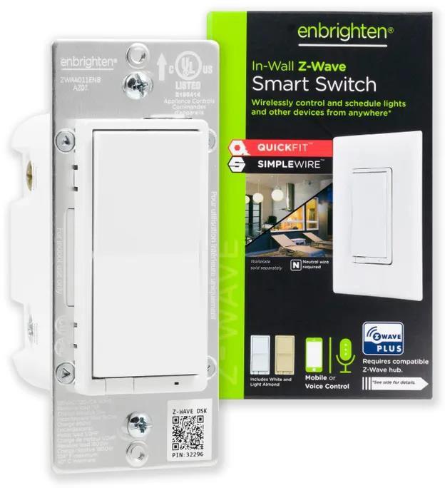

Engineering | Specification
Eco Dimmer Advanced Information Product Manual
Document No. | Engineering Specification – Z-Wave® Product Line (ZWA4012)
Version | 1.0
Description | This document mainly introduces the new generation Z-Wave Plus® In-Wall Smart Switch . The content mainly includes its interfaces, accessories, features, specifications, quick start, and software function definition.  In-Wall Smart Switch is a Z-Wave Plus v2 device with many advantages.  - Turn ON/OFF manually or remotely through the Z-Wave controller.  - Can be added in multiple groups and scenes.  - Auto-detect line/load terminals.  - May be used in single-pole installation or 3-way wiring configurations.  - Compatible with all LED, CFL, incandescent and halogen lights.  - Interchangeable paddle.  - Uses a standard, rocker-style wallplate for single-gang installations (wallplate not included).  - Multicolor LED indicates switch location in a dark room.  - Screw terminal installation – requires wiring connections for line (hot), load, neutral and ground. Traveler wire required for 3-way installation.  - This Z-Wave device has advanced features that allow you to customize your experience. These features can only be adjusted by a Z-Wave enabled controller that supports the Z-Wave configuration command class. For a complete list of adjustable configurations, visit www.ezzwave.com/config.  - Support SmartStart, which makes inclusion more convenient.  - Support S2, which makes it more secure and reliable.  - Support Long Range, extended communication range is more than 400 meters.
Written By
Date
Reviewed By
Date
Approved By
Date

Table of Content
- OVERVIEW 1
  - Important safety information 1
  - About Z-Wave 1
  - About SmartStart 1
  - About Z-Wave Long Range 1
  - About The Product 1
- INTERFACES & INSTALLATION 3
  - Interfaces 3
  - Installation Wiring Diagram 3
- FEATURES & SPECIFICATIONS 5
  - Structural Characteristics 5
  - Hardware Characteristics 5
  - Software Characteristics 5
- PRODUCT QUICK START 7
  - Z-Wave DSK Location 7
  - How to add the product into Z-Wave network 7
  - How to remove the product from Z-Wave network 7
  - How to factory reset 7
- SOFTWARE FUNCTION DEFINITION 7
  - User Behavior Interaction 9
  - Supported Command Classes 10
  - Basic Command Class mapping 10
  - ZWAVEPLUS_INFO 10
  - Manufacturer Specific 11
  - Version 11
  - Association Group Info 11
  - Central Scene 12
  - Indicator 12
  - Configuration 12

OVERVIEW

Important safety information

Please read this Engineering Specification carefully for correct and effective use.
Failure to follow the recommendations set forth by JASCO Limited may be dangerous or cause a violation of the law. The manufacturer, importer, distributor, and/or reseller will not be held responsible for any loss or damage resulting from not following any instruction in this guide or in other materials.
The product is intended for indoor use in dry locations only. Do not use in damp, moist, and /or wet locations.

About Z-Wave
Z-Wave is the international wireless protocol for communication in the Smart Home.
Z-Wave ensures a reliable communication by reconfirming every message (two-way communication) and every mains powered node can act as a repeater for other nodes (meshed network) in case the receiver is not in direct wireless range of the transmitter.
This device and every other certified Z-Wave device can be used together with any other certified Z-Wave device regardless of brand and origin as long as both are suited for the same frequency range.
If a device supports secure communication it will communicate with other devices secure as long as this device provides the same or a higher level of security. Otherwise it will automatically turn into a lower level of security to maintain backward compatibility.

About SmartStart
SmartStart enabled products can be added into a Z-Wave network by scanning the Z-Wave QR Code present on the product with a controller providing SmartStart inclusion. No further action is required and the SmartStart product will be added automatically within 10 minutes of being switched on in the network vicinity.

About Z-Wave Long Range
Z-Wave Long Range device can only support be included via SmartStart. Extract the DSK from end device and paste it into the DSK Value in PC Controller, make sure the 'Long Range' option is ticked.
The controller doesn't do channel scanning the same way as in end device. The controller will scan 4 channels, including 3 classic Z-Wave channels 9.6/40/100 kbps and 1 LR channel, using US_LR frequency will scan at 912 MHz while using US_LR_BACKUP will scan at 920 MHz during startup. The active LR channel can be switch at runtime.

About The Product
This product can be operated in any Z-Wave network with other Z-Wave certified devices from other manufacturers. All mains operated nodes within the network will act as repeaters regardless of vendor to increase reliability of the network.

This device is a security enabled Z-Wave Plus product that is able to use encrypted Z-Wave Plus messages to communicate to other security enabled Z-Wave Plus products. S2 Security Enabled Controller is required to operate the device.

INTERFACES & INSTALLATION

Interfaces
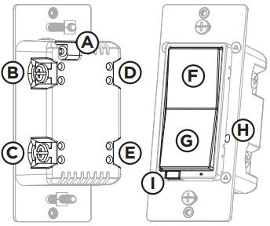

Terminology | Description
A | Ground (Green/bare)
B | Line or load (Black)
C | Line or load (Black)
D | Traveler (Red/other)
E | Neutral (White)
F | Top rocker — press to turn ON device
G | Bottom rocker — press to turn OFF device
H | Menu button
I | Air gap switch — pull the air gap switch out to disconnect the power. Push it all the way back in for normal operation.
  - Installation

Single-Switch Wiring:

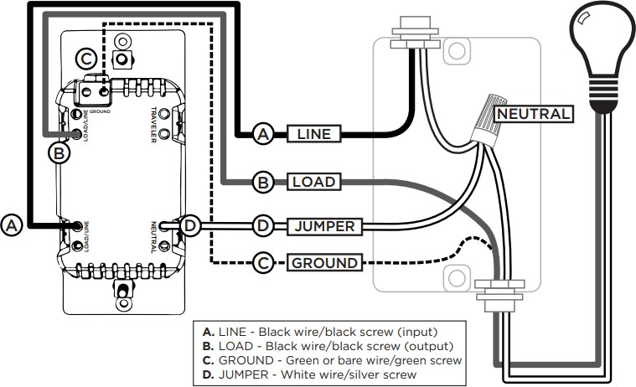

Standard 3-Way Switch Wiring:
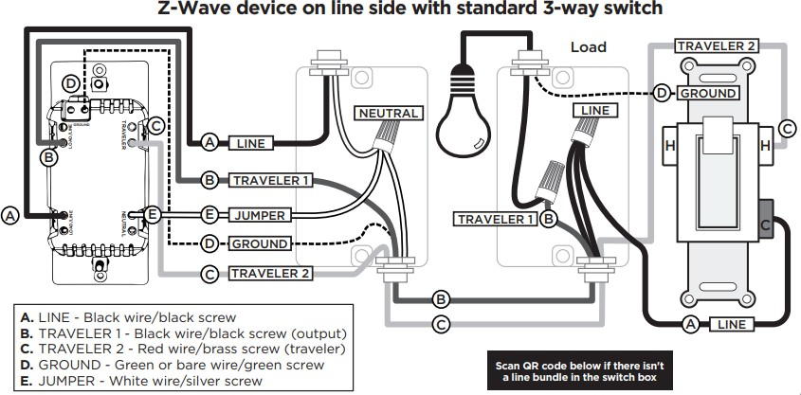

FEATURES & SPECIFICATIONS

Structural Characteristics

Parameter | Value
Product Identifier | ZWA4012
Dimensions | 104.9*43.9*29.9mm
Weight | 650g
Color | White
Usage | For indoor use.
Operating Temperature | 32-104°F (0-40°C)
Relative Humidity | 8% to 85% non-condensing

Hardware Characteristics

Parameter | Value
Z-Wave Module | EFR32ZG23A010F512GM40
Z-Wave TX Power | Max: 14dBm
Z-Wave Antenna Distance | 40m (Indoor) / 200m (Outdoor) / >400(US-LR)
Indicator Light Color | Multicolor
Power | 100VAC,60Hz
Maximum Loads | 960W incandescent, 1/2HP motor or 1800W (15A) resistive
Max standby power

Software Characteristics

Parameter | Value
Wireless Technology | Z-Wave
Certification Type | Z-Wave Plus v2
Z-Wave SDK Version | 7.18.08
Z-Wave Library Type | Enhanced 232 Slave
Z-Wave Role Type | ZWAVEPLUS_INFO_REPORT_ROLE_TYPE_SLAVE_ALWAYS_ON (0x05)
Generic Device Type | GENERIC_TYPE_SWITCH_BINARY (0x10)
Specific Device Type | SPECIFIC_TYPE_NOT_USED (0x00)
Security Class | Non-Security, S2-UNAUTHENTICATED, S2-AUTHENTICATED
SmartStart | Support. After powering on, SmartStart is auto active if it’s out of the Z-Wave network.
Over The Air （OTA） | Support. Firmware can be updated via RF.
Multichannel Device | No
Association | Support. Refer to Section 5.7 Association Group Info.
Factory Reset | Support. Refer to Section 4.4 How to factory reset.
Power-down Memory | Support. All command settings will stay unchanged even power down.
Scene Control | Support. Refer to Section 5.8 Central Scene

Group Control | Support. Refer to Section 5.7 Association Group Info
On/Off Status Report | Support. When Manual or Z-Wave control, send out Switch Multilevel Report via Group 1.
Signal Repeater | Support.
Z-Wave Long Range | Support.

PRODUCT QUICK START

Z-Wave DSK Location
The QR code are stocked to the side of the case, DSK is included in the QR code. The DSK code can be found on the DSK label which is attached on the packaging box.
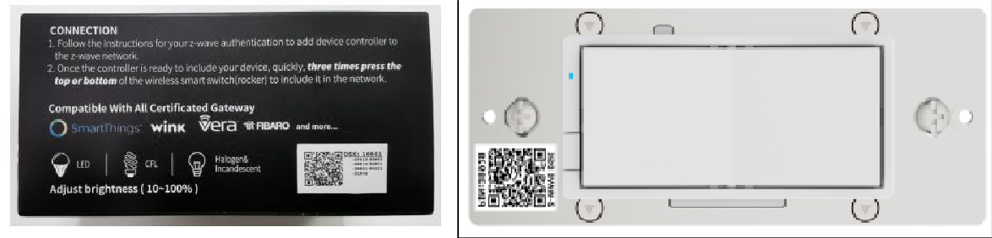
Please do not remove or damage them.

How to add the product into Z-Wave network
- Follow the user guide of hub to enter inclusion mode.

- Press Top paddle or Bottom paddle, enter "Include mode".

- The LED will fast blink green during the inclusion, and then solid green for 2 seconds to indicate the inclusion is successful, otherwise the LED will solid red for 2 seconds in which you need to repeat the process form step 1.

How to remove the product from Z-Wave network
- Follow the user guide of hub to enter exclusion mode.

- Press Top paddle or Bottom paddle, enter "Exclusion mode".

- LED will fast blink green during the exclusion, and then solid green for 2 seconds to indicate that the exclusion is successful, otherwise the LED will solid red for 2 seconds in which you need to repeat the process form step 1.

How to factory reset
- Please use this procedure only when the network primary controller is missing or otherwise inoperable.

- Pull the Airgap switch. Press and hold the Bottom paddle, push the Airgap switch back in and continue holding the Bottom paddle for 10 seconds. The LED will flash once each of the 8 colors then stop, the Switch will reset itself to factory default by sending a "Device Reset Locally Notification" to gateway.

  - 3-Way Configuration
The smart device is set to work with add-on switches by default. To use with a standard 3-way switch, follow the steps below.
- Pull out the air gap switch.

- While pressing the top paddle, push in the air gap switch.
- Continue pressing the top paddle until the LED flashes yellow three times to indicate standard 3-way switch configuration.
- Repeat these steps to return to the add-on switch setting – LED flashes blue three times.

  - Cycle LED
The LED below the dimmer acts as a guide light or status indicator. How to cycle through options:
- Press menu button for five seconds.
- Press up three times and down one time quickly – indicator flashes blue.
- Push the top paddle:
  - Once for LED ON when the load is OFF – illuminates orange to confirm.
  - Twice for LED ON when the load is ON – illuminates yellow to confirm.
  - Three times for always OFF – illuminates pink to confirm.
  - Four times for always ON – illuminates purple to confirm.
- Press menu button once to save – indicator flashes green twice.

  - Change LED Indicator Color
The LED indicator color can be changed from the device.
- Press menu button for five seconds.
- Press top paddle once and bottom paddle once – LED illuminates in selected color.
- Press top or bottom paddle to cycle through color options:

- Red  - Orange  - Yellow  - Green | - Blue (default)  - Pink  - Purple  - White
- Press menu button once to save – indicator flashes green twice.

SOFTWARE FUNCTION DEFINITION

User Behavior Interaction

User behavior | Out of the Z-Wave network | In the Z-Wave network
Power on | Send Inclusion Requests for SmartStart
Inclusion network | Press 1x Top paddle or Bottom paddle, enter "Include mode" | NA
Exclusion network | NA | Press Top paddle or Bottom paddle, enter "Exclusion mode"
Factory reset | NA | Pull the Airgap switch. Press and hold the bottom button, push the Airgap switch back in and continue holding the bottom button for 10 seconds
On/Off Control | Press Top paddle or Bottom paddle the switch will be on or off | Press Top paddle or Bottom paddle the switch will be on or off  Send Switch Binary Report to association group 1
Group Control | NA | Press Top paddle or Bottom paddle the dimmer will Send Basic Set to go association group 2  Press 2x Top paddle or Bottom paddle the dimmer will Send Basic Set to go association group 3
Scene Control | NA | Press 1x/2x/3x/hold/release the Top paddle or Bottom paddle.  Send Central Scene Notification to association group 1

Supported Command Classes

Command |  | Mapped
COMMAND_CLASS_ZWAVEPLUS_INFO_V2 | 2 | None
COMMAND_CLASS_TRANSPORT_SERVICE_V2 | 2 | None
COMMAND_CLASS_SECURITY_2_V1 | 1 | None
COMMAND_CLASS_SUPERVISION_V1 | 1 | None
COMMAND_CLASS_APPLICATION_STATUS_V1 | 1 | None
COMMAND_CLASS_BASIC_V2 | 2 | Highest granted Security Class
COMMAND_CLASS_SWITCH_BINARY_V4 | 4 | Highest granted Security Class
COMMAND_CLASS_CONFIGURATION_V4 | 4 | Highest granted Security Class
COMMAND_CLASS_ASSOCIATION_V2 | 2 | Highest granted Security Class
COMMAND_CLASS_ASSOCIATION_GRP_INFO_V3 | 3 | Highest granted Security Class
COMMAND_CLASS_MULTI_CHANNEL_ASSOCIATION_V3 | 3 | Highest granted Security Class
COMMAND_CLASS_VERSION_V3 | 3 | Highest granted Security Class
COMMAND_CLASS_MANUFACTURER_SPECIFIC_V2 | 2 | Highest granted Security Class
COMMAND_CLASS_DEVICE_RESET_LOCALLY_V1 | 1 | Highest granted Security Class
COMMAND_CLASS_POWERLEVEL_V1 | 1 | Highest granted Security Class
COMMAND_CLASS_FIRMWARE_UPDATE_MD_V5 | 5 | Highest granted Security Class
COMMAND_CLASS_NOTIFICATION_V8 | 8 | Highest granted Security Class
COMMAND_CLASS_CENTRAL_SCENE_V3 | 3 | Highest granted Security Class
COMMAND_CLASS_SCENE_ACTUATOR_CONF_V1 | 1 | Highest granted Security Class
COMMAND_CLASS_SCENE_ACTIVATION_V1 | 1 | Highest granted Security Class
COMMAND_CLASS_INDICATOR_V3 | 3 | Highest granted Security Class

Basic Command Class mapping
Basic Command maps to Switch Multilevel Command Class, as shown below.

Command | Mapped
Basic Set | Switch Binary Set
Basic Report | Switch Binary Report
Basic Get | Switch Binary Get

ZWAVEPLUS_INFO
The Command is used to differentiate between Z-Wave Plus v2, Z-Wave for IP and Z-Wave devices. This command provides additional information about the Z-Wave Plus v2 device in question.

Parameter | Value
Z-Wave Plus Version | 0x02
Role Type | 0x05 (ZWAVEPLUS_INFO_REPORT_ROLE_TYPE_SLAVE_ALWAYS_ON)
Node Type | 0x00 (ZWAVEPLUS_INFO_REPORT_NODE_TYPE_ZWAVEPLUS_NODE)
Installer Icon Type | 0x0704 (ICON_TYPE_SPECIFIC_ON_OFF_POWER_SWITCH_WALL_LAMP)
User Icon Type | 0x0700 (ICON_TYPE_GENERIC_ON_OFF_POWER_SWITCH)

Manufacturer Specific
The Command is used to advertise manufacturer specific information.

Parameter | Value
Manufacturer ID 1 | 0x00
Manufacturer ID 2 | 0x63
Product Type ID 1 | 0x49
Product Type ID 2 | 0x52
Product ID 1 | 0x32
Product ID 2 | 0x39

Version
The Command may be used to obtain the Z-Wave library type, the Z-Wave protocol version used by the application, the individual command class versions used by the application.

Parameter | Value
Z-Wave Protocol Library Type | 0x03
Z-Wave Protocol Version | 0x07
Z-Wave Protocol Sub Version | 0x12
Firmware 0 Version | Z-Wave Chip Firmware Version Major
Firmware 0 Sub Version | Z-Wave Chip Firmware Version Minor
Hardware Version | 0x01
Number of firmware targets | 0x00

Association Group Info
The Command is used to manage associations to Node ID destinations.

ID | Name | Count | Profile | Function
1 | Lifeline | 5 | General: Lifeline (0x0001) | Switch Binary Report(0x2503)： Issued when switch status changed.  Device Reset Locally Notification (0x5A01)： Issued when Factory Reset is performed.  Central Scene Notification(0x5B03)： Issued when up/down button is performed.  Central Scene Configuration Notification(0x5B06) ：  Issued when Central Scene Configuration changed. Configuration Report(0x7006)

Issued when the configuration value is changed by manual.
Indicator Report(0x8703)：
Issued when indicator set received.
2 | Basic Set for Single Press | 5 | General: KEY01 (0x2001) | Basic Set (0x2001) ：  Issued when press Top paddle or Bottom paddle.
3 | Basic Set for Double Press | 5 | General: KEY02 (0x2002) | Basic Set (0x2001) ：  Issued when press 2x Top paddle or Bottom paddle.

Central Scene
The Command is used to advertise external switch action, such.

Top paddle:

Action | KeyAttributes | SceneNumber | Description
Held | 0x02 | 0x01
Released | 0x01 | 0x01
1x | 0x00 | 0x01
2x | 0x03 | 0x01
3x | 0x04 | 0x01

Bottom paddle:

Action | KeyAttributes | SceneNumber | Description
Held | 0x02 | 0x02
Released | 0x01 | 0x02
1x | 0x00 | 0x02
2x | 0x03 | 0x02
3x | 0x04 | 0x02

Indicator
The Command is used to help end users to monitor the operation or condition of the application provided by a supporting node.
Indicator ID |  | Property ID
Node Identify | 0x50 | On Off Period | 0x03
Node Identify | 0x50 | On Off Cycles | 0x04
Node Identify | 0x50 | On time within an On/Off period | 0x05

Configuration

The Command allows product specific configuration parameters to be changed.

Note: No Bulk Support equals to True. It will return an Application Rejected Request Command when receiving Configuration Bulk Set or Get (if received without Supervision encapsulation). It will reset all its configuration parameters if either manually reset to factory default or receives a Configuration Default Reset Command. It will NOT modify or reset any configuration parameter when being included or excluded of a Z-Wave network.

Parameter 3:

Parameter | 0x03 (3)
Name | LED light mode
Info | Set the LED light mode
Properties | Size |  | 1 | Min Value | 0
Properties | Format |  | Enumerated | Max Value | 3
Properties | Read-only |  | False | Default Value | 0
Properties | Altering capabilities |  | False | Advanced | False
Description | Set the LED Light Mode.
Description | Value | Function
Description | 0 | LED ON when device is OFF, LED is OFF when device is ON.
Description | 1 | LED ON when device is ON, LED is OFF when device is OFF.
Description | 2 | LED always OFF.
Description | 3 | LED always ON.

Parameter 4:

Parameter | 0x04 (4)
Name | Invert Switch
Info | Reverse the default ON/OFF Paddle switch
Properties | Size |  | 1 | Min Value | 0
Properties | Format |  | Enumerated | Max Value | 1
Properties | Read-only |  | False | Default Value | 0
Properties | Altering capabilities |  | False | Advanced | False
Description | Reverse the default ON/OFF Paddle switch.
Description | Value | Function
Description | 0 | Default Paddle Switch orientation.
Description | 1 | Invert (up side down) the Paddle Switch orientation.

Parameter 5:

Parameter | 0x05 (5)
Name | Select 3-Way type
Info | Configure standard 3-Way or Add-On Switch
Properties | Size | 1 | Min Value | 0
Properties | Format | Enumerated | Max Value | 1

 | Read-only |  | False | Default Value | 0
 | Altering capabilities |  | False | Advanced | False
Description | Configure standard 3-Way or Add-On Switch.
Description | Value | Function
Description | 0 | Add-On Switch.
Description | 1 | Standard 3-Way Switch.

Parameter 19:

Parameter | 0x13 (19)
Name | Alternate Exclusion
Info | Alternative way to perform Exclusion
Properties | Size |  | 1 | Min Value | 0
Properties | Format |  | Enumerated | Max Value | 1
Properties | Read-only |  | False | Default Value | 0
Properties | Altering capabilities |  | False | Advanced | False
Description | Alternative way to perform Exclusion.
Description | Value | Function
Description | 0 | Default Press Single Paddle switch (top or bottom paddle switch) once.
Description | 1 | Press Menu button once.

Parameter 34:

Parameter | 0x22 (34)
Name | LED light color
Info | Set the LED light color
Properties | Size |  | 1 | Min Value | 1
Properties | Format |  | Enumerated | Max Value | 8
Properties | Read-only |  | False | Default Value | 5
Properties | Altering capabilities |  | False | Advanced | False
Description | Set the LED Light Color.
Description | Value | Function
Description | 1 | RED
Description | 2 | ORANGE
Description | 3 | YELLOW
Description | 4 | GREEN
Description | 5 | BLUE
Description | 6 | PINK
Description | 7 | PURPLE
Description | 8 | WHITE

Parameter 35:

Parameter | 0x23 (35)
Name | LED light intensity
Info | Set the LED light intensity
Properties | Size |  | 1 | Min Value | 1
Properties | Format |  | Enumerated | Max Value | 7
Properties | Read-only |  | False | Default Value | 4
Properties | Altering capabilities |  | False | Advanced | False
Description | Set the LED Light Intensity.
Description | Value | Function
Description | 1 | Lowest.
Description | …
Description | 7 | Highest.

Parameter 36:

Parameter | 0x24 (36)
Name | Guide light mode intensity
Info | Set the guide light mode intensity
Properties | Size |  | 1 | Min Value | 1
Properties | Format |  | Enumerated | Max Value | 7
Properties | Read-only |  | False | Default Value | 4
Properties | Altering capabilities |  | False | Advanced | False
Description | Set the Guide light Mode Intensity.
Description | Value | Function
Description | 1 | Lowest.
Description | …
Description | 7 | Highest.

Parameter 39:

Parameter | 0x27 (39)
Name | Relay control
Info | Disable manual control relay
Properties | Size |  | 1 | Min Value | 0
Properties | Format |  | Enumerated | Max Value | 1
Properties | Read-only |  | False | Default Value | 0
Properties | Altering capabilities |  | False | Advanced | False
Description | Disable manual control relay.
Description | Value | Function
Description | 0 | Relay is controlled by the paddle switch.
Description | 1 | Relay is not controlled, relay is always OFF, and power always ON .

Parameter 84:

Parameter | 0x54 (84)
Name | Reset Factory Default
Info | Reset Switch to Factory Defaults
Properties | Size |  | 1 | Min Value | 0
Properties | Format |  | Enumerated | Max Value | 1
Properties | Read-only |  | False | Default Value | 0
Properties | Altering capabilities |  | False | Advanced | False
Description | Reset Switch to Factory Defaults.
Description | Value | Function
Description | 0 | Disable.
Description | 1 | Enable.

