SNP- SNPC22026

Z-Wave® SmartLink Gateway User Manual
Document Revision v4.0



This document is property of VISION AUTOMOBILE ELECTRONICS INDUSTRIAL

Content
SNP- SNPC22026 1
Z-Wave® SmartLink Gateway User Manual 1
1. Introduction 3
2. Quick Install 5
2.1 Setting SmartLink Gateway network configuration 5
2.1.1Wifi Setting 5
2.1.1.1 Sta Mode 6
2.1.1.2 Ap Mode 6
2.1.2 Reboot Schedule 7
2.1.3 MQTT/Cloud Server Setting 8
2.2 RS 485 8
3. Website Introduction 9
4. System Functions 9
4.1 Change Password 9
4.2 Change Time zone 10
4.3 Account Management 11
4.3.1 Add User 11
4.3.2 Account List 12
4.4 Upgrade System Firmware 14
5 Scenes Functions 15
5.1 Add Scene Rule 16
5.2 Delete Scene Rule 17
5.3 Enable/Disable scene rule 18
5.4 Scene schedule 18
5.5 Scene task implement directly 19
6 Z-Wave Functions 20
6.1 Adding Device (Inclusion) 20
6.2 Remove Device (Exclusion) 22
6.3 Network Replication (Copy) 23
6.4 Network Update 23
6.5 Check a Z-Wave device 24
6.6 Replace a failed Z-Wave device 26
6.7 Remove a failed Z-Wave device 27
6.8 Request capability rediscovery 28
6.9 Including the SmartLink Gateway to an existing network (Learn mode) 29
6.10 Factory Default Reset 30
6.11 Device Event History 32
6.12 Add/Remove node to SmartStart List 33
6.13 Additional Information 34
7. Security Functionality 47
7.1 Setting Security Mode 47
7.2 Disable Security Mode 47
7.3 Setting the security mode detection devices 47
7.4 Turn off all sirens 48
8. Supported Z-Wave Device Classes 48
9. Supported Z-Wave Command Classes 48

Introduction
Thanks for choosing SmartLink Gateway. The product is designed primarily as a Z-Wave Gateway / Controller to work with other Z-Wave enabled devices.
This product can be operated in any Z-Wave network with other certified devices from other manufacturers. All non-battery operated nodes within the network will act as repeaters regardless of vendor to increase reliability of the network. It is suggested to place the product near your home Internet router. Before installing, please check that you have an available Wi-Fi and power socket in the desired location.

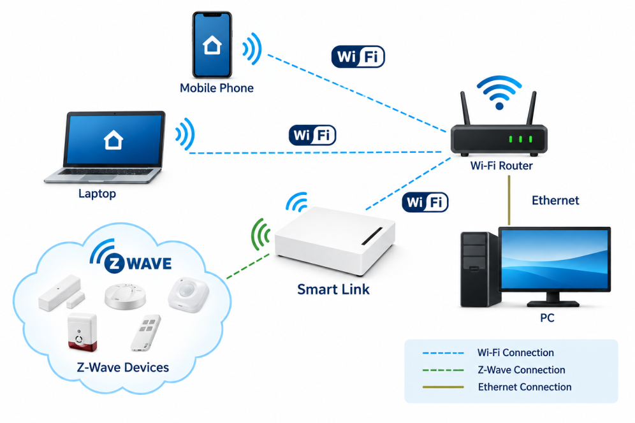
Figure 1: Network Diagram
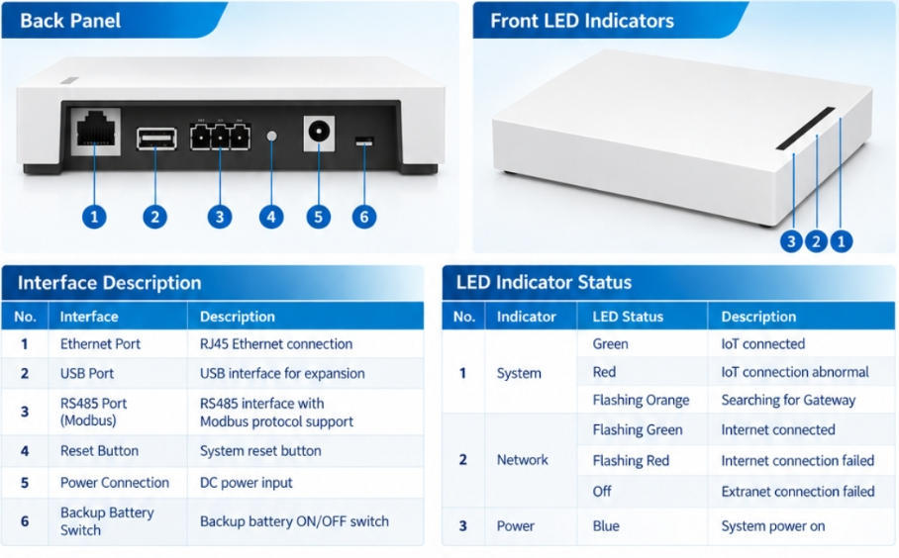
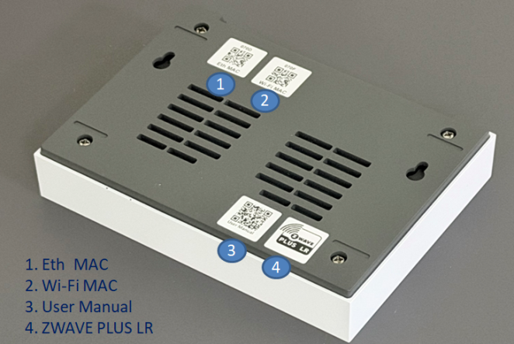

Figure 2: SmartLink Gateway Hardware Overview

Quick Install
Before installing your Z-Wave network SmartLink Gateway please follow these steps to install your SmartLink Gateway:
Step 1: Plug in USB Type-C power to SmartLink Gateway.
Step 2: Connect the SmartLink Gateway Wi-Fi “VisionSensorHub_XXXXXX” via your laptop or mobile phone, the Wi-Fi password is 12345678.
Step 3: Visit https://VisionSensorhub/index.html or https://192.168.109.1/index.html in your browser (Google Chrome/ Microsoft Edge).
Step 4: Log in the website of SmartLink Gateway, the default username is root and password is rt1234.

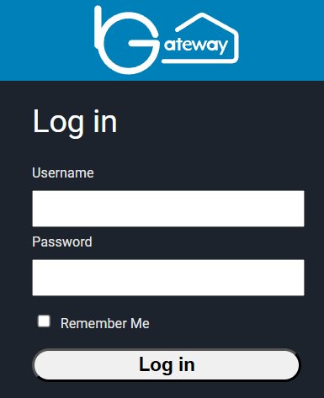

Setting SmartLink Gateway network configuration

2.1.1Wifi Setting
There are two modes. One is Ap mode, and the other is Sta mode.
Sta mode: The gateway connects to an existing Wi-Fi network as a client.
Ap mode: The gateway creates its own Wi-Fi network and allows other devices to connect to it.

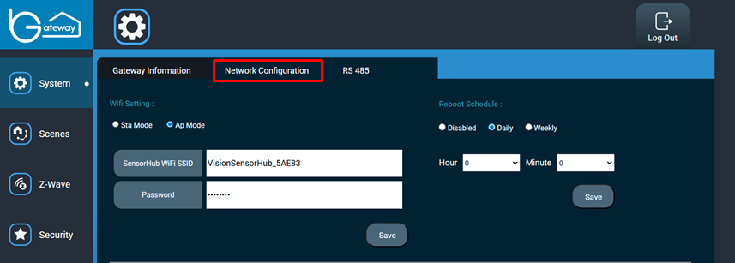

Sta Mode
Please follow the steps to set up Wi-Fi via Sta mode for SmartLink Gateway.
Step 1: Select Sta mode.
Step 2: Use to scan available owned Wi-Fi SSID and then key-in password to connect network.
Step 3: Confirm router information if correct and then click “Save” button. The system will be restarted, please wait a moment.
Step 4: If the network is connected successfully, the light of SmartLink Gateway will be blue and green.
Step 5: If the network is failed to connect, the light will be blue, please press the reset button three times and hold it on the third press to restore the default Wi-Fi configurations.
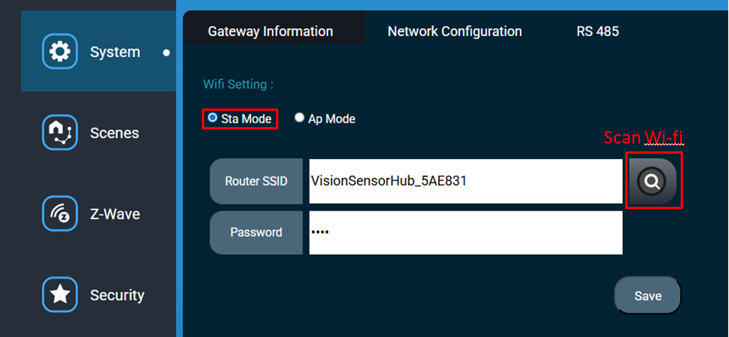

Ap Mode
Step 1: Select Ap mode.
Step 2: Type WiFI SSID
Step 3: Type Password
Step 4: Click “Save” button
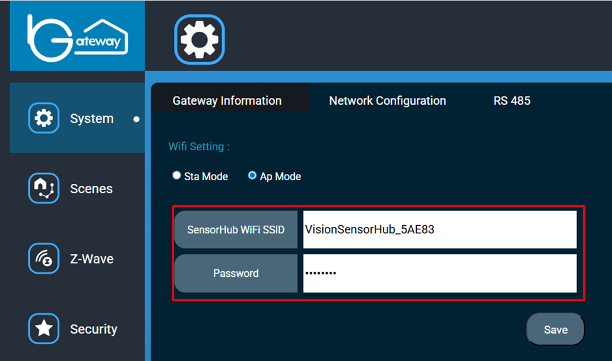

Reboot Schedule
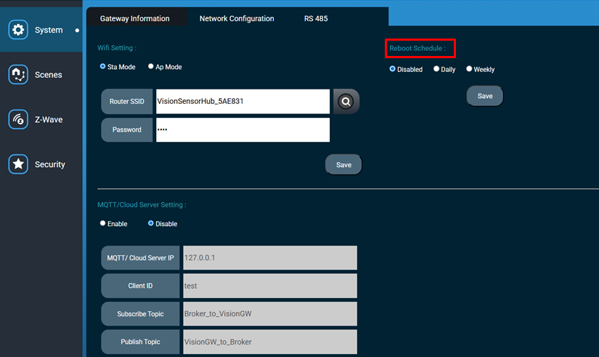
Disable – Automatic reboot is disabled. The system will not reboot automatically.
Daily – The system will reboot automatically at the specified time every day.
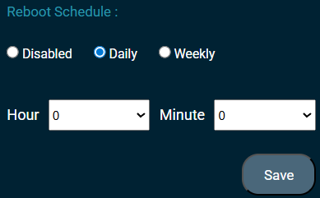
Weekly – The system will reboot automatically at the specified time on the selected day of each week
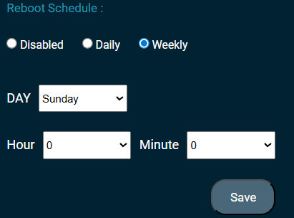

MQTT/Cloud Server Setting
This page is used to configure the MQTT connection between the device and the cloud server. Currently, this feature is disabled and will be supported in a future release.
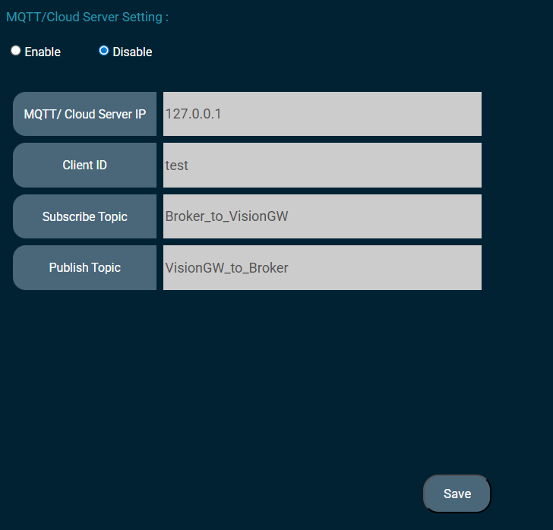

RS 485
Currently, the SmartLink Gateway hardware does not support RS485. This page can be ignored.
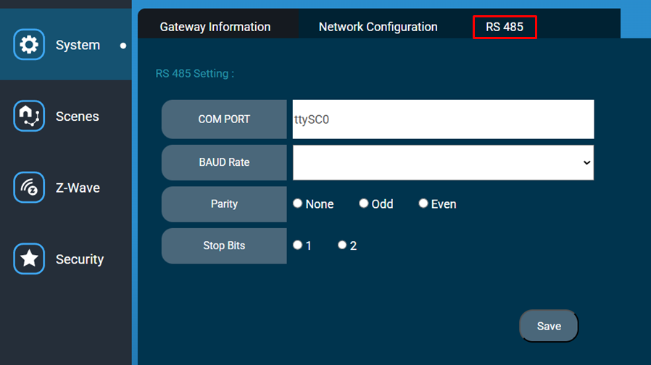

Website Introduction
The website has four main menus： “System”, “Scenes”, “Z-Wave” and “Security”.
- “System”: displaying version of SmartLink Gateway, network configuration, time zone setting, account management, RS485, and password change.
- “Scenes”: Users can customize the linkage between different devices.
- “Z-Wave”: displaying Z-Wave devices. User can control all devices.
- “Security”: Provides home security configuration.

System Functions
You can upgrade firmware, change password, change time zone, account management and setting network.

4.1 Change Password
Step 1: Click the icon “Change Password”.
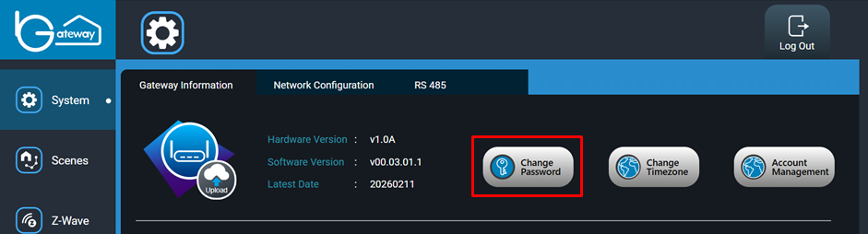
Step 2: Enter the current password in the first line.
Step 3: Enter the new password in the second line.
Step 4: Enter the new password again in the third line.
Step 5: Click “Change” button to save setting.
Step 6: If setting up successful, and then website will log out automatically.

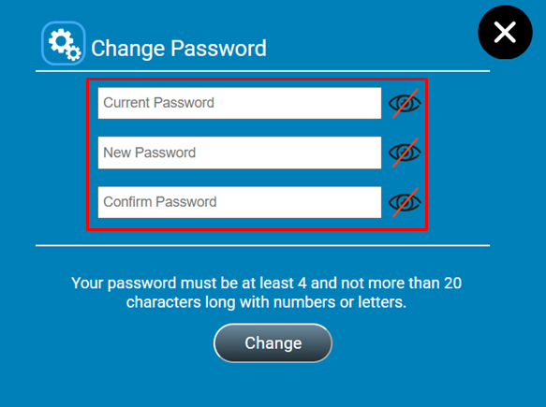

4.2 Change Time zone
Step 1: Click “Change Time zone” button.
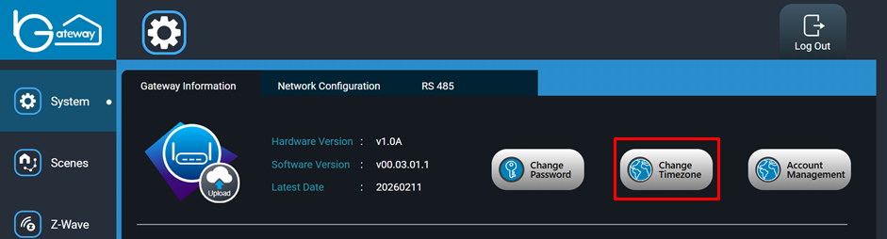
Step 2: Select your time zone.
Step 3: Input the Network Time Protocol (NTP) Server if you want to calibrate the system time from network.
Step 4: Click “Change” button for save setting.

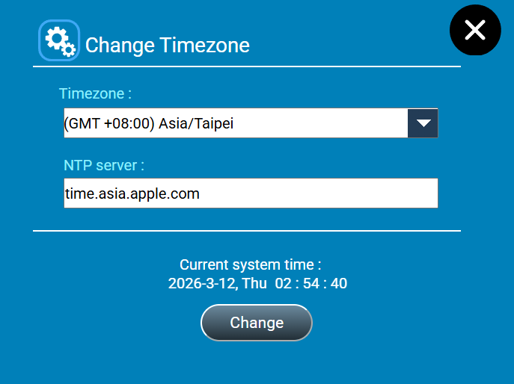

4.3 Account Management
Click “Account Management” button

4.3.1 Add User
Step 1: Click “Add User”.

Step 2: Enter username in the first line.
Step 3: Enter password in the second line.
Password should meet the following requirement
- Minimum of 6 characters
- Not too similar to username
- Must contain at least one letter and one number
Step 4: Select privilege i.e. Guest, Power User or Admin in the third line.
Step 5: Click “Save” button to save setting.
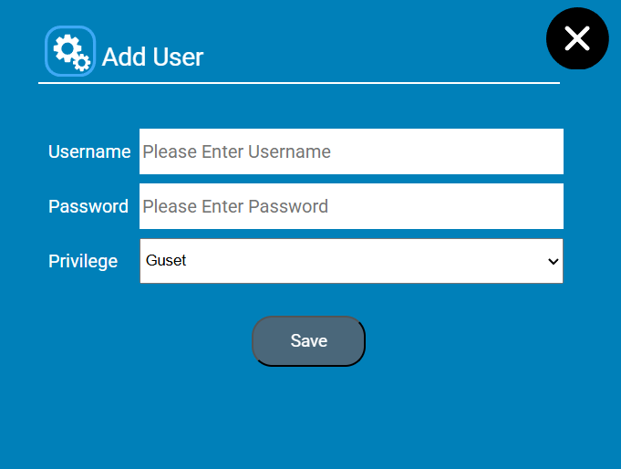

4.3.2 Account List
Account List shows the number of accounts.

Click “Account List”.
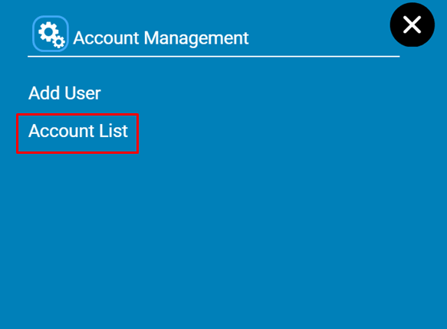

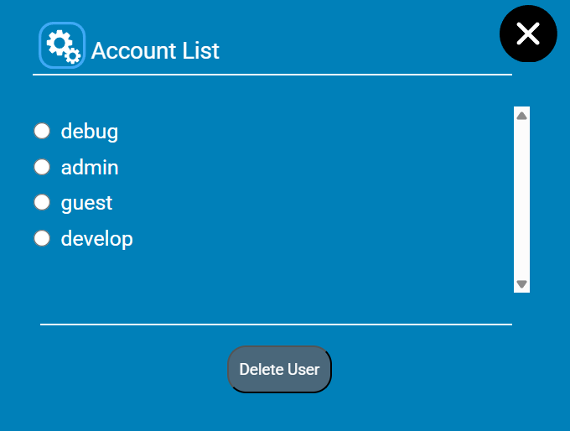

Next, you can delete the user you want. Then, click “Delete User” button.
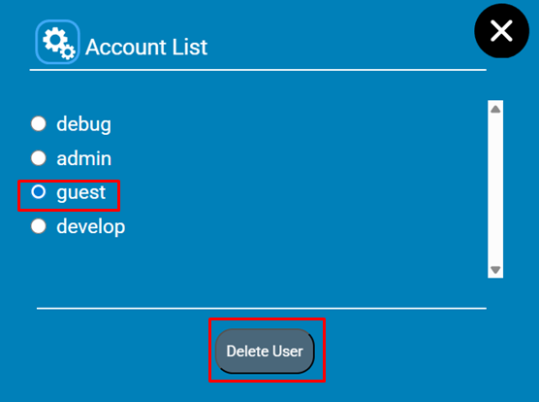
After deleting,
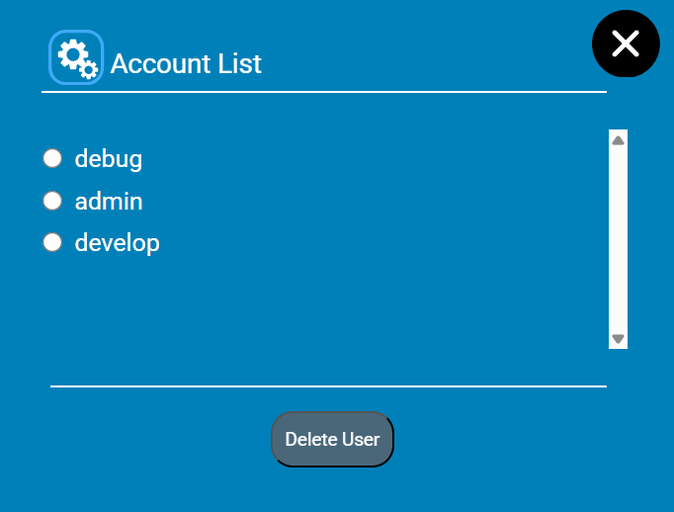

4.4 Upgrade System Firmware
Step 1: Click the “Upload” icon.

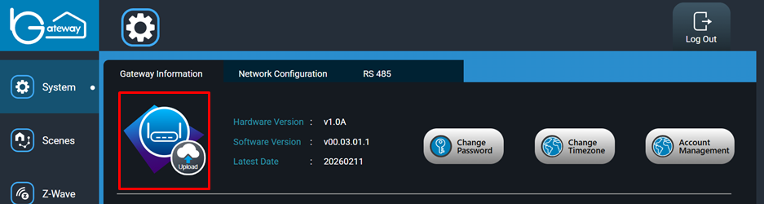
Step 2: Click the “Browse” button to select the firmware file (filename.bin).
Step 3: Click the “Upgrade” button to start upgrading firmware.

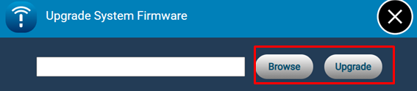
Step 4: Wait 600 seconds until upgrade finished.
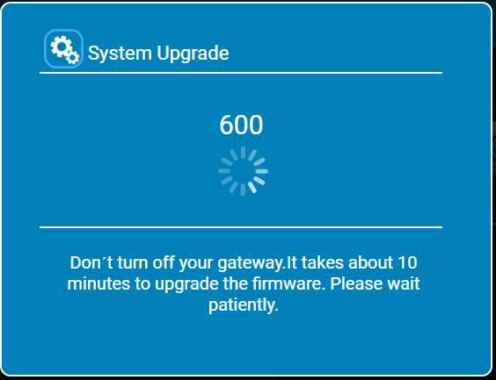
If the number above stays stuck at 0, press F5 to refresh the page. If a "Not secure" website warning appears, accept it and proceed, then log in again. After logging in, please verify that the firmware version has been updated. If the version has not changed, repeat from step 1.
If upgrading failed, please refresh the web page, and then back to the step 1.
Otherwise, you will see.
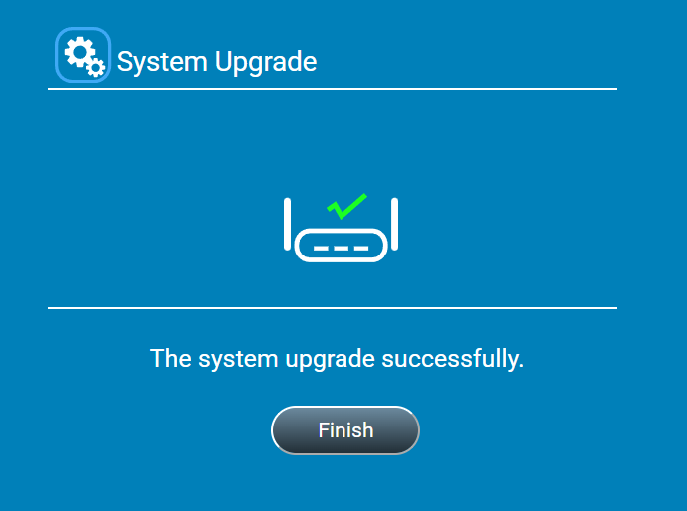

Scenes Functions
You can integrate numbers of Z-Wave devices which can be executed by any of the following triggers:
- Events
The designated devices can be triggered by notification of another device.
- Schedule
The designated devices can be triggered by preset time.
- Manual
A user can manually execute a Scene by clicking “Run”.

5.1 Add Scene Rule
Step 1: Click “Add New Scene” button.
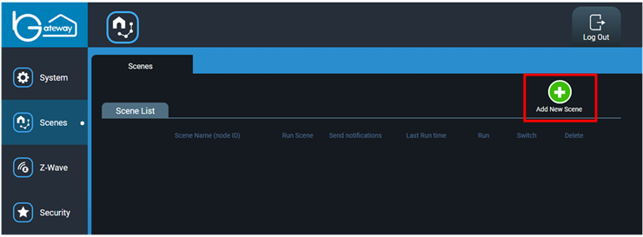
Step 2: Enter scene name.
Step 3: Select scene icon and then click “Next” button.
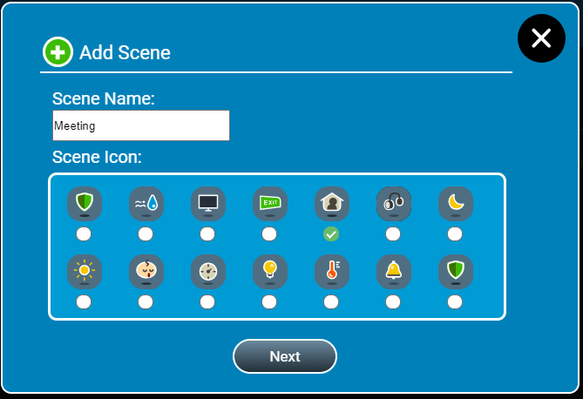
Step 4: Select location of trigger device.
Step 5: Select device of trigger event.
Step 6: Select event of trigger device.
Step 7: Click the “Next” button.
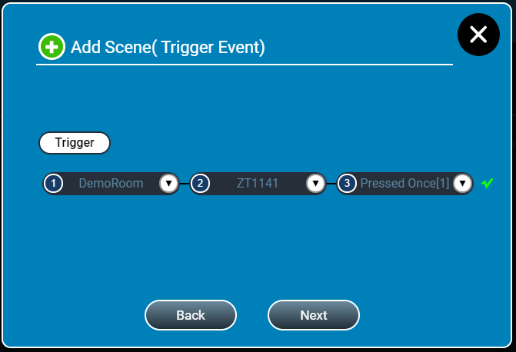
Step 8: Select location of task device.
Step 9: Select device of task event.
Step 10: Select event of task device.
Step 11: Click the “Next” button.
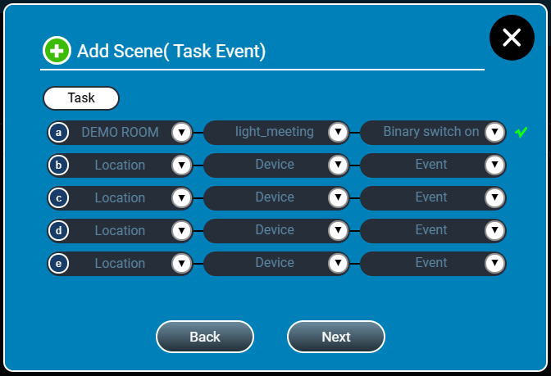
Step 12: Check information and then click the “Finish” button.
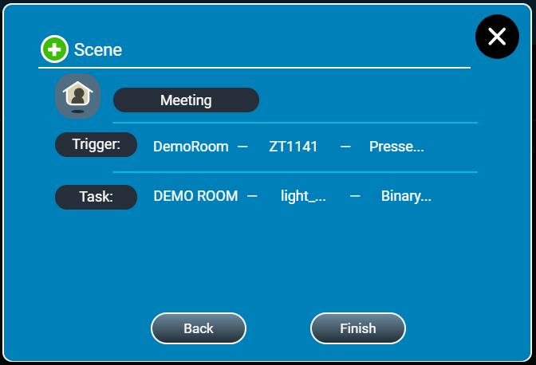

5.2 Delete Scene Rule
Step 1: Click the scene delete button.
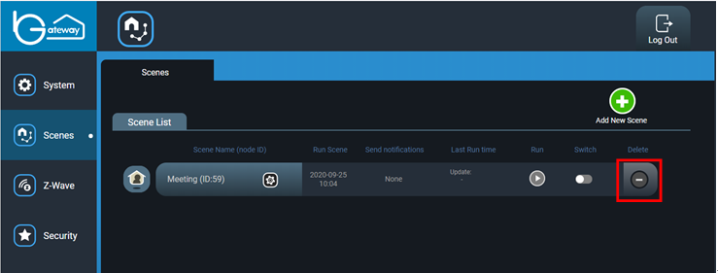
Step 2: Click the “OK” button.
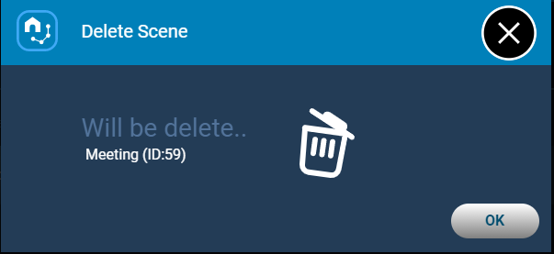

5.3 Enable/Disable scene rule
Step 1: Click the scene switch button.
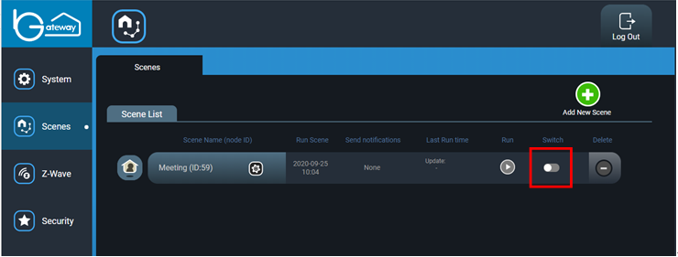

5.4 Scene schedule
Step 1: Click the scene setting.
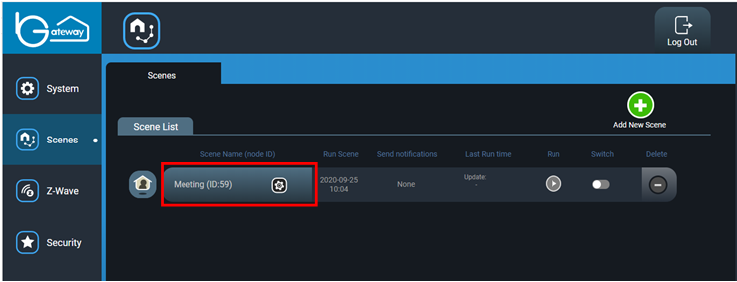
Step 2: Click the “schedule” icon.
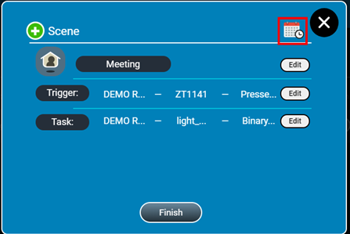
Step 3: Select date, time and repeat days.
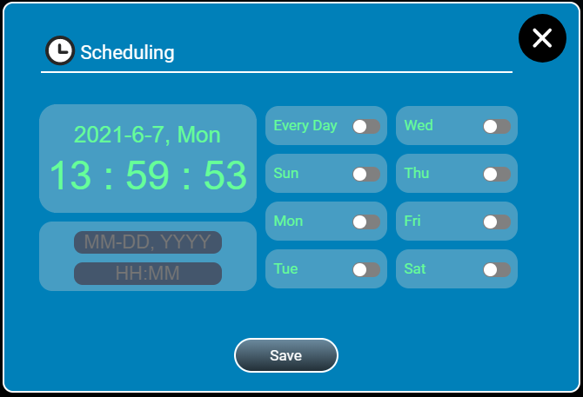
Step 4: Click the “Save” button.

5.5 Scene task implement directly
Step 1: Click the scene Run button.
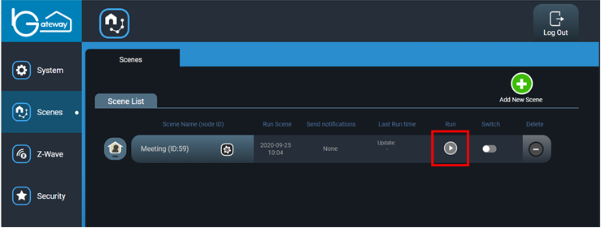

Z-Wave Functions

6.1 Adding Device (Inclusion)
Step 1: Click button “Add Device” on the website.
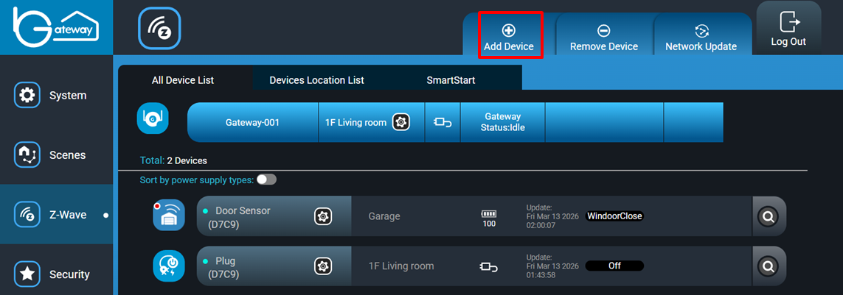
Step 2: Select gateway uuid, then click “Next” button
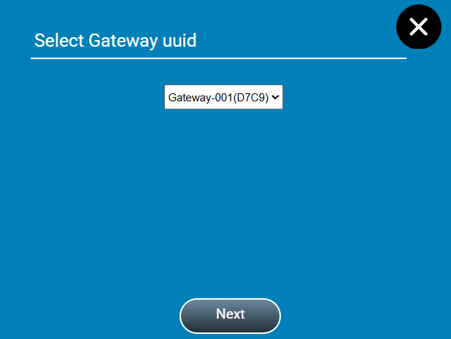
Step 3: System is on inclusion mode and waiting for user to trigger inclusion mode of device. If you would like to stop this action, just taps Exit button.
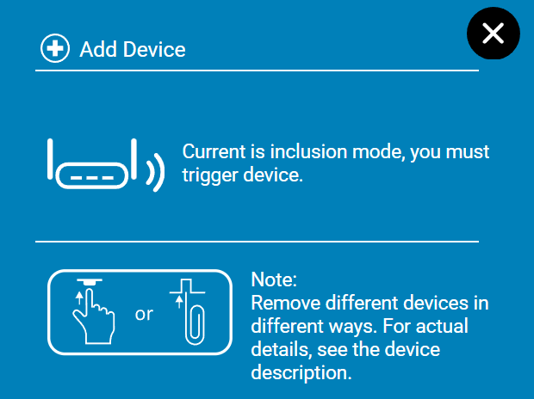
Step 3: After triggering device, the gateway will show “Setting Security Grant”. If the device supports S2 Security, please choose the security level for the device. If the selection is “S2 Access Control” or “S2 Authenticated”, the system will prompt user to input the device first 5 digit of the DSK.
If device only supports S0, the gateway will automatically skip “Setting Security Grant” step.
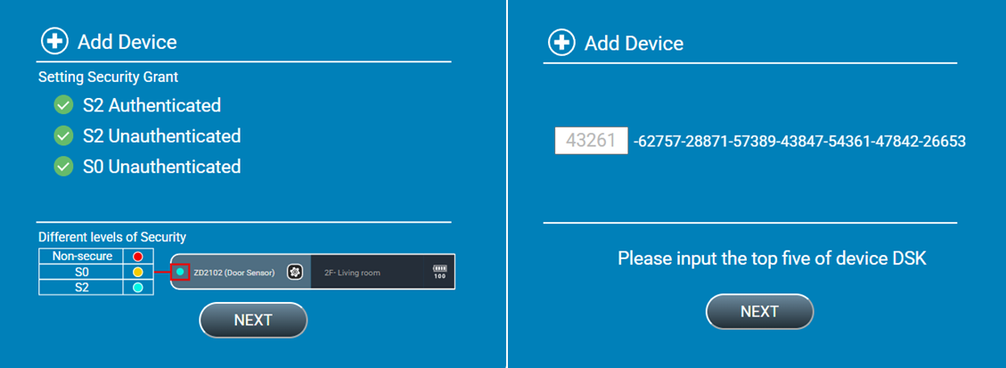
Step 4: Wait for the whole inclusion process to finish; it may take up to 1-2 minutes depending on the device.
Step 5: If the inclusion is successful, the system will show “device included successfully”. Otherwise, a failure message will appear.

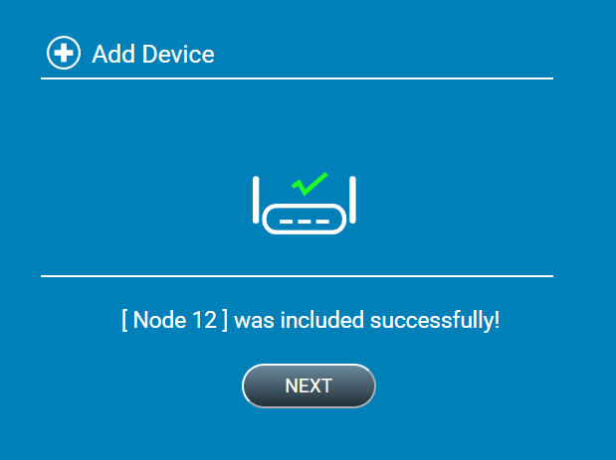
Step 6: If the inclusion is successful, you will be asked to name the device and set up a location of the device.
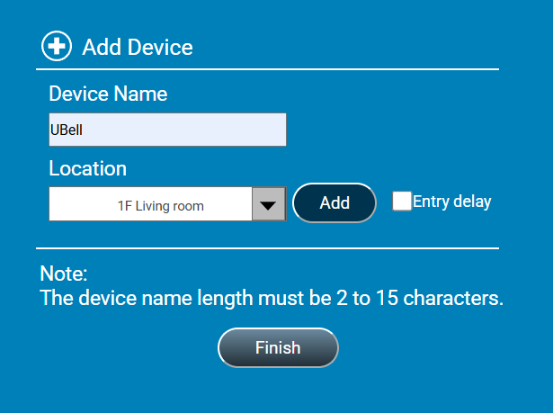

6.2 Remove Device (Exclusion)
Step 1: Click button “Remove Device”.
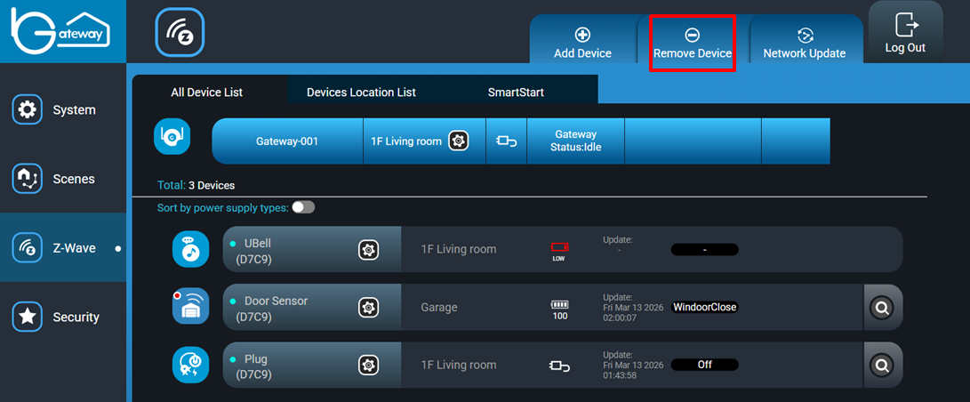
Step 2: Select gateway uuid, then click “Next” button.
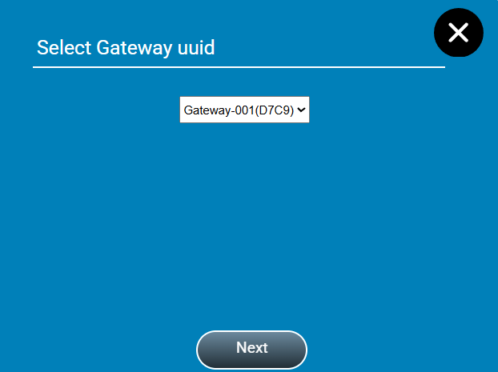

Step 3: System is on exclusion mode and waiting for user to trigger the intended device to removal mode. If you would like to stop this action, just taps Exit button.

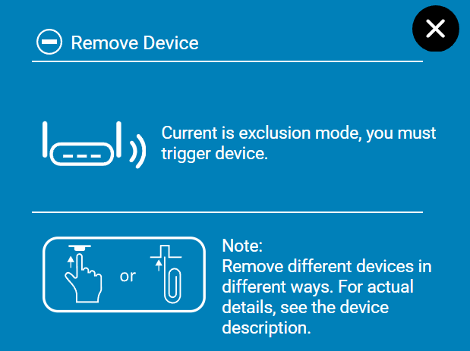
Step 3: If the exclusion is successful, system will show the excluded node ID on the pop-up window.
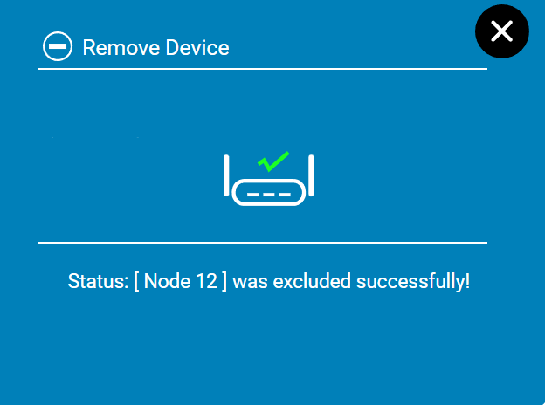

6.3 Network Replication (Copy)
Initiate a replication to copy network information from your gateway to another controller.
- Start the add device process in Adding Device.
- Follow the manufacturer’s instructions of the other controller to enable it to go into learn mode.
- Enter DSK code if necessary, and await the whole process to finish.

6.4 Network Update
Update your Z-Wave network for maintenance and optimization routine, which includes checking and repairing node return routes and checking node neighbors. This operation will also be performed at least 10 minutes. 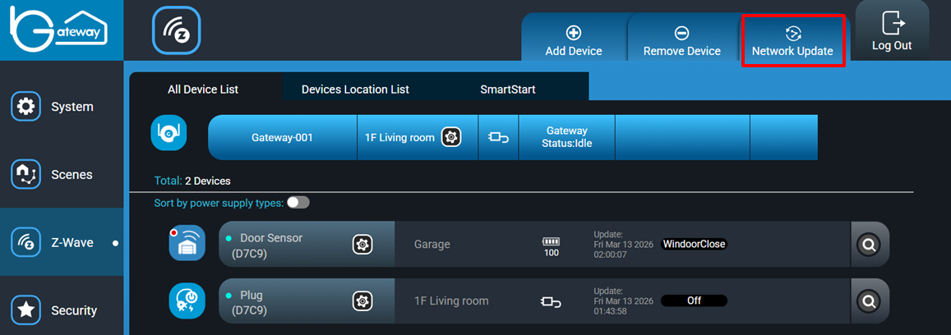

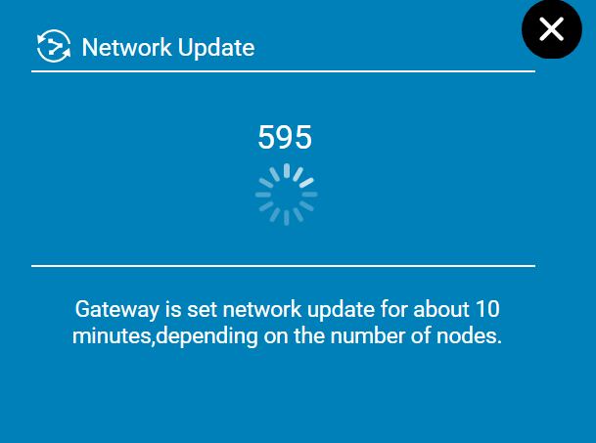

6.5 Check a Z-Wave device
Check and attempt to locate missing or out of range devices, if icon turns gray, the device loses connection. Note if device is a battery type, the battery maybe is out of power.
Step 1: Click “Check” button.
Step 2: Wait gateway for looking for missing device.
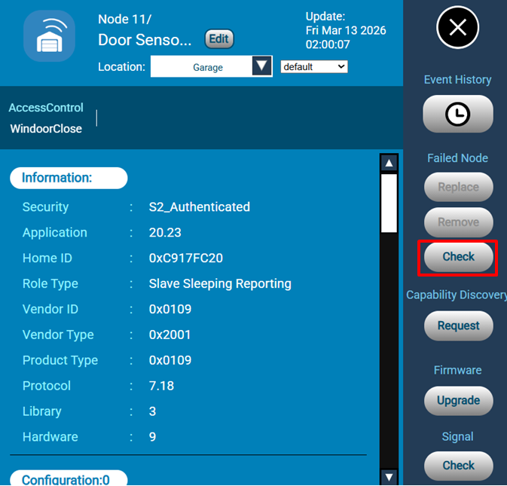

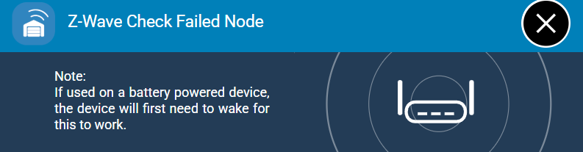

6.6 Replace a failed Z-Wave device
Step 1: Click “Replace” button.
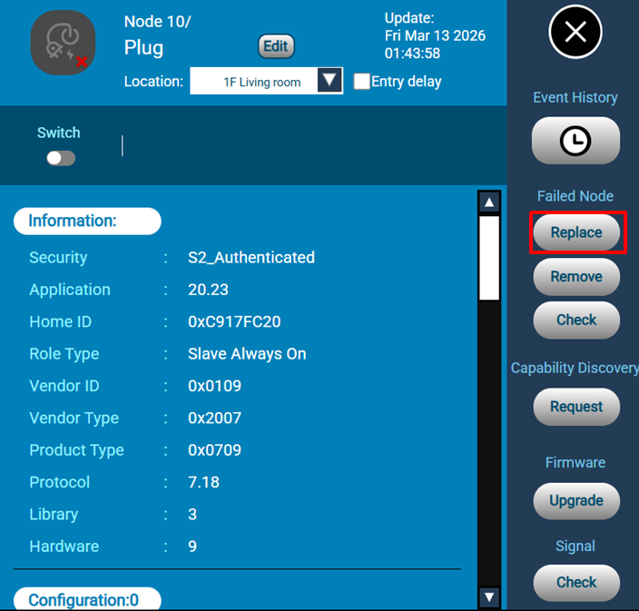
Step 2: Start the add device process in Adding Device.
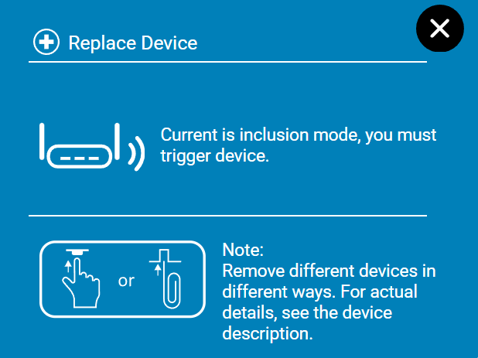
Step 3: Follow the manufacturers instructions of the other controller to enable it to go into learn mode.
Step 4: Enter DSK code if necessary, and await the whole process to finish.

6.7 Remove a failed Z-Wave device
Step 1: Click “Remove” button, if the device is failed node.
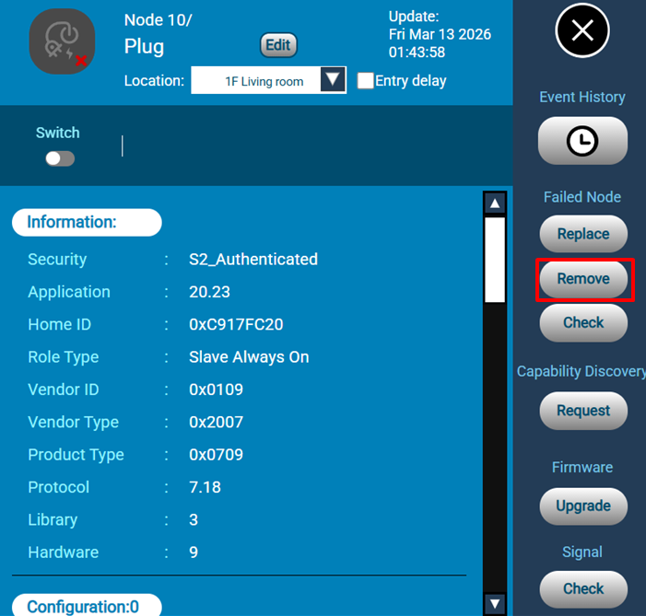
Step 2: Click “Remove” button would force remove the device.
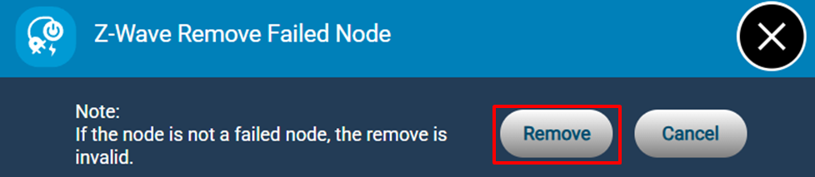

Step 3: If the exclusion is successful, system will show the exclude node ID on the pop-up window.
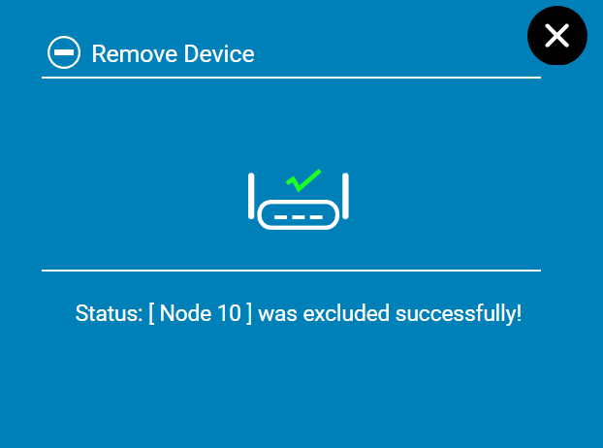

6.8 Request capability rediscovery
Step 1: Click “Request” button, the SmartLink Gateway would rediscovery the device capability.

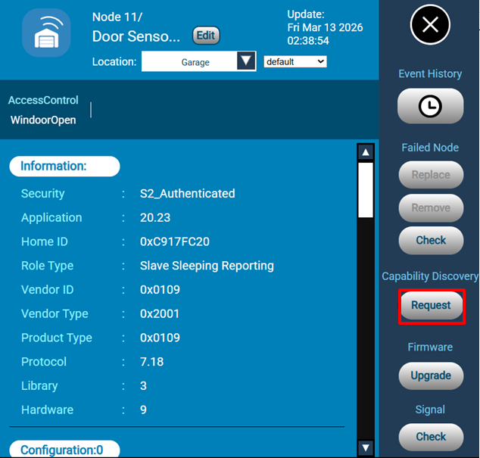
Step 2: If successful, the device information would update correctly.
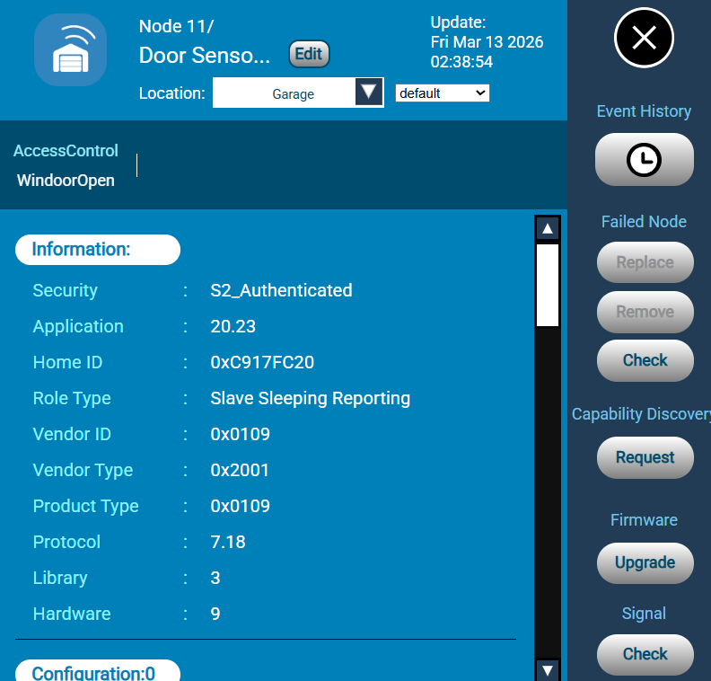

6.9 Including the SmartLink Gateway to an existing network (Learn mode)
The Z-Wave gateway can also function as an Inclusion / Secondary Controller in the existing Z-Wave network.
Step 1: Follow the manufacturer’s instructions of the other controller to enable it into Add mode.
Step 2: Click “Learn Mode” button. If it is a S2 Controller, the DSK of the Gateway will appear. Please key in the DSK to the other Controller UI when prompted.
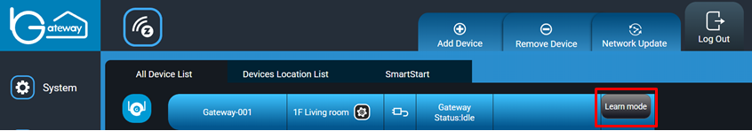

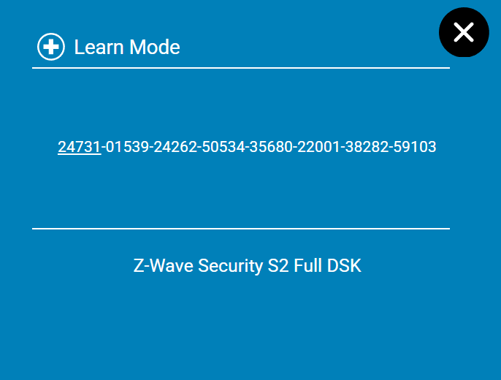
Step 3: When completed, the UI will show the existing Controller and device(s) in the network.

6.10 Factory Default Reset
Factory resets of Z-Wave controller. Do note that once this is done, any device in the Z-Wave network will not be accessible. Hence proceed with caution when doing reset as it is irreversible. If this controller is the primary controller for your network, resetting it will result in the nodes in your network being orphaned and it will be necessary after the reset to exclude and re-include all of the nodes in the network. If this controller is being used as a secondary controller in the network, use this procedure to reset this controller only in the event that the network primary controller is missing or otherwise inoperable.

Step 1: Click Gateway setting button.

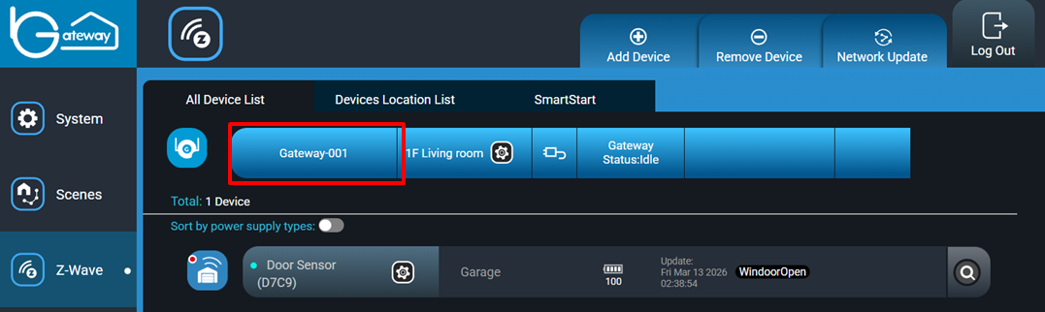
Step 2: Select “Z-Wave Reset” button.
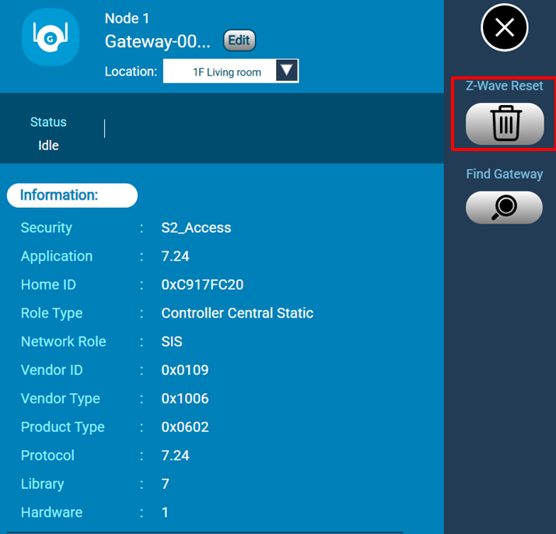
Step 3: Confirm the dialog. Click “Reset” button will perform a factory reset to the Gateway.

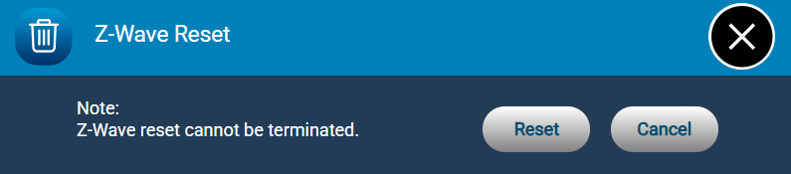
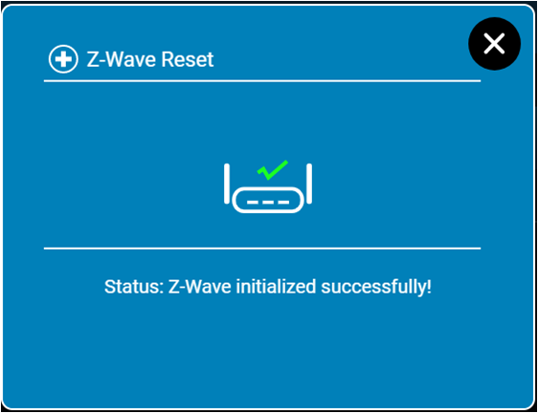

6.11 Device Event History
Click the icon to show history of device.

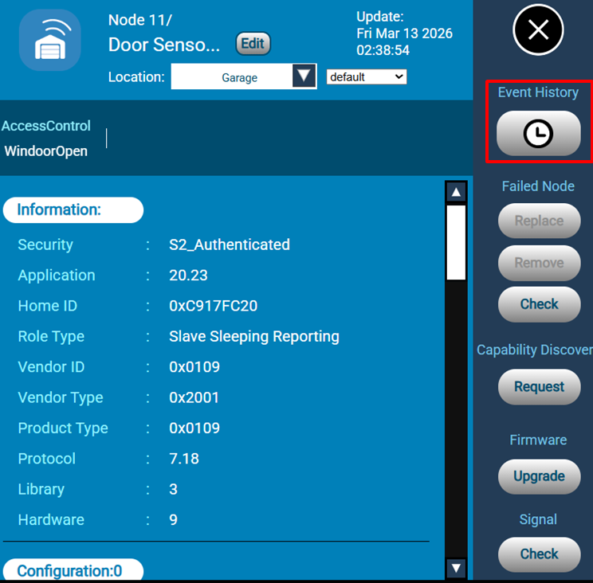
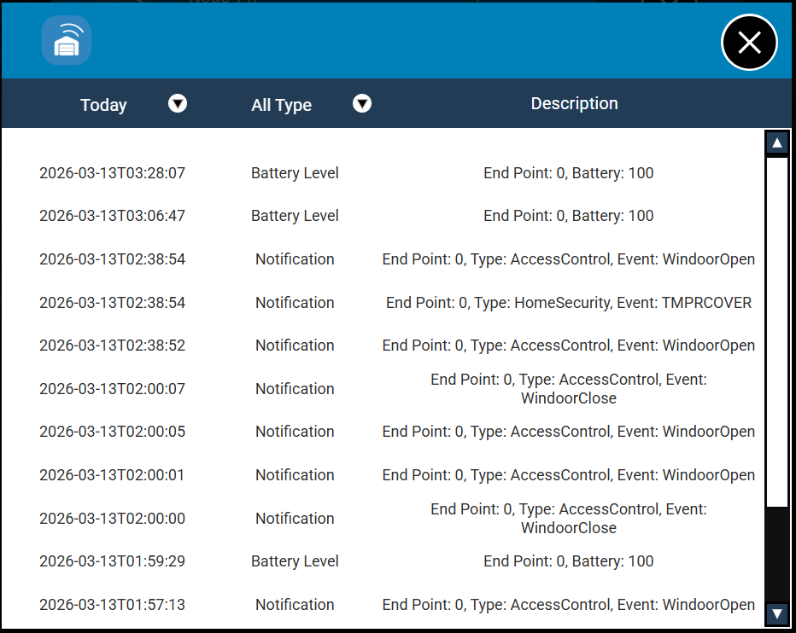

6.12 Add/Remove node to SmartStart List
Step 1: Click “SmartStart” from Z-Wave menu.
Step 2: Enter the 40-digit decimal S2 DSK number of the device to be added using SmartStart and press “Send”. Check the “Long Range” option if the device supports Long Range.

No further action is required and the SmartStart product will be added automatically.
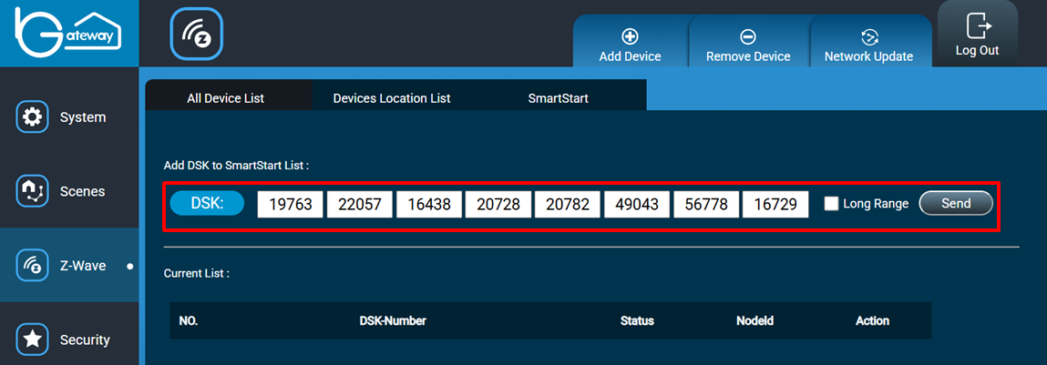
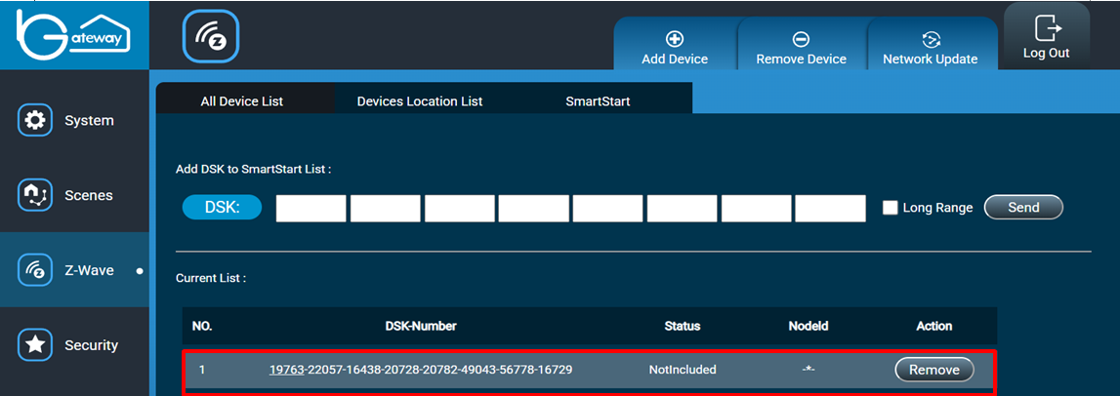
Step 3: You can use “Remove” button to remove the specified DSK.

6.13 Additional Information

6.13.1 Controlled Command Classes
Our product has two ways to control device. End user could quickly switch status from node table (such as switch on/off, lock/unlock, multi level switch, etc.) or click configuration icon to enter detail setting of the node.

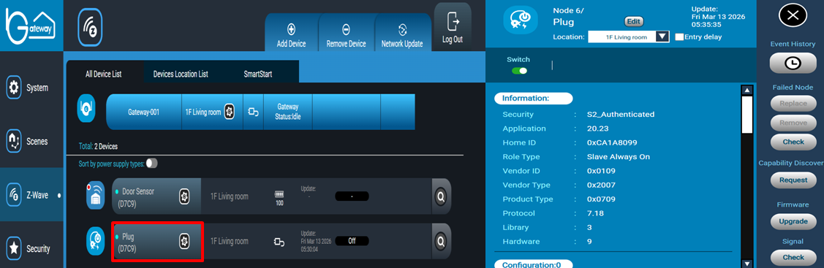

6.13.2 Association Command Class and Multi Channel Association Command Class
The gateway supports Association Command Class. It has one association group 1("Lifeline" group); only one device can be associated to this group. The Gateway will send reset notifications to the associated device when the factory reset is performed on the Gateway.

End user could control Association Command and Multi Channel Command from detail setting interface. If device supports Association Command Class and Multi Channel Association Command Class at same time the gateway only show Multi Channel Association Command Class in the detail setting.
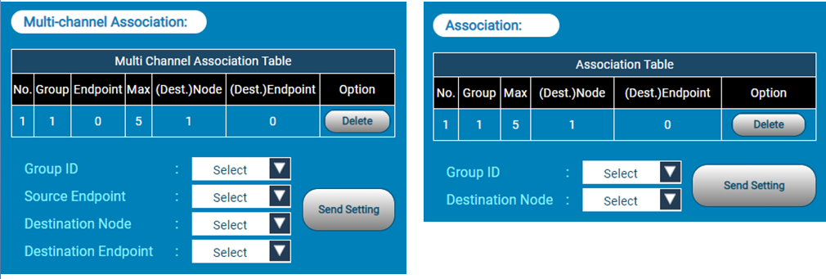

6.13.3 Basic Command Class
The gateway is able to controlled Basic Set/Get CC to devices but not supported. It’s going to ignores requests when others controller send Basic Set/Get CC to Gateway. This command must to enter detail setting interface.
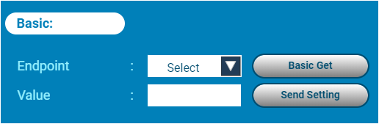

6.13.4 Battery Command Class
The gateway display battery level on node table when device support Battery Command Class. Or send battery get command from detail setting interface manually.

6.13.5 Binary Switch Command Class
End user could switch status from detail setting of the node.
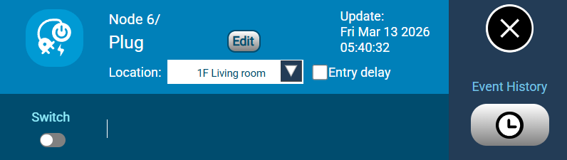

6.13.6 Door Lock Command Class
End user could switch lock and unlock from detail setting of the node.
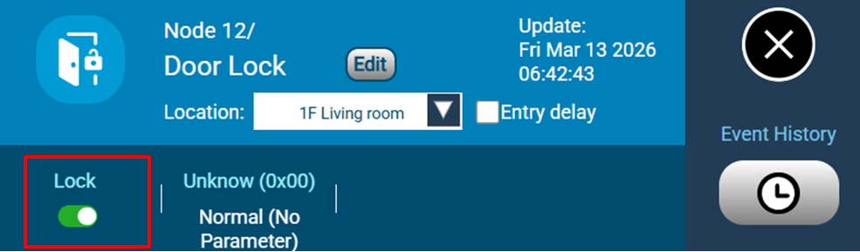

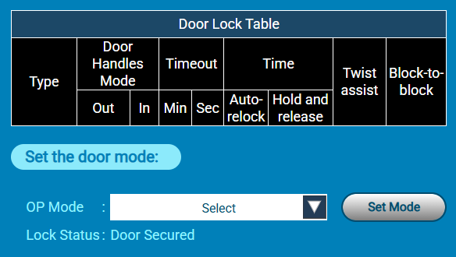
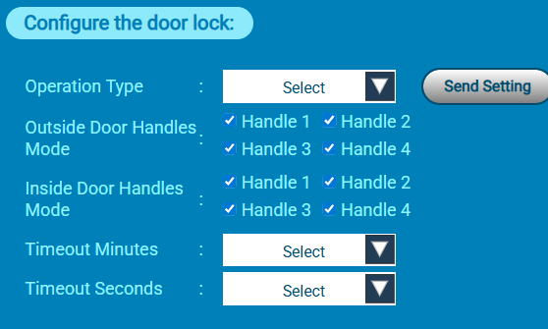

6.13.7 Central Scene Command Class
The gateway provide setting scene in the detailed setting.

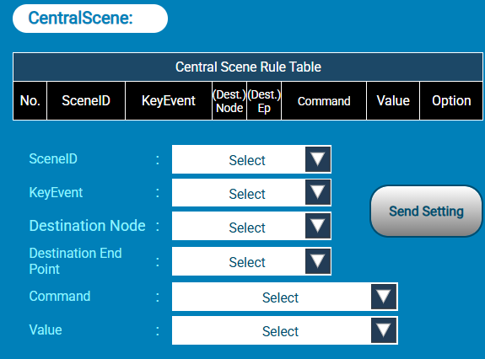
If you want to test your scenes, you must trigger central scene device.
•Pressing shortly the key can be used as trigger for scenes.
• Holding the key does nothing.
• Releasing the key (after long press) can be used as trigger for scenes.
• Holding and releasing are both shown as "Long Pressed" each.

6.13.8 Configuration Command Class
End user could control this command from the detailed setting interface. Set and Get must refer device user manual.
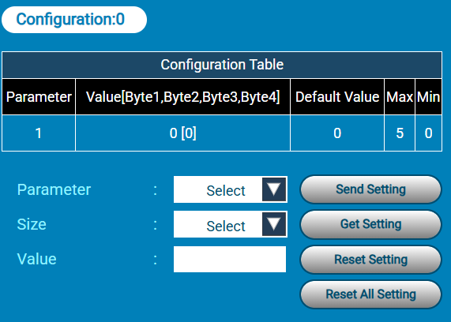

6.13.9 Firmware Update MD Command Class
This command must enter the detailed setting interface and click button “Upgrade”.
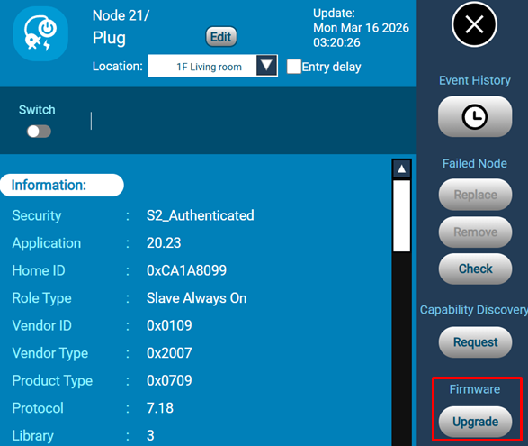
Some devices have several firmware targets. End user must click the “Get” button to get firmware targets information and select targets before firmware update.
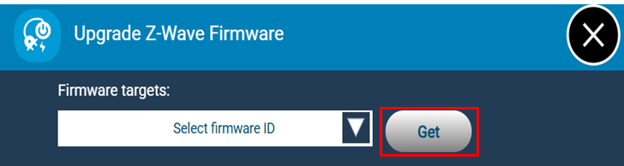
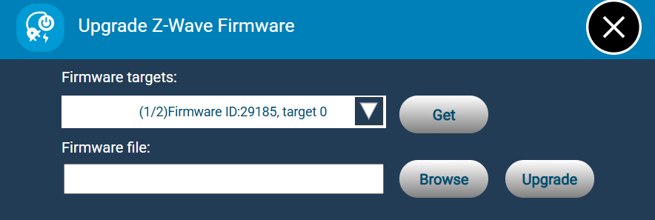

6.13.10 Indicator Command Class
End users could control this command from the detailed setting interface or click the icon to identify itself. The supporting node will be switched on 600ms and switched off 200ms three times.
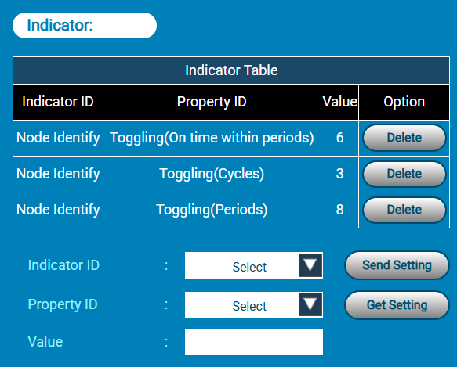
End user could click “Find Gateway” button to find gateway, the gateway will be blinks with red light.
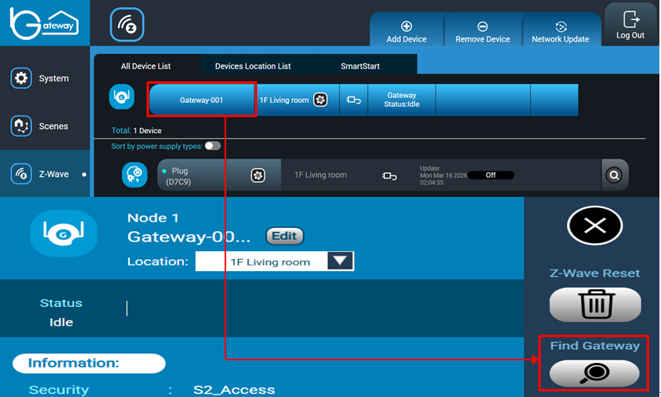

6.13.11 Meter Command Class
End users could get different unit from the detailed setting interface.

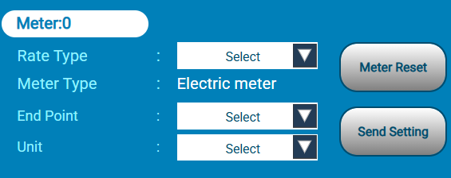
Note: If a meter device supports multiple meter types, all readings can be viewed in the Event History of the device’s detail view.

6.13.12 Multilevel Switch Command Class
End users could switch level 0 to 100 from node table. If you want to confirm the current level, you must enter the detailed setting.
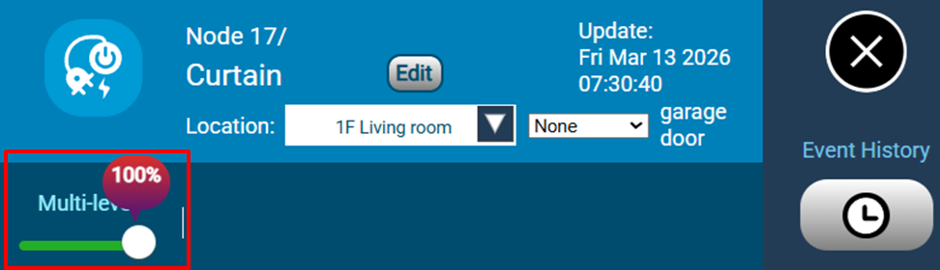

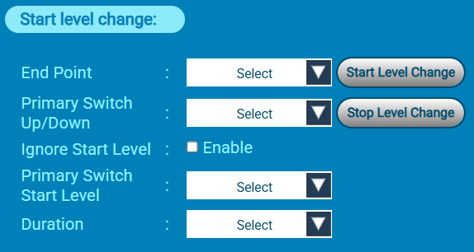

6.13.13 Notification Command Class
When gateway has received a Notification Command Report, it displays on node table.
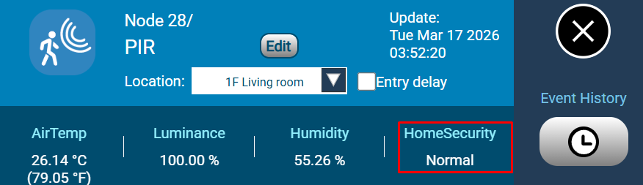

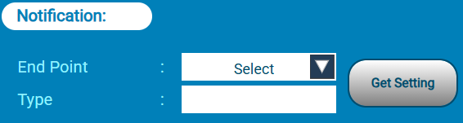

6.13.14 Power Level Command Class
End users could control this command from the detailed setting interface.
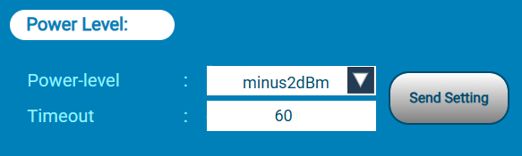

6.13.15 Sensor Multilevel Command Class
When gateway received Sensor Multilevel Command Report it display on node table. The gateway doesn’t provide end user send this command.

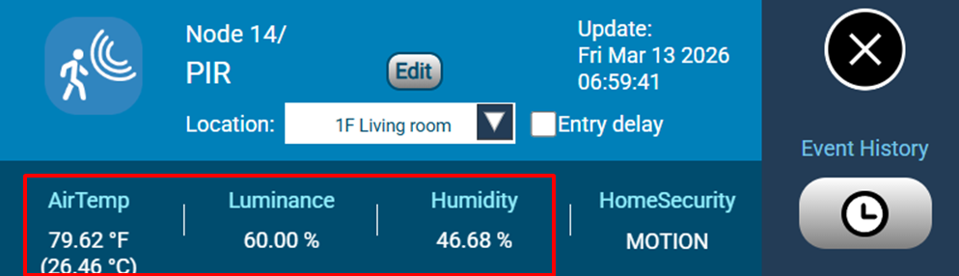

6.13.16 Security Command Class
The gateway is a security-enabled device. When a security-enabled Z-Wave device is added to the Gateway’s network, its secure communication will be 128-bit AES encrypted. Whether S0 or S2 is used, they will depend on the included device. End users could view security level from the detailed setting interface.
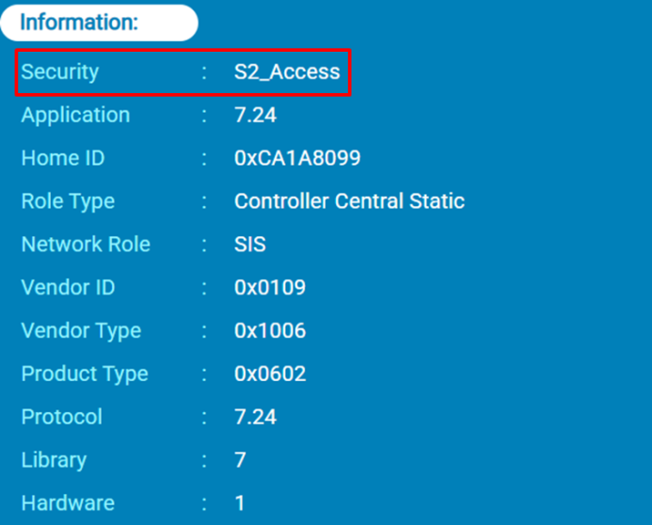

6.13.17 Sound Switch Command Class
End users could switch sound tone and volume from the detailed setting interface.
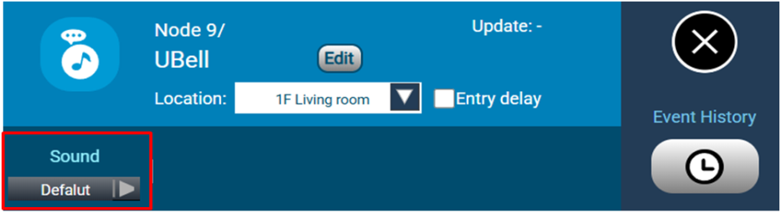
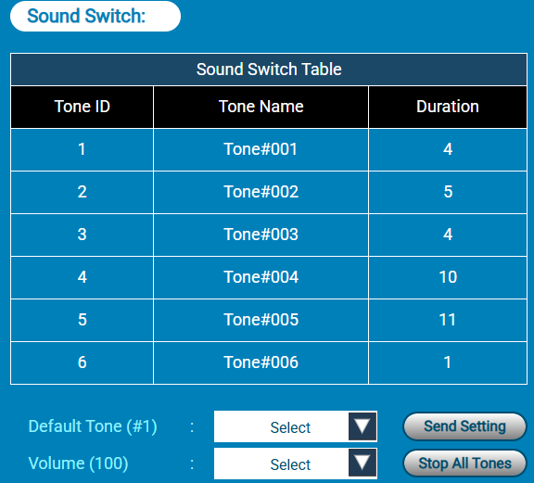

6.13.18 User Code Command Class
End users could control this command from the detailed setting interface.
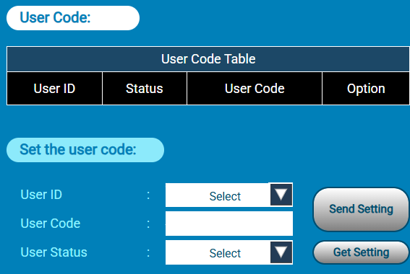

6.13.19 Wake Up Command Class
End users could control this command from the detailed setting interface.
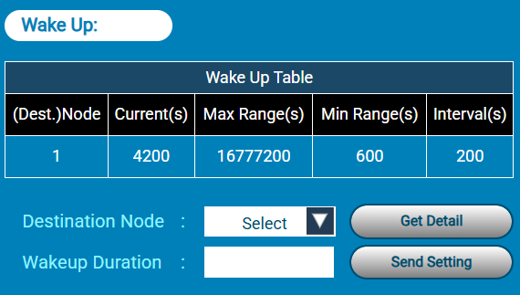

6.13.20 Anti-Theft Unlock Command Class
End users could control this command from the detailed setting interface.
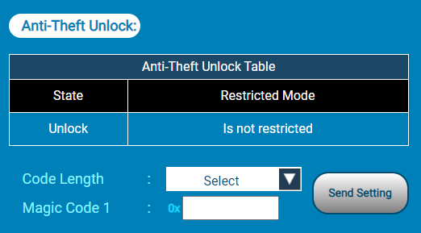

Simple AV Control Command Class
End users could control this command from the detailed setting interface.

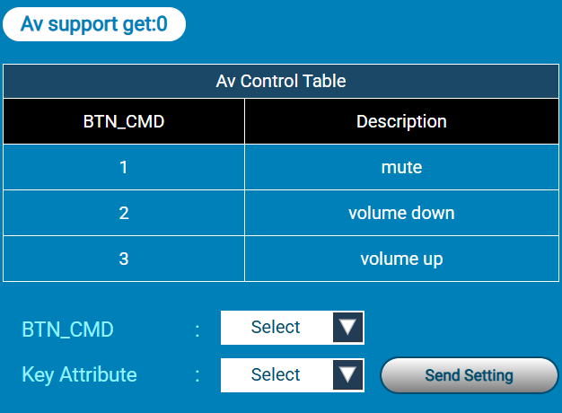
Key Attribute : Key Down, Key up

Thermostat Mode Command Class
End users could control this command from the detailed setting interface.
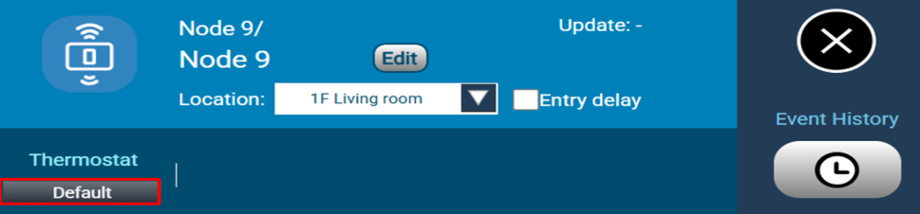
The above only set the mode.
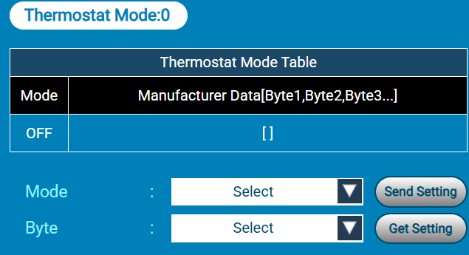
The above can set and see the report mode in the table.

Thermostat Setpoint Command Class
End users could control this command from the detailed setting interface.

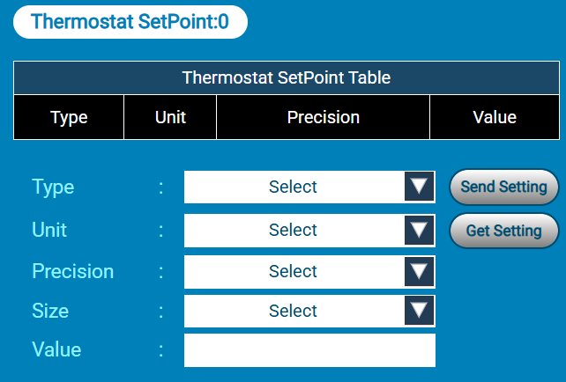

Thermostat Fan Mode Command Class
End users could control this command from the detailed setting interface.
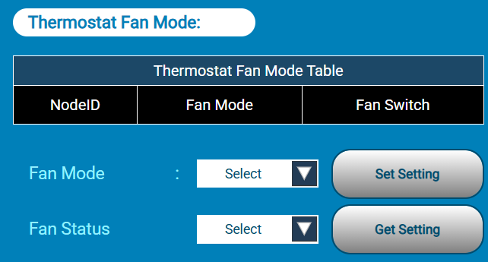

Thermostat Fan State Command Class
When the fan state changes, the new state is displayed in the Thermostat Fan State Table.
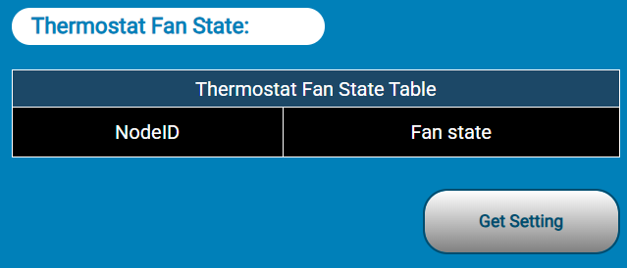

Thermostat Operating State Command Class
When the operating state changes, the new state is displayed in the Thermostat Operating Table.
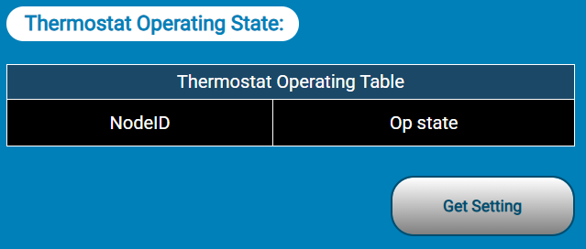

Security Functionality

7.1 Setting Security Mode
Step 1: Switch your security mode.
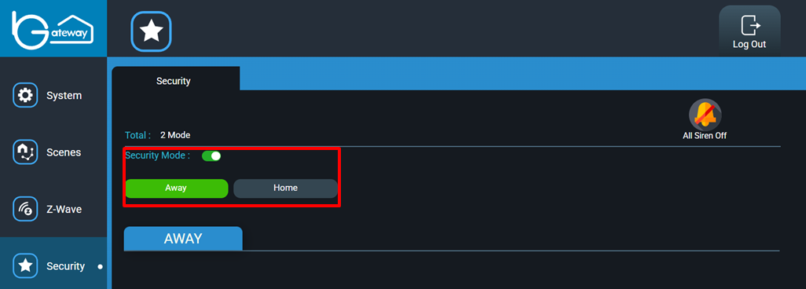
Step 2: If setting successfully, the background of security mode will become green color.

7.2 Disable Security Mode
Step 1: If you want to disable security mode, please click toggle button of “Security Mode” side.
Step 2: Enter website to log in and then click “OK” button.

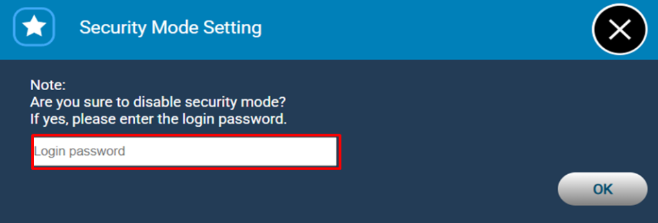

7.3 Setting the security mode detection devices
Step 1: Select the security mode
Step 2: Select the devices to detect in the security mode.
Step 3: Click “Save” button.

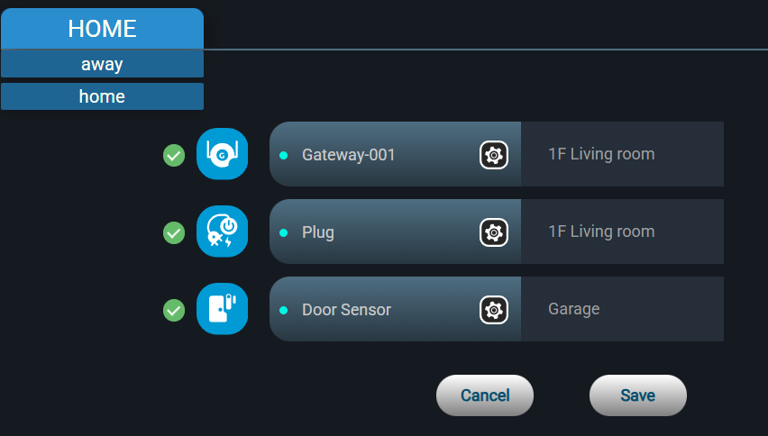

7.4 Turn off all sirens
Step 1: Click the “All sirens off” button for turning off all sirens.

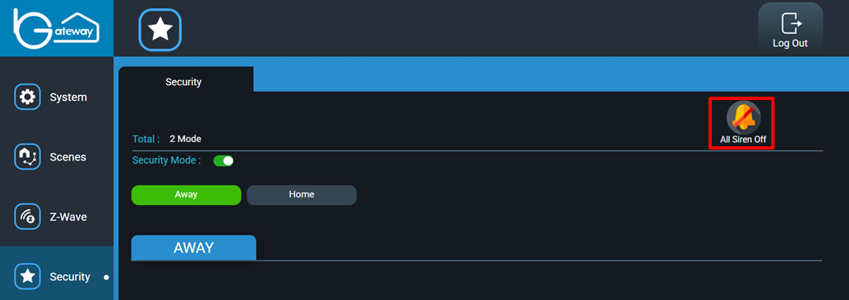

Supported Z-Wave Device Classes
Device Class | Value | Type
GENERIC_TYPE_STATIC_CONTROLLER | 02 | Generic
SPECIFIC_TYPE_GATEWAY | 07 | Specific

Supported Z-Wave Command Classes
Command Class | Version | Security level
APPLICATION_STATUS | 1 | none
ASSOCIATION | 3 | highest granted
ASSOCITAION_GRP_INFO | 3 | highest granted
CRC-16_ENCAP | 1 | none
DEVICE_RESET_LOCALLY | 1 | highest granted
FIRMWARE_UPDATE_MD | 5 | highest granted
INCLUSION_CONTROLLER | 1 | none
INDICATOR | 3 | none
MANUFACTURER_SPECIFIC | 2 | This command class is supported secure only if DUT is included on S2 security level.
MULTI_CMD | 1 | none
MULTI_CHANNEL_ASSOCIATION | 4 | highest granted
NETWORK_MANAGEMENT_BASIC | 2 | highest granted
NETWORK_MANAGEMENT_PROXY | 4 | highest granted
NETWORK_MANAGEMENT_INCLUSION | 4 | highest granted
NETWORK_MANAGEMENT_INSTALLATION_MAINTENANCE | 4 | highest granted
NODE_PROVISIONING | 1 | This command class only supported if DUT is SIS and works on S2 Access security level
POWERLEVEL | 1 | highest granted
SECURITY | 1 | none
SECURITY_2 | 1 | none
SUPERVISION | 1 | none
TIME | 1 | none
TRANSPORT_SERVICE | 2 | none
VERSION | 3 | highest granted
ZWAVEPLUS_INFO | 2 | none

